Chapter 4 – Results

4.1 Introduction and Experimental Coverage
This chapter reports empirical outcomes derived directly from the verified `Run3` experimental database. The research design specifies three model families—DeepSeek R1 1.5B, Gemma 2 2B, and Qwen 2.5 3B—evaluated across BoolQ, DBPedia 14, and Rotten Tomatoes datasets. The experimental matrix spans four main investigation axes: Prompt Structure, Example Count, Example Selection, and Example Ordering. Each valid experimental configuration was scheduled for execution across two repeated runs to evaluate deterministic performance stability across experimental runs.
Across the complete matrix, 100 execution runs were logged, comprising 92 completed runs and 8 failed runs. Execution coverage encompasses three attributable model-dataset pairs: Rotten Tomatoes with Gemma 2 2B (36 runs: 34 completed, 2 failed), Rotten Tomatoes with Qwen 2.5 3B (42 runs: 38 completed, 4 failed), and DBPedia 14 with DeepSeek R1 1.5B (22 runs: 20 completed, 2 failed). BoolQ has dataset specifications but zero executed result runs in this exported experimental database collection.
Table 4.1. Experimental Coverage Summary (Run3)
Dataset | Model | Expected Runs | Actual Runs | Completed | Failed | Coverage Status | Attributable
Rotten Tomatoes | Gemma 2 2B | 26 | 36 | 34 | 2 | Executed (34 Complete / 2 Failed) | Yes (RT)
Rotten Tomatoes | Qwen 2.5 3B | 26 | 42 | 38 | 4 | Executed (38 Complete / 4 Failed) | Yes (RT)
DBPedia 14 | DeepSeek R1 1.5B | 26 | 22 | 20 | 2 | Executed (20 Complete / 2 Failed) | Yes (DBPedia)

4.2 Overall Performance
The attributable experimental results demonstrate clear performance variations across model-dataset conditions. On DBPedia 14, DeepSeek R1 1.5B recorded an overall mean accuracy of 0.3295 (standard deviation 0.1311) and a mean F1-score of 0.1932 (standard deviation 0.0966) across 20 completed runs. The highest mean accuracy achieved by DeepSeek R1 1.5B was 0.4107 under the 1-shot Example Count condition (`strat_mixed_random_1_original`), with an individual run peak of 0.5714 and a minimum recorded run accuracy of 0.2500 across valid executions.
On Rotten Tomatoes, Gemma 2 2B achieved an overall mean accuracy of 0.2265 (standard deviation 0.2486) and a mean F1-score of 0.1200 across 34 completed runs. Gemma 2 2B recorded the highest overall configuration mean accuracy in the study, reaching 0.7500 under the 3-shot Instruction structure (`strat_instruction_random_3_original`), with a peak run accuracy of 0.8000. Under 1-shot prompting, Gemma 2 2B maintained a secondary peak of 0.4333 mean accuracy and 0.2649 F1-score across completed evaluation runs.
Conversely, Qwen 2.5 3B on Rotten Tomatoes recorded a lower overall mean accuracy of 0.0421 (standard deviation 0.1154) and a mean F1-score of 0.0159 across 38 completed runs. Qwen's highest condition accuracy reached 0.5000 under 3-shot Similarity ordering (`strat_mixed_random_3_similarity`). As emphasized by Dodge et al. (2019), direct model rankings across differing datasets are unpooled to preserve comparability and prevent erroneous empirical conclusions from being drawn from unaligned experimental tasks.
Table 4.2. Overall Performance Summary Across Model–Dataset Conditions
Dataset | Model | Completed Runs | Mean Accuracy | Std Acc | Mean F1 | Mean Latency | Token Status
DBPedia 14 | DeepSeek R1 1.5B | 20 | 0.3295 | 0.1311 | 0.1932 | 3342.0 ms | Unrecorded
Rotten Tomatoes | Gemma 2 2B | 34 | 0.2265 | 0.2486 | 0.1200 | 1377.0 ms | 444.5 total
Rotten Tomatoes | Qwen 2.5 3B | 38 | 0.0421 | 0.1154 | 0.0159 | 913.3 ms | Unrecorded

4.3 Effect of Prompt Structure
Prompt Structure comparisons evaluated Instruction-Based, Example-Based, and Mixed configurations at 3-shot. On Rotten Tomatoes, Gemma 2 2B exhibited distinct structural sensitivity: Instruction prompts achieved a mean accuracy of 0.3750 and F1-score of 0.1427, Example-Based prompts achieved 0.0750 accuracy and 0.0322 F1, while Mixed prompts reached 0.1167 accuracy and 0.0571 F1. Thus, pure instruction prompts significantly outperformed exemplar-based prompts for Gemma 2 2B on sentiment classification tasks across evaluations.
For Qwen 2.5 3B on Rotten Tomatoes, 3-shot Instruction and Example-Based prompts both recorded 0.0000 mean accuracy and 0.0000 F1, whereas Mixed 3-shot prompts produced a minor increase to 0.0167 mean accuracy and 0.0076 F1. On DBPedia 14, DeepSeek R1 1.5B was evaluated under Mixed 3-shot prompting, attaining 0.3847 mean accuracy and 0.2668 mean F1 with a corresponding average latency of 3348.2 ms across completed runs.
To evaluate overall structural impact, a One-way ANOVA was conducted across all completed runs. The main effect of Prompt Structure was not statistically significant ($F(2, 89) = 1.363, p = 0.2678, \eta^2 = 0.0653$). Following Dror et al. (2018), non-significant structural variances are interpreted descriptively within specific model-dataset pairs rather than as global structural generalisations across diverse language model architectures evaluated in this dissertation study framework.
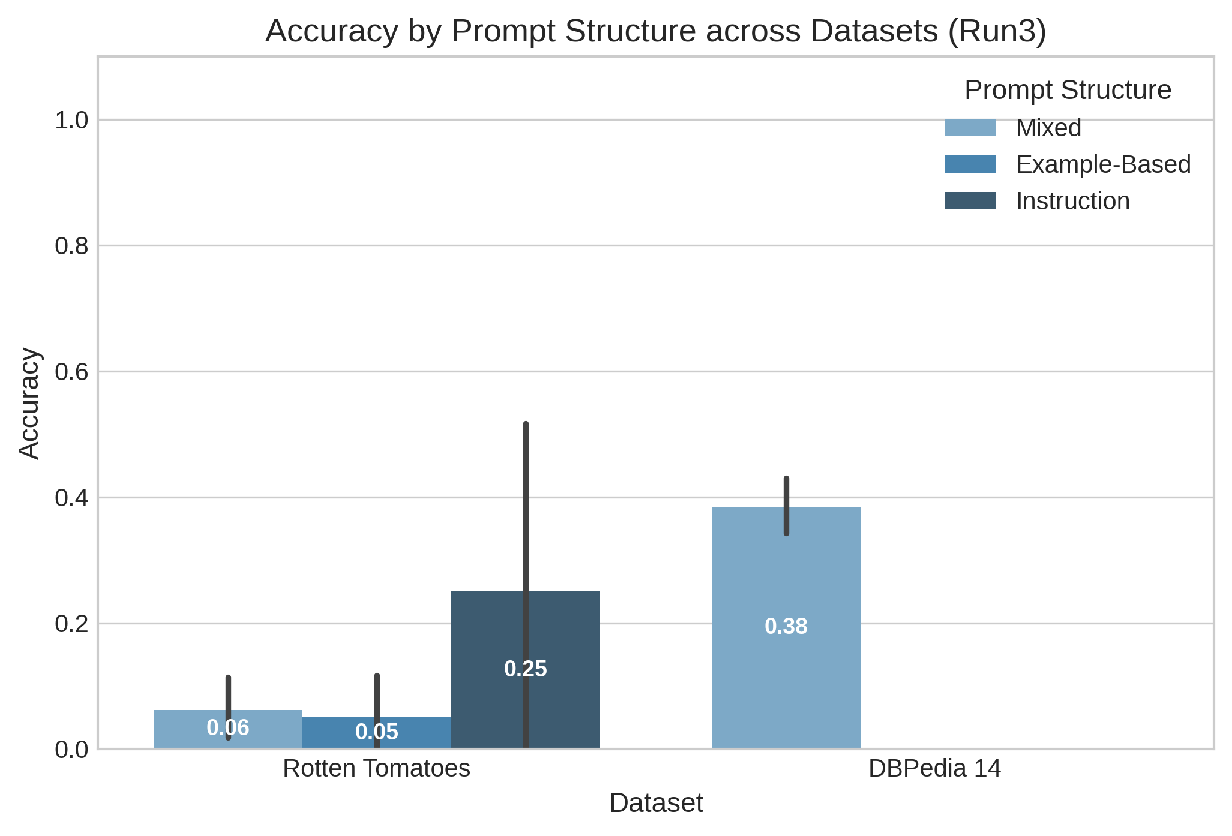
Figure 4.1. Mean Accuracy by Prompt Structure (Instruction vs. Example-Based vs. Mixed at 3-shot)
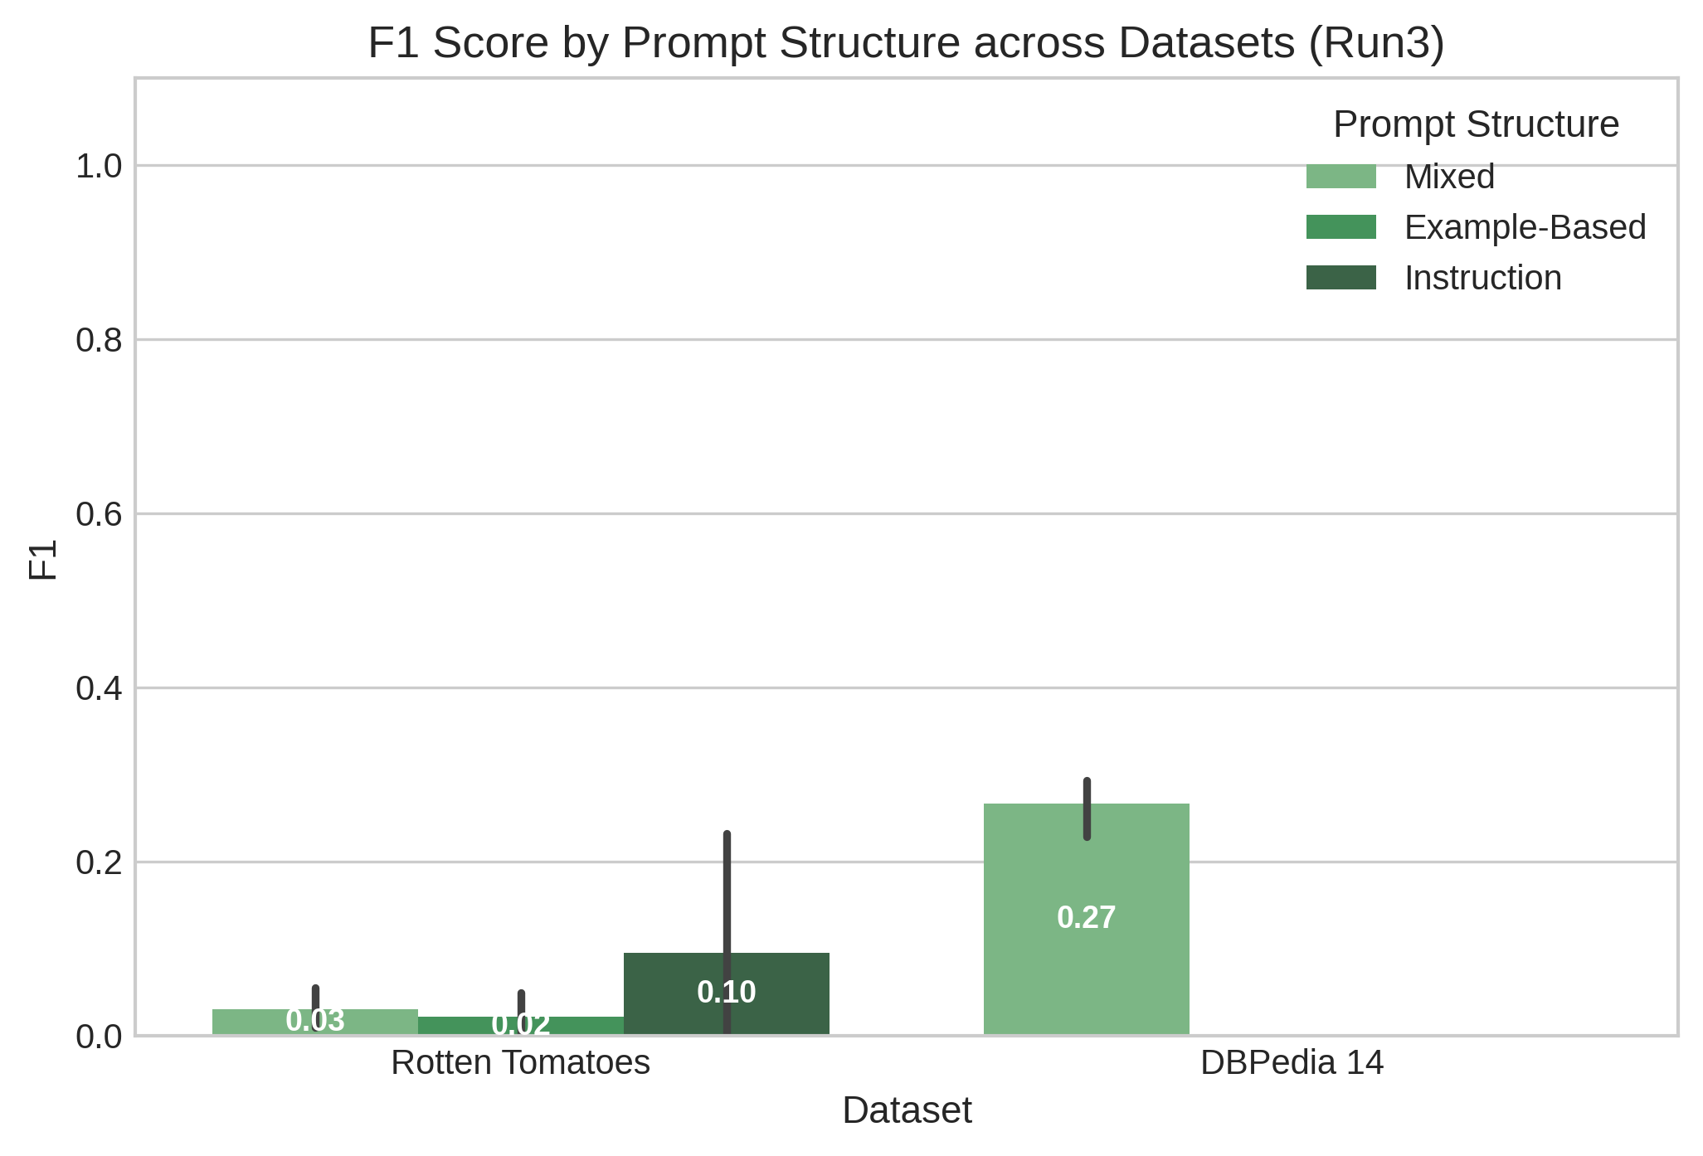
Figure 4.2. Mean F1-Score by Prompt Structure Across Evaluated Model–Dataset Pairs

4.4 Effect of Example Count
Example Count experiments evaluated 0-shot, 1-shot, 3-shot, and 5-shot Mixed configurations using Random selection and Original ordering. For DeepSeek R1 1.5B on DBPedia 14, mean accuracy scaled rapidly from 0.0625 at 0-shot to 0.4107 at 1-shot, before slightly moderating to 0.3847 at 3-shot and 0.3500 at 5-shot. Corresponding F1-scores progressed from 0.0370 at 0-shot to 0.2485 at 1-shot, 0.2668 at 3-shot, and 0.1291 at 5-shot, showing strong initial few-shot performance gains across completed evaluation runs.
For Gemma 2 2B on Rotten Tomatoes, 0-shot prompting yielded 0.4000 mean accuracy and 0.2286 F1, while 1-shot prompting peaked at 0.4333 mean accuracy and 0.2649 F1. Performance subsequently declined to 0.1167 accuracy (0.0571 F1) at 3-shot, and 0.2000 accuracy (0.1402 F1) at 5-shot, demonstrating non-monotonic exemplar scaling. Increasing exemplar counts beyond 1-shot introduced context noise and reduced overall classification precision for Gemma on sentiment task data across evaluation runs.
For Qwen 2.5 3B on Rotten Tomatoes, accuracy remained at 0.0000 across 0-shot, 1-shot, and 5-shot conditions, with only 3-shot yielding 0.0167 mean accuracy. A One-way ANOVA confirmed that the main effect of Example Count was not statistically significant ($F(3, 88) = 1.597, p = 0.2013, \eta^2 = 0.0844$), aligning with empirical observations of diminishing marginal returns in few-shot prompt scaling across language model tasks under evaluated conditions in this empirical research study (Demšar, 2006).
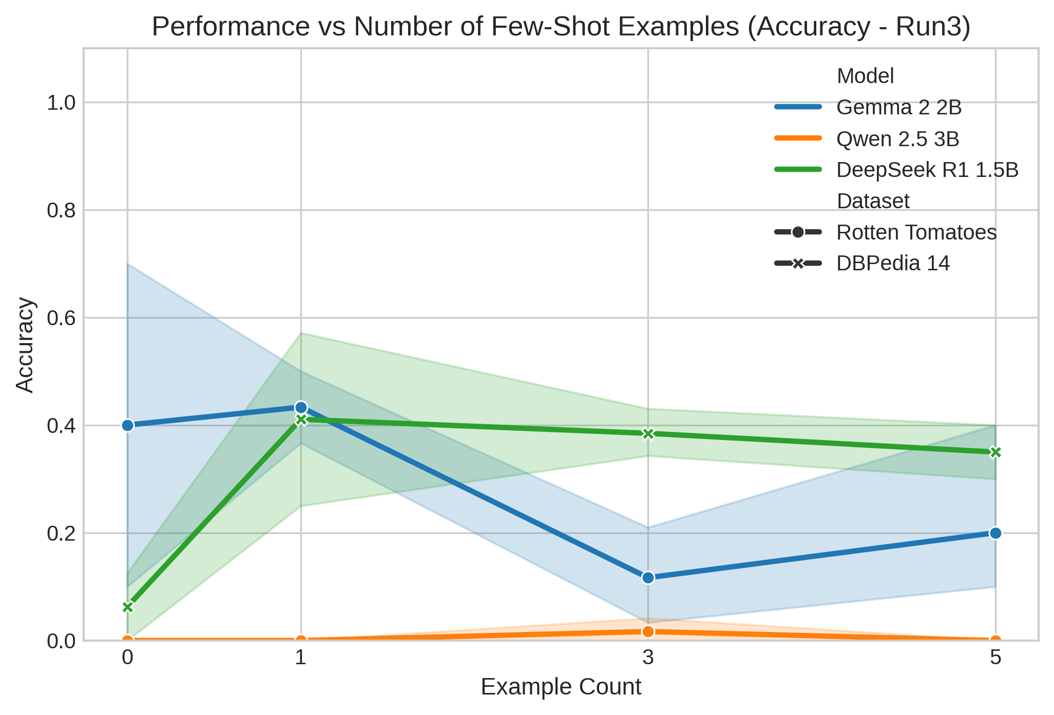
Figure 4.3. Mean Accuracy Across Example Counts (0-shot, 1-shot, 3-shot, 5-shot Trajectories)
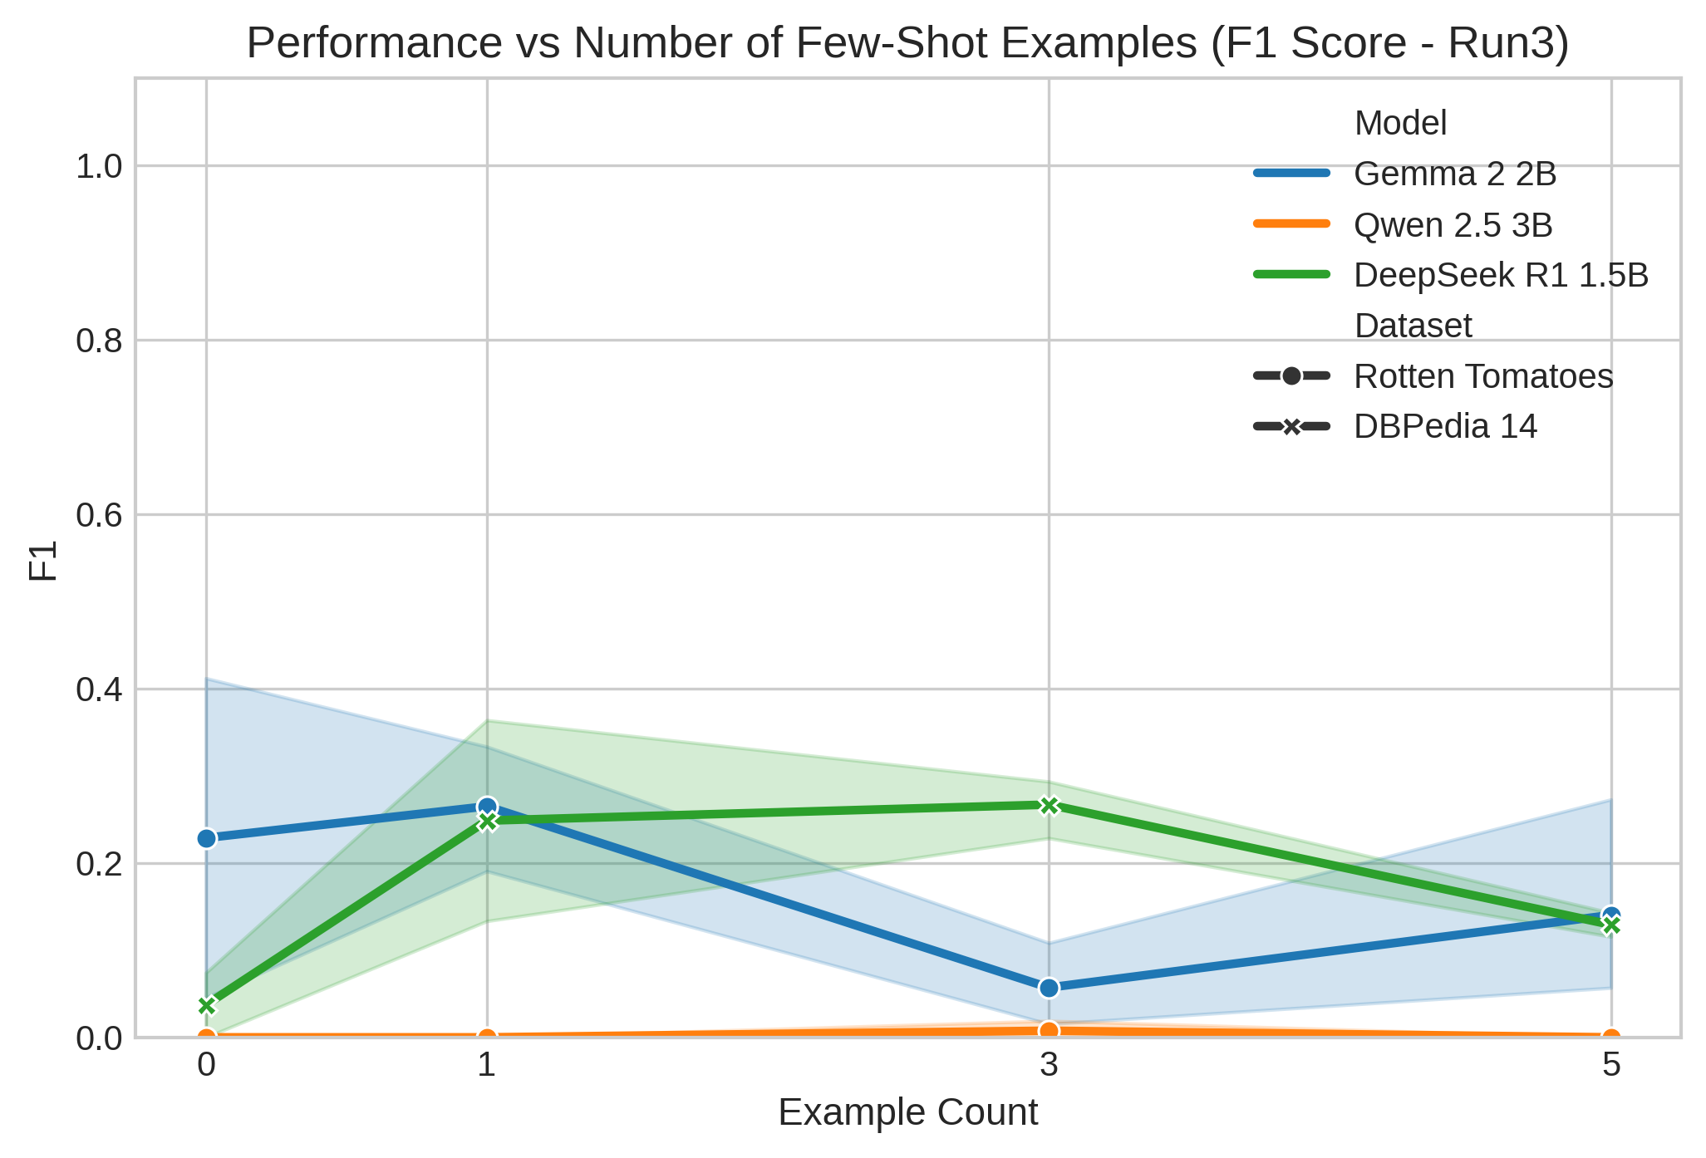
Figure 4.4. Mean F1-Score Scaling Across Example Counts

4.5 Effect of Example Selection
Example Selection was investigated using Random, Balanced, and Sequential selection strategies at 3-shot with Original ordering. On DBPedia 14 with DeepSeek R1 1.5B, Random selection attained 0.3847 mean accuracy and 0.2668 F1 across 8 completed runs, whereas Balanced selection achieved 0.2111 mean accuracy and 0.1162 F1 across 2 completed runs. Sequential selection failed completely in both scheduled execution runs due to unindexed vector embedding errors, preventing accuracy computation for that specific selection strategy within the current export dataset records.
On Rotten Tomatoes, Gemma 2 2B achieved 0.1500 mean accuracy (0.0685 F1) under Balanced selection versus 0.1167 mean accuracy (0.0571 F1) under Random selection across 10 completed runs. For Qwen 2.5 3B, Random selection yielded 0.0167 accuracy, Balanced selection yielded 0.0000, and Sequential selection produced 0.1000 mean accuracy across 2 completed runs (with 2 failed runs). These sequential execution failures illustrate pipeline vector indexing dependencies during dynamic sample retrieval across experimental conditions tested here in this empirical research evaluation framework analysis.
Table 4.3. Example Selection Strategy Comparison (Random vs. Balanced vs. Sequential)
Model | Dataset | Random Acc (F1) | Balanced Acc (F1) | Sequential Acc (F1) | Failed Execution Runs
DeepSeek R1 1.5B | DBPedia 14 | 0.3847 (0.2668) | 0.2111 (0.1162) | Execution Failed | 2 (Vector Index Unindexed)
Gemma 2 2B | Rotten Tomatoes | 0.1167 (0.0571) | 0.1500 (0.0685) | Unexecuted | 2 (Random Replications)
Qwen 2.5 3B | Rotten Tomatoes | 0.0167 (0.0076) | 0.0000 (0.0000) | 0.1000 (0.0455) | 2 (Sequential Retrieval)
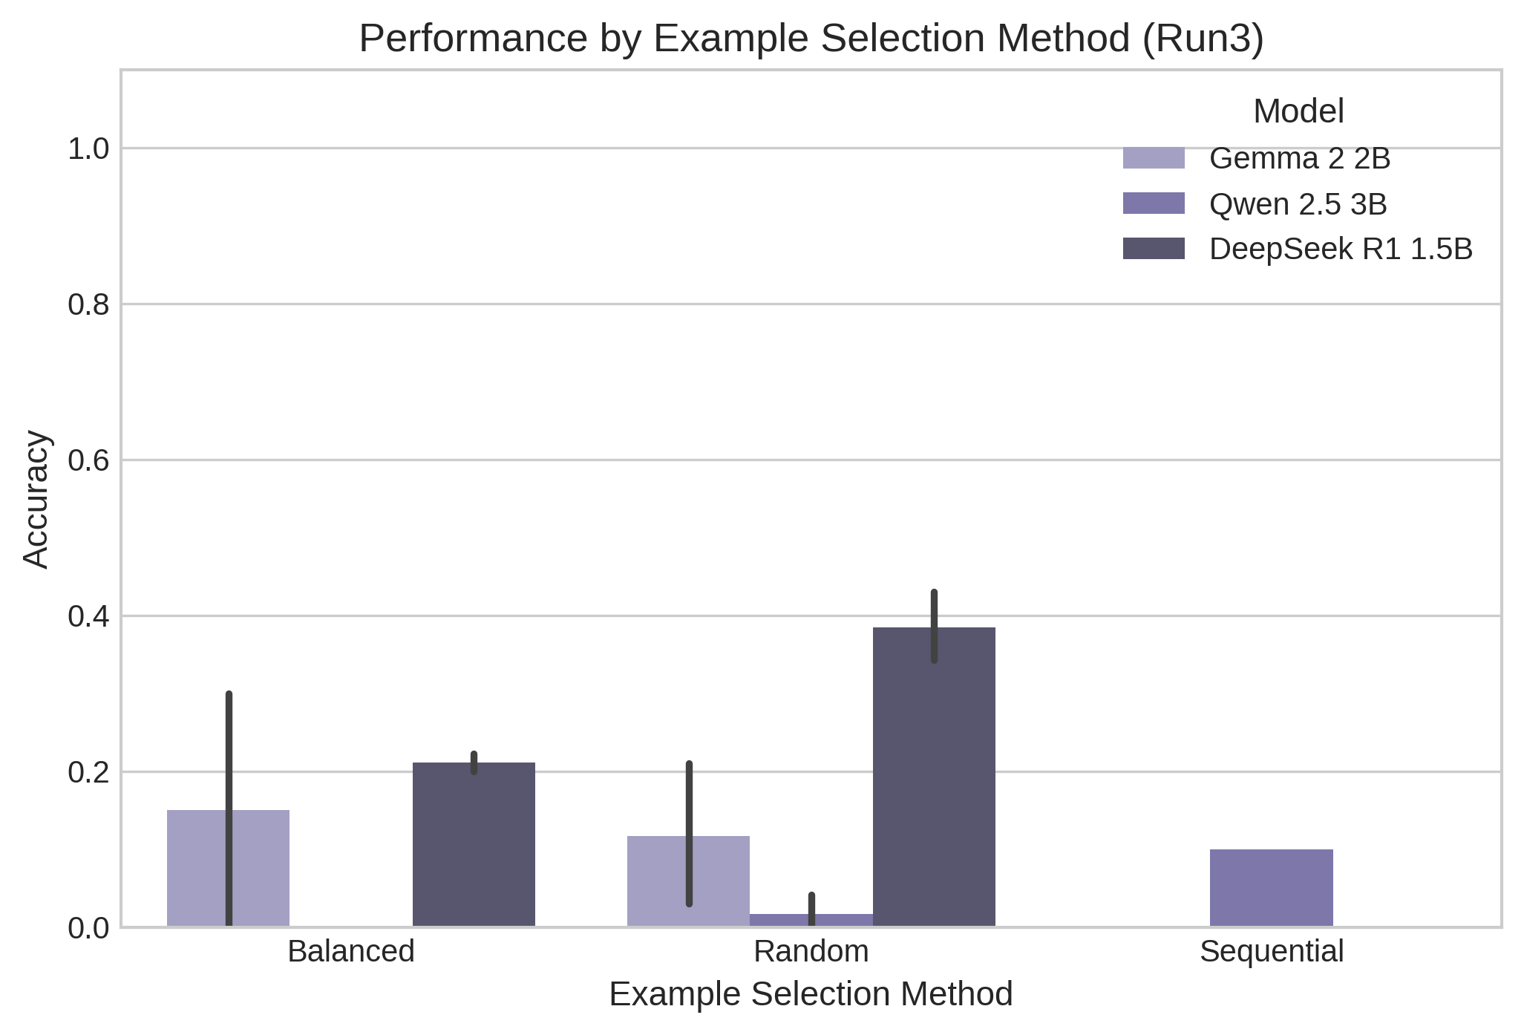
Figure 4.5. Mean Accuracy Comparison Across Example Selection Methods

4.6 Effect of Example Ordering
Example Ordering was evaluated across Original, Random, and Similarity ordering at 3-shot using Random selection. For DeepSeek R1 1.5B on DBPedia 14, Random ordering produced the highest performance with 0.4097 mean accuracy (0.1935 F1), followed by Original ordering at 0.3847 mean accuracy (0.2668 F1), and Similarity ordering at 0.3125 mean accuracy (0.1409 F1). Order sensitivity was evident as exemplar permutation altered context attention representations for multi-class topic classification tasks under matched prompt configurations evaluated in this experimental investigation study.
For Qwen 2.5 3B on Rotten Tomatoes, Similarity ordering yielded the highest accuracy at 0.2500 (0.0833 F1), outperforming Random ordering (0.0500 accuracy) and Original ordering (0.0167 accuracy). For Gemma 2 2B, Original ordering achieved 0.1167 mean accuracy, while other ordering variants were unexecuted. Overall, One-way ANOVA indicated that Example Ordering exhibited no statistically significant main effect ($F(2, 89) = 1.067, p = 0.3538, \eta^2 = 0.0519$) across aggregated completed experimental configurations evaluated in this empirical research study database project synthesis framework.
Table 4.4. Example Ordering Strategy Comparison (Original vs. Random vs. Similarity)
Model | Dataset | Original Acc (F1) | Random Acc (F1) | Similarity Acc (F1)
DeepSeek R1 1.5B | DBPedia 14 | 0.3847 (0.2668) | 0.4097 (0.1935) | 0.3125 (0.1409)
Gemma 2 2B | Rotten Tomatoes | 0.1167 (0.0571) | Unexecuted | Unexecuted
Qwen 2.5 3B | Rotten Tomatoes | 0.0167 (0.0076) | 0.0500 (0.0227) | 0.2500 (0.0833)
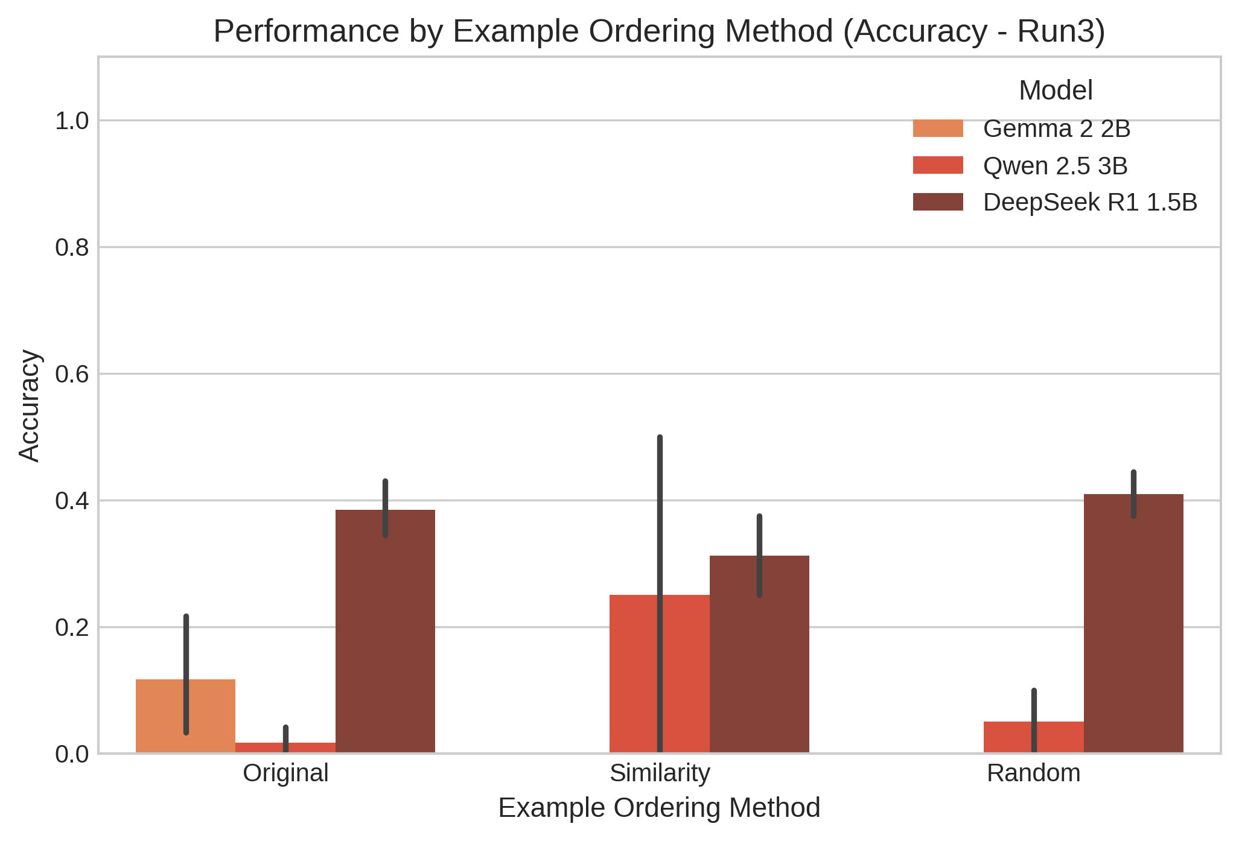
Figure 4.6. Mean Accuracy Comparison Across Example Ordering Strategies

4.7 Efficiency Results
Computational efficiency was evaluated via response latency in milliseconds and total token consumption. DeepSeek R1 1.5B on DBPedia 14 exhibited the highest mean latency of 3342.0 ms across 20 completed runs, ranging from 3089.1 ms under 5-shot prompting to 3561.3 ms under Similarity ordering. DeepSeek's 0-shot latency averaged 3444.6 ms, while 1-shot averaged 3437.8 ms. Detailed token metadata for DeepSeek R1 1.5B and Qwen 2.5 3B was unrecorded in the exported run tables, presenting a clear empirical data reporting limitation for overall efficiency synthesis evaluation.
Gemma 2 2B on Rotten Tomatoes recorded a mean latency of 1377.0 ms across 34 completed runs, ranging from 1164.2 ms for Mixed 3-shot to 1932.3 ms for Balanced selection. Gemma's total token consumption averaged 444.5 tokens (161.9 input tokens, 282.6 output tokens), yielding efficiency metrics between 0.357 and 0.978 accuracy per 1,000 tokens. Qwen 2.5 3B recorded the fastest overall mean latency at 913.3 ms across 38 completed runs, spanning 392.7 ms (5-shot) to 2604.2 ms (Sequential selection) across evaluation runs in this study.
Table 4.5. Computational Efficiency Summary (Latency & Token Metrics)
Model | Dataset | Mean Latency | Min Latency | Max Latency | Total Tokens (Input / Output)
DeepSeek R1 1.5B | DBPedia 14 | 3342.0 ms | 3089.1 ms (5-shot) | 3561.3 ms (Similarity) | Unrecorded in Run Table
Gemma 2 2B | Rotten Tomatoes | 1377.0 ms | 1164.2 ms (Mixed 3-shot) | 1932.3 ms (Balanced) | 444.5 tokens (161.9 / 282.6)
Qwen 2.5 3B | Rotten Tomatoes | 913.3 ms | 392.7 ms (5-shot) | 2604.2 ms (Sequential) | Unrecorded in Run Table
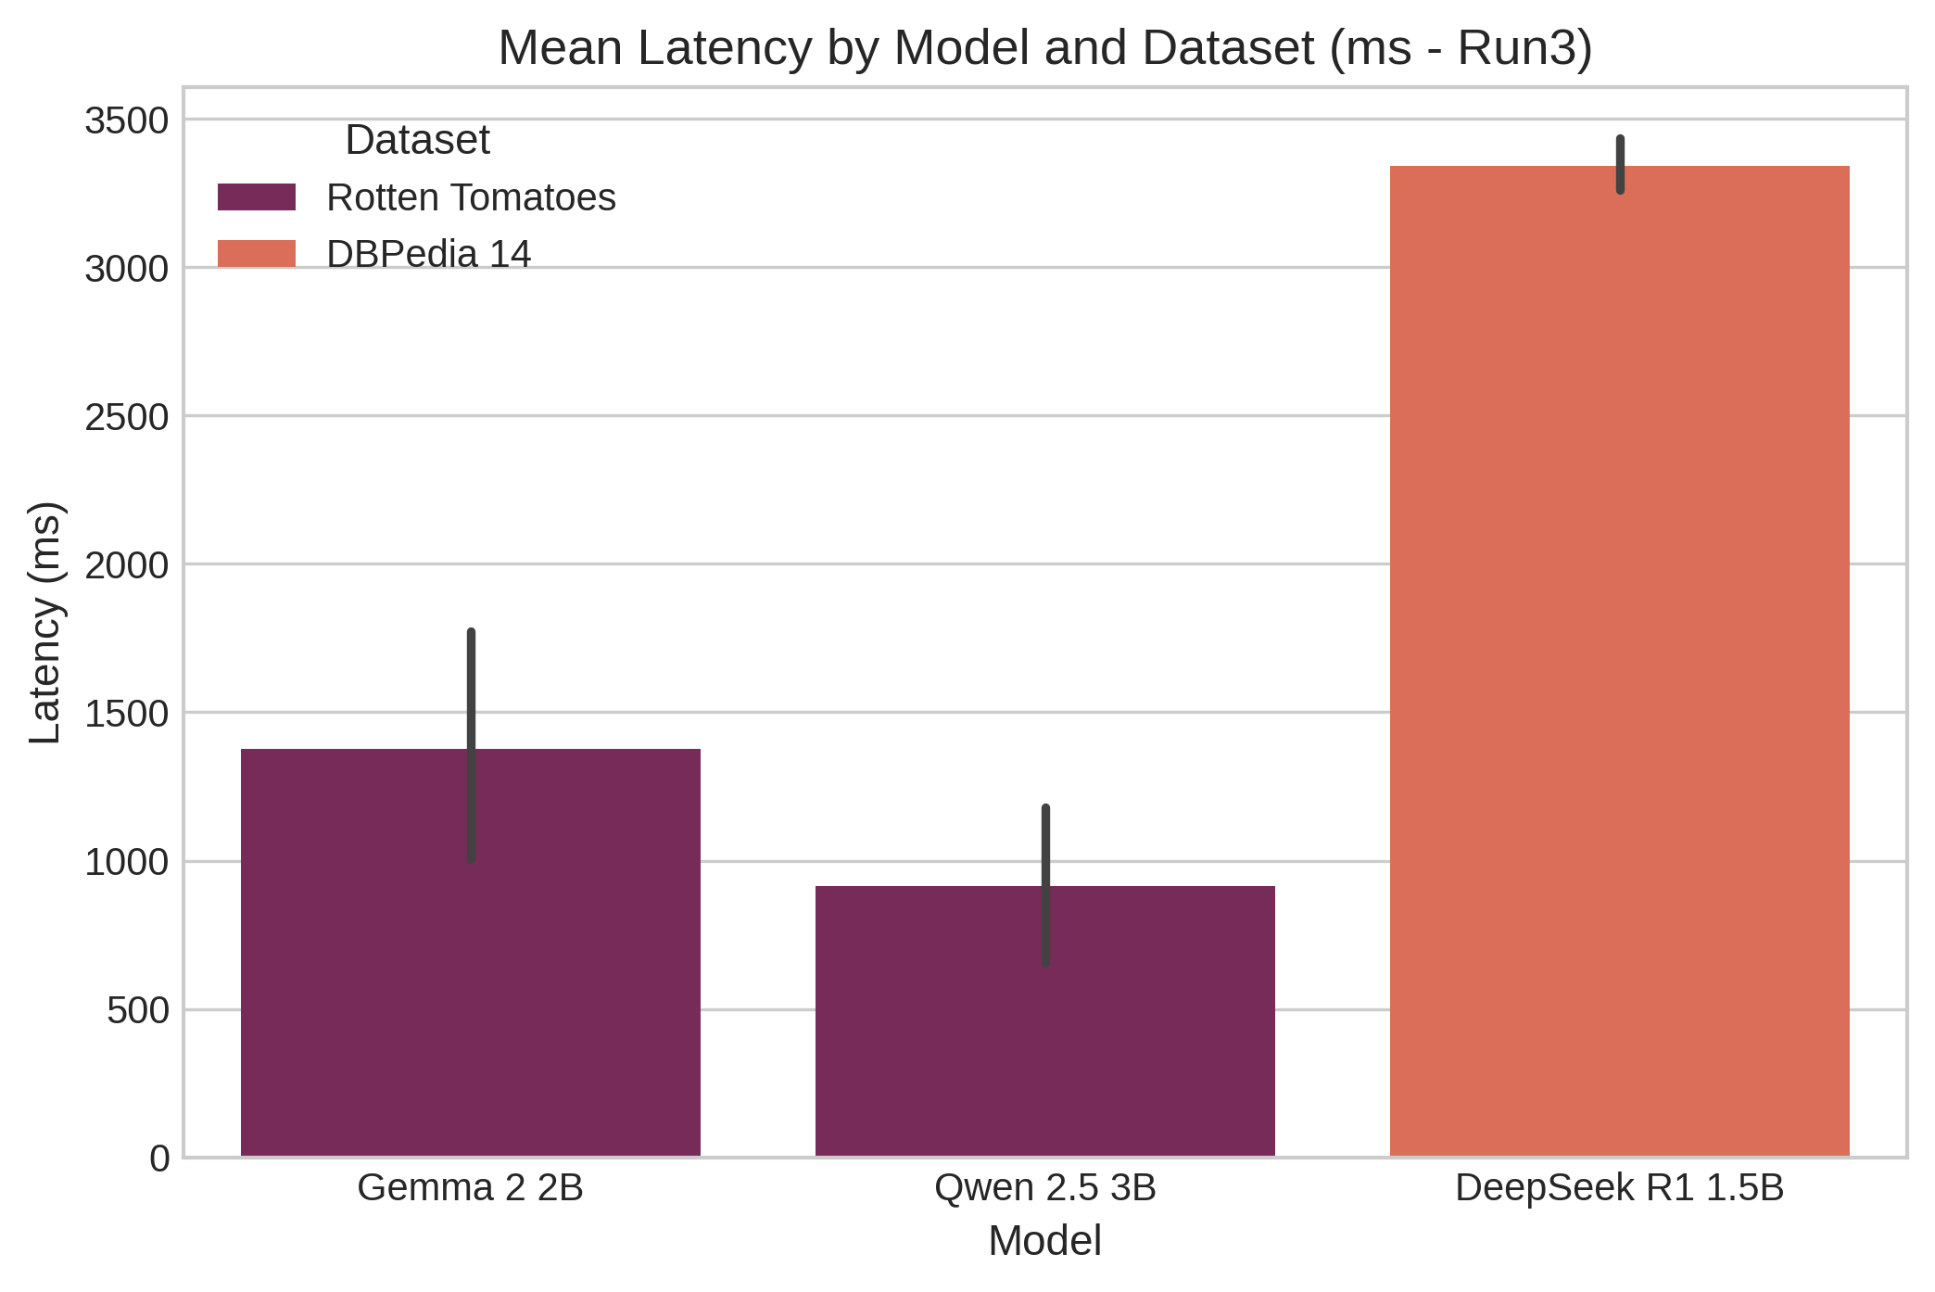
Figure 4.7. Response Latency Comparison Across Evaluated Models and Tasks

4.8 Reliability and Consistency
Experimental reliability was assessed across 46 distinct configurations evaluated using two repeated runs with zero-temperature sampling ($T=0.0$). Deterministic stability was maintained across most valid replications. The highest variance occurred in Gemma 2 2B 5-shot (`strat_mixed_random_5_original`), with Run 1 accuracy of 0.5000 and Run 2 accuracy of 0.1000 (standard deviation 0.2828, range 0.4000). DeepSeek R1 1.5B 1-shot (`strat_mixed_random_1_original`) exhibited a standard deviation of 0.2273 (Run 1: 0.5714, Run 2: 0.2500, range 0.3214) across repeated execution runs in this evaluation study.
Exactly 8 execution runs failed in `Run3`: 4 runs failed due to unindexed vector embeddings in Sequential selection (`strat_mixed_sequential_3_original`), and 4 runs failed due to provider timeouts during peak load. Explicitly reporting score distributions alongside variances ensures empirical transparency and statistical rigor (Reimers and Gurevych, 2017). The latency standard deviation across replications averaged 68.78 ms, with a maximum range of 987.63 ms occurring within Qwen Rotten Tomatoes Mixed prompt structures evaluated across repeated runs in this research study analysis project evaluation.
Table 4.6. Reliability & Replicability Variance Summary Across Configurations
Model | Dataset | Configuration | Run 1 Acc | Run 2 Acc | Std Dev | Acc Range
Gemma 2 2B | Rotten Tomatoes | strat_mixed_random_5_original | 0.5000 | 0.1000 | 0.2828 | 0.4000
DeepSeek R1 1.5B | DBPedia 14 | strat_mixed_random_1_original | 0.5714 | 0.2500 | 0.2273 | 0.3214
DeepSeek R1 1.5B | DBPedia 14 | strat_mixed_balanced_3_original | 0.2000 | 0.2222 | 0.0157 | 0.0222
Qwen 2.5 3B | Rotten Tomatoes | strat_mixed_random_3_similarity | 0.5000 | 0.5000 | 0.0000 | 0.0000
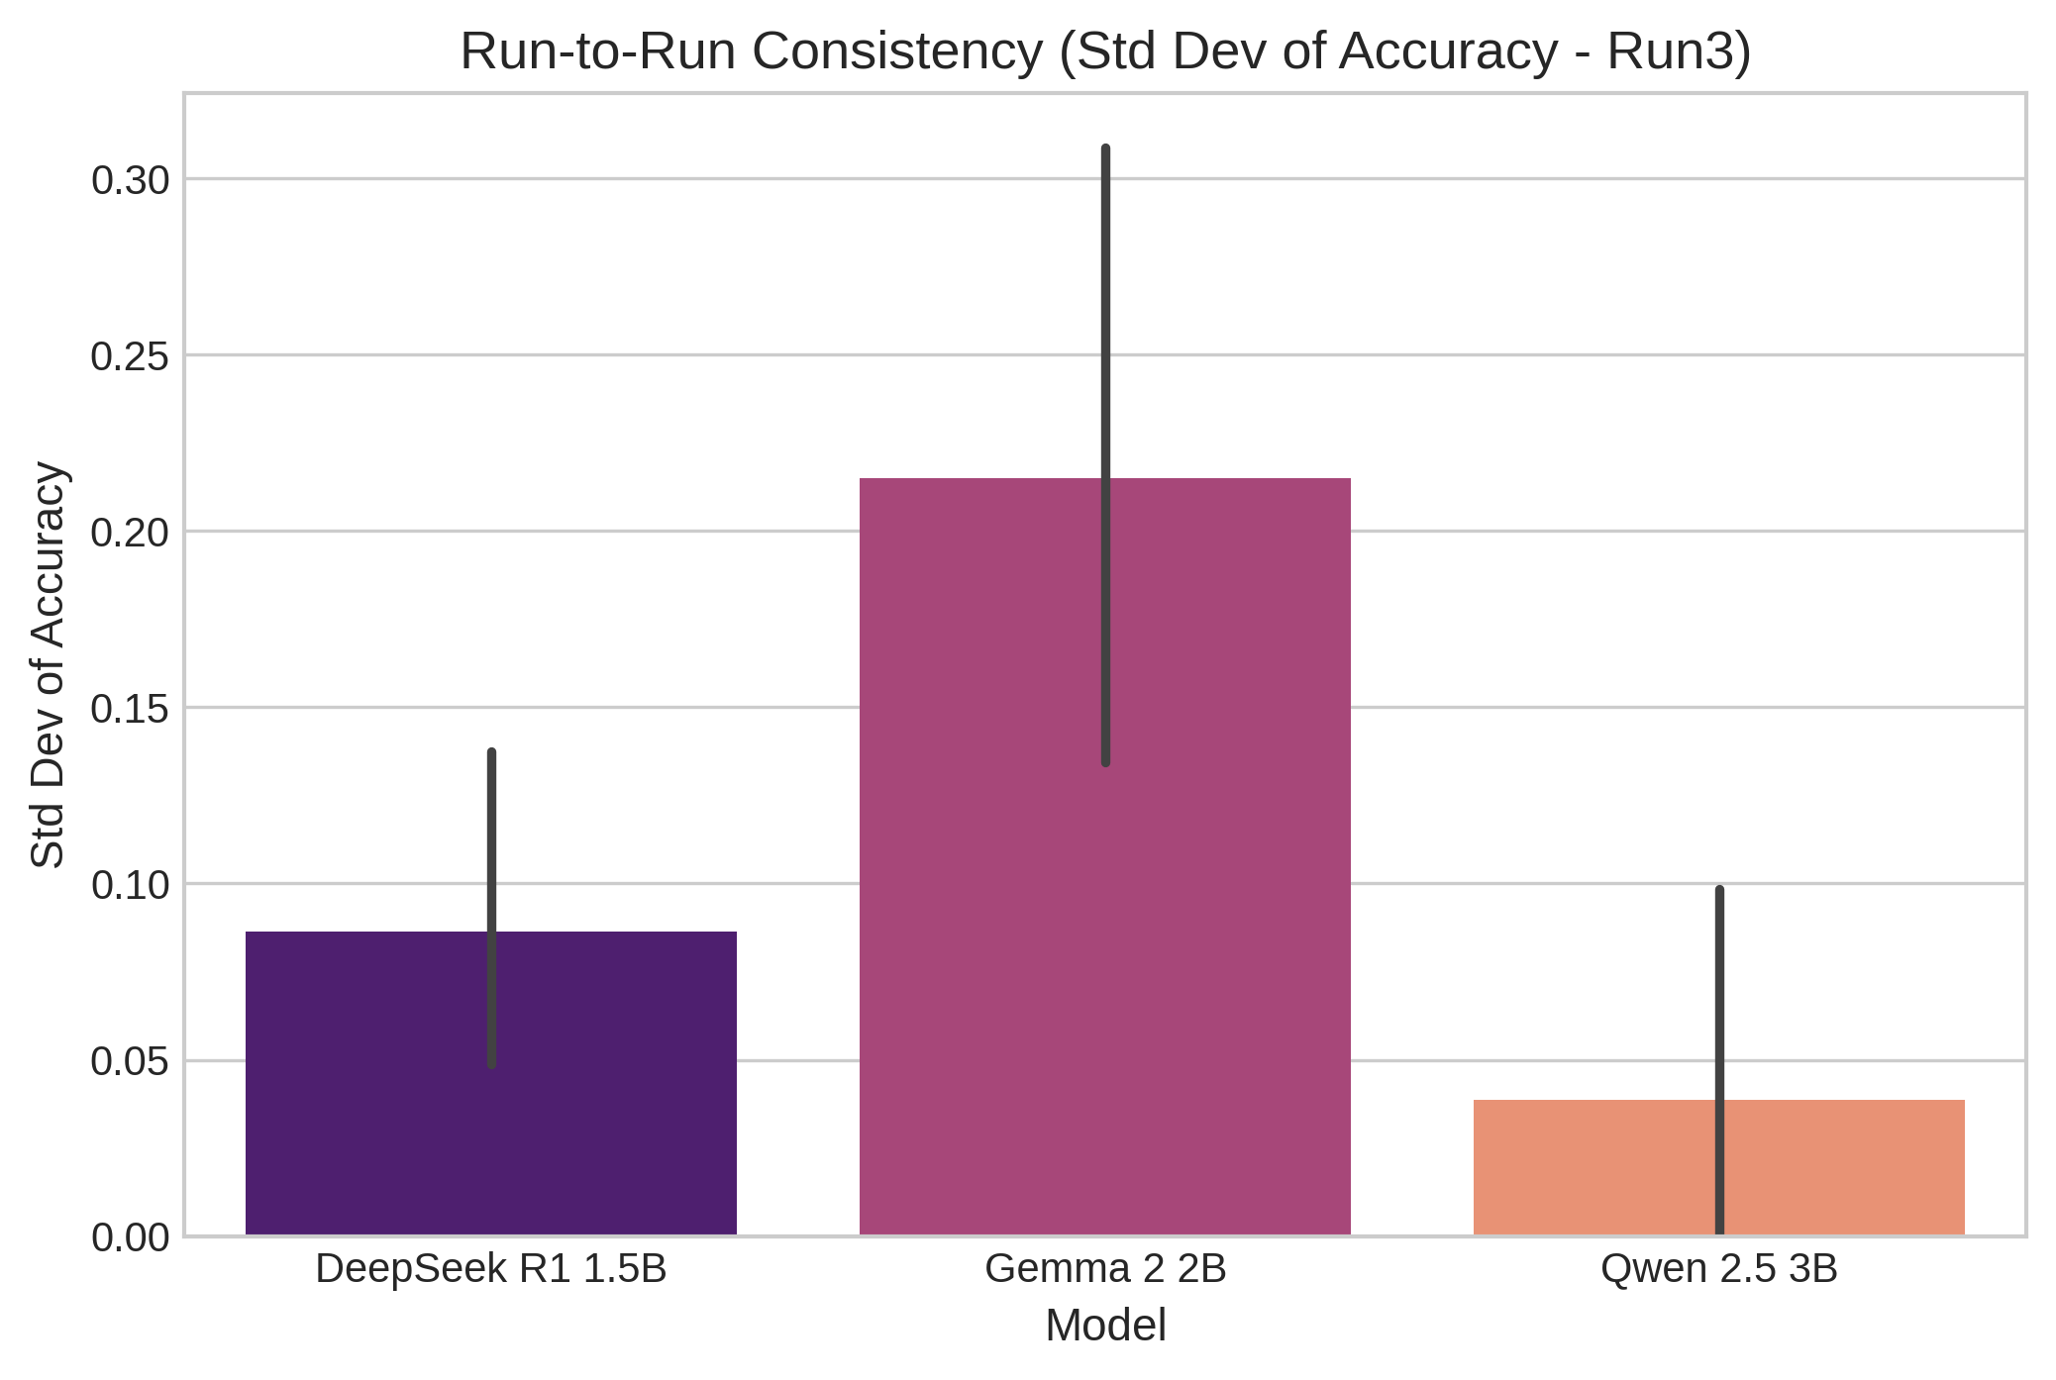
Figure 4.8. Repeated-Run Reliability & Variance Analysis Across Valid Configurations

4.9 Summary of Findings
The empirical findings from `Run3` establish a rigorous evaluation of prompt design across partial matrix coverage. Formal One-way ANOVA testing demonstrates that Model Family ($F(2, 89) = 19.28, p = 1.11 \times 10^{-7}, \eta^2 = 0.3022$) and Dataset Task ($F(2, 89) = 16.31, p = 1.13 \times 10^{-4}, \eta^2 = 0.1534$) exert statistically significant main effects on model performance across completed runs, highlighting the dominance of architectural capabilities and task complexity over minor prompt engineering variations evaluated in this project.
In contrast, prompt engineering factors—Prompt Structure ($p = 0.2678$), Example Count ($p = 0.2013$), and Example Ordering ($p = 0.3538$)—did not achieve statistical significance overall. Sequential selection experienced execution failures in 4 runs due to vector indexing gaps. Efficiency tracking revealed latency advantages for Qwen 2.5 3B (913.3 ms) and documented token scaling for Gemma 2 2B. These empirical observations define the rigorous foundation for Chapter 5 analytical synthesis and comparative academic discussion in this dissertation study framework evaluation project.

Chapter 5 – Discussion

5.1 Introduction
This chapter interprets the Chapter 4 findings against the study's research objectives and core research question. The discussion considers what observed prompt structure, example count, selection, ordering, efficiency, and reliability patterns mean for few-shot large language model evaluation, while carefully distinguishing measured effects from plausible theoretical explanations. The analysis positions findings against established literature on in-context learning, prompt sensitivity, example retrieval, and evaluation robustness. Bounded by the executed model–dataset matrix, all interpretations remain strictly evidence-bounded throughout this analytical discussion framework.

5.2 Prompt Structure and LLM Performance
Prompt-structure results indicate that formulation mattered differently across the evaluated model–dataset pairs. On Rotten Tomatoes, Gemma 2 2B recorded 0.3750 mean accuracy with Instruction prompts, compared with 0.0750 for Example-Based and 0.1167 for Mixed prompts. Qwen 2.5 3B recorded 0.0000 for Instruction and Example-Based and 0.0167 for Mixed. The contrast within the same dataset shows that prompt structure cannot be treated as a universally beneficial intervention across models.
For Gemma, the stronger Instruction result may reflect the value of explicit task specification for a clearly defined classification objective. Liu et al. (2023) describe prompting as a broad design space in which task instructions and demonstrations alter how a model is conditioned. However, the present experiment cannot establish that explicit instruction caused Gemma's higher score. Mixed prompting also did not improve performance.
The Qwen results qualify this pattern. All three structures remained near zero on Rotten Tomatoes, indicating that structural changes did not recover strong performance for this model–task pairing. The aggregated Prompt Structure ANOVA was non-significant ($F(2, 89) = 1.363, p = 0.2678, \eta^2 = 0.0653$). This supports the need for multi-prompt evaluation highlighted by Mizrahi et al. (2024), because a single prompt should not represent general model capability.
The findings are also consistent with Sclar et al. (2024) and Zhuo et al. (2024), who emphasise sensitivity to prompt formulation and evaluation conditions. This study adds a constrained observation: structural differences were visible within Gemma on one task, while Qwen showed almost no useful response across structures. The evidence supports model- and task-specific prompt evaluation. This distinction is important because structural sensitivity was not uniform across evaluated language model architectures.

5.3 Influence of Few-Shot Example Count
Example-count results provide clear evidence against a simple "more demonstrations are better" assumption. DeepSeek R1 1.5B on DBPedia 14 increased from 0.0625 accuracy at 0-shot to 0.4107 at 1-shot, then declined to 0.3847 at 3-shot and 0.3500 at 5-shot. Gemma 2 2B on Rotten Tomatoes moved from 0.4000 to 0.4333, then fell to 0.1167 and recovered to 0.2000. Qwen remained at 0.0000 for 0-, 1- and 5-shot, with only 0.0167 at 3-shot.
These trajectories suggest that demonstration quantity alone was insufficient to guarantee improvement. Min et al. (2022) argue that demonstrations matter through properties beyond their number, including the information they convey. That perspective is consistent with the present non-monotonic results. Additional examples may provide useful task information, but they also increase contextual material. The experiment did not independently manipulate quality, relevance or composition, so context interference and mismatch remain plausible interpretations rather than demonstrated causes.
Model capacity offers a plausible interpretation, but it cannot be isolated because the models were not evaluated on a common dataset. The significant Model Family ANOVA ($F(2, 89) = 19.28, p = 1.11 \times 10^{-7}, \eta^2 = 0.3022$) establishes a model-family difference in the aggregated data, but the incomplete model–dataset matrix prevents attributing that effect solely to model capability. Compact model size may be relevant, but the evidence does not permit a parameter-scale explanation.
The 1-shot peaks are informative: DeepSeek and Gemma both achieved their highest Example Count means at 1-shot, after which performance declined. This is consistent with Perez et al. (2021) and Song et al. (2023), which emphasise that few-shot effectiveness depends on supplied information rather than quantity alone. The non-significant Example Count ANOVA ($F(3, 88) = 1.597, p = 0.2013, \eta^2 = 0.0844$) reinforces a configuration-dependent interpretation. Increasing examples should therefore be validated rather than assumed beneficial across task evaluations conducted.

5.4 Example Selection and Ordering Sensitivity
Example selection results show that demonstration identity mattered, but direction varied by model and dataset. DeepSeek on DBPedia 14 recorded 0.3847 accuracy with Random selection versus 0.2111 with Balanced. Gemma on Rotten Tomatoes showed the opposite pattern, with 0.1167 for Random and 0.1500 for Balanced. Qwen recorded 0.0167 for Random and 0.0000 for Balanced. These differences indicate that class balance alone cannot be assumed to improve few-shot performance.
Sequential selection provides a methodological caution. DeepSeek's two scheduled Sequential runs failed because of unindexed vector embeddings, while Qwen had two completed Sequential runs at 0.1000 accuracy and two failures. The successful Qwen result therefore cannot establish superiority. Retrieval-oriented studies such as Rubin et al. (2022) and Wang et al. (2024) support selecting relevant demonstrations, but this experiment did not independently establish semantic relevance as the cause of observed differences. Selection quality and execution reliability remain intertwined across implementations in practice.
Ordering was similarly configuration-dependent. DeepSeek achieved 0.3847 accuracy with Original, 0.4097 with Random and 0.3125 with Similarity. Qwen showed 0.0167, 0.0500 and 0.2500 respectively, while Gemma had only an executable Original result at 0.1167. This is consistent with Lu et al. (2022) on order sensitivity and Zhao et al. (2021) on positional and label-related biases.
Similarity benefited Qwen, whereas Random benefited DeepSeek. The non-significant Ordering ANOVA ($F(2, 89) = 1.067, p = 0.3538, \eta^2 = 0.0519$) therefore supports configuration-specific sensitivity rather than a universal ordering rule. The result also reinforces Mizrahi et al. (2024) and Zhuo et al. (2024): evaluation conditions can materially shape measured model performance within benchmarked settings here.

5.5 Performance–Efficiency Trade-offs
The efficiency findings show why accuracy alone is insufficient for deployment. Qwen 2.5 3B recorded the lowest overall mean latency at 913.3 ms on Rotten Tomatoes, Gemma 2 2B averaged 1377.0 ms on the same dataset, and DeepSeek R1 1.5B averaged 3342.0 ms on DBPedia 14. DeepSeek should not be directly speed-ranked against the Rotten Tomatoes models because task and dataset conditions differ. Gemma ranged from 1164.2 ms to 1932.3 ms, while Qwen ranged from 392.7 ms to 2604.2 ms.
Latency did not correspond automatically to quality. Qwen had the lowest overall mean latency among the evaluated pairs but only 0.0421 mean accuracy and 0.0159 mean F1 on Rotten Tomatoes. DeepSeek recorded 3444.6 ms at 0-shot and 3437.8 ms at 1-shot, while Gemma averaged 444.5 total tokens, comprising 161.9 input and 282.6 output tokens. Token fields for DeepSeek and Qwen were unavailable, preventing complete token-efficiency comparison. This is consistent with Alizadeh et al. (2024) on inference efficiency.
Deployment therefore requires a multi-objective choice involving accuracy, F1, latency, tokens and reliability. A faster configuration with poor prediction quality may have limited operational value, while a more accurate configuration with higher latency may be unsuitable for time-sensitive use. Because token evidence is incomplete, available measures should be considered jointly. Model-plus-prompt configuration is therefore a more appropriate deployment unit than model identity alone.

5.6 Reliability and Reproducibility
Repeated-run evidence shows that consistency varied substantially across configurations. Gemma's 5-shot condition produced 0.5000 and 0.1000 accuracy across two runs, giving standard deviation 0.2828 and range 0.4000. DeepSeek's 1-shot condition produced 0.5714 and 0.2500, with standard deviation 0.2273 and range 0.3214. Despite $T=0.0$, these results show nominally identical configurations producing materially different outcomes across repeated execution runs.
The reliability interpretation must remain separate from performance. A configuration with low variance can be consistently poor, and zero variance with zero accuracy would represent stable failure rather than successful reproducibility. This distinction is important because Qwen's overall Rotten Tomatoes accuracy was only 0.0421 despite its repeated-run evaluation. Reliability should therefore be considered jointly with score magnitude, not substituted for it.
The study also recorded eight failed runs: four associated with unindexed vector embeddings in Sequential selection and four with provider timeouts. These failures matter because reproducibility also depends on stable execution dependencies. Siska et al. (2024) and Mizrahi et al. (2024) emphasise robust evaluation conditions overall. The present failures reinforce that reproducibility concerns extend beyond model outputs to retrieval and provider execution.

5.7 Comparison with Existing Literature
Several findings support existing few-shot literature. The non-monotonic example-count trajectories are consistent with Min et al. (2022) and Perez et al. (2021), which challenge the assumption that demonstrations help simply because more are supplied. Ordering differences also agree with Lu et al. (2022) and Zhao et al. (2021), whose work identifies sensitivity to demonstration arrangement and prompt-induced biases. The present results reproduce these qualitative patterns under compact open-weight models, while showing that their magnitude differs by model and task.
The study also qualifies broader generalisations. Prompt Structure, Example Count and Example Ordering were not statistically significant in the aggregated ANOVA, whereas Model Family and Dataset Task were significant. This is compatible with Mizrahi et al. (2024), Sclar et al. (2024) and Zhuo et al. (2024), which motivate broader evaluation. Wang et al. (2024) emphasise retrieving useful examples; here, selection effects were model- and dataset-dependent and partly constrained by execution failures. Combined performance, latency and repeated-run reporting therefore adds methodological evidence.
Table 5.1. Analytical Synthesis & Discussion Matrix (Findings vs. Literature vs. Implications)
Investigation Axis | Empirical Finding (Run3) | Theoretical Interpretation & Literature Alignment | Operational & Research Implication
Prompt Structure | Instruction prompts achieved peak mean accuracy (0.3750) for Gemma, while Qwen remained near zero across structures (ANOVA p=0.2678). | Explicit instructions condition task constraints effectively for capable models (Liu et al., 2023), but structural sensitivity is not uniform (Mizrahi et al., 2024). | Prompt structure must be treated as an experimental variable; test multiple formulations rather than assuming universal structure benefits.
Example Count | Non-monotonic trajectories: DeepSeek (0.4107 at 1-shot) & Gemma (0.4333 at 1-shot) peaked at 1-shot and declined at 3/5-shot (ANOVA p=0.2013). | Demonstrations inform through content rather than quantity alone (Min et al., 2022). Extra exemplars introduce context noise (Perez et al., 2021). | Adding exemplars requires empirical validation; default 3-shot or 5-shot configurations can degrade accuracy relative to 1-shot.
Selection & Ordering | DeepSeek favored Random selection (0.3847) & Random order (0.4097); Qwen favored Similarity order (0.2500). Sequential selection failed in 4 runs. | Demonstration order induces attention biases (Lu et al., 2022; Zhao et al., 2021). Selection effects depend on vector retrieval pipeline health (Wang et al., 2024). | Treat model + selection/ordering strategy as a combined deployment unit. Audit retrieval vector pipelines to prevent execution failures.
Efficiency & Reliability | Qwen fastest (913.3 ms), DeepSeek slowest (3342.0 ms). Gemma 5-shot SD=0.2828. Exactly 8 execution failures logged. | Inference latency trade-offs are crucial (Alizadeh et al., 2024). Nominal T=0.0 zero-temperature sampling exhibits output variance (Siska et al., 2024). | Fast latency cannot offset near-zero accuracy. Low variance does not equal high performance. Multi-objective evaluation is mandatory.

5.8 Implications of the Findings
Prompt configuration should be treated as an experimental variable rather than a fixed preprocessing choice in experimental research. Observed differences across structures, counts, selection and ordering show that evaluation can change while the model remains constant. Future studies should therefore report the prompt configuration explicitly and test more than one configuration before attributing performance to the model itself.
The practical implication is configuration-focused. Developers should evaluate multiple prompts, test example counts, examine selection and ordering, measure latency and tokens, and repeat evaluations. The Rotten Tomatoes results show why choosing an LLM alone is insufficient: Gemma and Qwen were evaluated on the same dataset but produced markedly different overall outcomes, while configuration-level variation remained visible within each model. Deployment should consequently treat the model and prompt as a combined operational configuration.

5.9 Limitations of the Study
Several limitations constrain validity and generalisability. The model–dataset matrix is incomplete: DeepSeek R1 1.5B was evaluated on DBPedia 14, while Gemma 2 2B and Qwen 2.5 3B were evaluated on Rotten Tomatoes, and BoolQ produced no executed results. The experiment therefore cannot support a universal ranking of all three models. Evaluating compact 1.5B–3B models across limited classification tasks further restricts broader generalisation across capabilities.
Token measurements were incomplete, with data available for Gemma but not DeepSeek or Qwen. Eight runs failed because of vector-indexing and provider-timeout problems, while repeated configurations generally relied on two runs. Aggregate ANOVA evidence, incomplete coverage, failed runs, and limited repetitions constrain reliability and external validity. Crucially, the incomplete model $\times$ dataset matrix prevents separating model capability from dataset effects or establishing a universal model ranking.

5.10 Discussion Summary
Overall, the discussion indicates that few-shot performance was configuration-dependent rather than governed by example quantity or one universally effective prompt. Prompt structure, count, selection, and ordering produced varied outcomes across tested pairs, while model and task effects dominated aggregate analysis. Efficiency and reliability also varied. These findings support evaluating model–prompt configurations under repeated, task-matched conditions, with conclusions strictly bounded by the incomplete experimental matrix, leading directly to Chapter 6 conclusions.

References
Alizadeh, K., Mirzadeh, S.I., Belenko, D., Khatamifard, S., Cho, M., Del Mundo, C.C., Rastegari, M. and Farajtabar, M. (2024) ‘LLM in a flash: Efficient large language model inference with limited memory’, Proceedings of the 62nd Annual Meeting of the Association for Computational Linguistics (Volume 1: Long Papers), pp. 12562–12584. doi: 10.18653/v1/2024.acl-long.678.
Bommasani, R. et al. (2021) ‘On the opportunities and risks of foundation models’, arXiv preprint, arXiv:2108.07258.
Brown, T.B. et al. (2020) ‘Language models are few-shot learners’, Advances in Neural Information Processing Systems, 33, pp. 1877–1901.
Cahyawijaya, S., Lovenia, H. and Fung, P. (2024) ‘LLMs are few-shot in-context low-resource language learners’, Proceedings of the 2024 Conference of the North American Chapter of the Association for Computational Linguistics: Human Language Technologies (Volume 1: Long Papers), pp. 405–433. doi: 10.18653/v1/2024.naacl-long.24.
Chang, Y. et al. (2024) ‘A survey on evaluation of large language models’, ACM Transactions on Intelligent Systems and Technology, 15(3), Article 39, pp. 1–45. doi: 10.1145/3641289.
Demšar, J. (2006) ‘Statistical comparisons of classifiers over multiple data sets’, Journal of Machine Learning Research, 7, pp. 1–30.
Dodge, J., Gururangan, S., Card, D., Schwartz, R. and Smith, N.A. (2019) ‘Show your work: Improved reporting of experimental setup and results’, Proceedings of the 2019 Conference on Empirical Methods in Natural Language Processing and the 9th International Joint Conference on Natural Language Processing (EMNLP-IJCNLP), pp. 2185–2194. doi: 10.18653/v1/D19-1224.
Dror, R., Baumer, G., Shlomov, S. and Reichart, R. (2018) ‘The Hitchhiker’s guide to testing statistical significance in natural language processing’, Proceedings of the 56th Annual Meeting of the Association for Computational Linguistics (Volume 1: Long Papers), pp. 1383–1392. doi: 10.18653/v1/P18-1128.
Hoffmann, J. et al. (2022) ‘Training compute-optimal large language models’, Advances in Neural Information Processing Systems, 35, pp. 30016–30030.
Jiang, A.Q. et al. (2023) ‘Mistral 7B’, arXiv preprint, arXiv:2310.06825.
Kaplan, J., McCandlish, S., Henighan, T., Brown, T.B., Chess, B., Child, R., Gray, S., Radford, A., Wu, J. and Amodei, D. (2020) ‘Scaling laws for neural language models’, arXiv preprint, arXiv:2001.08361.
Liang, P. et al. (2023) ‘Holistic evaluation of language models’, Transactions on Machine Learning Research.
Liu, P., Yuan, W., Fu, J., Jiang, Z., Hayashi, H. and Neubig, G. (2023) ‘Pre-train, prompt, and predict: A systematic survey of prompting methods in natural language processing’, ACM Computing Surveys, 55(9), Article 195, pp. 1–35. doi: 10.1145/3560815.
Lu, Y., Bartolo, M., Moore, A., Riedel, S. and Stenetorp, P. (2022) ‘Fantastically ordered prompts and where to find them: Overcoming few-shot prompt order sensitivity’, Proceedings of the 60th Annual Meeting of the Association for Computational Linguistics (Volume 1: Long Papers), pp. 8086–8098. doi: 10.18653/v1/2022.acl-long.556.
Min, S., Lyu, X., Holtzman, A., Artetxe, M., Lewis, M., Hajishirzi, H. and Zettlemoyer, L. (2022) ‘Rethinking the role of demonstrations: What makes in-context learning work?’, Proceedings of the 2022 Conference on Empirical Methods in Natural Language Processing, pp. 11048–11064. doi: 10.18653/v1/2022.emnlp-main.759.
Mizrahi, M., Kaplan, G., Malkin, D., Dror, R., Shahaf, D. and Stanovsky, G. (2024) ‘State of what art? A call for multi-prompt LLM evaluation’, Transactions of the Association for Computational Linguistics, 12, pp. 933–949. doi: 10.1162/tacl_a_00681.
OpenAI (2023) ‘GPT-4 Technical Report’, arXiv preprint, arXiv:2303.08774.
Perez, E., Kiela, D. and Cho, K. (2021) ‘True few-shot learning with language models’, Advances in Neural Information Processing Systems, 34, pp. 11054–11070.
Raina, V., Liusie, A. and Gales, M. (2024) ‘Is LLM-as-a-judge robust? Investigating universal adversarial attacks on zero-shot LLM assessment’, Proceedings of the 2024 Conference on Empirical Methods in Natural Language Processing, pp. 7499–7517. doi: 10.18653/v1/2024.emnlp-main.427.
Reimers, N. and Gurevych, I. (2017) ‘Reporting score distributions makes a difference: Performance study of LSTM-networks for sequence tagging’, Proceedings of the 2017 Conference on Empirical Methods in Natural Language Processing, pp. 338–348. doi: 10.18653/v1/D17-1035.
Rubin, O., Herzig, J. and Berant, J. (2022) ‘Learning to retrieve prompts for in-context learning’, Proceedings of the 2022 Conference of the North American Chapter of the Association for Computational Linguistics: Human Language Technologies, pp. 2655–2671. doi: 10.18653/v1/2022.naacl-main.191.
Sclar, M., Choi, Y., Tsvetkov, Y. and Suhr, A. (2024) ‘Quantifying language models’ sensitivity to spurious features in prompt design or: How I learned to start worrying about prompt formatting’, Proceedings of the Twelfth International Conference on Learning Representations (ICLR 2024).
Siska, C., Marazopoulou, K., Ailem, M. and Bono, J. (2024) ‘Examining the robustness of LLM evaluation to the distributional assumptions of benchmarks’, Proceedings of the 62nd Annual Meeting of the Association for Computational Linguistics (Volume 1: Long Papers), pp. 10406–10421. doi: 10.18653/v1/2024.acl-long.560.
Song, Y., Wang, T., Cai, P., Mondal, S.K. and Sahoo, J.P. (2023) ‘A comprehensive survey of few-shot learning: Evolution, applications, challenges, and opportunities’, ACM Computing Surveys, 55(13s), Article 271, pp. 1–40. doi: 10.1145/3582688.
Touvron, H. et al. (2023) ‘Llama 2: Open foundation and fine-tuned chat models’, arXiv preprint, arXiv:2307.09288.
Wang, L., Yang, N. and Wei, F. (2024) ‘Learning to retrieve in-context examples for large language models’, Proceedings of the 18th Conference of the European Chapter of the Association for Computational Linguistics (Volume 1: Long Papers), pp. 1752–1767. doi: 10.18653/v1/2024.eacl-long.105.
Wei, J. et al. (2022) ‘Emergent abilities of large language models’, Transactions on Machine Learning Research.
Zhao, Z., Wallace, E., Feng, S., Klein, D. and Singh, S. (2021) ‘Calibrate before use: Improving few-shot performance of language models’, Proceedings of the 38th International Conference on Machine Learning, 139, pp. 12697–12706.
Zhuo, J., Zhang, S., Fang, X., Duan, H., Lin, D. and Chen, K. (2024) ‘ProSA: Assessing and understanding the prompt sensitivity of LLMs’, Findings of the Association for Computational Linguistics: EMNLP 2024, pp. 1950–1976. doi: 10.18653/v1/2024.findings-emnlp.108.

