WAREHOUSE KEEPER
Stock, expiry, storage and climate in one website
Abstract
Warehouse Keeper is a single website that helps a warehouse manager decide what to sell first, how much to sell each day, and whether goods are being stored safely. Many warehouses keep stock, expiry dates, storage space and sales in separate notebooks, so perishables pass their expiry date unnoticed and heat or humidity damages goods before anyone reacts.
The system brings these records together. It builds a sell-first list that sorts goods by days left to expiry and suggests a daily quantity to sell, along with a 20% discount price for goods close to expiry. It checks temperature and humidity in each storage zone against safe ranges and flags every item kept in a zone that is out of range. It also shows how full each zone is, the stock value at cost, and the profit earned on every sale. The result is less spoilage and waste, a better daily sales quantity, safer storage and a complete view of space and money.

Problem Statement and Objectives

Problem Statement
A warehouse holding perishable and non-perishable goods faces three connected problems:
- Goods spoil unseen. Perishables pass their expiry date because nobody can see which stock should be sold first.
- Wrong climate. Heat or humidity outside the safe range shortens shelf life before anyone notices.
- No full picture. Space left, stock value and sales are recorded separately in different notebooks.

Objectives
The goal is one website that shows what to sell, how much to sell, and whether storage is safe. The specific objectives are to:
- Rank stock by days left to expiry and show clearly which goods to sell first.
- Suggest the quantity to sell each day so that stock clears before it expires.
- Suggest a discount price for goods close to expiry and show a loss figure for expired goods.
- Monitor temperature and humidity for every storage zone and alert when readings leave the safe range.
- Show storage filled, stock value and profit on one screen.

Proposed Solution
Warehouse Keeper is a website with four working parts that share the same stock records.
- Sell-first list. Orders goods by urgency and tells the user how much to sell. Expired goods get a Dispose button and a loss figure. Non-perishable goods show their stock level and a reorder alert.
- Climate check. Compares each zone’s temperature and humidity with its safe range and flags the items stored there.
- Storage and price details. Shows how full each zone is, the stock value at cost, the discount price for near-expiry goods and the profit on every sale.
- Disposal and reorder handling. Removes expired stock from the active list and records the loss, and warns when non-perishable stock runs low.
Together these let one person see the condition of the whole warehouse without moving between notebooks.

Data Collection and Processing

Data Collected
The system works on two kinds of data. Stock data covers each item’s name, quantity, expiry date, storage zone, buying price and selling price, together with the sales made. Climate data covers the temperature and humidity of each storage zone. Climate readings are typed in by the user or come from sensors. The project demonstration uses sample (demo) data, with items such as milk, paneer, tomato, banana, spinach, rice, sugar and oil.

Storage Zones and Safe Ranges
Zone | Safe temperature | Safe humidity | Goods kept here
Cold room | 2 to 6 °C | 80 to 95 % | Milk, paneer
Fresh store | 8 to 14 °C | 85 to 95 % | Tomato, banana, spinach
Dry store | 15 to 27 °C | 40 to 60 % | Rice, sugar, oil
Table 1: Safe climate range for each storage zone

Processing
- Days left to expiry are worked out for every perishable item and used to place the item in an urgency band.
- Each zone’s latest reading is compared with the ranges in Table 1; an item inherits the alert of the zone it is stored in.
- Stock value at cost is calculated from quantity and buying price, and storage filled is shown as a percentage for each zone.
- Profit is tracked on every sale from the buying and selling price.

AI Model and Optimization Algorithm
Warehouse Keeper uses a rule-based decision method rather than a trained machine-learning model. The rules are simple and transparent, so a warehouse manager can see exactly why an item is placed where it is. The aim of the method is to minimise spoilage and loss by selling the right goods, in the right quantity, before they expire.

Sell-First Prioritisation
Days to expiry | Status | Action taken by the system
2 days or less | Sell now | Sell about stock ÷ days left each day. A 20% discount price is suggested.
3 to 7 days | Sell soon | Warns when normal daily sales will not clear the stock in time.
8 days or more | Fine for now | Stays in expiry order behind the urgent goods.
Table 2: Urgency bands and actions

Optimisation Logic
- Sort all perishable stock by days left, so the earliest expiry is always at the top of the list.
- For urgent stock, set the daily sales target to stock ÷ days left, which spreads the quantity evenly over the time remaining.
- For stock in the 3 to 7 day band, compare normal daily sales with the quantity that must be cleared; if normal sales fall short, raise a warning.
- Apply a 20% discount price to goods close to expiry to speed up their sale.
- For expired goods, offer a Dispose action and report the loss; for non-perishable goods, raise a reorder alert when the stock level is low.

Climate Rule Check
For each zone, the system tests whether the temperature and humidity lie inside the safe range in Table 1. If either value is outside its range, the zone shows an alert and every item stored in the zone is flagged.

Architecture
The system is a website organised in three layers:
Layer | Role
Input | Stock details, sales, and zone temperature and humidity readings, entered by the user or supplied by sensors.
Processing | Days-left calculation, sell-first ranking, daily quantity and discount price, climate range check, stock value, storage filled and profit.
Output | Sell-first list, climate alerts, storage filled chart, stock value, discount price and profit figures on the website.
Table 3: Layers of Warehouse Keeper
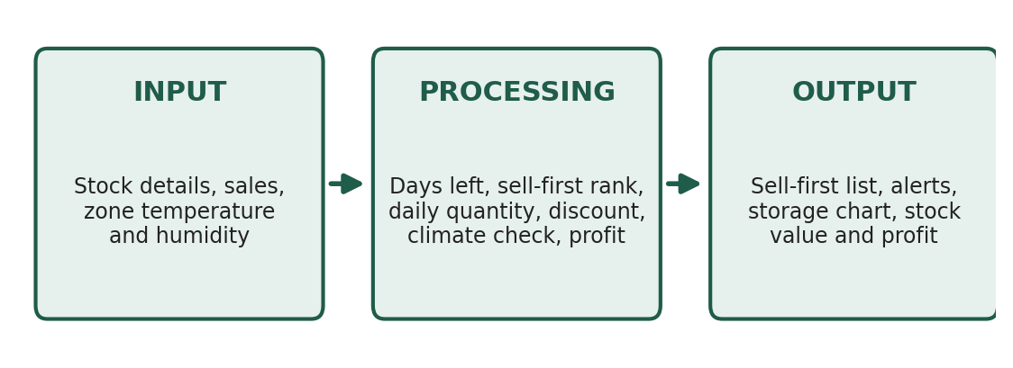
Figure 1: Architecture of Warehouse Keeper

6.2 Workflow
- The user enters or updates stock, sales and climate readings.
- The system calculates days left for each item and places it in an urgency band.
- The system checks every zone against its safe temperature and humidity range.
- The website displays the sell-first list with daily quantities and discount prices, climate alerts, storage filled and money figures.
- The user acts on the list: sells, disposes of expired goods or reorders stock, and the records update.

Implementation, Testing and Results

Implementation
The solution is implemented as a website that brings stock, expiry, storage and climate together in one place. Its screens present the sell-first list, the climate check for each zone, and the storage and price details.

Testing
The system was demonstrated using sample data covering perishable goods in the cold room and fresh store and non-perishable goods in the dry store. The tests looked at whether goods appeared in the correct urgency band, whether a zone outside its safe range raised an alert, and whether storage, stock value and profit figures were shown correctly.

Results
With the demo data, the website produced the following outputs:
Zone | Storage filled | Remarks
Cold room | 64 % | Milk, paneer
Fresh store | 51 % | Tomato, banana, spinach
Dry store | 74 % | Rice, sugar, oil; most heavily filled zone
Table 4: Storage filled by zone (demo data)
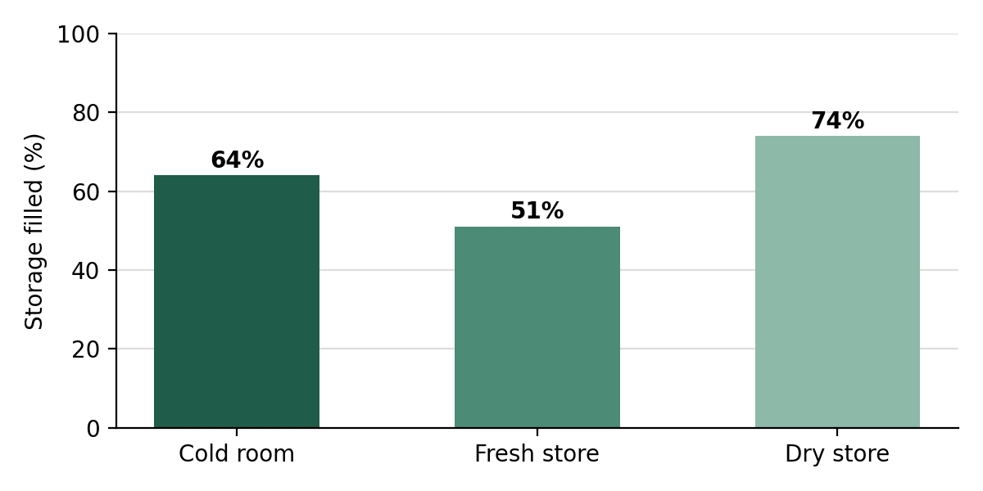
Figure 2: Storage filled by zone (demo data)
- Stock value at cost: ₹88,600 (demo data).
- Discount price: 20% off for goods close to expiry.
- Profit: tracked on every sale from the buying and selling price.
- Goods were sorted by urgency, with expired goods offered a Dispose button and a loss figure, and non-perishables showing stock level and reorder alerts.

Conclusion
Warehouse Keeper replaces scattered notebooks with one website that answers three questions: what to sell, how much to sell, and whether storage is safe. Its benefits are less spoilage and waste, the right quantity sold each day, safe climate in every zone, and a full view of space and money.

