**PROJECT REPORT**

**Introduction:**

The MSSRS Restaurant app is a Python-based application aiming at helping Cashiers at restaurants to generate invoices, and to store data of customers that visit them. It is a GUI-based application, making it as user-friendly as possible. It generates a bill at the end which is stored in its own dataset, and also features e-mailing the bill to the customer’s mail. Also for the cashier’s use, the application features analysis of Veg and Non-Veg dishes ordered in the days of the week, as well as number of customers visiting. It also shows the number of customers visiting in a week using a bar graph.

**Objective, Scope, Application:**

In today’s era of Cloud and storing information in E-way, we cannot store info like bills etc. in restaurants manually on paper, since it will take a lot of time and energy, as well as wastage of paper, also making it more difficult to manage. Hence, we use an application to do these functionalities, which is connected to a database, to store all this information. Our project aims at helping restaurant owners store, manage and analyse the info of their customers and their bills, as it is easier to maintain than manual paperwork. Also, the receipt email is sent to the customer, which helps the restaurant to further keep track of and invite their previous customers through email. All of this information is stored in the form of database tables, and is easy to retrieve for further use.

**Design:**

**PyQt5** is module used for the GUI-designing of the project. This version supports Drag-and-Drop, which makes it easier to create the frontend GUI.

<http://pyqt.sourceforge.net/Docs/PyQt5/>

**MySQL** is a database management system, used for creating/updating/managing databases for storing data. In this project, it is used for storing the dishes along with their prices purchased by the customer.

<https://dev.mysql.com/doc/>

**Pandas** is an in-built Python package used to work with ‘labeled’ data. It is basically used for data analysis.

<https://pandas.pydata.org/pandas-docs/stable/>

**NumPy** is a core library in Python, which is similar to MATLAB, and is used in working with multi-dimensional array objects.

<https://docs.scipy.org/doc/>

**Matplotlib** is a plotting library for Python and its numerical mathematics extension NumPy. It provides an object-oriented API for embedding plots into GUI based applications using Tkinter, Qt, etc.

<https://matplotlib.org/contents.html>

**Project on Github:** <https://github.com/sagarambilpure/Restaurant-Bill>

**Screenshots:**

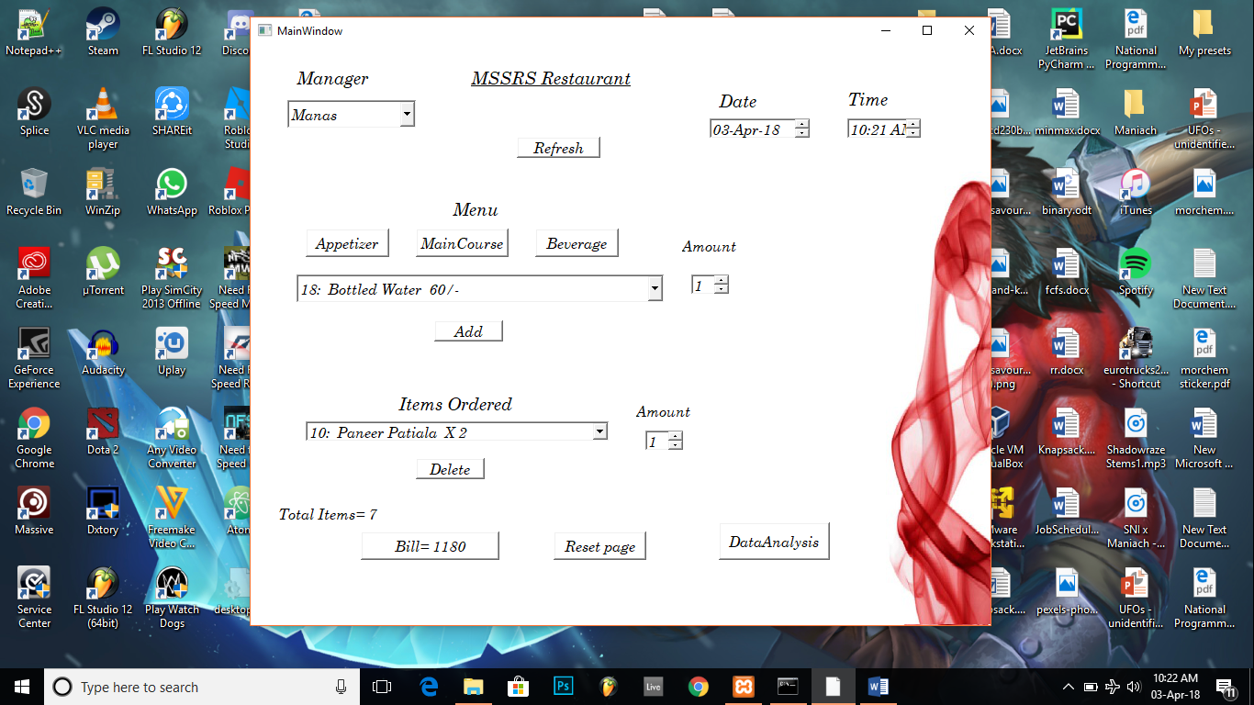

The main screen of the application provides a list for all the managers to select from.

The menu is categorised in three different categories, which can be accessed by simple clicking the respective-named button.

Each menu provides a dropdown list of all the items in each category. On the bottom is a selector to go through the ordered items, and also a button to delete, if any.

At the very end are buttons to calculate the final bill along with the taxes, a reset button, as well as to open the analysed data from past orders.

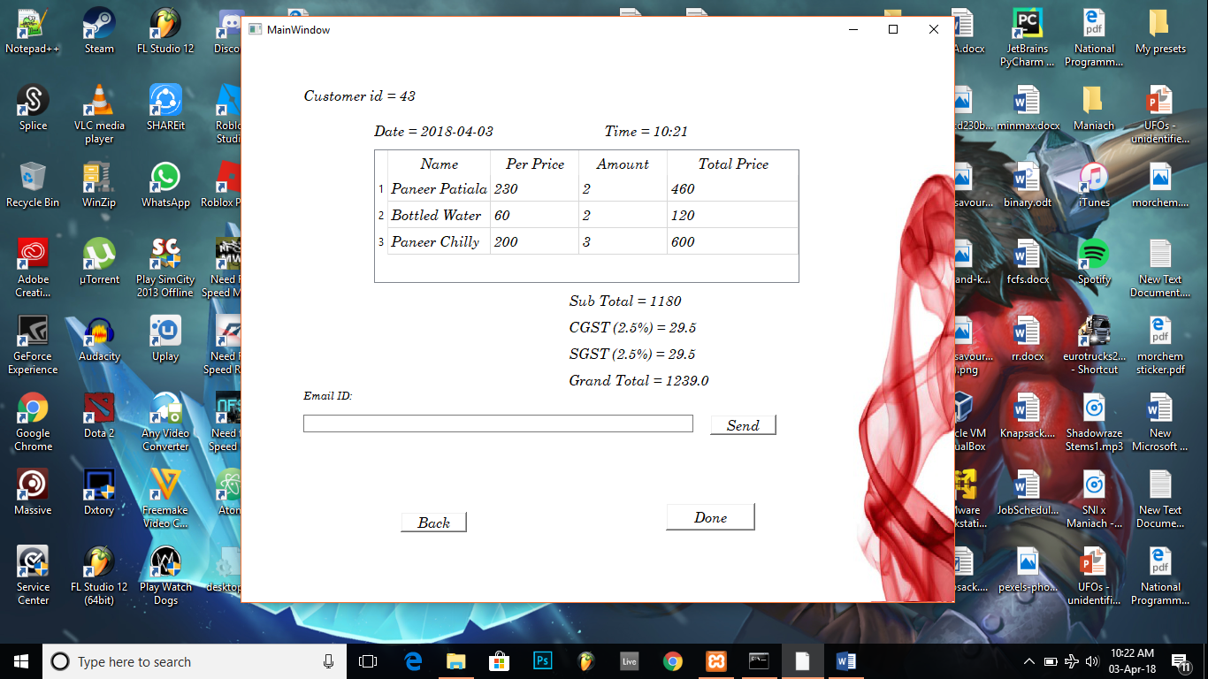

The final billing screen is as shown besides. It provides a unique customer ID, with the date and time of purchase, as well as all the dishes purchased, with the taxes calculated.

Also below is a field to enter the customer’s email address, which mails the bill after the “Send” button is clicked.

The screen besides is shown if we click the “Data Analysis” button. The data from every day is analysed according to the dataset stored. A bar graph shows the number of people visiting on a weekly basis. A pie-chart is generated on the basis of Veg & Non-Veg dishes ordered on every day. If no customers come on a particular day, it shows “NO DATA”.

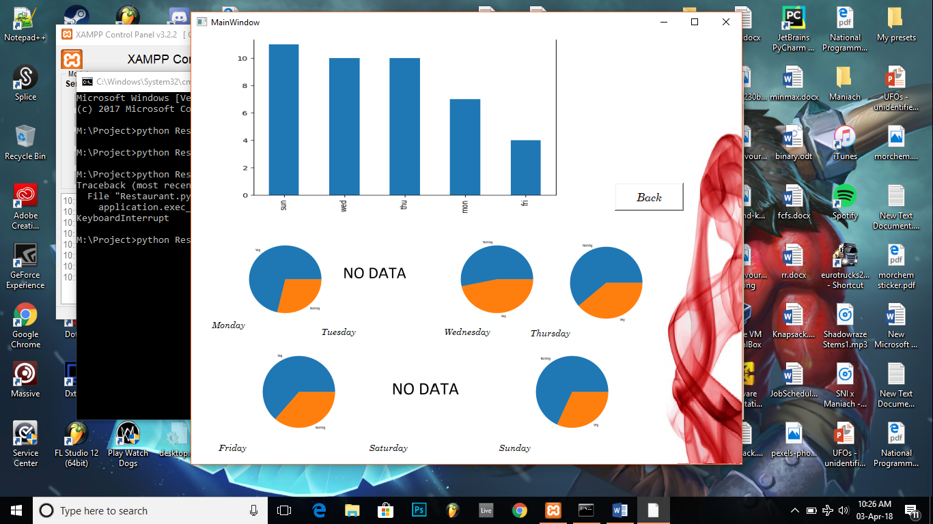

**Conclusion:** Since the project is an open-source project, the code can be viewed and modified as per need. Also due to the data analysis, a restaurant can decide on the basis of customers per day on how much stock they should keep on every day.