Object-Oriented Programming

**Lab 02: Problem Modeling and Encapsulation**

# UML & Astah

# Problem Statement of AIMS Project

# Use case diagram

# UML Class Diagram for use cases related to cart management

# Create Aims class

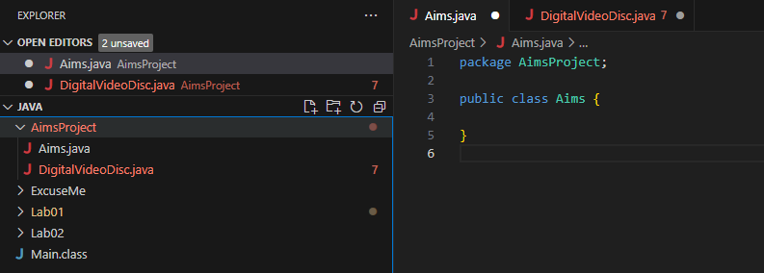

# Create the DigitalVideoDisc class and its attributes

# Create accessors and mutators for the class DigitalVideoDisc

**Reading Assignment:** When should accessor methods be used?

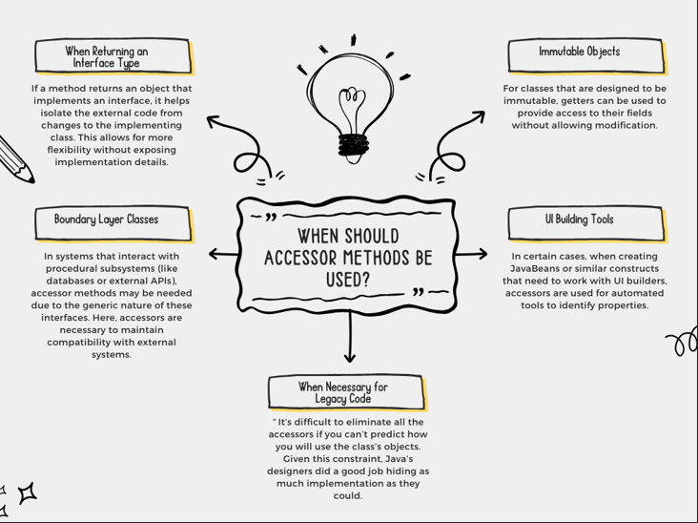

# Create Constructor method

**Question:**

- If you create a constructor method to build a **DVD** by title then create a constructor method to build a **DVD** by category. Does JAVA allow you to do this?

-> Nếu tạo các phương thức khởi tạo khác nhau bởi title và category thì Java vẫn cho phép điều này. Đó được gọi là nạp chồng trong java.

# Create the Cart class to work with DigitalVideoDisc

# Create Carts of DigitalVideoDiscs

# Removing items from the cart

# References

James Rumbaugh, Ivar Jacobson, and Grady Booch (2004). *Unified Modeling Language Reference Manual, The (2nd Edition)*. Pearson Higher Education