**Transportation Model for UBER&LYFT**

By

# PARTHVI JOSHI-L024

**ARYAN KULKARNI-L027**

**KRISH MANIAR-L033**

**HARSH MEHTA-L034**

Under the supervision of

## Prof. Khinal Parmar

**Prof.Ami Munshi**

**Prof.Mahesh Mali**

(Designation, CSDS 311 Program, MPSTME)

Name of the Chairperson

( )

**SVKM’s NMIMS University**

(Deemed-to-be University)



**MUKESH PATEL SCHOOL OF TECHNOLOGY MANAGEMENT & ENGINEERING**

**Vile Parle (W), Mumbai-56**

**2022-23**

**Table of Contents**

|  |  |  |  |  |  |  |  |  |  |  |  |  |  |  |  |  |  |  |  |  |  |  |  |  |  |  |  |  |  |  |
| --- | --- | --- | --- | --- | --- | --- | --- | --- | --- | --- | --- | --- | --- | --- | --- | --- | --- | --- | --- | --- | --- | --- | --- | --- | --- | --- | --- | --- | --- | --- |
| |  |  | | --- | --- | | **Particulars** | Page No. | | **Chapter 1 Introduction** | 4 | | **1.1 Background of the topic** | 4 | | **1.2 Motivation and Scope of the report** | 5 | | **1.3** **Problem Statement** | 5 | | **Chapter 2 Literature survey** | 6 | | **2.1 Introduction to overall topic** | 6 | | **Chapter 3 Methodology and Implementation** | 8 | | **3.1 Flowchart** | 8 | | **3.2 Dashboard** | 9 | | **3.3 Python Implementation Procedure** | 10 | | **Chapter 4 Result and Analysis** | 12 | | **References** | 16 | | **Appendix** | 17 | | |  |
|  | | |
|  |  |  |
|  |  |  |
|  |  |  |
|  | |  |
|  |  |  |
|  |  |  |
|  | |  |
|  |  |  |
|  |  |  |
|  | |  |
|  | |  |
|  | |  |
|  | |  |
|  | |  |
|  | |  |

**Chapter 1**

**Introduction**

* 1. **Background of the topic**

This report consists of the analysis of Uber and Lyft rides with a variety of data parameters obtained from Kaggle.com. We’ve used a Transportation Model to calculate the most cost effective choice and distance .

Transportation model is a special class of linear programming that deals with shipping a commodity from sources (e.g. factories) to destinations (e.g. ware houses) .

Objective: The goal of a transportation model is to determine the schedule for transportation from source to destination in such a way that travelling costs are minimised while all demand and supply constraints are met.

Uber Technologies, Inc., or simply Uber, is an American technology firm. Its services include ride-hailing, food delivery, package delivery, couriers, freight transportation, and electric bicycle and motorised scooter rental through a partnership with Lime. Similarly, in the United States, Lyft, Inc., based in San Francisco, California, provides mobility as a service, ride-hailing, vehicles for hire, motorised scooters, a bicycle-sharing system, rental cars, and food delivery.

* 1. **Motivation and Scope of the report**

The solution obtained at the end is of utmost importance in our day to day lives since it helps us obtain the most cost effective choice between Uber and Lyft of sources and destinations at various distances. It also helps us analyze the demand for various types of cars used to travel which could be used for companies during production. The analysis is also based on the various reasons why people use taxis and understanding those reasons in order to keep the cars ready at the respective action based on the purpose. This assists the company in locating their outlets as well as the availability of cabs in various locations.It also helps the companies to decide their most profitible route and analyze at which location they are falling short of vehicles.

The price parameter also keeps changing based on the day of the week and even that is analyzed in our project .

* 1. **Problem statement**

To calculate the optimal solution(minimization of cost) of Transportation Simplex Model using Python between six sources and destinations based on the supply and demand given. Also general analysis of comparison between various parameters given in the dataset. Use SAS Visual Analytics to visualize the data in the form of a dashboard using multiple objects.

**Chapter 2**

**Literature survey**

* 1. **Introduction to overall topic**

The topic is the comparison between two Cab ride companies called UBER AND LYFT . The minimization of cost is calculated using the transportation model in which we have six sources and six destinations . The demand and supply of each has been calculated and the optimal solution has been obtained using the Python language. Transportation problem (TP) is one of the most important areas of Operations Research, with numerous applications in inventory control, communication networks, production planning, scheduling, and personal allocation, among others. Transportation issues are critical in logistics and supply chain management for cost reduction and service improvement. In today's highly competitive market, organisations are under increasing pressure to find better ways to create and deliver products and services to customers. How and when to send products to customers in the quantities they desire while remaining cost-effective becomes more difficult. Transportation models provide a strong framework for meeting this challenge. They ensure the efficient movement of raw materials and the timely availability of finished goods.

**Chapter 3**

**Methodology and Implementation**

**3.1 ) Flowchart**

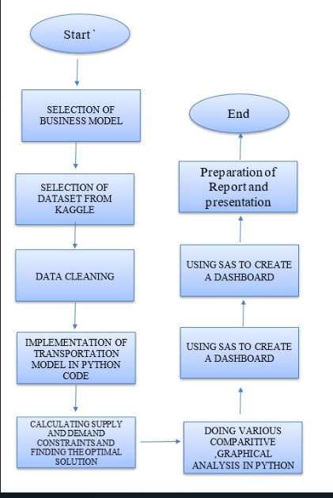

Fig 3.1.1)Depicting the flow of the project .

**3.2)Dashboard**

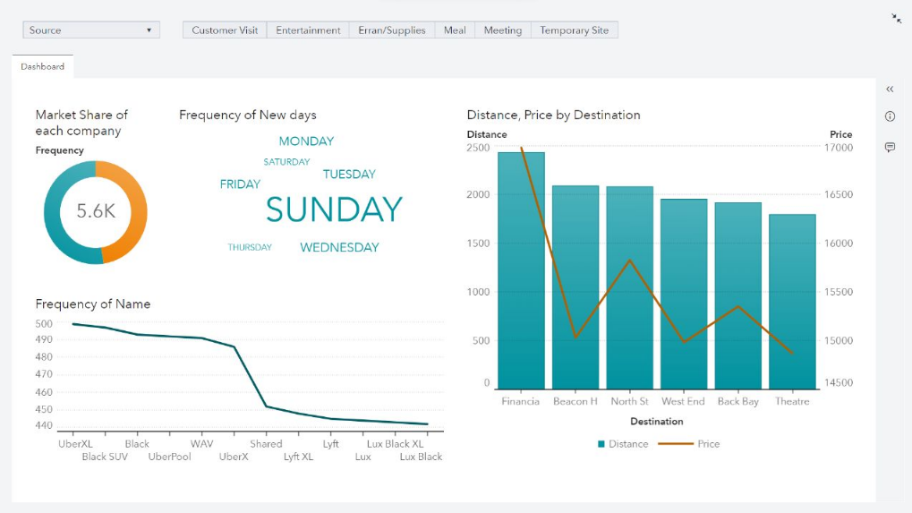

Fig 3.2.1) The diagram above depicts the dashboard used to demonstrate the topic under consideration.

**3.3)Python Procedure**

* We imported some libraries of pandas and pulp. (Pulp:- Lpproblem, LpMinimize ….)
* Calculated demands for 6 different destinations and 6 different sources and we noticed that demand>supply, so we added dummy destination.
* We created a linear optimization problem, generated an index list for decision variable x and created a model to solve the program.
* Form the LP objective function and that are subjected to demand constraints and supply constraints.
* Then we use inbuilt function model.solve() to solve the LP problem.
* And at last we print the minimum cost that will be incurred to the

cab company for satisfying all demand and supply.

**Chapter 4**

**Results and Analysis**

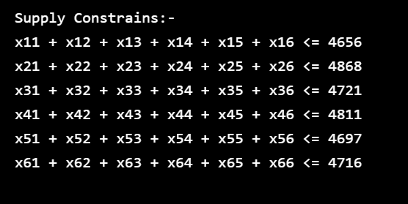

Fig 4.1) Output of supply constraints

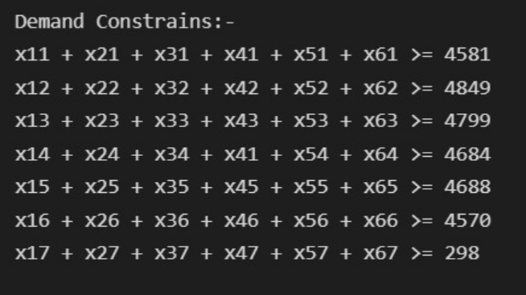

Fig 4.2) Output of demand constraints

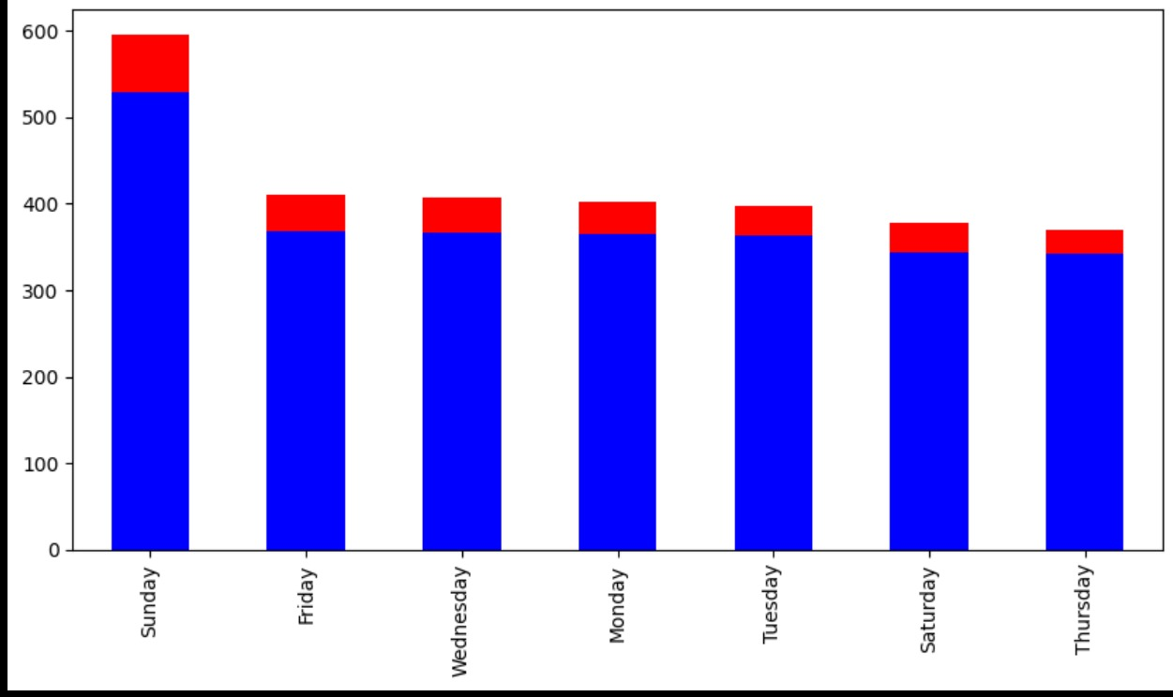

Fig 4.3) We see that sunday has the most trips and we can conclude that Uber is more preferred than Lyft.

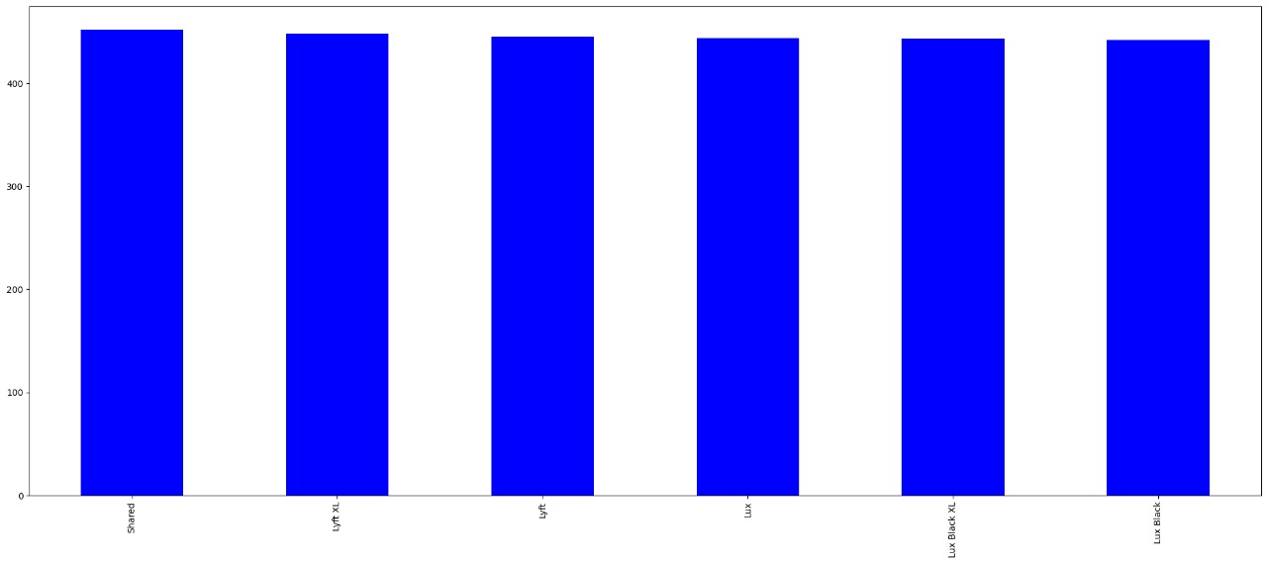

Fig 4.4) The demand for all kind of cars are almost similar in the data set.

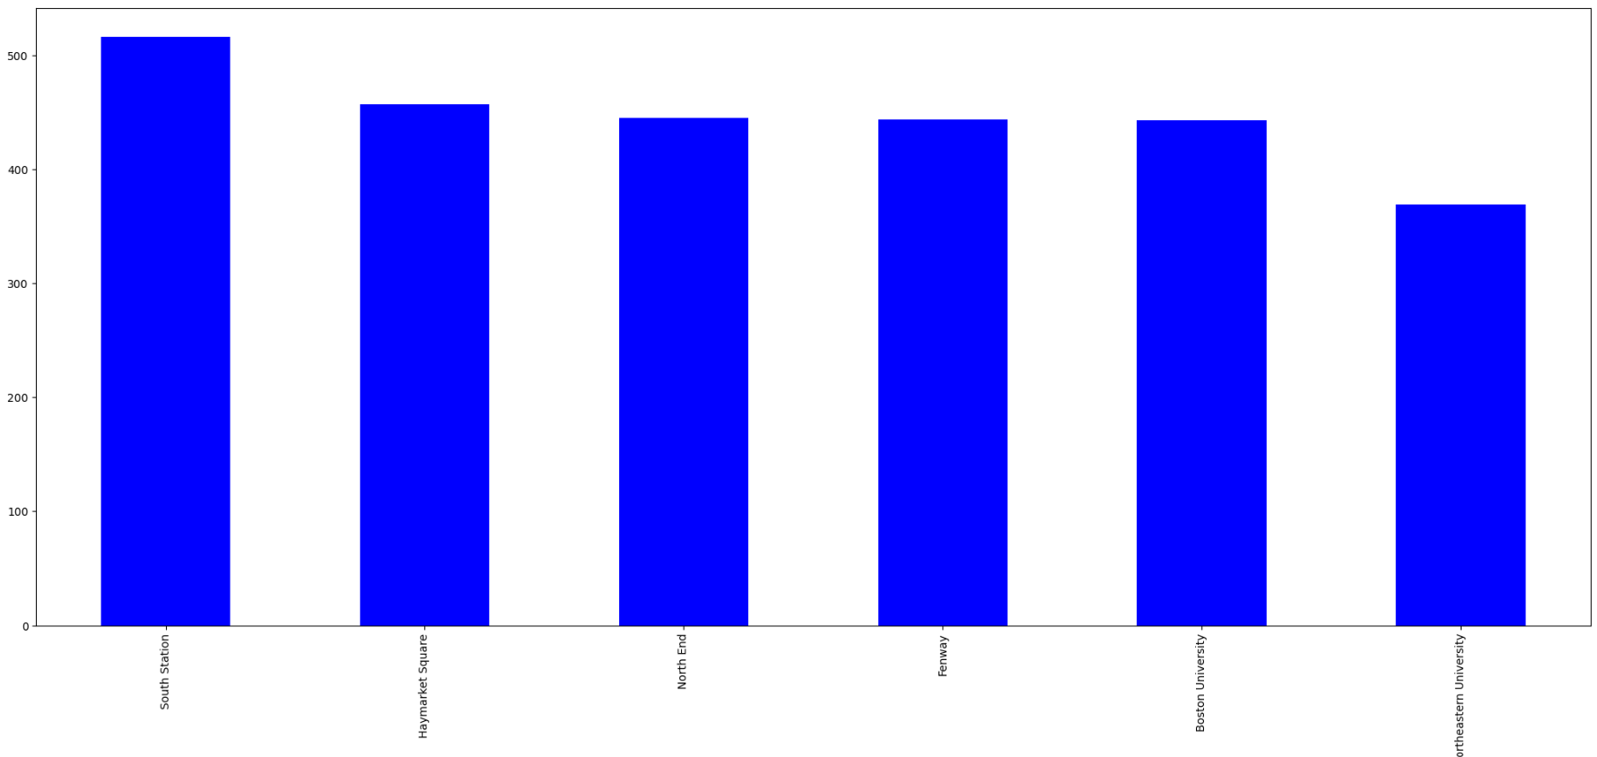

Fig 4.5) Most people start their journey from South Station, followed by Haymarket Square using Lyft.

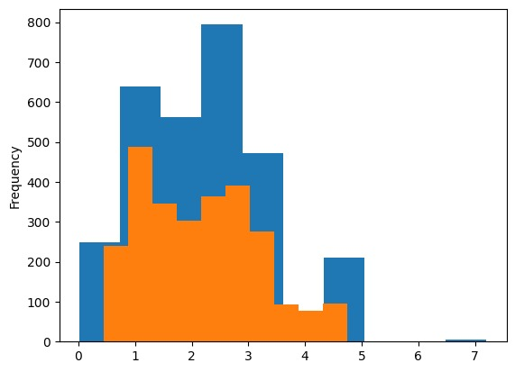

Fig 4.6) We can say that mostly people travel for short distances only using Uber and Lyft and in that also preference is given to Uber.

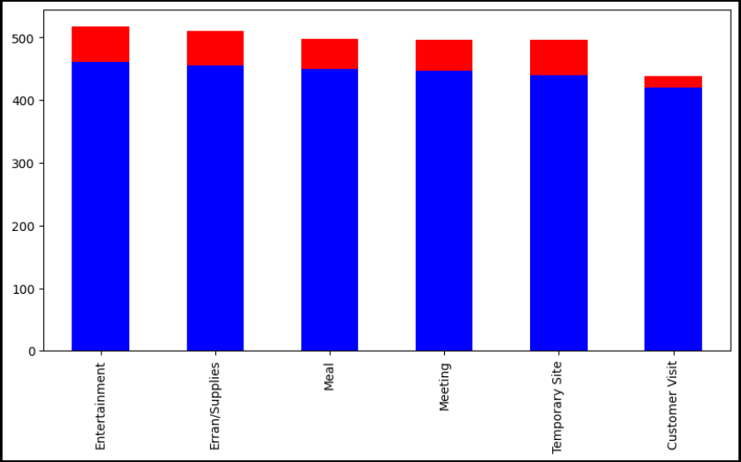

Fig 4.7) Depicts the various Purposes of the rides taken by people by both companies.



Fig 4.8) Shows the final result of our TRANSPORTATION MODEL.

On the basis of the given Project the following results were obtained which could help the companies to take respective business decisions :

* The solution obtained is of utmost importance in our day to day lives since it helps us obtain the most cost effective choice between Uber and Lyft of sources and destinations at various distances.
* It helps us analyze the demand for various types of cars used to travel which could be used for companies during production.
* This assists the company in locating their outlets as well as the availability of cabs in various locations.
* It also helps the companies to decide their most profitable route and analyze at which location they are falling short of vehicles.
* As figure 4.8 represents the final cost effective value that the company has to spend as per the demand and supply constraints.

**References**

1. unknown. (2022, October 4). <https://www.projectpro.io/article/uber-data-analysis-project-using-machine-learning-in-python/589#:~:text=all%20New%20Projects-,The%20Uber%20Datasets,Uber%20users%20in%20two%20cities>
2. *Uber & Lyft Cab prices*. (n.d.). Kaggle: Your Machine Learning and Data Science Community. <https://www.kaggle.com/datasets/ravi72munde/uber-lyft-cab-prices>
3. Dhanapal, A. (2016, March). *A literature review of transportation problems*. <https://www.researchgate.net/publication/301660695_A_literature_review_of_transportation_problems>

**APPENDIX**

**(SOURCE CODE)**

#Import pulp modeler function

from pulp import LpProblem, LpVariable, LpStatus, LpMinimize, GLPK, value, LpMaximize

import pandas as pd

df = pd.read_csv('finalminiprojectdata.csv')

#Calculating demands for each 6 destinations

demand1 = df[df["Destination"] ==  "Back Bay"]

sumofdemand1 = demand1["Demand"].sum()

demand1 = df[df["Destination"] ==  "Beacon Hill"]

sumofdemand2 = demand1["Demand"].sum()

demand1 = df[df["Destination"] ==  "Financial District"]

sumofdemand3 = demand1["Demand"].sum()

demand1 = df[df["Destination"] ==  "North Station"]

sumofdemand4 = demand1["Demand"].sum()

demand1 = df[df["Destination"] ==  "Theatre District"]

sumofdemand5 = demand1["Demand"].sum()

demand1 = df[df["Destination"] ==  "West End"]

sumofdemand6 = demand1["Demand"].sum()

dummydemand = 298

print("Demand Constrains:- ")

print("x11 + x21 + x31 + x41 + x51 + x61 >=",sumofdemand1)

print("x12 + x22 + x32 + x42 + x52 + x62 >=",sumofdemand2)

print("x13 + x23 + x33 + x43 + x53 + x63 >=",sumofdemand3)

print("x14 + x24 + x34 + x41 + x54 + x64 >=",sumofdemand4)

print("x15 + x25 + x35 + x45 + x55 + x65 >=",sumofdemand5)

print("x16 + x26 + x36 + x46 + x56 + x66 >=",sumofdemand6)

print("x17 + x27 + x37 + x47 + x57 + x67 >=",dummydemand)

#Calculating maximum supply for each 6 sources

source1 = df[df["Source"] ==  "Boston University"]

sumofsource1 = source1["Supply"].sum()

source1 = df[df["Source"] ==  "Fenway"]

sumofsource2 = source1["Supply"].sum()

source1 = df[df["Source"] ==  "Haymarket Square"]

sumofsource3 = source1["Supply"].sum()

source1 = df[df["Source"] ==  "North End"]

sumofsource4 = source1["Supply"].sum()

source1 = df[df["Source"] ==  "Northeastern University"]

sumofsource5 = source1["Supply"].sum()

source1 = df[df["Source"] ==  "South Station"]

sumofsource6 = source1["Supply"].sum()

print("Supply Constrains:-")

print("x11 + x12 + x13 + x14 + x15 + x16 <=" , sumofsource1)

print("x21 + x22 + x23 + x24 + x25 + x26 <=" , sumofsource2)

print("x31 + x32 + x33 + x34 + x35 + x36 <=" , sumofsource3)

print("x41 + x42 + x43 + x44 + x45 + x46 <=" , sumofsource4)

print("x51 + x52 + x53 + x54 + x55 + x56 <=" , sumofsource5)

print("x61 + x62 + x63 + x64 + x65 + x66 <=" , sumofsource6)

#Data for linear optimization problem

M = 6  #Supply points

N = 7  #Demand points

a = range(1, M+1)

a1 = range(M)

b = range(1, N+1)

b1 = range(N)

#Index list for decision variable x

xindx = [(a[i],b[j]) for j in b1 for i in a1]

#Creation of the model that will contain the data and solve the LP

model = LpProblem("Transportaion LP problem", LpMinimize)

#Creation of the decision variable

x = LpVariable.dicts("X",xindx,0,None)

#Supply constsraints

model += x[1,1] + x[1,2] + x[1,3] + x[1,4] + x[1,5] + x[1,6] + x[1,7] <= sumofsource1

model += x[2,1] + x[2,2] + x[2,3] + x[2,4] + x[2,5] + x[2,6] + x[2,7] <= sumofsource2

model += x[3,1] + x[3,2] + x[3,3] + x[3,4] + x[3,5] + x[3,6] + x[3,7] <= sumofsource3

model += x[4,1] + x[4,2] + x[4,3] + x[4,4] + x[4,5] + x[4,6] + x[4,7] <= sumofsource4

model += x[5,1] + x[5,2] + x[5,3] + x[5,4] + x[5,5] + x[5,6] + x[5,7] <= sumofsource5

model += x[6,1] + x[6,2] + x[6,3] + x[6,4] + x[6,5] + x[6,6] + x[6,7] <= sumofsource6

#Demand constraints

model += x[1,1] + x[2,1] + x[3,1] + x[4,1] + x[5,1] + x[6,1]  >= sumofdemand1

model += x[1,2] + x[2,2] + x[3,2] + x[4,2] + x[5,2] + x[6,2]  >= sumofdemand2

model += x[1,3] + x[2,3] + x[3,3] + x[4,3] + x[5,3] + x[6,3]  >= sumofdemand3

model += x[1,4] + x[2,4] + x[3,4] + x[4,4] + x[5,4] + x[6,4]  >= sumofdemand4

model += x[1,5] + x[2,5] + x[3,5] + x[4,5] + x[5,5] + x[6,5]  >= sumofdemand5

model += x[1,6] + x[2,6] + x[3,6] + x[4,6] + x[5,6] + x[6,6]  >= sumofdemand6

model += x[1,7] + x[2,7] + x[3,7] + x[4,7] + x[5,7] + x[6,7]  >= dummydemand

model.solve()

print("Status: ", LpStatus[model.status])

for v in model.variables():

    print(v.name, "=" , v.varValue)

print("objective Function" , value(model.objective))