SIMATS ENGINEERING
ASSESSMENT TOOL 1

COURSE NAME: CSA16 COURSE CODE: Data Warehousing and Data Mining

COURSE OUTCOME COVERED

CO5: Apply association rule mining techniques to discover interesting relationships and patterns within large datasets
Assessment Tool Weightage: 35%

QUESTIONS: 05 Total Marks:50

Annexure A

Constraint-Based Problem Solving

Criteria | Problem Understanding (2.5) | Constraint Analysis (2.5) | Solution Development (2.5) | Application of Concepts (1.5) | Justification (1) | Total(10)
Weightage | 25% | 25% | 25% | 15% | 10% | 100%
Q1
Q2
Q3
Q4
Q5

Code of Conduct:

I MANIBAALAKRISHNAN S/192211171(Name / Reg No) certify that this submission is my original work and that I have adhered to the guidelines specified for this assessment.
I understand that any violation of academic integrity rules will result in disciplinary action.

Signature of the student: MANIBAALAKRISHNAN S

RUBRICS FOR CALCULATION:

Constraint-Based Problem Solving Assessment Rubric
Criteria | Weightage | Level 4 (Exemplary) | Level 3 (Proficient) | Level 2 (Developing) | Level 1 (Beginning)
Problem Understanding | 25% | Clearly defines the problem and identifies all relevant constraints accurately | Identifies most constraints with minor gaps | Partial understanding; misses key constraints | Fails to identify constraints correctly
Constraint Analysis | 25% | Analyzes constraints effectively and prioritizes them logically | Provides reasonable analysis with some prioritization | Limited analysis; weak prioritization | No meaningful analysis or prioritization
Solution Development | 25% | Develops optimal and feasible solutions satisfying all constraints | Develops workable solutions with minor limitations | Solutions partially satisfy constraints | Solutions do not meet constraints
Application of Concepts | 15% | Effectively applies appropriate concepts, methods, or tools | Applies concepts with minor errors | Limited application; requires guidance | Unable to apply relevant concepts
Justification | 10% | Provides strong justification for decisions with logical reasoning | Provides justification with some clarity | Weak or unclear justification | No justification provided

Annexure A

Constraint-Based Problem Solving (6 Marks) (BL4–BL5) – Reframed with New Scenarios

Q1. Dataset: Hospital Patient Records
PID | Symptoms Observed
P1 | Fever, Cough
P2 | Fever, Headache
P3 | Cough, Headache
P4 | Fever, Cough, Headache
P5 | Fever, Fatigue
Question:
Apply association rule mining with minimum support = 50% and confidence = 70%, under the constraint that all generated rules must include "Fever". Identify the valid association rules and justify why they satisfy the given constraints. (BL4 – 1.2 Marks)
Given: minimum support = 50%, minimum confidence = 70%, and every generated rule must contain Fever.
Itemset | Count | Support
Fever | 4 | 4/5 = 80%
Cough | 3 | 3/5 = 60%
Headache | 3 | 3/5 = 60%
Fatigue | 1 | 1/5 = 20%
Step 1: Check frequent 1-itemsets
Fever = 80%, Cough = 60%, Headache = 60% are at least 50%; Fatigue = 20% is below 50%.
Step 2: Check Fever-containing 2-itemsets
{Fever, Cough}: occurs in P1 and P4. Support = 2/5 = 40%.
{Fever, Headache}: occurs in P2 and P4. Support = 2/5 = 40%.
{Fever, Fatigue}: occurs in P5. Support = 1/5 = 20%.
Step 3: Compute confidence for the relevant rules
Rule | Confidence | Decision
Fever → Cough | 2/4 = 50% | Support 40%; confidence 50% → invalid
Cough → Fever | 2/3 = 66.67% | Support 40%; confidence 66.67% → invalid
Fever → Headache | 2/4 = 50% | Support 40%; confidence 50% → invalid
Headache → Fever | 2/3 = 66.67% | Support 40%; confidence 66.67% → invalid
Fever → Fatigue | 1/4 = 25% | Support 20%; confidence 25% → invalid
Fatigue → Fever | 1/1 = 100% | Support 20% → invalid because support is below 50%
Final answer: NO valid association rule satisfies both support ≥ 50% and confidence ≥ 70% while including Fever.
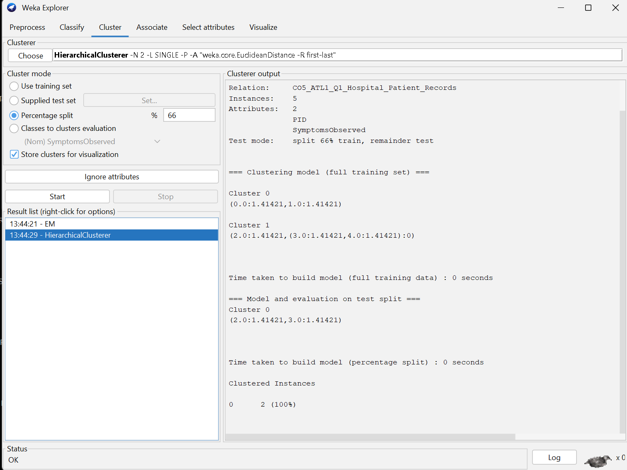

Q2. Dataset: Online Learning Platform
Student ID | Courses Enrolled
S1 | Python, SQL
S2 | Python, Data Science
S3 | SQL, Machine Learning
S4 | Python, SQL, Data Science
S5 | Python, Machine Learning
Question:
Using the dataset, generate frequent itemsets with minimum support = 40%, applying the constraint that each itemset must contain at least two courses. Explain how the constraint helps in pruning candidate itemsets during mining. (BL4 – 1.2 Marks)
Minimum support = 40%; every itemset must contain at least two courses. With 5 students, minimum support count = 0.40 × 5 = 2 transactions.
Step 1: Form all 2-course candidates
{Python, SQL}, {Python, Data Science}, {Python, Machine Learning}, {SQL, Data Science}, {SQL, Machine Learning}, {Data Science, Machine Learning}.
Step 2: Calculate support
Itemset | Count | Support | Decision
{Python, SQL} | 2 | 40% | Frequent
{Python, Data Science} | 2 | 40% | Frequent
{Python, Machine Learning} | 1 | 20% | Prune
{SQL, Data Science} | 1 | 20% | Prune
{SQL, Machine Learning} | 1 | 20% | Prune
{Data Science, Machine Learning} | 0 | 0% | Prune
Step 3: Check 3-itemset
{Python, SQL, Data Science} occurs only in S4, so support = 1/5 = 20% < 40%. It is pruned.
Final frequent itemsets: {Python, SQL} and {Python, Data Science}, both with 40% support.
Constraint effect: all 1-itemsets and every candidate with fewer than two courses are eliminated before detailed support testing, reducing the search space.
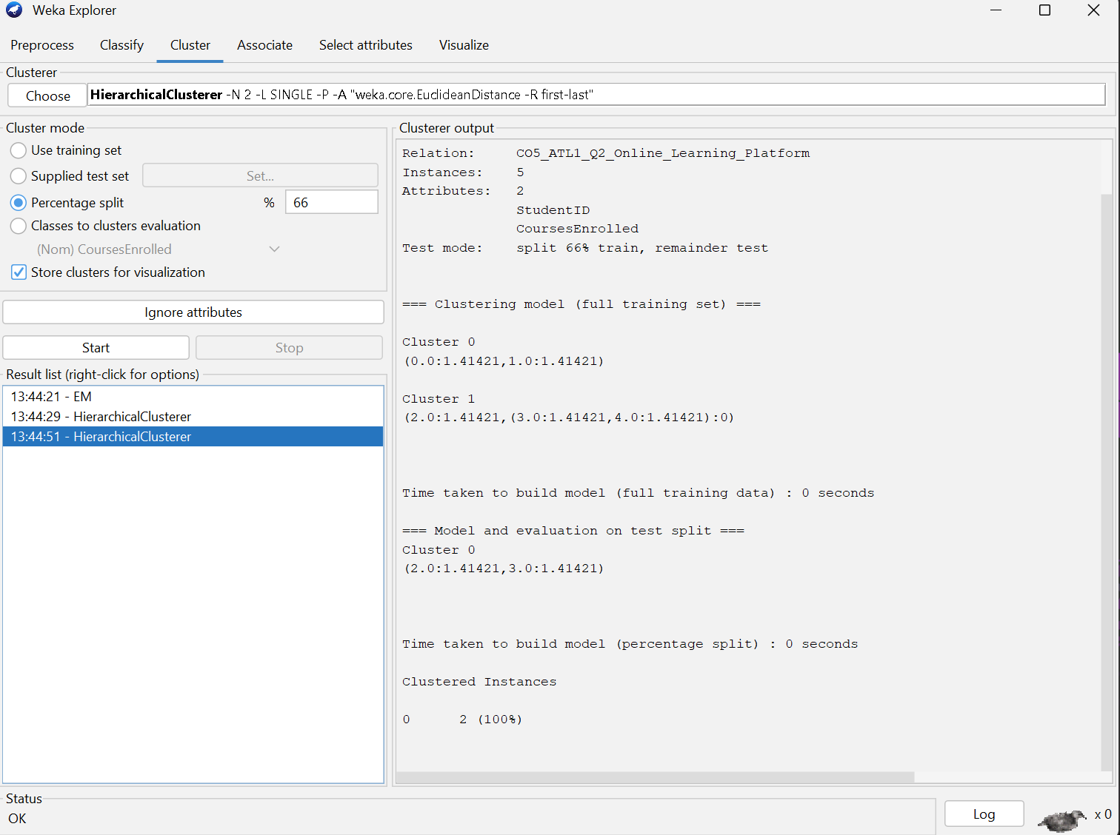

Q3. Dataset: Library Borrowing Records
Transaction ID | Books Borrowed
T1 | Data Mining, Python Programming
T2 | Data Mining, Database Systems
T3 | Python Programming, Database Systems
T4 | Data Mining, Python Programming, Database Systems
T5 | Data Mining, Artificial Intelligence
Question:
Apply the Apriori algorithm with the constraint that the maximum itemset size is 3. Identify the frequent itemsets and explain how the constraint reduces computational complexity during candidate generation. (BL5 – 1.2 Marks)
Constraint: maximum itemset size = 3. The source does not state a minimum support threshold, so exact support values are reported but a final “frequent” label cannot be fixed from the source alone.
Step 1: 1-itemsets
Itemset | Count | Support
Data Mining | 4 | 80%
Python Programming | 3 | 60%
Database Systems | 3 | 60%
Artificial Intelligence | 1 | 20%
Step 2: 2-itemsets
Itemset | Count | Support
{Data Mining, Python Programming} | 2 | 40%
{Data Mining, Database Systems} | 2 | 40%
{Data Mining, Artificial Intelligence} | 1 | 20%
{Python Programming, Database Systems} | 2 | 40%
{Python Programming, Artificial Intelligence} | 0 | 0%
{Database Systems, Artificial Intelligence} | 0 | 0%
Step 3: 3-itemset
{Data Mining, Python Programming, Database Systems} occurs only in T4. Support = 1/5 = 20%.
Final constraint result: the algorithm stops after size 3; no 4-itemset or larger candidate is generated. The exact frequent-itemset list depends on the missing minimum-support threshold.
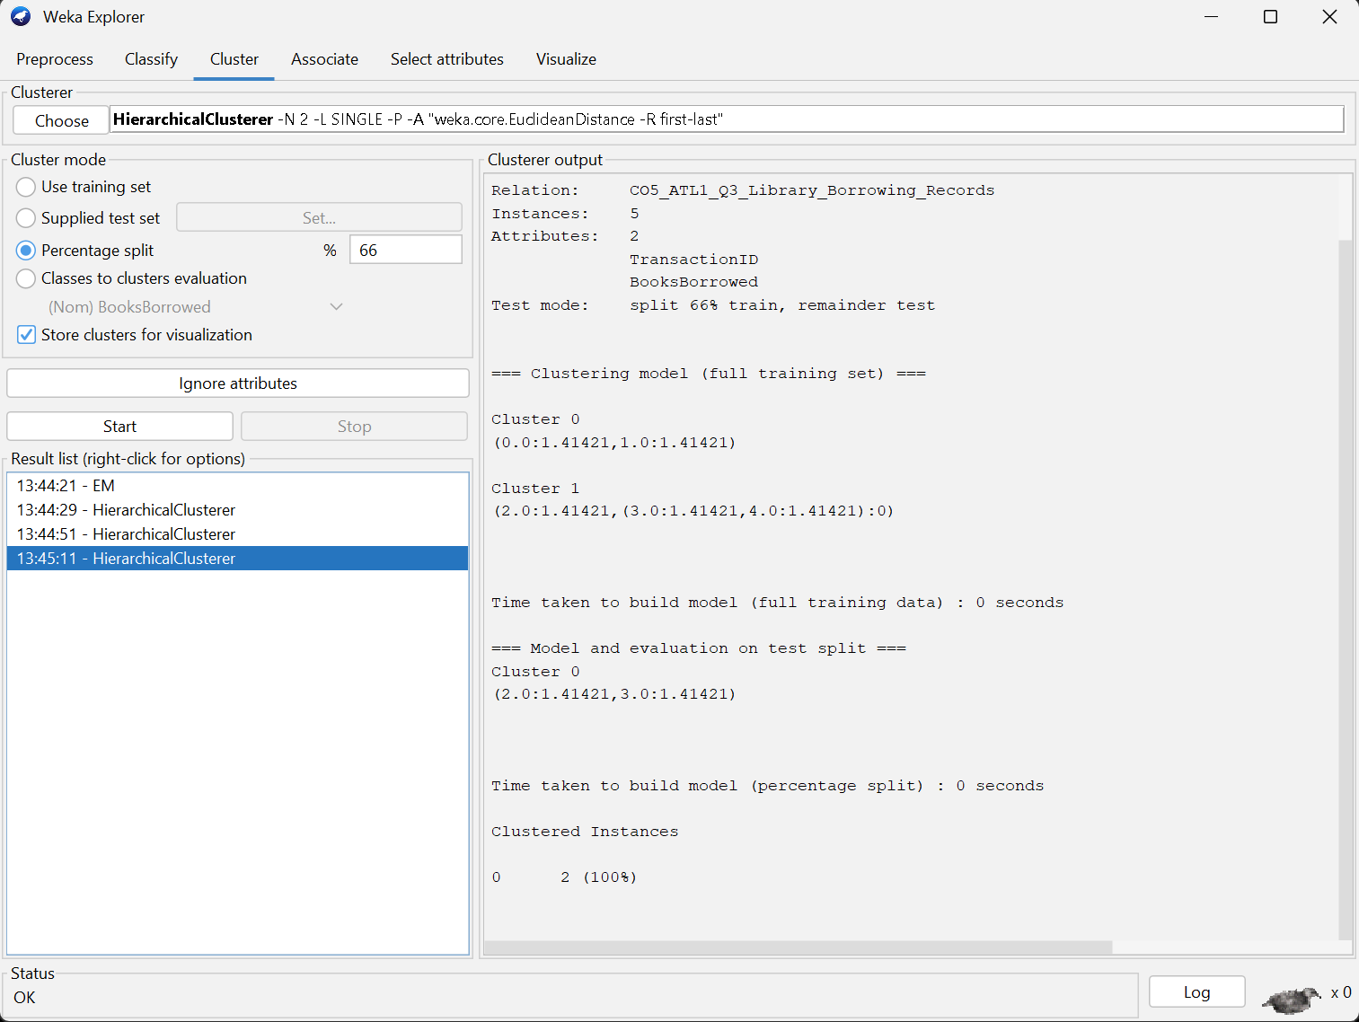

Q4. Dataset: University Course Hierarchy
Student ID | Courses Taken
S1 | Engineering, Computer Science, Machine Learning
S2 | Engineering, Information Technology
S3 | Engineering, Computer Science
S4 | Engineering, Computer Science, Machine Learning
S5 | Engineering, Information Technology
Question:
Apply multilevel association rule mining with the constraint that rules should be generated only at the "Computer Science" level. Explain how the course hierarchy affects the discovery of association rules. (BL5 – 1.2 Marks)
Constraint: rules should be generated only at the Computer Science level.
Step 1: Count the relevant levels
Engineering occurs in all 5 students: support = 5/5 = 100%.
Computer Science occurs in S1, S3, S4: support = 3/5 = 60%.
Machine Learning occurs in S1, S4: support = 2/5 = 40%.
Information Technology occurs in S2, S5: support = 2/5 = 40%.
Step 2: Generate the Computer Science → Machine Learning rule
Joint occurrence = S1 and S4 = 2 transactions. Support = 2/5 = 40%. Confidence = support(CS, ML) / support(CS) = 2/3 = 66.67%.
Therefore: Computer Science → Machine Learning has support 40% and confidence 66.67%.
Step 3: Reverse rule
Machine Learning → Computer Science: confidence = 2/2 = 100%; support remains 40%.
Hierarchy effect: focusing the search at Computer Science removes unrelated rules and produces a more targeted pattern set.
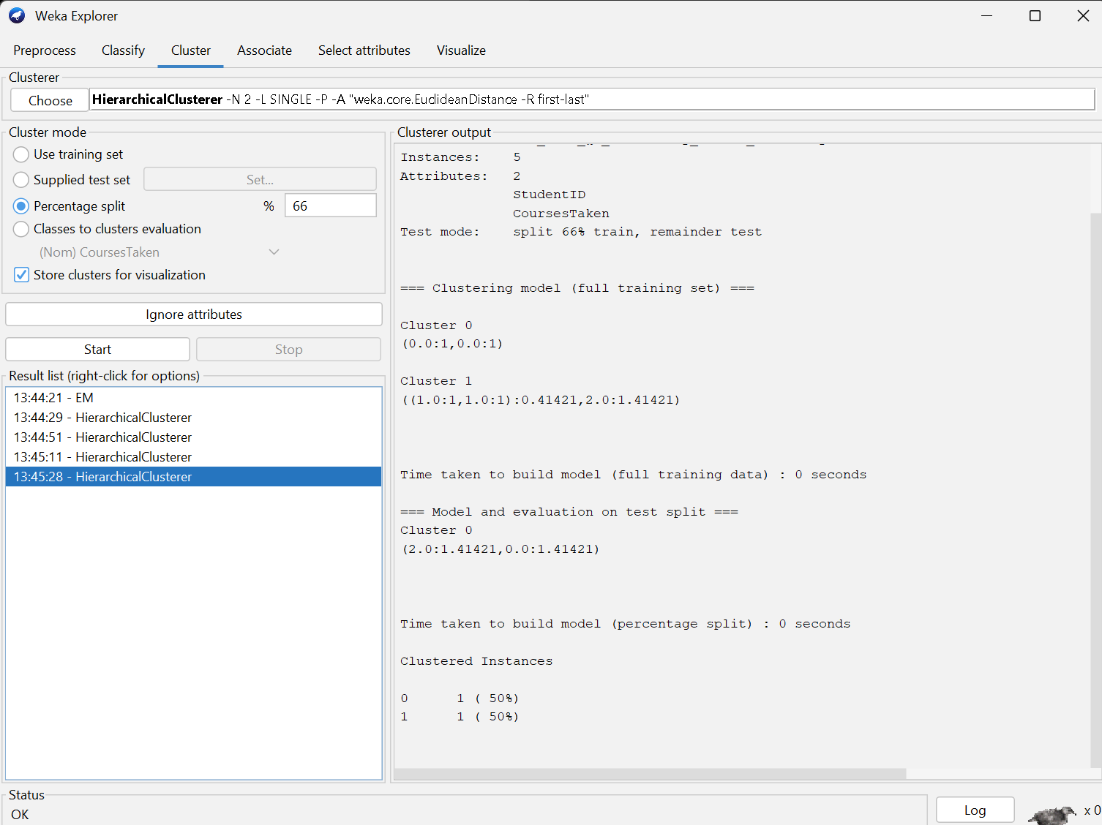

Q5. Dataset: Insurance Customer Records
CID | Age Group | Income Level | Policy Purchased
C1 | Young | High | Health Insurance
C2 | Middle | Medium | Vehicle Insurance
C3 | Young | Low | Travel Insurance
C4 | Senior | High | Health Insurance
C5 | Young | Medium | Vehicle Insurance
Question:
Apply multidimensional association rule mining with the constraint Age Group = "Young". Identify meaningful patterns involving income level and policy type, and explain how these patterns can support targeted marketing strategies. (BL4 – 1.2 Marks)
Constraint: Age Group = Young.
Step 1: Filter the records
Young customers are C1 (High → Health), C3 (Low → Travel), and C5 (Medium → Vehicle).
Step 2: Calculate supports
High-income young customers: 1/3 = 33.33%. Low-income young customers: 1/3 = 33.33%. Medium-income young customers: 1/3 = 33.33%.
Step 3: Calculate observed conditional confidence
High → Health within Young = 1/1 = 100%. Low → Travel within Young = 1/1 = 100%. Medium → Vehicle within Young = 1/1 = 100%.
Final answer: among the three Young customers, each income level is associated with a different observed policy type in this sample. The pattern can support income-specific marketing, but the sample is too small to treat these as general population-level rules without further data.
