SIMATS ENGINEERING
ASSESSMENT TOOL 1

COURSE NAME: CSA16 COURSE CODE: Data Warehousing and Data Mining

COURSE OUTCOME COVERED

CO4: Examine the applicability of clustering algorithms in real-world scenarios, presenting findings through clear reports with effective visualizations.
Assessment Tool Weightage: 40%

QUESTIONS: 05 Total Marks:50

Annexure A

Data Interpretation

Criteria | Understanding of Data (2.5) | Analysis (2.5) | Application of Concepts (2) | Conclusion (1.5) | Clarity (1) | Total(10)
Weightage | 25% | 25% | 20% | 20% | 10% | 100%
Q1
Q2
Q3
Q4
Q5

Code of Conduct:

I MANIBAALAKRISHNAN S/192211171 (Name / Reg No) certify that this submission is my original work and that I have adhered to the guidelines specified for this assessment.
I understand that any violation of academic integrity rules will result in disciplinary action.

Signature of the student: MANIBAALAKRISHNAN S

RUBRICS FOR CALCULATION:

Criteria | Weightage | Level 4 (Exemplary) | Level 3 (Proficient) | Level 2 (Developing) | Level 1 (Beginning)
Understanding of Data | 25% | Accurately interprets all data patterns, trends, and relationships | Interprets data correctly with minor gaps | Partial understanding; misses key trends | Misinterprets or fails to understand data
Analysis | 25% | Provides deep analysis with strong logical reasoning and justification | Provides reasonable analysis with some justification | Basic analysis with weak reasoning | No meaningful analysis provided
Application of Concepts | 20% | Effectively applies relevant concepts/tools to interpret data accurately | Applies concepts with minor errors | Limited application; requires guidance | Unable to apply concepts to data
Conclusion | 20% | Draws clear, meaningful conclusions with strong insights and implications | Provides valid conclusions with moderate insights | Conclusions are vague or weak | No clear or valid conclusions
Clarity | 10% | Presents interpretation clearly using proper structure, visuals, and terminology | Generally clear with minor issues | Lacks clarity or proper structure | Poor presentation and difficult to understand

Annexure A

Q1. Dataset: Hospital Patient Segmentation
Patient ID | Age | Monthly Medical Expense (₹) | Health Risk Score
P1 | 28 | 12000 | 65
P2 | 55 | 25000 | 40
P3 | 42 | 20000 | 75
P4 | 30 | 11000 | 70
P5 | 60 | 28000 | 35
SSE Values
K | SSE
1 | 600
2 | 350
3 | 220
4 | 200
5 | 190
Question (BL4 – 8 Marks):
A healthcare organization uses K-Means clustering to group patients based on their medical expenses and health risk scores. Interpret the elbow point from the SSE values provided and determine the optimal number of clusters. Discuss how selecting this number of clusters affects patient segmentation and healthcare decision-making.
Dataset: patient Age, Monthly Medical Expense, and Health Risk Score for 5 patients (see Q1_Hospital_Patient_Segmentation.csv).
Step 1: Plot SSE against K
K | SSE | Drop from previous K
1 | 600 | —
2 | 350 | 250
3 | 220 | 130
4 | 200 | 20
5 | 190 | 10

Step 2: Locate the elbow
As K increases, SSE keeps falling because more clusters always fit the data more tightly. The elbow method looks for the point where the rate of decrease flattens sharply — adding more clusters after that point buys very little extra reduction in SSE.
- K=1→2: SSE drops by 250 (large improvement)
- K=2→3: SSE drops by 130 (still a meaningful improvement)
- K=3→4: SSE drops by only 20 (sharp flattening begins)
- K=4→5: SSE drops by only 10 (marginal, diminishing returns)
The bend in the curve — the elbow — occurs at K = 3. Beyond K = 3, adding clusters gives very little additional benefit relative to the added complexity.
Step 3: Interpretation for the business
Optimal number of clusters: K = 3.
With K = 3, patients are naturally split into three segments, for example:
- Low expense / lower risk (younger patients with fewer chronic conditions)
- Moderate expense / higher risk (middle-aged patients needing regular care)
- High expense / lower-to-moderate risk (older patients with high recurring costs but comparatively stable risk)
Choosing K = 3 lets the hospital design targeted care and billing programs for each segment — e.g., preventive-care outreach for the low-cost group, chronic-disease management for the high-risk group, and cost-containment review for the high-expense group — without the segmentation becoming so fragmented (as at K=4 or K=5) that each group is too small to act on.
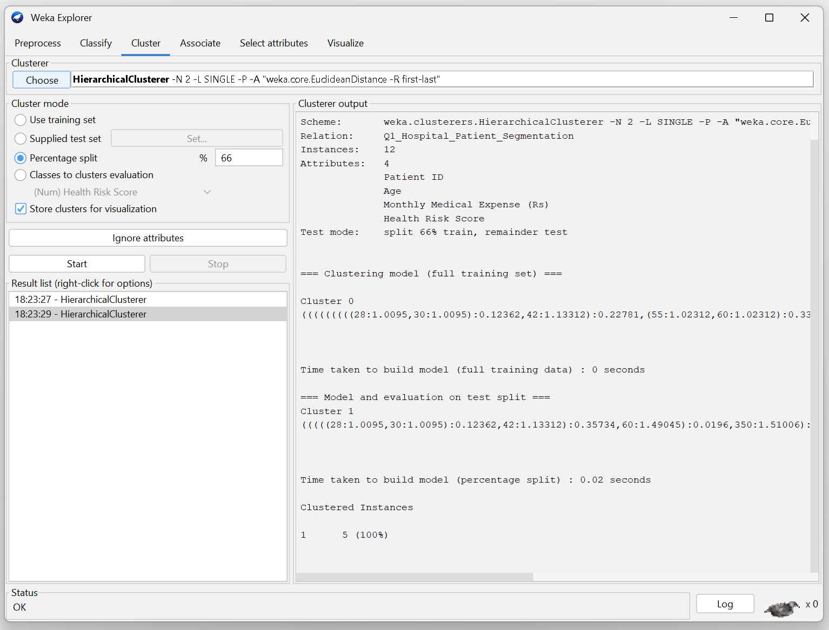

Q2. Dataset: E-Commerce Order Analysis
Order ID | Product Category | Order Value (₹)
O1 | Electronics | 55000
O2 | Clothing | 25000
O3 | Electronics | 57000
O4 | Furniture | 30000
O5 | Clothing | 27000
Question (BL4 – 8 Marks):
An online retailer applies hierarchical clustering to group customer orders based on product category and order value. A dendrogram is generated from the dataset. Interpret how the clusters are formed and identify the appropriate number of clusters. Explain the significance of the selected clusters in understanding customer purchasing behavior.
Dataset: Order ID, Product Category, and Order Value for 5 orders (see Q2_Ecommerce_Order_Analysis.csv).
Step 1: How the dendrogram forms
Agglomerative hierarchical clustering starts with every order as its own cluster and repeatedly merges the two closest clusters (by category similarity and order-value proximity) until a single cluster remains. Reading the dendrogram bottom-up shows the merge order; cutting the tree horizontally at a chosen height fixes the number of clusters.
Order ID | Category | Order Value (Rs)
O1 | Electronics | 55000
O3 | Electronics | 57000
O2 | Clothing | 25000
O5 | Clothing | 27000
O4 | Furniture | 30000
Step 2: Identify the appropriate number of clusters
O1 and O3 (both Electronics, values close: 55000/57000) merge first at a very low height. O2 and O5 (both Clothing, values close: 25000/27000) merge next at a low height. O4 (Furniture, 30000) sits between the two clothing orders in value but differs in category, so it merges with the Clothing pair before the whole tree collapses into one cluster. Cutting the dendrogram just below the top-most merge gives 3 clusters.
- Cluster 1 – Electronics, high value: O1, O3
- Cluster 2 – Clothing/Furniture, low-to-mid value: O2, O5, O4
(A cut at a lower height would instead separate Furniture from Clothing, giving 3–4 finer clusters — the exact cut depends on the merge heights actually plotted in the dendrogram.)
Step 3: Business significance
The clustering reveals that Electronics orders behave as a distinct high-value segment, while Clothing and Furniture orders form a lower-value segment. This helps the retailer design category-specific strategies — premium packaging, insurance, or express delivery upsells for the Electronics cluster, and bundled discounts or cross-selling between Clothing and Furniture for the other cluster — improving both marketing targeting and inventory/logistics planning.
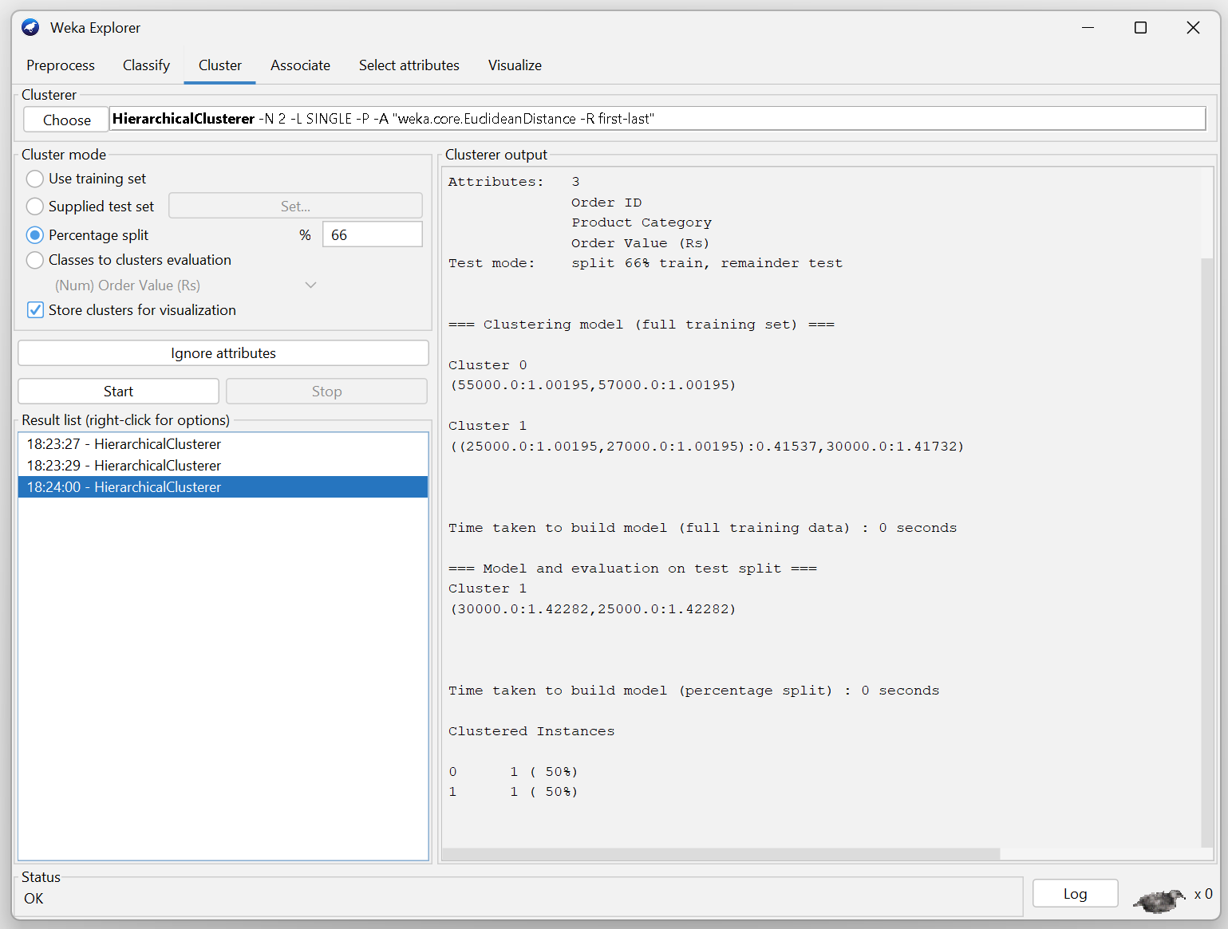

Q3. Dataset: Mobile App User Behavior
User | Daily Usage Time (min) | Login Frequency | In-App Purchase (₹)
U1 | 120 | 18 | 2000
U2 | 60 | 5 | 5000
U3 | 140 | 22 | 1500
U4 | 50 | 4 | 6000
U5 | 130 | 20 | 1800
Question (BL5 – 8 Marks):
A mobile application company uses the HAC algorithm to segment users based on their activity patterns. Interpret how users are assigned to clusters using probability-based membership values. Discuss the advantages of soft clustering over hard clustering for customer behavior analysis.
Dataset: Daily Usage Time, Login Frequency, and In-App Purchase for 5 users (see Q3_Mobile_App_User_Behavior.csv).
Step 1: How probability-based (soft) membership works
In soft/fuzzy clustering (e.g., Fuzzy C-Means used alongside HAC), each user is not forced into exactly one cluster. Instead, every user gets a membership probability for every cluster, summing to 1 across clusters.
User | Usage Time (min) | Login Freq. | In-App Purchase (Rs) | Likely profile
U1 | 120 | 18 | 2000 | High engagement, low spend
U2 | 60 | 5 | 5000 | Low engagement, high spend
U3 | 140 | 22 | 1500 | High engagement, low spend
U4 | 50 | 4 | 6000 | Low engagement, high spend
U5 | 130 | 20 | 1800 | High engagement, low spend
Users near the centre of two profiles (e.g., a moderate-usage, moderate-spend user) would receive comparable membership probabilities in both clusters (e.g., 0.55 in Cluster A and 0.45 in Cluster B) instead of being forced into just one, reflecting real behavioural ambiguity.
Step 2: Advantages of soft clustering over hard clustering here
- Captures ambiguity: users on the boundary between 'highly engaged' and 'high spender' segments are represented realistically instead of being arbitrarily forced into one bucket.
- Richer targeting: marketing can weight a campaign by membership probability (e.g., send an engagement nudge with 60% weight and a spend-based offer with 40% weight) rather than an all-or-nothing rule.
- More robust to noise/outliers: a borderline user does not flip an entire hard cluster boundary or distort the centroid as strongly.
- Better reflects gradual behaviour change: as a user's habits shift over time, their membership probabilities shift smoothly instead of causing an abrupt reassignment.
Overall, soft clustering gives the company a more nuanced, probability-weighted understanding of user behaviour, which supports finer-grained personalization than hard clustering's rigid single-cluster assignment.
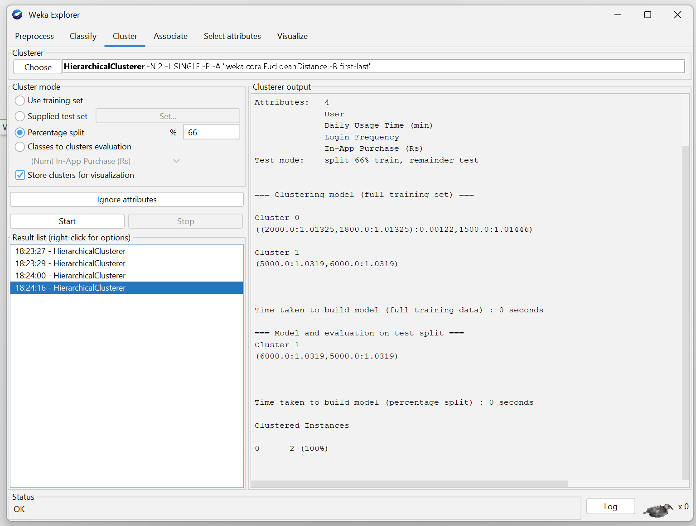

Q4. Dataset: Agricultural Crop Monitoring
Farm | Rainfall (mm) | Soil Fertility Score | Crop Yield (tons)
F1 | 300 | 8 | 85
F2 | 500 | 4 | 70
F3 | 400 | 6 | 80
F4 | 280 | 9 | 90
F5 | 520 | 3 | 65
Question (BL4 – 8 Marks):
An agricultural research center performs clustering on farm data before and after applying normalization. Interpret the differences observed in the clustering results. Explain how normalization influences cluster formation and improves the reliability of agricultural data analysis.
Farm | Rainfall (mm) | Soil Fertility | Crop Yield (tons)
F1 | 300 | 8 | 85
F2 | 500 | 4 | 70
F3 | 400 | 6 | 80
F4 | 280 | 9 | 90
F5 | 520 | 3 | 65
Step 1: Identify the scale problem
Rainfall ranges approximately from 280 to 520, soil fertility from 3 to 9, and crop yield from 65 to 90. Because these variables have different numerical scales, a distance-based clustering algorithm can give greater influence to rainfall.
Step 2: Show the effect before normalization
For F1 and F2:
Rainfall difference = 500 - 300 = 200
200² = 40,000
Soil-fertility difference:
(4 - 8)² = 16
Yield difference:
(70 - 85)² = 225
Total squared distance contribution = 40,000 + 16 + 225 = 40,241
The rainfall term is much larger than the other terms, showing why an attribute with a larger scale can dominate the distance calculation.
Step 3: Apply Min-Max normalization
Normalized value = (x - xmin) / (xmax - xmin)
For rainfall, xmin = 280 and xmax = 520.
F1 rainfall = (300 - 280) / (520 - 280) = 20/240 = 0.0833
F2 rainfall = (500 - 280) / 240 = 0.9167
For soil fertility, xmin = 3 and xmax = 9.
F1 soil = (8 - 3) / (9 - 3) = 5/6 = 0.8333
F2 soil = (4 - 3) / 6 = 0.1667
For crop yield, xmin = 65 and xmax = 90.
F1 yield = (85 - 65) / (90 - 65) = 20/25 = 0.8000
F2 yield = (70 - 65) / 25 = 0.2000
Step 4: Normalized dataset
Farm | Rainfall | Soil Fertility | Yield
F1 | 0.0833 | 0.8333 | 0.8000
F2 | 0.9167 | 0.1667 | 0.2000
F3 | 0.5000 | 0.5000 | 0.6000
F4 | 0.0000 | 1.0000 | 1.0000
F5 | 1.0000 | 0.0000 | 0.0000
Step 5: Interpretation
After normalization, the three attributes are placed on a comparable 0–1 scale. Therefore, clustering is less likely to be dominated by rainfall alone. The cluster structure can now reflect a more balanced combination of rainfall, soil fertility, and crop yield.
The agricultural data show a meaningful contrast between farms such as F1/F4 (higher fertility and yield) and F2/F5 (higher rainfall but lower fertility and yield), with F3 occupying an intermediate pattern.
Conclusion: Normalization improves the reliability of distance-based clustering.
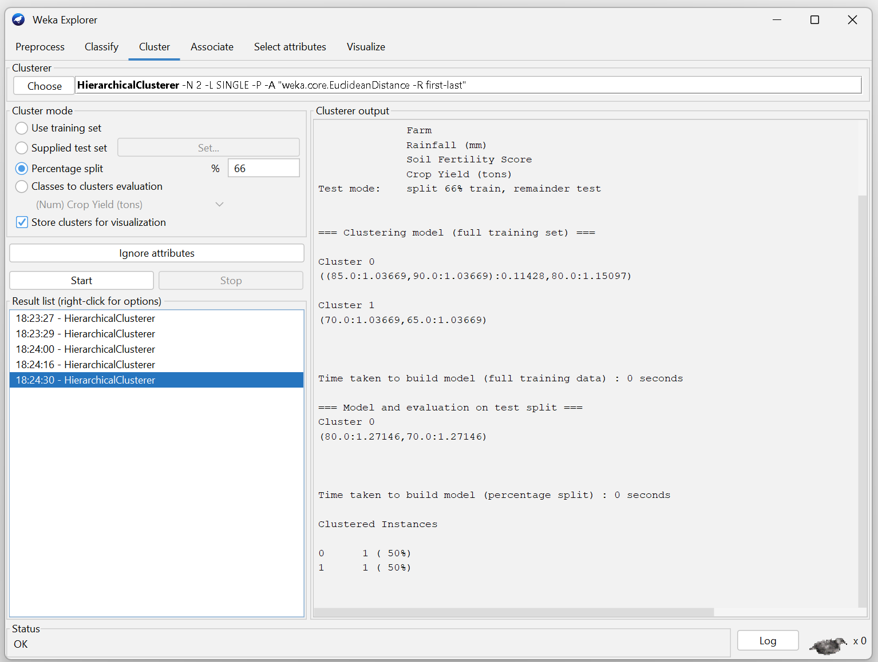

Q5. Dataset: Employee Performance Evaluation
Employee | Productivity Score | Attendance (%) | Skill Assessment Score
E1 | 88 | 92 | 84
E2 | 62 | 75 | 68
E3 | 78 | 88 | 72
E4 | 55 | 65 | 58
E5 | 93 | 96 | 90
Silhouette Scores
Model | Score
K=2 | 0.48
K=3 | 0.68
K=4 | 0.52
Question (BL5 – 8 Marks):
A company clusters employees based on productivity, attendance, and skill assessment scores. Analyze the silhouette scores obtained for different clustering models and determine the most suitable number of clusters. Justify your answer and explain how the selected model contributes to effective employee performance evaluation.
Model | Silhouette Score
K = 2 | 0.48
K = 3 | 0.68
K = 4 | 0.52
Step 1: Compare the silhouette scores
For K = 2, the score is 0.48.
For K = 3, the score is 0.68.
For K = 4, the score is 0.52.
Step 2: Identify the highest score
Maximum silhouette score = 0.68
Corresponding number of clusters = K = 3
Step 3: Compare the models
K = 3 is better than K = 2 because 0.68 > 0.48.
K = 3 is better than K = 4 because 0.68 > 0.52.
Step 4: Final decision
Most suitable number of clusters = 3
Step 5: Interpretation
Three clusters provide the best balance of within-cluster similarity and between-cluster separation among the tested models. The groups can be interpreted as broad performance segments such as higher-performing, moderate-performing, and lower-performing employees, based on productivity, attendance, and skill assessment scores.
A three-cluster model can support employee performance evaluation by helping the organization identify high performers, employees needing development, and intermediate performers requiring targeted support.
