SIMATS ENGINEERING
ASSESSMENT TOOL 2

COURSE NAME: CSA16 COURSE CODE: Data Warehousing and Data Mining

COURSE OUTCOME COVERED

CO4: Examine the applicability of clustering algorithms in real-world scenarios, presenting findings through clear reports with effective visualizations.
Assessment Tool Weightage: 40%

QUESTIONS: 05 Total Marks:50

Annexure A

Industry Problem Solving Task

Criteria | Understanding of Industry Problem (2) | Application of Engineering Concepts (2.5) | Solution Design (2.5) | Use of Tools (2) | Analysis (1) | Total(10)
Weightage | 20% | 25% | 25% | 20% | 10% | 100%
Q1
Q2
Q3
Q4
Q5

Code of Conduct:

I MANIBAALAKRISHNAN S/192211171 (Name / Reg No) certify that this submission is my original work and that I have adhered to the guidelines specified for this assessment.
I understand that any violation of academic integrity rules will result in disciplinary action.

Signature of the student: MANIBAALAKRISHNAN S

RUBRICS FOR CALCULATION:

Criteria | Weightage | Level 4 – Exemplary | Level 3 – Proficient | Level 2 – Developing | Level 1 – Beginning
Criteria | Weightage | Level 4 – Exemplary | Level 3 – Proficient | Level 2 – Developing | Level 1 – Beginning
Understanding of Industry Problem | 20% | Comprehensive understanding of real-world problem and constraints | Good understanding with minor gaps in requirements | Basic understanding; some requirements unclear | Poor understanding; misinterprets problem context
Application of Engineering Concepts | 25% | Applies advanced and relevant concepts effectively to solve the problem | Applies appropriate concepts with minor errors | Limited application of concepts | Incorrect or no application of concepts
Solution Design | 25% | Innovative, practical, and feasible solution aligned with industry standards | Logical and feasible solution with minor gaps | Basic solution with limited feasibility | Unclear or impractical solution
Use of Tools | 15% | Effective use of modern tools, technologies, and real data | Appropriate use of tools with correct implementation | Limited or inconsistent use of tools | Minimal or incorrect use of tools
Analysis | 10% | Thorough analysis with validated results and performance evaluation | Good analysis with reasonable validation | Basic analysis with limited validation | Poor or no analysis
Professionalism | 5% | Highly professional, well-documented, and clearly presented work | Good documentation and presentation | Basic documentation with some gaps | Poor documentation and presentation

Annexure A

Q1 . Dataset: Supermarket Purchases
Customer | Visits/Month | Avg Spend (₹) | Items Bought
C1 | 10 | 2000 | 15
C2 | 4 | 5000 | 8
C3 | 12 | 1800 | 18
C4 | 3 | 6000 | 6
C5 | 11 | 2100 | 16
Question:
Using the above dataset, propose a clustering approach to segment customers and explain how it supports targeted marketing. (BL3 – 7 Marks)
Customer | Visits/Month | Avg Spend (₹) | Items Bought
C1 | 10 | 2000 | 15
C2 | 4 | 5000 | 8
C3 | 12 | 1800 | 18
C4 | 3 | 6000 | 6
C5 | 11 | 2100 | 16

Step 1: Identify clustering variables
Use Visits/Month, Avg Spend, and Items Bought as the numerical features for clustering. Customer ID is only an identifier and is not used for distance calculation.
Step 2: Observe similarity between customers
C1, C3, and C5 have high visit frequency and buy many items, with similar spending values. C2 and C4 have low visit frequency and buy fewer items, but their average spending is much higher.
Step 3: Form meaningful clusters
A suitable two-cluster segmentation is: Cluster 1 = {C1, C3, C5}; Cluster 2 = {C2, C4}.
Step 4: Interpret Cluster 1
C1, C3, and C5 are frequent shoppers with high item volume and comparatively lower average spend per visit. They can be treated as frequent/value customers.
Step 5: Interpret Cluster 2
C2 and C4 visit less frequently, buy fewer items, but have high average spending. They can be treated as high-spend/low-frequency customers.
Step 6: Targeted marketing
Cluster 1 can receive loyalty rewards, repeat-purchase offers, bundles, and points-based promotions. Cluster 2 can receive premium offers, personalized high-value products, and incentives to increase visit frequency.
Step 7: Conclusion
Clustering converts raw purchase behavior into actionable customer segments, allowing the supermarket to use different marketing strategies instead of treating all customers identically.
Final answer: A practical two-cluster customer segmentation is {C1, C3, C5} and {C2, C4}, supporting differentiated targeted marketing.
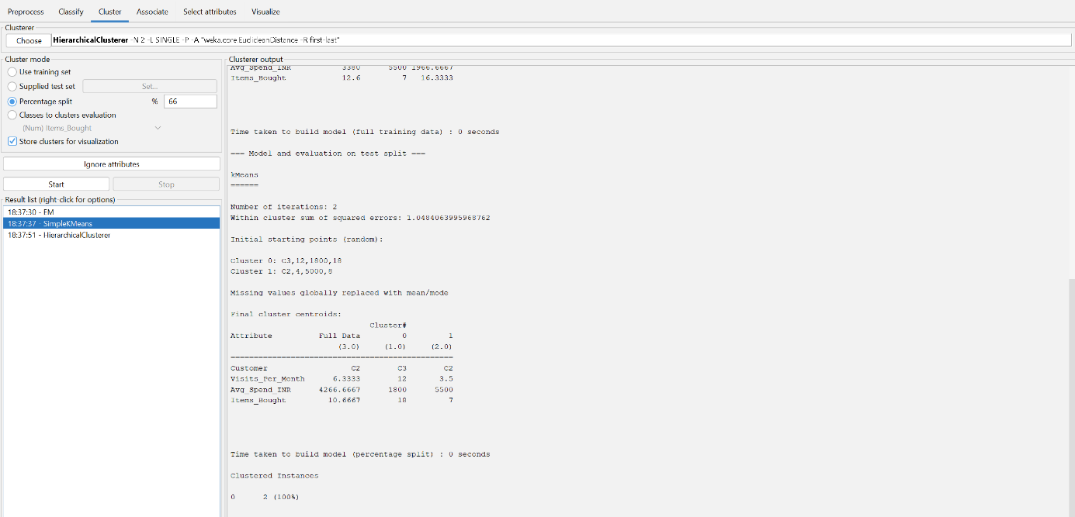

Q2. Dataset: Credit Card Transactions
Transaction | Amount (₹) | Location | Time (hrs)
T1 | 200 | Chennai | 10
T2 | 5000 | Delhi | 2
T3 | 150 | Chennai | 11
T4 | 7000 | Mumbai | 1
T5 | 180 | Chennai | 12
Question:
Design a clustering-based solution using this dataset to detect unusual or fraudulent transactions. (BL4 – 7 Marks)

Transaction | Amount (₹) | Location | Time (hrs)
T1 | 200 | Chennai | 10
T2 | 5000 | Delhi | 2
T3 | 150 | Chennai | 11
T4 | 7000 | Mumbai | 1
T5 | 180 | Chennai | 12
Step-by-step solution
Step 1: Identify clustering variables
Use Transaction Amount and Time as numerical features. Location can be treated as a categorical attribute when constructing a complete clustering model.
Step 2: Find the normal transaction pattern
T1, T3, and T5 have very low transaction amounts and occur around 10–12 hours. They form a consistent low-value/daytime pattern.
Step 3: Find unusual observations
T2 and T4 have very large transaction amounts (₹5000 and ₹7000) and occur at very early hours (2 and 1 hours). These observations are far from the normal pattern.
Step 4: Proposed clusters
A suitable initial segmentation is Cluster 1 = {T1, T3, T5} (normal pattern) and Cluster 2 = {T2, T4} (high-value/odd-hour pattern).
Step 5: Fraud-risk interpretation
Cluster 2 should be flagged for investigation because both transactions have substantially higher amounts and unusually early transaction times. Clustering identifies them as behaviorally distinct; it does not by itself prove fraud.
Step 6: Operational solution
Create a monitoring rule around the unusual cluster. Transactions assigned to this cluster can be sent for additional verification, OTP confirmation, customer notification, or manual review.
Step 7: Conclusion
Clustering can act as an anomaly-screening layer by separating common transaction behavior from unusual behavior. The unusual cluster receives higher fraud-risk attention.
Final answer: Use clustering to separate the normal pattern {T1, T3, T5} from the unusual high-value/odd-hour pattern {T2, T4}; the latter should be investigated as potentially fraudulent, not automatically labeled as fraud.
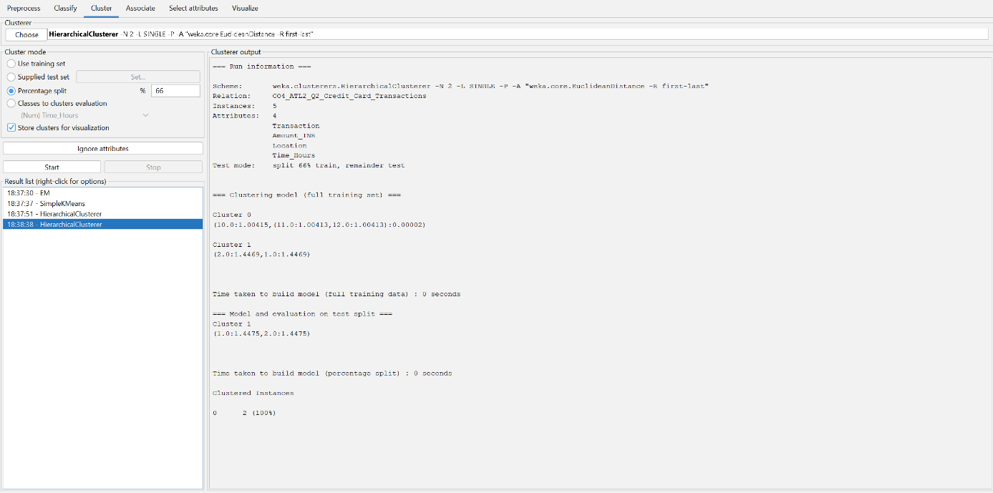

Q3. Dataset: Telecom Usage
User | Call Duration (min) | Data Usage (GB) | Recharge (₹)
U1 | 300 | 5 | 200
U2 | 100 | 2 | 100
U3 | 350 | 6 | 220
U4 | 80 | 1 | 90
U5 | 320 | 5.5 | 210
Question:
Explain how clustering can be applied to identify churn-prone users and improve customer retention strategies. (BL4 – 7 Marks)

User | Call Duration (min) | Data Usage (GB) | Recharge (₹)
U1 | 300 | 5 | 200
U2 | 100 | 2 | 100
U3 | 350 | 6 | 220
U4 | 80 | 1 | 90
U5 | 320 | 5.5 | 210
Step-by-step solution
Step 1: Select behavioral features
Use Call Duration, Data Usage, and Recharge amount to represent each user's engagement and spending behavior.
Step 2: Identify highly engaged users
U1, U3, and U5 have high call duration, high data usage, and higher recharge values. They form a high-engagement customer group.
Step 3: Identify low-engagement users
U2 and U4 have much lower call duration, data usage, and recharge values. They form a low-engagement group and are more suitable candidates for churn-risk attention.
Step 4: Form clusters
A suitable two-cluster interpretation is Cluster 1 = {U1, U3, U5} and Cluster 2 = {U2, U4}.
Step 5: Relate clusters to churn
The low-engagement cluster can be treated as churn-prone because reduced usage and lower recharge activity can indicate declining customer engagement. This is a risk indicator, not proof that the user will churn.
Step 6: Retention strategy
For Cluster 2, provide targeted retention offers such as affordable recharge plans, bonus data, personalized packs, service reminders, and incentives to increase usage. Cluster 1 can receive loyalty benefits and premium plans to maintain engagement.
Step 7: Conclusion
Clustering helps the telecom company prioritize retention efforts by focusing attention on users whose usage pattern is substantially weaker than the active-user cluster.
Final answer: Cluster {U1, U3, U5} represents highly engaged users, while {U2, U4} represents low-engagement users who should receive higher churn-risk monitoring and retention interventions.
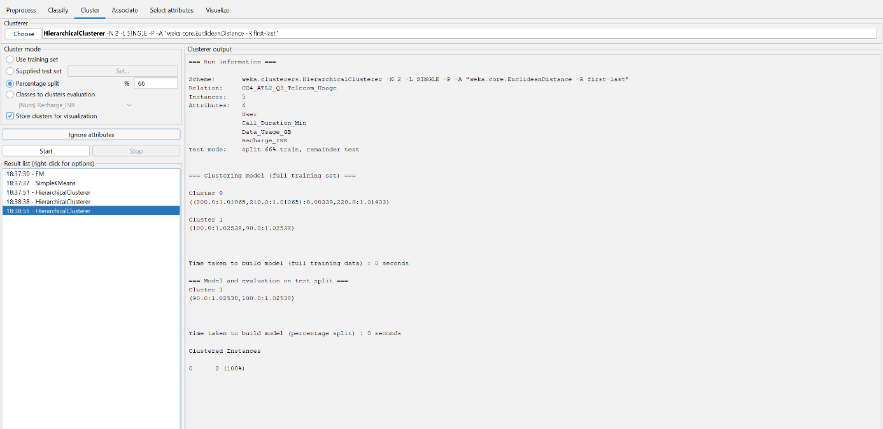

Q4 . Dataset: E-commerce Behavior
User | Product Views | Clicks | Purchases
U1 | 50 | 20 | 5
U2 | 30 | 10 | 2
U3 | 60 | 25 | 6
U4 | 20 | 8 | 1
U5 | 55 | 22 | 5
Question:
Suggest a clustering technique to group users and explain how it improves recommendation systems. (BL3 – 7 Marks)
User | Product Views | Clicks | Purchases
U1 | 50 | 20 | 5
U2 | 30 | 10 | 2
U3 | 60 | 25 | 6
U4 | 20 | 8 | 1
U5 | 55 | 22 | 5
Step-by-step solution
Step 1: Select behavioral variables
Use Product Views, Clicks, and Purchases as the clustering features. These represent browsing interest, interaction, and conversion behavior.
Step 2: Identify highly engaged users
U1, U3, and U5 have high views, high clicks, and high purchase counts. They form a high-engagement/high-conversion group.
Step 3: Identify lower-engagement users
U4 has the lowest values across all three attributes. U2 is also lower than the top group, with moderate activity and purchases.
Step 4: Proposed clustering
A practical three-level segmentation is: High engagement = {U1, U3, U5}; Medium engagement = {U2}; Low engagement = {U4}.
Step 5: Choose a clustering technique
K-Means is suitable for this small numerical dataset because all three behavioral variables are numeric and users can be grouped according to similarity across these features.
Step 6: Use clusters in recommendations
For high-engagement users, recommendations can emphasize complementary products, premium products, and cross-selling. Medium-engagement users can receive personalized products based on recent activity. Low-engagement users can receive popular items, reminders, discounts, and re-engagement recommendations.
Step 7: Conclusion
Clustering allows the recommendation system to apply different recommendation strategies to users with different engagement and purchase patterns, improving personalization.
Final answer: K-Means can group users by views, clicks, and purchases; a practical interpretation is {U1, U3, U5} as high engagement, U2 as medium engagement, and U4 as low engagement.
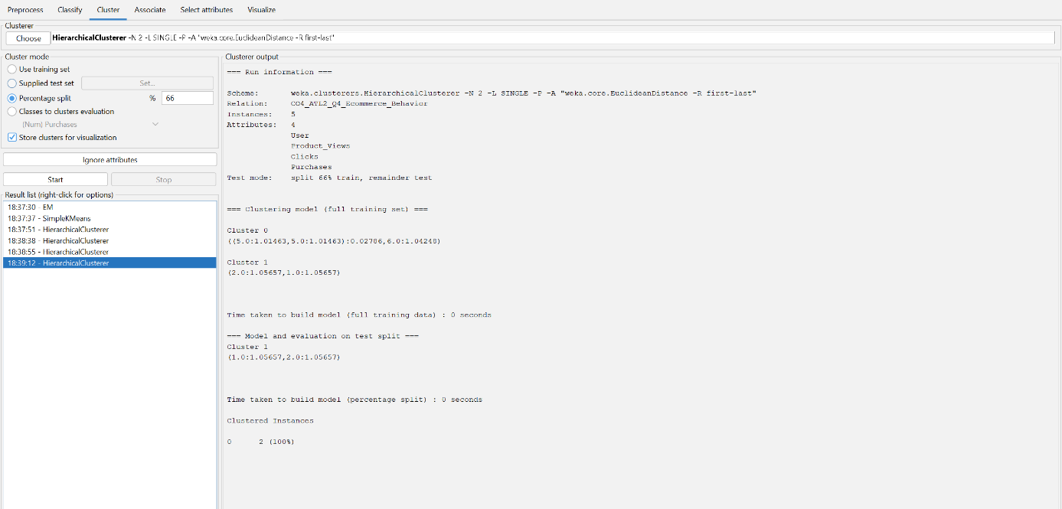

Q5. Dataset: Traffic Data
Location | Vehicle Count | Avg Speed (km/h) | Delay (min)
L1 | 200 | 30 | 10
L2 | 500 | 15 | 25
L3 | 220 | 28 | 12
L4 | 600 | 10 | 30
L5 | 210 | 32 | 9
Question:
Design a clustering-based solution to identify traffic congestion zones and explain how it helps in traffic management. (BL4 – 7 Marks)
Location | Vehicle Count | Avg Speed (km/h) | Delay (min)
L1 | 200 | 30 | 10
L2 | 500 | 15 | 25
L3 | 220 | 28 | 12
L4 | 600 | 10 | 30
L5 | 210 | 32 | 9
Step-by-step solution
Step 1: Select clustering variables
Use Vehicle Count, Average Speed, and Delay as the main numerical clustering features.
Step 2: Identify congested pattern
L2 and L4 have very high vehicle counts, low average speeds, and high delays. They show a strong congestion pattern.
Step 3: Identify low-congestion pattern
L1, L3, and L5 have lower vehicle counts, higher average speeds, and lower delays. They form a less-congested pattern.
Step 4: Form clusters
A suitable two-cluster segmentation is Cluster 1 = {L2, L4} (high congestion) and Cluster 2 = {L1, L3, L5} (lower congestion).
Step 5: Interpret the congestion cluster
L2 and L4 are priority congestion zones because high traffic volume is associated with low speeds and substantial delays.
Step 6: Traffic management decisions
For the high-congestion cluster, the authority can prioritize signal optimization, traffic diversion, additional public transport capacity, incident monitoring, and road-capacity improvements. The lower-congestion cluster requires normal monitoring and preventive management.
Step 7: Conclusion
Clustering helps authorities identify locations with similar traffic conditions and allocate traffic-management resources according to congestion severity.
Final answer: The dataset can be divided into a high-congestion cluster {L2, L4} and a lower-congestion cluster {L1, L3, L5}; the high-congestion zones should receive priority traffic-management actions.
