SIMATS ENGINEERING
ASSESSMENT TOOL 3

COURSE NAME: CSA16 COURSE CODE: Data Warehousing and Data Mining

COURSE OUTCOME COVERED

CO4: Examine the applicability of clustering algorithms in real-world scenarios, presenting findings through clear reports with effective visualizations.
Assessment Tool Weightage: 20%

QUESTIONS: 05 Total Marks:50

Annexure A

COMPARITIVE ANALYSIS

Criteria | Scope of Items (2) | Comparison Depth(2.5) | Use of Evidence (2) | Critical Thinking (2) | Clarity of Presentation (1) | Total(10)
Weightage | 20% | 25% | 20% | 20% | 10% | 100%
Q1
Q2
Q3
Q4
Q5

Code of Conduct:

I MANIBAALAKRISHNAN S/192211171 (Name / Reg No) certify that this submission is my original work and that I have adhered to the guidelines specified for this assessment.
I understand that any violation of academic integrity rules will result in disciplinary action.

Signature of the student: MANIBAALAKRISHNAN S

RUBRICS FOR CALCULATION:

 |  | Comparative analysis
Criteria | Weightage (%) | Level 4 (Exemplary) | Level 3 (Proficient) | Level 2 (Developing) | Level 1 (Beginning)
Scope of Items | 20% | Selects highly relevant items with clear scope and justification | Selects appropriate items with minor gaps | Selection is limited or partially relevant | Items are unclear or not relevant
Comparison Depth | 25% | Provides detailed and comprehensive comparison across multiple aspects | Provides adequate comparison with some depth | Limited comparison with few aspects | Very minimal or no comparison
Use of Evidence | 20% | Supports comparison with accurate data, examples, or references | Uses some supporting evidence with minor gaps | Limited or weak supporting evidence | No supporting evidence provided
Critical Thinking | 20% | Demonstrates strong critical thinking with clear interpretation and reasoning | Shows reasonable interpretation with minor gaps | Basic interpretation; lacks depth | No meaningful interpretation
Clarity of Presentation | 15% | Well-organized, clear, and logically structured presentation | Generally clear with minor issues | Somewhat unclear or poorly structured | Disorganized and difficult to understand

Annexure A

Q1 . Dataset: Assessment Tool 3: Comparative Analysis (25% → 5 Marks)
Time duration :45 Minutes
Assessment Tool 3 (Low)

Q1 . Dataset: Customer Data
Customer | Income (₹) | Spending Score
C1 | 30000 | 60
C2 | 60000 | 40
C3 | 50000 | 70
C4 | 28000 | 65
C5 | 65000 | 35
Question:
Compare K-means and hierarchical clustering using this dataset and explain differences in performance and scalability. (BL3 – 1 Mark)
Customer | Income (₹) | Spending Score
C1 | 30,000 | 60
C2 | 60,000 | 40
C3 | 50,000 | 70
C4 | 28,000 | 65
C5 | 65,000 | 35

Step 1: Identify the clustering objective. The aim is to group customers with similar income and spending-score patterns.
Step 2: K-means is centroid-based. It assigns each customer to the nearest centroid and works well when the number of clusters is specified in advance.
Step 3: From the dataset, C1 and C4 have lower income and relatively high spending scores, while C2 and C5 have higher income and lower spending scores. C3 has high income and the highest spending score.
Step 4: Hierarchical clustering builds a hierarchy of groups by successively merging similar customers (agglomerative) or splitting groups (divisive). It can be represented by a dendrogram.
Step 5: For this small dataset, both methods can provide meaningful groups. However, K-means is generally faster and more scalable for large datasets, whereas hierarchical clustering becomes more computationally expensive as the dataset grows.
Final comparison: K-means is more suitable when scalability and repeated clustering of large customer datasets are important. Hierarchical clustering is useful for small datasets when a hierarchy of customer relationships is valuable.
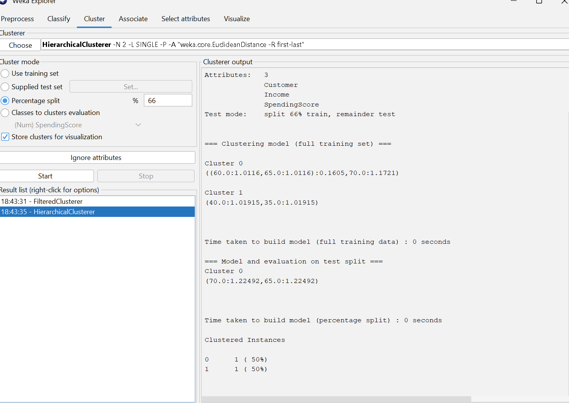

Q2. Dataset: Document Data
Document | Word1 | Word2 | Word3
D1 | 0.2 | 0.5 | 0.3
D2 | 0.1 | 0.6 | 0.3
D3 | 0.8 | 0.1 | 0.1
D4 | 0.75 | 0.15 | 0.1
D5 | 0.2 | 0.4 | 0.4
Question:
Compare K-means and EM algorithms in handling overlapping clusters for the given dataset. (BL4 – 1 Mark)
Document | Word1 | Word2 | Word3
D1 | 0.2 | 0.5 | 0.3
D2 | 0.1 | 0.6 | 0.3
D3 | 0.8 | 0.1 | 0.1
D4 | 0.75 | 0.15 | 0.1
D5 | 0.2 | 0.4 | 0.4

Step 1: Observe the document patterns. D1, D2 and D5 have relatively high Word2 values, while D3 and D4 have very high Word1 values.
Step 2: K-means assigns every document to one cluster. Therefore, each document receives a single hard cluster label.
Step 3: EM (Expectation-Maximization) uses probabilistic membership. A document can have a probability of belonging to more than one cluster.
Step 4: For clearly separated documents such as D3 and D4, both methods can identify a strong Word1-oriented group. D1, D2 and D5 are also similar, but an overlapping or borderline document can be represented more flexibly by EM.
Step 5: Therefore, for overlapping clusters, EM is more informative because it expresses uncertainty through membership probabilities, while K-means forces a single assignment.
Final comparison: K-means is simpler and faster, but EM is better suited when documents may partially belong to multiple topics or clusters.
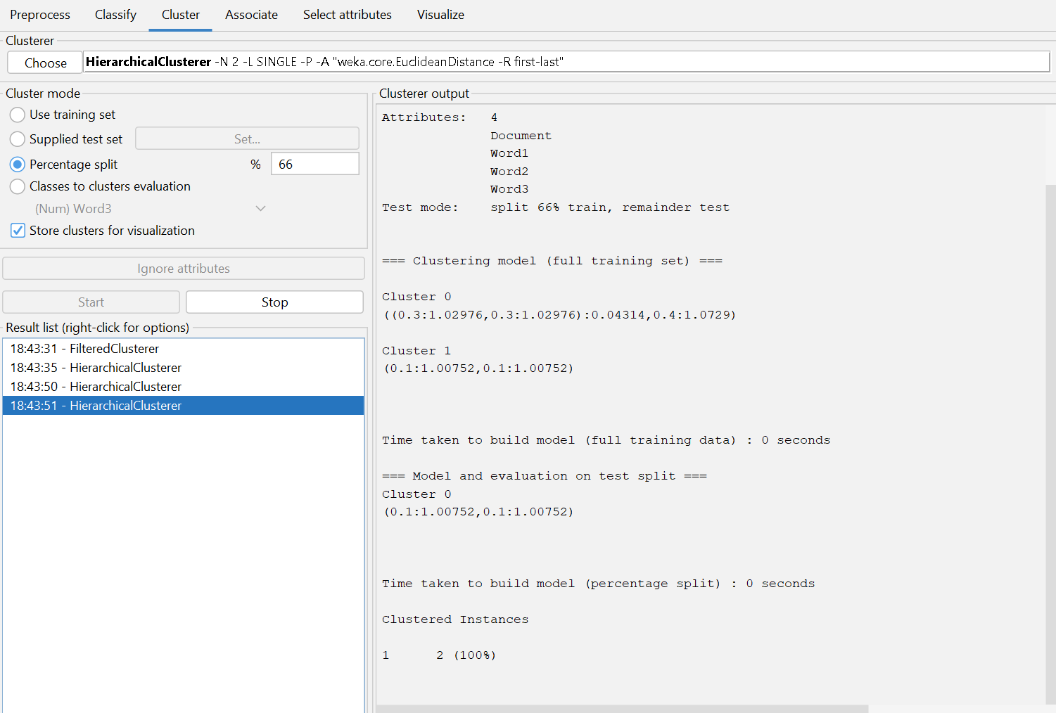

Q3. Dataset: Geographic Data
Point | Latitude | Longitude
P1 | 13.08 | 80.27
P2 | 13.10 | 80.25
P3 | 12.97 | 80.22
P4 | 13.05 | 80.30
P5 | 13.00 | 80.20
Question:
Compare Euclidean and Manhattan distance metrics and analyze their impact on clustering results. (BL4 – 1 Mark)
Point | Latitude | Longitude
P1 | 13.08 | 80.27
P2 | 13.10 | 80.25
P3 | 12.97 | 80.22
P4 | 13.05 | 80.30
P5 | 13.00 | 80.20

Step 1: Euclidean distance between two points is the straight-line distance: d = √((x1−x2)^2 + (y1−y2)^2).
Step 2: Manhattan distance is the sum of absolute coordinate differences: d = |x1−x2| + |y1−y2|.
Step 3: For P1 and P2: Euclidean distance = √((13.08−13.10)^2 + (80.27−80.25)^2) = √(0.0004+0.0004) ≈ 0.0283.
Step 4: For P1 and P2: Manhattan distance = |13.08−13.10| + |80.27−80.25| = 0.02 + 0.02 = 0.04.
Step 5: Both metrics indicate that P1 and P2 are very close. However, they calculate closeness differently, so the ranking of some point pairs and the resulting cluster boundaries can change.
Final comparison: Euclidean distance is suitable when direct geometric closeness is important. Manhattan distance is useful when movement or distance is better represented as movement along separate coordinate directions. The chosen metric can therefore affect cluster membership.
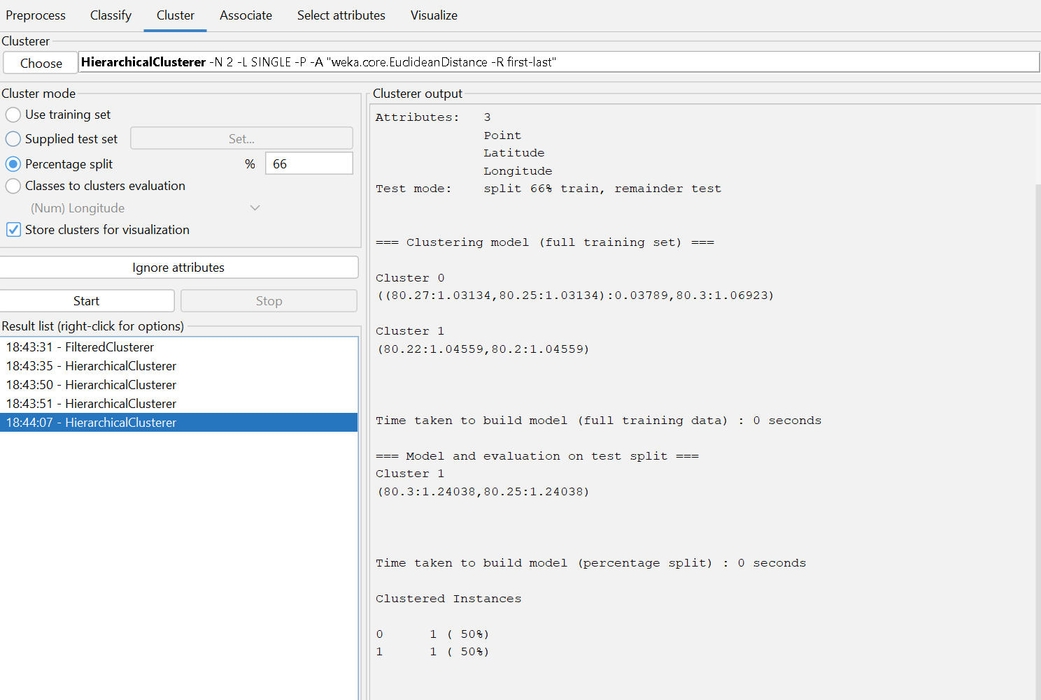

Q4. Dataset: Retail Products
Product | Sales (₹) | Frequency
P1 | 50000 | 20
P2 | 30000 | 10
P3 | 52000 | 22
P4 | 25000 | 8
P5 | 32000 | 12
Question:
Compare agglomerative and divisive clustering approaches and explain their suitability for this dataset. (BL3 – 1 Mark)
Product | Sales (₹) | Frequency
P1 | 50,000 | 20
P2 | 30,000 | 10
P3 | 52,000 | 22
P4 | 25,000 | 8
P5 | 32,000 | 12

Step 1: Identify the product patterns. P1 and P3 have high sales and high purchase frequency. P2 and P5 have moderate/lower values, while P4 has the lowest sales and frequency.
Step 2: Agglomerative clustering starts with each product as its own cluster and repeatedly merges the most similar clusters until a hierarchy is formed.
Step 3: Divisive clustering starts with all products in one cluster and repeatedly splits the cluster into smaller groups.
Step 4: For this small dataset, agglomerative clustering is convenient because the similar product pairs can be merged step by step and the hierarchy can be inspected using a dendrogram.
Step 5: A likely first grouping is P1 with P3 because their sales and frequencies are very similar. P2 and P5 are also relatively similar, while P4 is the most distinct.
Final comparison: Agglomerative clustering is the more practical choice for this small retail dataset because it directly builds groups from individual products and makes the hierarchy easy to interpret. Divisive clustering is useful when a top-down partitioning process is preferred but can be more expensive to implement.
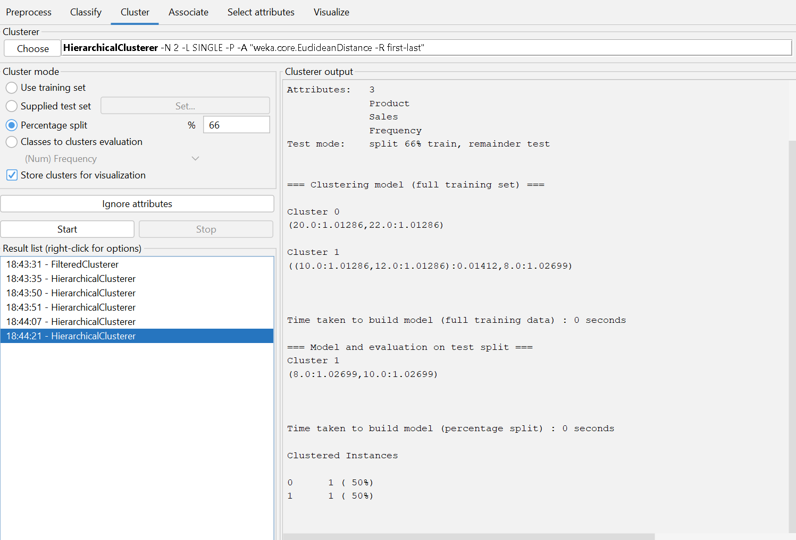

Q5 . Dataset: Mixed Attributes
Item | Price (₹) | Category | Rating
I1 | 500 | A | 4.5
I2 | 300 | B | 3.8
I3 | 550 | A | 4.7
I4 | 250 | B | 3.5
I5 | 520 | A | 4.6
Question:
Compare centroid-based and density-based clustering techniques and analyze their effectiveness on mixed data types. (BL4 – 1 Mark)
Item | Price (₹) | Category | Rating
I1 | 500 | A | 4.5
I2 | 300 | B | 3.8
I3 | 550 | A | 4.7
I4 | 250 | B | 3.5
I5 | 520 | A | 4.6

Step 1: Identify the attribute types. Price and Rating are numerical, while Category is categorical. Therefore, the dataset contains mixed attribute types.
Step 2: Centroid-based clustering, such as K-means, represents each cluster using a centroid and works naturally with numerical attributes. The categorical Category attribute requires suitable encoding or a mixed-data clustering method.
Step 3: Density-based clustering forms groups in dense regions and can identify irregularly shaped clusters and outliers. However, standard density calculations also need an appropriate representation of categorical values.
Step 4: The data shows a clear Category A group (I1, I3, I5) with high prices and high ratings, and a Category B group (I2, I4) with lower prices and lower ratings.
Step 5: For this small, structured dataset, centroid-based clustering can work after properly encoding the categorical attribute. Density-based clustering becomes more attractive when clusters have irregular shapes or when outlier detection is important.
Final comparison: Neither method should be applied blindly to the raw mixed data. The categorical attribute must be handled appropriately. For this dataset, a centroid-based approach is straightforward after suitable preprocessing, while density-based clustering is advantageous when irregular groups or noise are expected.
