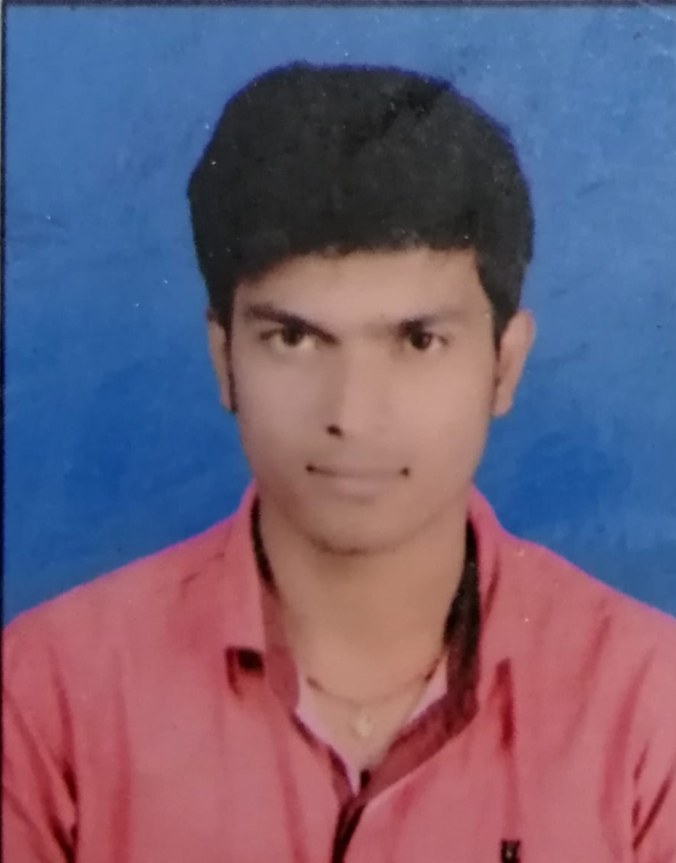
0605ritesh@gmail.com

––
MANIBHUSAN KUMAR
MCA Student
7004456570 / 7079000915
manibhusan165@gmail.com
Bansghat Masuria, 841409, Gopalganj, Bihar
INTERPERSONAL SKILLS
KEY PROJECTS
Master of Computer Application
(First year (CPI-6.93/10)) 2019-21
Marwadi Education Foundation
Bachelor of Computer Application
(Per-76.33%)2016 - 19
MMHA&P University ,PATNA
Intermediate
(Per-64%) 2014-2016
B.M.D.D, Gopalganj ,(Bihar)
Timing Flexibility
Communication Skills
Problem Solving

Willing to work in a challenging position with a growing organization where I can utilize my technical and interpersonal skills to serve the organization and enhanced the same.
MCA (Sem-3 Project)
Canteen Food Ordering System (PHP) (As coding partner)
MCA (Sem-5 Project)
Online Gas Booking System (Django (Python)) (As a coding partner)
Some of my interpersonal skills include the following:
Smart Working

o
P

Self Confidence
J
l

Positive Attitude

Playing Cricket
Social Networking
Traveling
Watching Movies
High School
(Per-66.8%) 2013
S.Y.R .H.S, Reotith , Gopalganj

Reporting
C Language
C++
Java
Python, Android
Mysql
Html,Css
Bootstrap,JavaScript

Skype-id live:.cid.6c0632989fcab013
EDUCATION
OBJECTIVE
EXPERTISE
OTHER SKILLS
HOBBIES

