|  |
| --- |
| **Guide to Operations** |
| API Portal  for  Axway API Gateway  Document Version 2.1 25 of March 2015 | | |



Copyright © Axway Software, 2015

All rights reserved.

No part of this publication may be reproduced, transmitted, stored in a retrieval system, or translated into any human or computer language, in any form or by any means, electronic, mechanical, magnetic, optical, chemical, manual, or otherwise, without the prior written permission of the copyright owner, Axway Software.

This document, provided for informational purposes only, may be subject to significant modification. The descriptions and information in this document may not necessarily accurately represent or reflect the current or planned functionalities of this product. Axway Software may change this publication, the product described herein, or both. These changes will be incorporated in new versions of this document. Axway Software does not warrant that this document is error free.

Axway Software recognizes the rights of the holders of all trademarks used in its publications.

Preface

Purpose of this DOCUMENT

This document describes the functionality, the deployment and configuration as well as the usage steps of the “API Portal” solution package.

Related documentation

This solution package is accompanied by a complete set of documentation, consisting of the following documents:

* Release Notes
* Guide to Operations

All documentation for this solution can be obtained from the Axway Global Support, Axway Customer Services or Axway Professional Services Organization.

Intended Audience

The intended audience of this guide is system administrators responsible for deployment, configuration and maintenance of this solution. It is recommended that readers be familiar with the products and systems listed in the “Requirements” section of this document.

# Table of Contents

1 Table of Contents 3

2 Overview 4

1. Functional Overview 4

2. Architectural Overview 4

3 Requirements 6

1. Operating Systems 6

2. Base Product Versions 6

3. Third-Party Products / Browsers 6

4 Installation 8

1. Installing and Configuring the Solution 8

4.1.1 Installation and Configuration 8

4.1.2 Custom property file update on the API Gateway server 11

4.1.3 Terms & Conditions text configuration 12

4.1.4 Rollback Instructions 13

5 Operation 14

1. Sign In and Sign Up (User Self-Registration). 14

2. User Profile and Change Password 16

3. User updates from API Portal admin UI. 19

4. Organization Administrators 19

5. Manage API Server Applications 20

5.5.1 Application List, Create Application 20

5.5.2 View, Edit and Delete an Application 22

6. API Catalog 25

7. Monitoring 28

5.7.1 Application Metrics tab 28

5.7.2 API Metrics tab 30

8. Help Center 33

6 Troubleshooting 34

1. General Troubleshooting Steps 34

2. API Response Class Details Missing 34

3. Product Limitations 35

6.3.1 Known Limitations in Monitoring Area 35

7 Support 36

1. Axway Global Support 36

2. Training and Consulting Services 36

Addendum API Portal Forum and Blog 37

Addendum Theming and Custom Styles 39

# Overview

in this chapter

This chapter briefly describes the features of the solution package.

## Functional Overview

Axway customers install and configure API Gateway Server to provide a set of network accessible interface APIs. These APIs can be exposed for usage by their partners. The present solution allows these partners to automate the usage of the APIs in applications. The partner’s developer teams can create applications to automate the communication of the partner sites with the API server. The information and appropriate documentation about the available API interfaces, as well as examples about how to use can be published in the API Portal.

The present API Portal solution is a Joomla! based application offering:

|  |  |
| --- | --- |
| End User sample functionality   * + Welcome page   + Login page   + Self-registration   + Applications management   + API Catalog   + API details (test) page   + Monitoring   + Help Center, including Discussion section (EasyDiscuss)   + Documentation   + Blog (EasyBlog) | * Users  This functionality is accessible to usres with role administrator only. They can execute basic operations on API Portal users and their applications   Admin Functionality   * API Portal Configuration |

## Architectural Overview

The diagram shows the interacting components. The present solution is presented on the diagram as ***API Portal (this solution)*** and isintegrated with the Axway **API Gateway** Server.



The API Portal exposes API Gateway Server data to portal users: user profiles, applications, API list and API details and test API functionality.

The API Portal allows customer users (managers, administrators, application developers) to self-register to API Gateway server, log in to it, manage there their profiles, manage their applications, view published APIs and test them.

It also allows the users to view portal help and documentation pages, and facilitates communication by adding forum and blog tools.

# Requirements

in this chapter

This chapter describes the system requirements for the solution package.

## Operating Systems

This solution is a **Joomla Web** site integrated with Axway API Gateway server shipped as an Axway Appliance (currently SuSE 11 SP3).

## Base Product Versions

The Portal requires the following backend in order to function:

* Axway API Gateway Server 7.4 – installed and functional.

**Note:** *This includes/requires the following modules:*

* + - API Gateway Analytics installed and configured
    - API Policy Studio and Configuration Studio are required in order to be able to configure API Gateway Analytics

The portal appliance includes the following packages:

* Joomla 3.3.1 (<http://www.joomla.org/technical-requirements.html>). This requires:
  + Apache Web Server v2.2 or v2.4 (http://www.apache.org/)
  + PHP v5.5.9 or above Support (http://www.php.net/)
  + MySQL database Server v5.1 or above (http://www.mysql.com/)
* T3 Framework plugin 2.3.0, installed and functional on Joomla.
* Purity III - Joomla template 1.1.0 (requires T3 Framework plugin) - installed and functional on Joomla.
* AllVideos (by JoomlaWorks) 4.6.1 - installed and functional on Joomla.
* PHP php5-mcrypt and php5-gd extensions installed and enabled on Joomla.

## Third-Party Products / Browsers

* Browser support as described in your Joomla documentation.
* Internet Explorer do not fully support CORS. You should enable cross domain request to be able to use test API page. Go to IE tools (Alt+X) -> Internet options -> Security tab -> press custom level button -> Miscellaneous -> Access data sources across domains -> enable -> ok.
* The test API functionality in the API catalog page requires browser with HTML5 support.
* *EasyDiscuss(*3.2.9463*)*  and *EasyBlog (*3.9.16263) Joomla plugins validated with the solution. Find more info in an Addendum to this document.

# Installation

in this chapter

This chapter describes how to install and un-install the solution package.

## Installing and Configuring the Solution

### Installation and Configuration

The Portal is available as a preinstalled appliance, and requires just some minor configurations. The Appliance should be powered on and successfully boot-up without any errors on terminal;

You can configure networking for the appliance from console. You can login with **admin** username and **changeme** password. After that you can get root access (su) with password – **changeme**.

On boot, the appliance automatically brings web server, serving the Portal frontend and Joomla backend.

On ports 80 and 443 – accessible via browser.

Joomla uses MySQL user **joomla** with password **changeme**. MySQL root password is **changeme**.

Login in the administrator UI in Joomla! Backend, usually http://**<HOSTNAME>**/administrator

Default username is **admin** and default password – **changeme**

Go to section Components >> API portal:

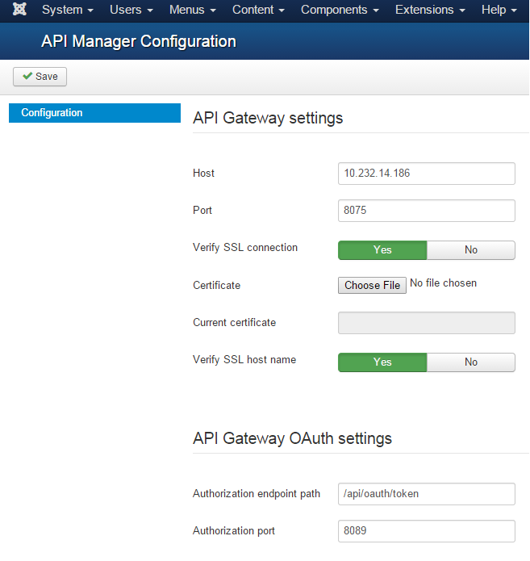

Fill-in your API Gateway host and API manager port (default is 8075). For host use a real host name or an IP.

The initial setup is complete, which means you should be able to enroll new users and login to the portal frontend at [http://<**HOSTNAME**>/](http://HOSTNAME/)

**Parameters:**

* **Host:** API Gateway host name
* **Port:** API Gateway Manager port
* **Verify SSL connection: Verify** SSL peer certificate for https connections
* **Certificate:** API Gateway Manager certificate
* **Current Certificate:** Currently used certificate
* **Verify SSL host name:** Verify certificate host name for https connections
* **Authorization endpoint path:** API Gateway Authorization endpoint path used to manage OAuth 2.0 client applications e.g. /api/oauth/token
* **Authorization port:** API Gateway Authorization endpoint port used to manage OAuth 2.0 client applications

Custom menu items for the API Portal and will create the appropriate admin page menu items for end-user page views and sub-page views in the API Catalog site:

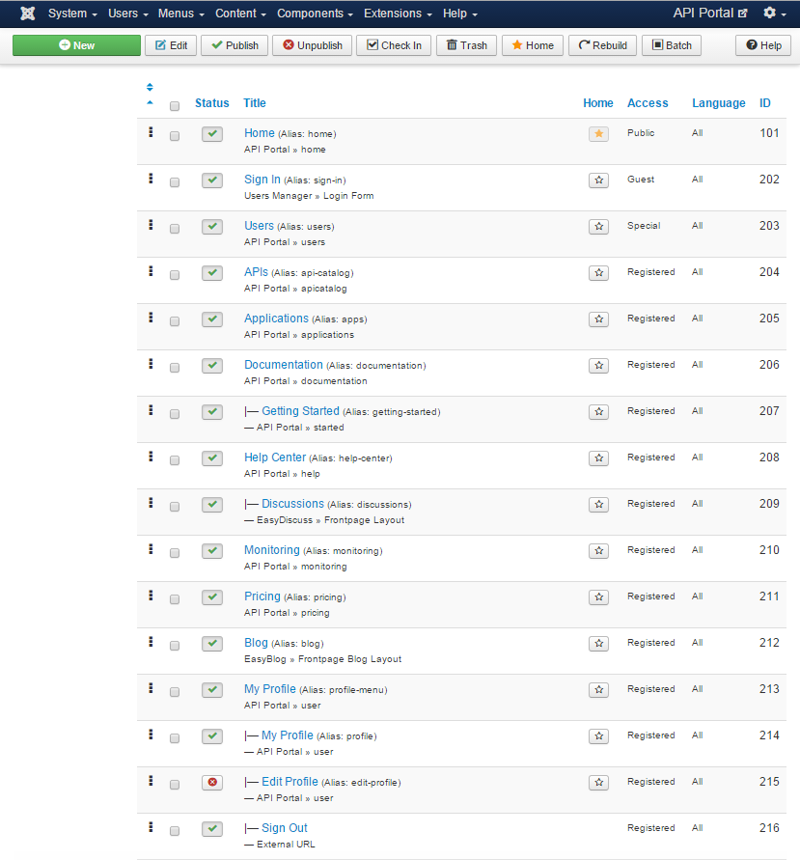

### Custom property file update on the API Gateway server

The delivery archive ***Axway-APIManager7.4-Manager-<version>.zip*** applies to the API Server. Unzip it as *api_manager* folder in a temp location.

1. **At this step we configure on the API Gateway server an additional custom user attribute for the user self-registration process in the portal. The code segment to use can be copied from *api_manager/custom.properties* file.**

Login to the machine hosting the API Gateway server. Find in the API Gateway server root the file ***app.conf*** located at . *../Axway-7.4/apigateway/webapps/apiportal/vordel/apiportal/app*

Backup the file first, then open it and find the fragment named *customPropertiesConfig* :

*customPropertiesConfig: {*

*user: {*

*// custom properties...*

*// placeholder for code to add here*

*}*

Add in the user sub-fragment (at // *placeholder for code to add here* ) the following:

*TermsAndConditionsAccepted: {*

*label: 'Accepted Terms and Conditions',*

*type: 'switch',*

*disabled: true,*

*permissions: {*

*admin: { read: true, write: false },*

*oadmin: { read: true, write: false },*

*user: { read: true, write: false }*

*},*

*options:[*

*{ value: false, label: 'NO' },*

*{ value: true, label: 'YES' }*

*]*

*}*

Save the file.

The property appears in admin UI ‘Editing user’ page after browser refresh:

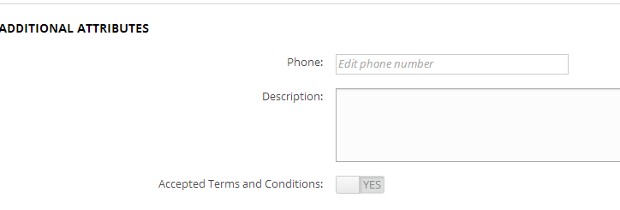

1. **Upload API Portal custom notification templates to the API Server.**

There is a README.txt in *api_manager/conf/email* with information with user or admin email template usage details.

Backup the folder *…/Axway-7.4/apigateway/webapps/apiportal/conf/email* before proceeding.

Copy from the unzipped delivery folder *api_manager/conf/email* over the *…/Axway-7.4/apigateway/webapps/apiportal/conf/email*

User templates use the configured ${portal.hostname} (API Portal host) in the URL. It should be configured in API Manager Settings -> External host: on the API Manager of the API Server.

Edit in the admin templates URL's manually to the host name of the API Manager.

The API Manager SMTP server needs to have been configured. There is no need to configure an SMTP server on the API Portal. 'Send mail' configuration in the Joomla 'Mail Settings' should be switched to 'Off'.

### Terms & Conditions text configuration

1. In order to specify the API Portal Terms & Conditions text, modify or replace the content of *components/com_apiportal/views/terms/tmpl/default.php.*
2. The API Portal is ready. Go to the end-user UI:

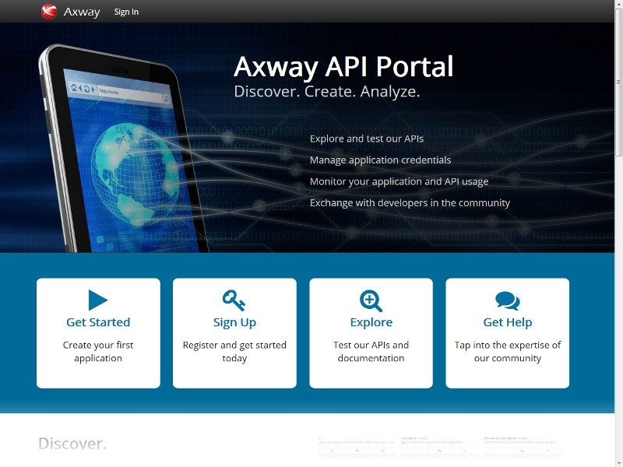

*API Portal welcome page*

### Rollback Instructions

Login as administrator, open package list and use *Uninstall* *“API Portal Package”* option to remove ***Axway-APIManager7.4-APIPortal-JoomlaExtension-<version>.zip*** and related elements.

# Operation

in this chapter

This chapter outlines the operation details as well as the process flow of the most common use-cases of the solution.

## Sign In and Sign Up (User Self-Registration).

To login click Sign In and enter your portal User ID and password.

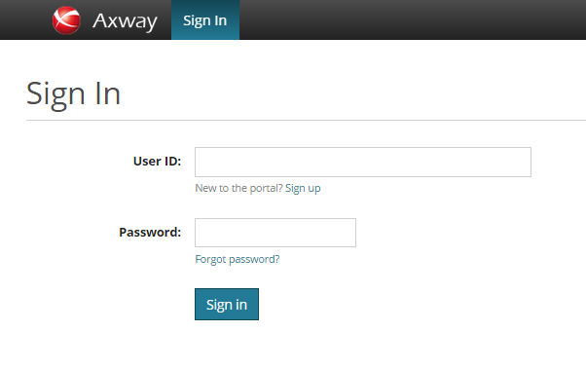

Use *Forgot password* link to changing your password in case you have forgotten it. You will receive a temporary one by an email.

If you do not have credentials, use *Sign Up* to self-register with the portal. See the following screen.

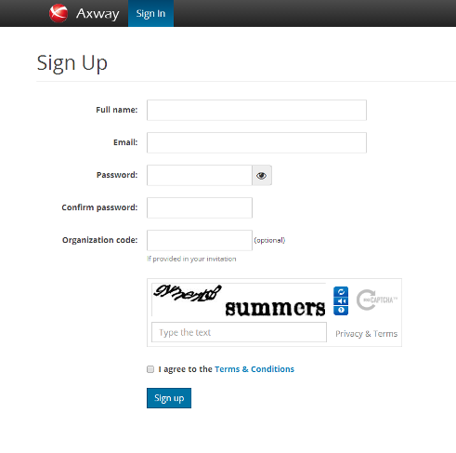

**Note:** There is no need to create Joomla! user. End-users will not be able to login with a Joomla! user if not registered with the API Server as shown above. When a user registers in API Server, a corresponding Joomla! user is created automatically.

**Note:** To enable captcha for sign up page go to *Extensions* select *Plugin Manager* and find *Captcha – ReCaptcha* plugin. If you are going to use this plugin, you have to set public and private keys. You will need a *Google* account to get these keys. After that *System* from main menu select *Global Configuration* and for *Default Captcha* select *Captcha – ReCaptcha*.

If registration is successful, a message will be shown on the page, and the user will receive an activation email. The user will be able to login after the account is activated.

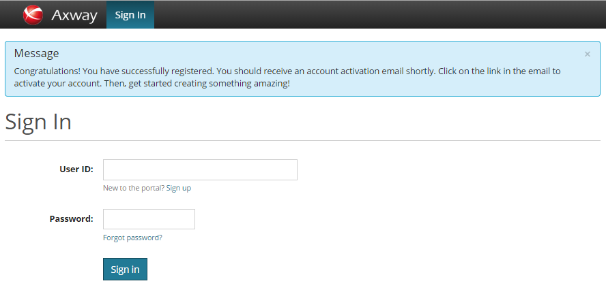

*A successful registration. Activation needed.*

**Note:** In case of not correct input data the page will show appropriate error message.

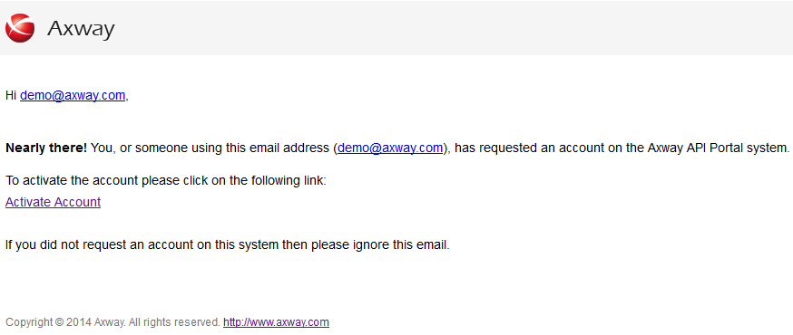

*Activation email*

## User Profile and Change Password

To login click Sign In and enter your portal email and password.

When logged in the user sees in the top horizontal menu he full portal menu item list.

The user can view and edit its API Gateway Server profile information and change its password.

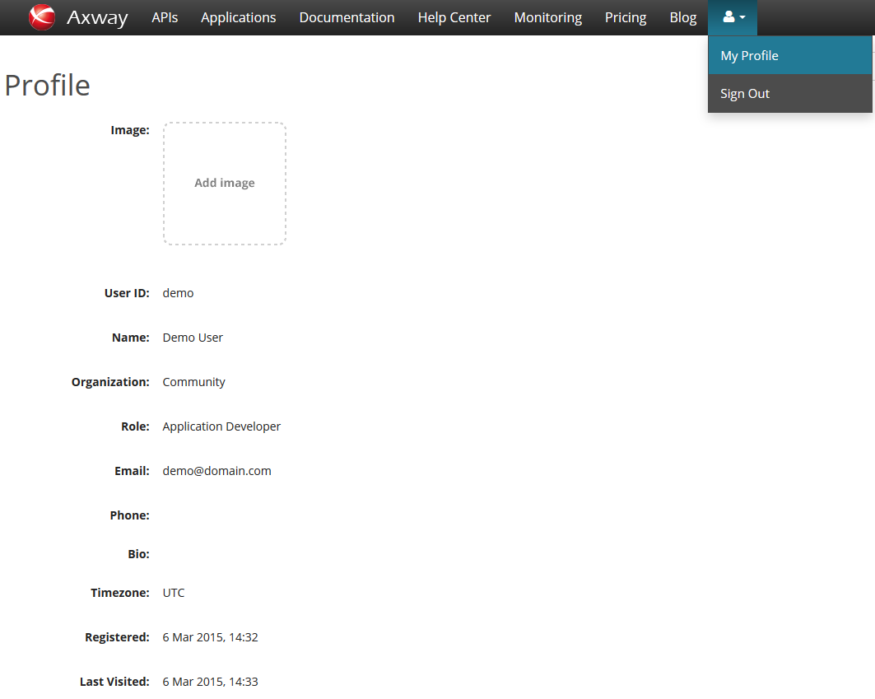

To proceed with editing profile info the user should click Edit profile.

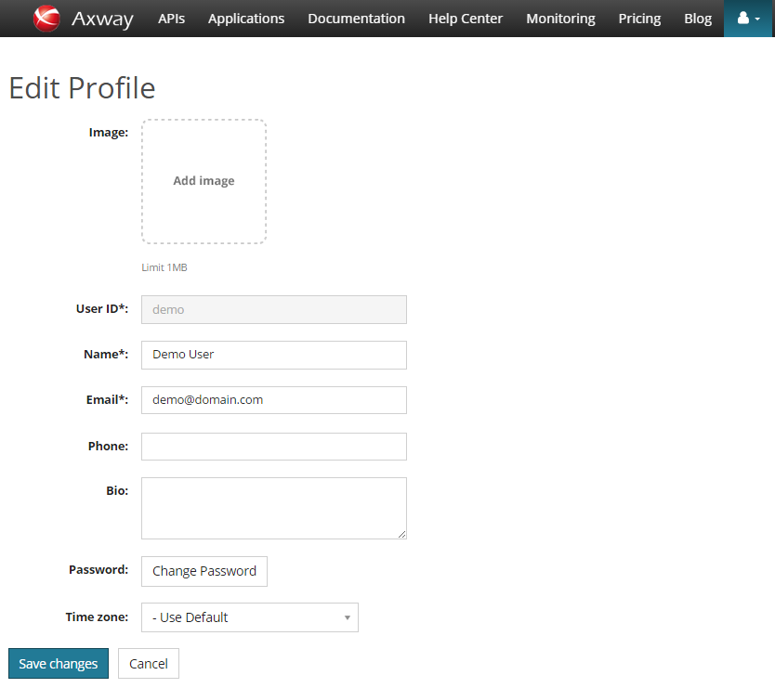

To change password user should use the *Change password* button.

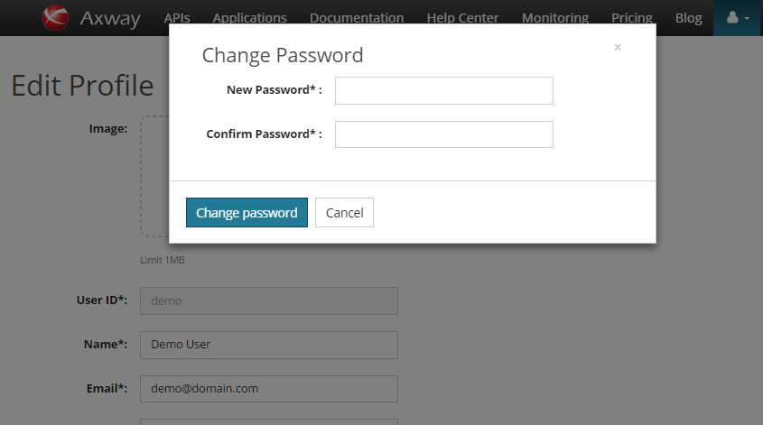

*Change Password*

## User updates from API Portal admin UI.

Deleting users, changing their passwords, user name and email address from the Joomla! Admin UI is supported with the following restriction: The logged in administrator must have credentials on the API Manager or the user will only get deleted locally.

An easy way to set this up is as follows:

* Have the 'apiadmin' user (or other API Manager user) log in to the API Portal Admin UI. This will create the Joomla user account apiadmin (or used API Manager User) as API Portal/Joomla Administrator.

## Organization Administrators

A user can be assigned in the API Manager to a role ‘Organization Administrators’. When logged to the API Portal End-user UI these users see an additional menu *Users*. An organization administrator can manage API Portal users in its organization (create, enable/disable, delete, edit details) including setting user role (API Manager Administrator, Organization Administrator, Application Developer) .

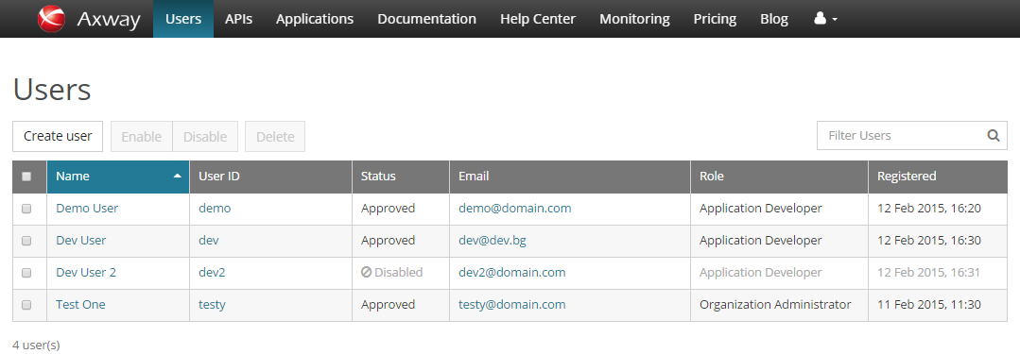

The Organization administrator can view and manage (edit, delete) applications created by or assigned to the other users of the API Portal.

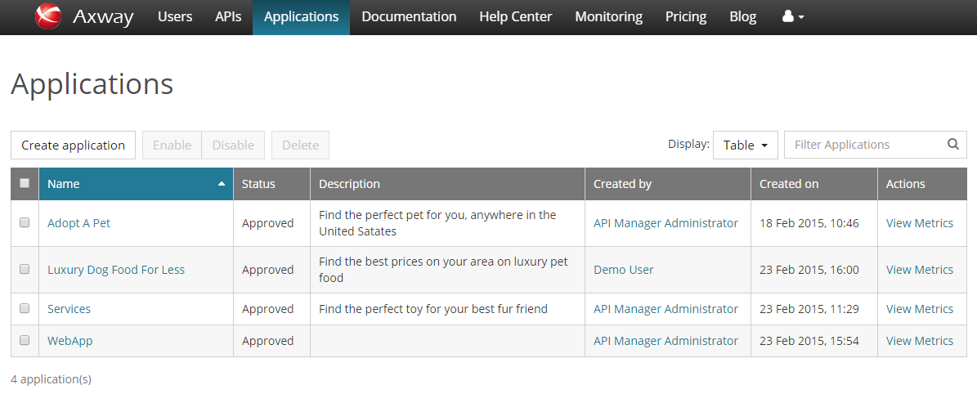

## Manage API Server Applications

The API Portal allows management of the user applications on the API Gateway server.

A user of role ‘Application Developer’ can view and manage (create, enable/disable, edit, delete) applications created by himself. A user can select share application option and select other users to share with an application.

A user can view applications of other users and manage them if they are shared with him.

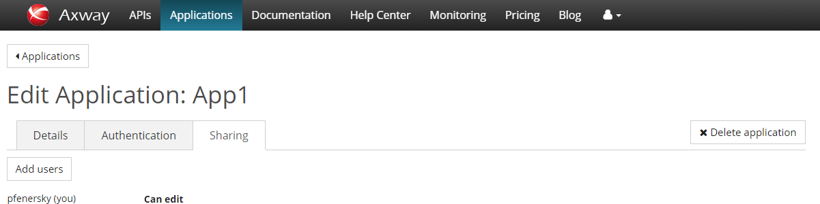

### Application List, Create Application

The *Applications* menu loads the Applications list for the current user.

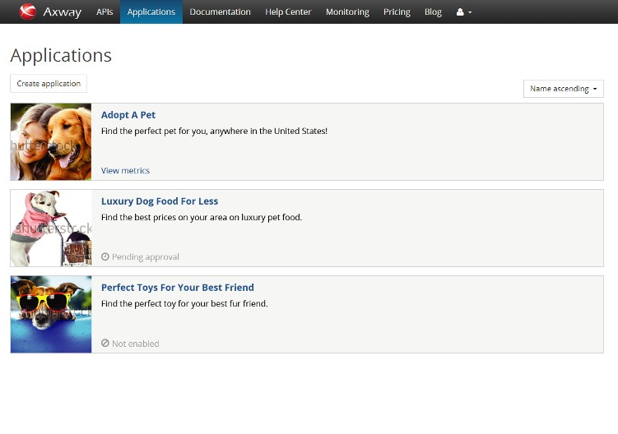

The list contains application details name, description, status (if not approved or not enabled).

Clicking *Create Application* opens a form to create a new application.

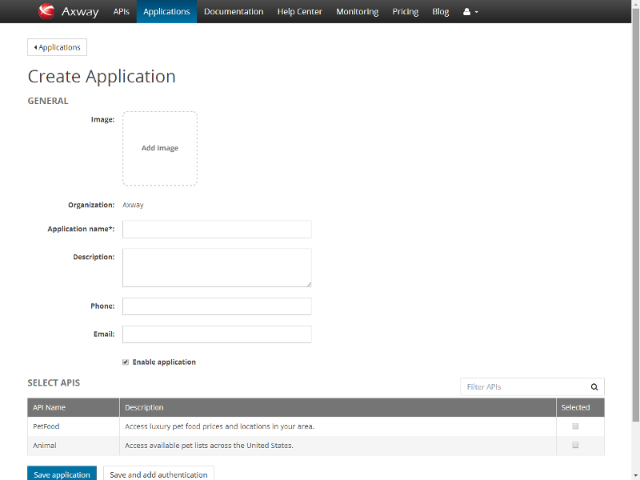

*Create Application page*

To assign any API to an application, select it in the ‘SELECT APIS’ table before saving the application.

Click *Save application*.

### View, Edit and Delete an Application

Clicking the application name on the application list page opens the application details page. The *Edit application* button opens this application for edition.

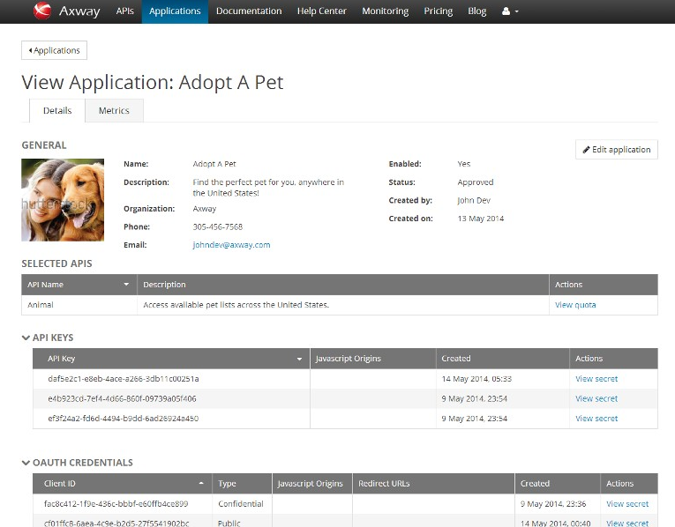

*View Application*

The *Metrics* link as well as the *View metrics* link in the previous screen opens the application usage metrics data for the selected application.

The *Edit Application* link opens *Edit Application:* *Details* tab and allows editing common details and also contains *Delete application* button to delete the application.

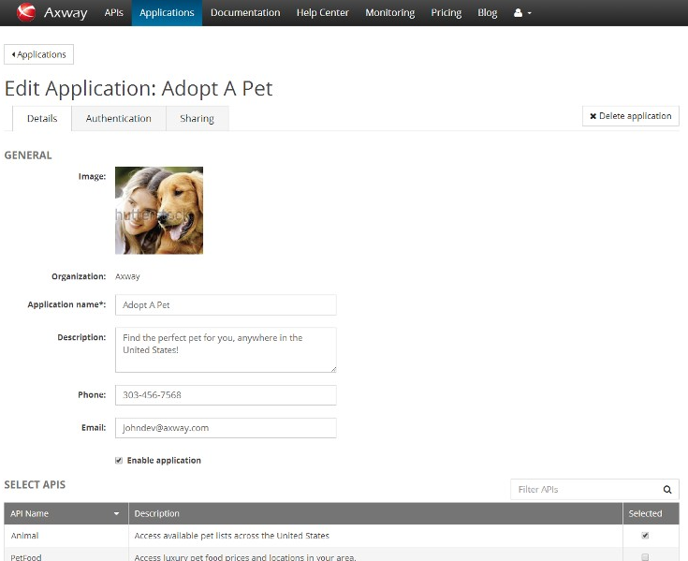

*Edit application: Details tab*

The *Delete Application* button is used to delete the current application.

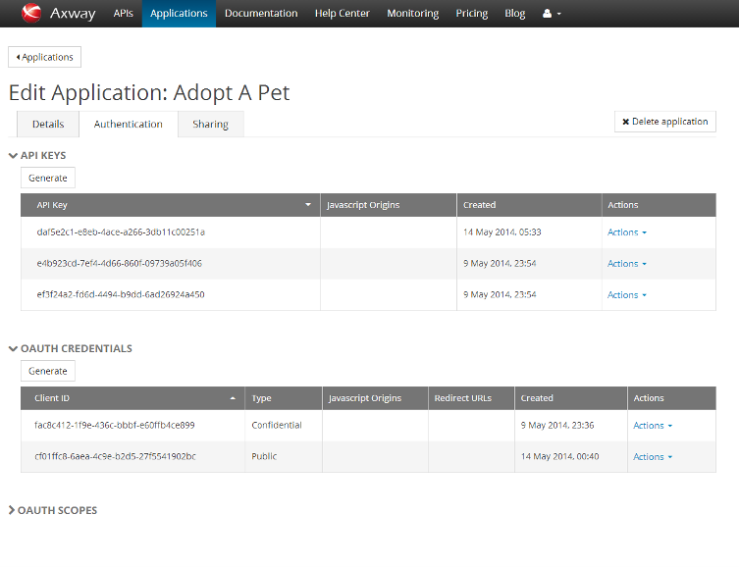

*Edit Application: Authentication tab*

A *Generate* link and *Actions* drop down boxes are operational links to operate information necessary to manage and test APIs: API Keys, client credentials. API keys and client IDs are generated with default JavaScript Origins value set to * (any).

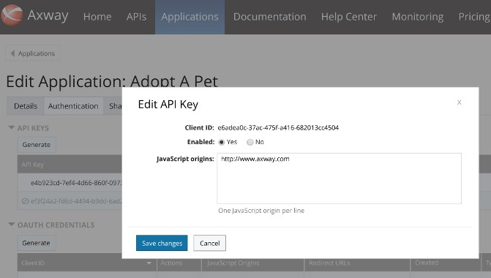

*Example action*

## API Catalog

The APIs page allows viewing API catalog list with filtering by API tags and sorting by API name.

Click on the API name or the *Test* link to view API details and test the API.

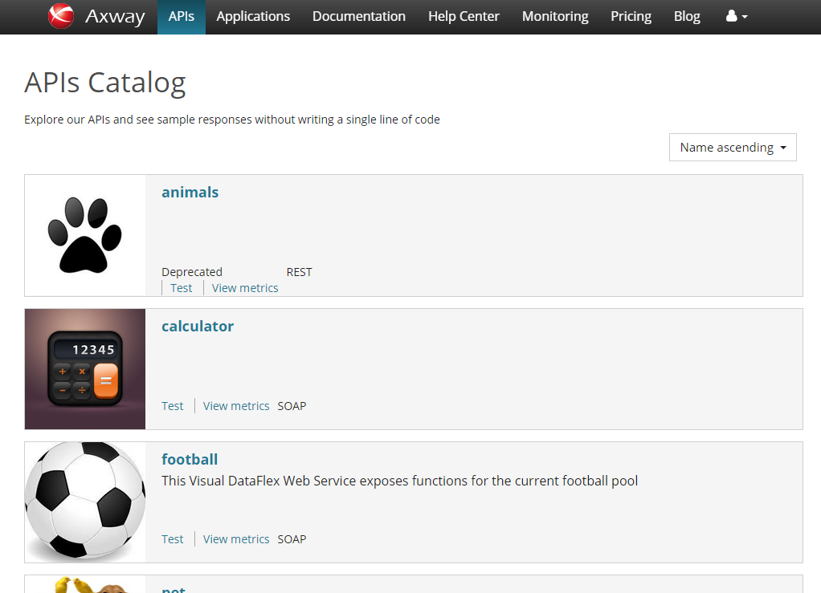

*API Catalog list   
with filtering by tag and sorting by name options*

The test API page bellow allows viewing API metadata like name, version, base path, API methods and their details:

* request parameters,
* response format,
* authentication details,
* quota,
* model schema link.

Clicking any method header row (as well as List/Expand Methods) toggles that method between collapsed and expanded.

*View metrics* link displays metrics information for the current API (See more in Monitoring section).

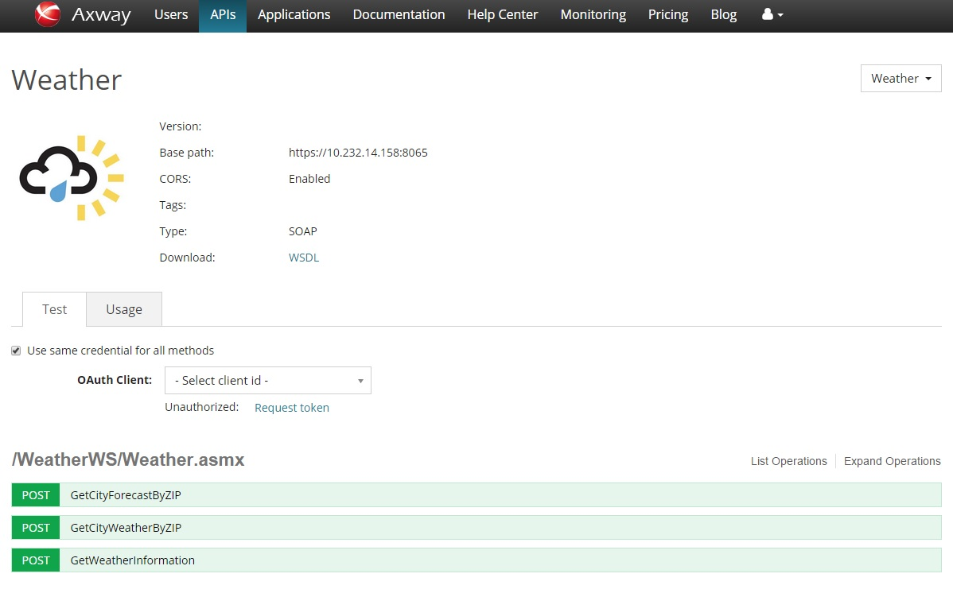

*Test* *API page*

When some or all of the following authorization methods are configured on the API Server they will be available on this API test page: API Key authorization, OAuth or Basic Authentication. To use a common authorization method for all methods, check ‘Use same credential for all methods’.

If not checked, the methods are available in each method.

Click a method name to expand and test it.

If OAuth option is selected when trying the API the web server redirects the user to the API Gateway acting as an authorization server to authenticate and authorize the server to access data on their behalf.   
After the user approves access, the web server receives a callback with an access token in the fragment of the redirect URL.   
After the token is granted, the application can access the protected data with the access token.

For additional information about OAuth (OAuth 2.0) delegated access configuration and usage see also *AxwayAPIGateway_7.4.0_OAuth_Guide.pdf.*

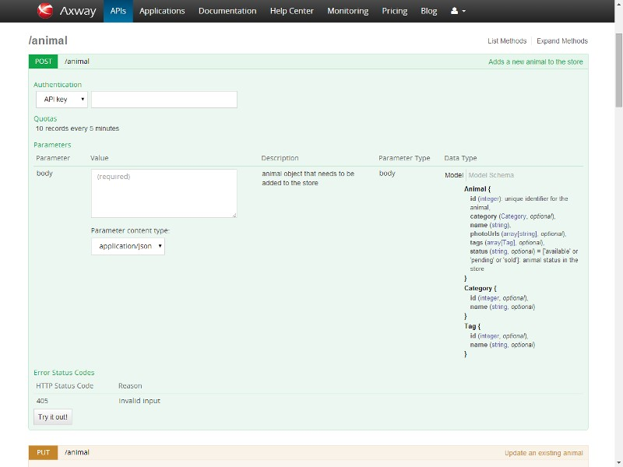

Select authentication type, enter appropriate value and appropriate parameter values and click “*Try it out!”.*

Formatted result set is returned.

In case of error, error status code and error reason details are returned.

## Monitoring

### Application Usage tab

The Monitoring page *Application Usage* tab presents summarized application usage information for a selected time range for all the applications.

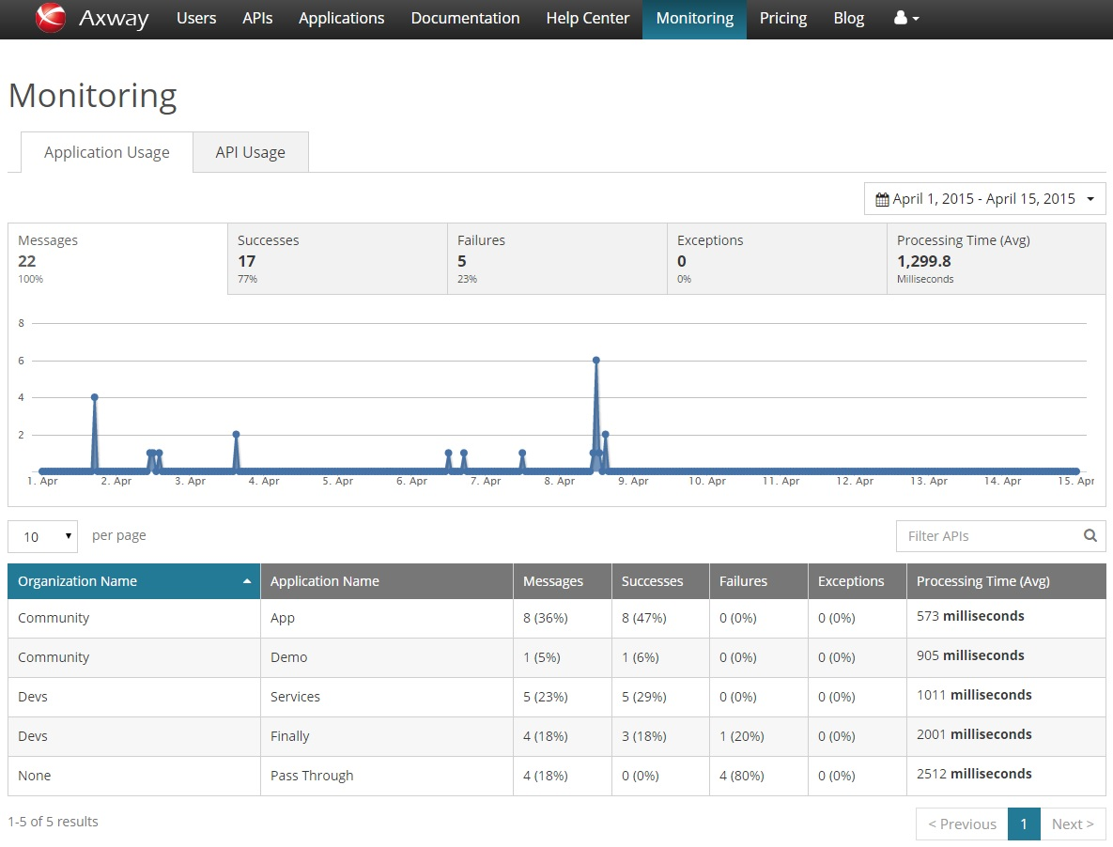

If an application is selected in the table below the chart, the chart will display application usage information for this application only.

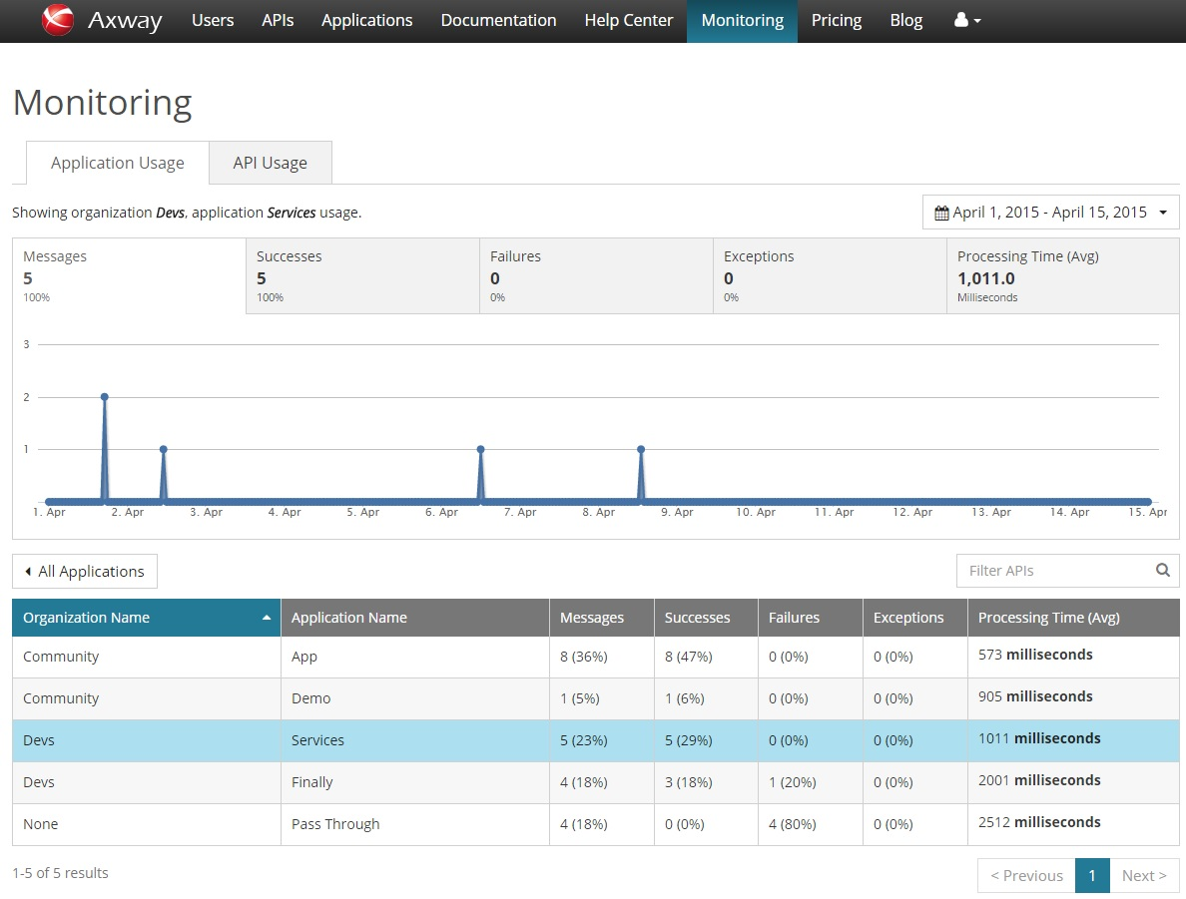

Time period drop down menu allows time period can be edited to view usage details for a different time period.

### API Usage tab

The API Usage tab shows information on API list and selected API usage metrics.

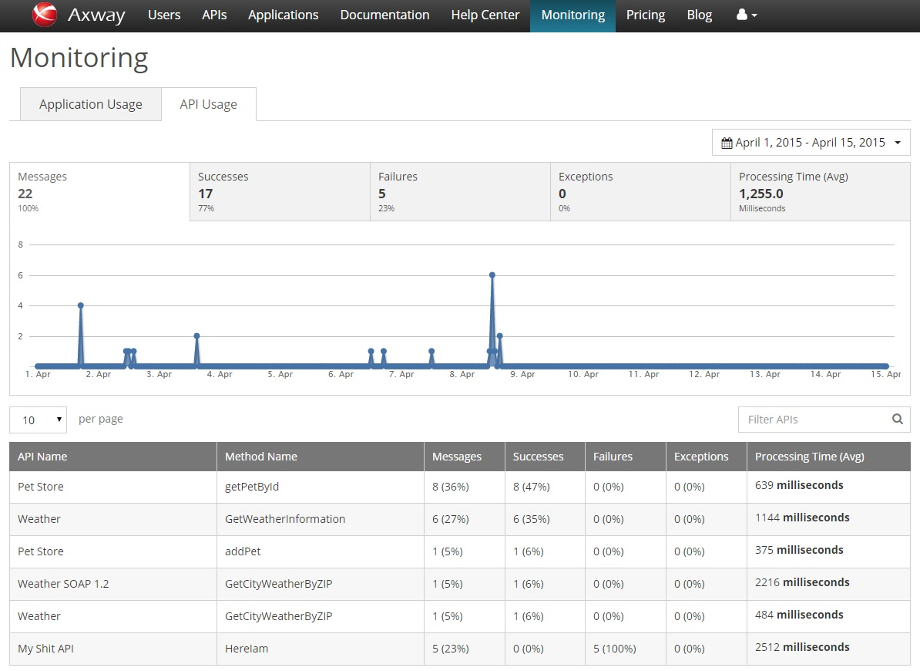

*‘All APIs’ usage. The table contains all APIs list.*

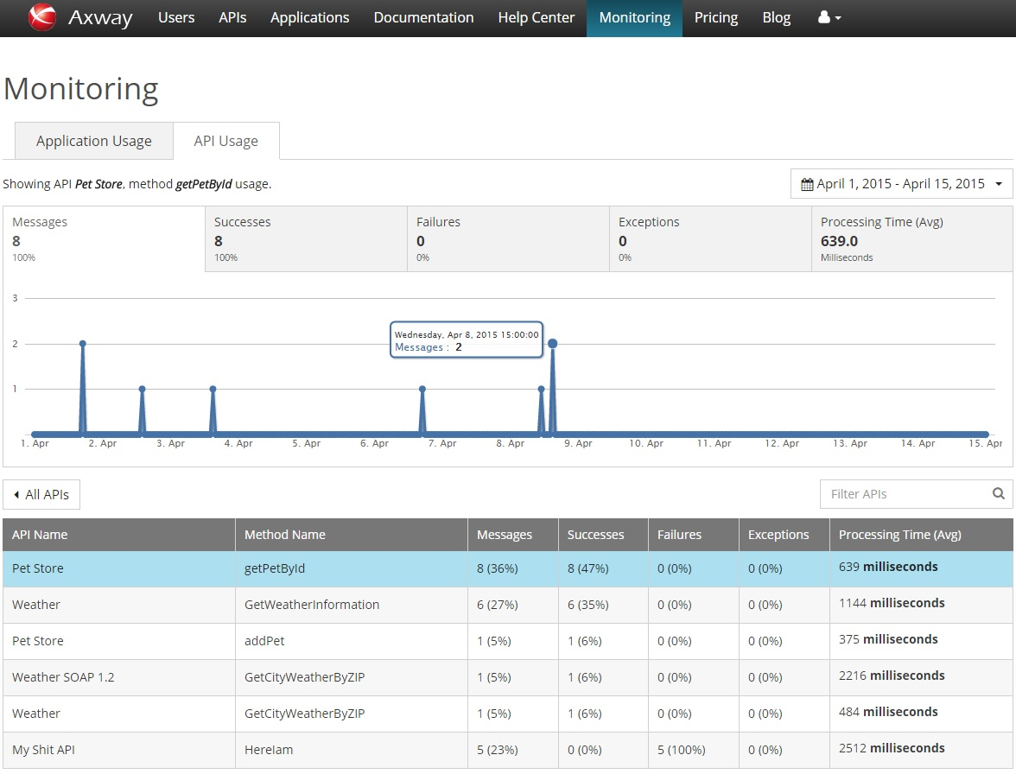

*Selected API usage information.*

Usebutton to return to all APIs metrics list.

Time period drop down menu allows time period can be edited to view usage details for a different time period.

## Help Center

The Help Center page contains links to API portal sections that would contain information useful to developers. The Help Center and its sections can be customized to best meet the needs of the customer.

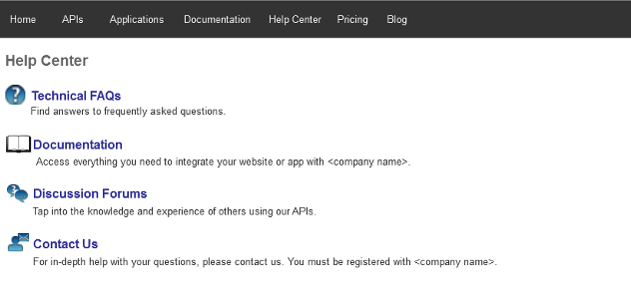

*Help center page*

# Troubleshooting

in this chapter

This chapter outlines the specific for the solution troubleshooting steps as well as some general troubleshooting approach recommendations.

## General Troubleshooting Steps

Should you encounter any problem with this solution please follow these steps:

Check if the observed issue is listed under the “known issues” section in the Release Notes document shipped with the installed package.

Restart the failing server(s) or client(s)

Collect the log files, screenshots or any other data related to the issue and approach Axway Global Support or your Axway Services contact.

Apache *error_log* file is located at /var/log/apache2/. Also you can turn on Joomla error reporting from Joomla admin UI System -> Global Configuration -> Server (tab) and set Error Reporting to desire level, BUT be careful because this may lead to throwing warnings and errors in API Portal pages. Do this only in critical situations and not in production!

## API Response Class Details Missing

Response class details missing, array[null] value displayed instead of details:

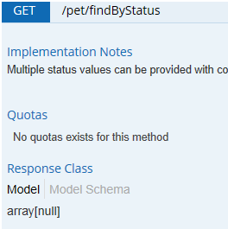

Expected (example):

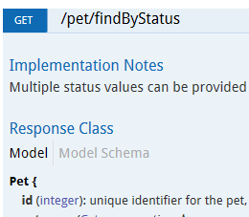

Go to *API Registration* in the API server manager UI. Unpublish the API. Go to *Editing API*, select the *Methods* tab and select API (Response type field) for the method. Publish the API

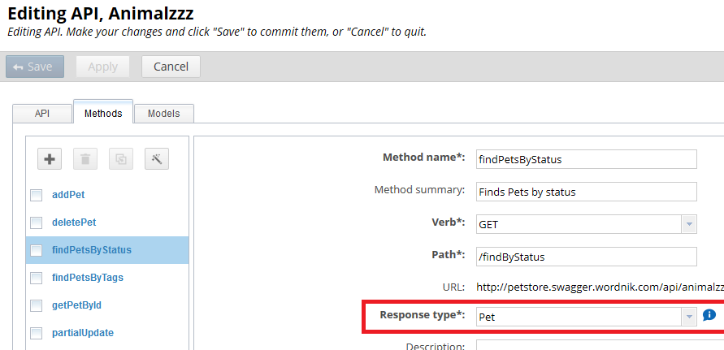

## Product Limitations

### Known Limitations in Monitoring Area

There is delay of about 5 minutes between actual API call and it's representation in the monitoring dashboard. It is a core product behavior.

# Support

in this chapter

This chapter contains references to the support and consulting sources available for the solution.

## Axway Global Support

The Axway Global Support team provides worldwide hotline support 24/7. You can find all hotline numbers on the Support website: [www.support.axway.com](http://www.support.axway.com/)

In addition, you can use the Axway Support website to download the latest information relating to the Axway products including:

Technical articles

Information about platforms

Service Packs and Patches

FAQs

## Training and Consulting Services

For more information about Axway/Tumbleweed training and consulting services, visit the Axway website: [www.axway.com](http://www.axway.com)

# Addendum API Portal Forum and Blog

The installation contains the forum and blog tools ***EasyDiscuss*** and ***EasyBlog***. The tools are managed through the plugin manager in the API Portal administrator site.

For more information consult:

* <http://demo.stackideas.com/easydiscuss> for Forum
* <http://demo.stackideas.com/easyblog> for Blog

The menu items for are *Help Center* > *Discussion*s and *Blog* in the API Portal top horizontal end user UI area.

Here are the additional configuration settings pre-set to better integrate these plugins with the API Portal end-user UI. Options which differ from the defaults are listed.

1. **Forum**

**Forum configuration**

**Settings** > **General>** Workflow:Who's Viewing: Enable who's viewing section - *No*

**Settings** > **General>** Location: General**:** Use static maps - *No*

**Settings** > **General>** Location:Discussions:Enable location tagging for discussions - *No*

**Settings** > **General>** Location: Replies: Enable location tagging for replies - *No*

**Settings** > **General>** Voting**:** Allow self votings - *No*

**Settings > Tabs >** Polls**:** Allow multiple votes - *No*

**Settings > Tabs >** Site Details : Access:*Manager, Administrator*

**Settings > Antispam:** Enable Recaptcha – *Yes*

**Settings > Layout**:General: Theme: Default theme - *flatt*

**Settings > Layout**:Toolbar**:** SearchBar**:**Category filter toolbar - *Yes*

**Settings > Layout**:Avatars**:** Integrations: Use profile linking - *Yes*

**Settings > Layout**: Avatars: Integrations:Profile picture integrations - *EasyBlog*

**Settings > Layout**: Categories:Category**:** Order category by **-** *Latest*

**Settings > Layout**: Categories:Category**:** Toggle categories - *Yes*

**Settings > Layout**: Profile: Edit Profile: Account -*No*

**Settings > Layout**: Profile: Edit Profile: Location -Yes

**Settings > Layout**: Profile: Edit Profile: Site details > *Access: Manager, Administrator*

**Settings > Notifications:** Email Configurations: Sender email – appropriate API Portal sender email

**Settings > Notifications:** Email Configurations: Sender's name - API Portal

**Settings > Notifications**: Email templates: Email Title - *appropriate email title*

**Settings > Notifications: Toolbar:** Show members – *No*

**Settings > Notifications: Show login toolbar -** No

**Settings > Social integrations -** *No* (for all items’ options)

**Categories -** Add ‘Animals’ category

**Badges -** Unpublish ‘Love Fool’ badge

**Post Types -** Add ‘*Question’*, ‘*Idea’*. Change ‘*Issue’* to ‘*Problem’*. Unpublish *‘Task’*.

**Points -** Unpublish *‘Unlike a discussion’, ‘Unlike a reply’, ‘Unvote an answer’, ‘Unvote a question’, ‘Unvote a reply’*

**Ranks -** Change default item names to ‘New member’, ‘Junior’, ‘Senior’, ‘Expert’

1. **Blog**

**Blog configuration**

**Settings > Workflow: General tab:** Blog description -*Up-to-date information on the latest advances across various industries and technologies, as well as new and updated Axway products - TBD*

**Settings > Workflow: Subscriptions tab:** Allow registrations during subscription - *Yes*

**Settings** > **Workflow**: **Locations** **tab**: Enable location services - *No*

**Settings** > **Workflow**: **Locations** **tab**: Show map on blog front page -*No*

**Settings** > **Workflow**: **Locations** **tab**: Show map on entry page - *No*

**Settings** > **Workflow**: **Ratings tab:** Display users who rated - *No*

**Settings** > **Media: General:** Resize original image - *Yes*

**Settings** > **Media: Media manager:** Enable lightbox by default - *Yes*

**Settings** > **SEO: General:** Enable unicode aliases - *Yes*

**Settings** > **Comments:** General tab**:** Allow non-members to comment - *No*

**Settings** > **Comments:** General tab**:** Require comment title - *Yes*

**Settings** > **Comments:** General tab**:** Show title field - *Yes*

**Settings** > **Comments:** Antispam tab:Enable or disable Recaptcha integrations - *Yes*

**Settings** > **Layout:** General tab:Display: Display comment in blog listings - *Yes*

**Settings** > **Layout**: General tab:Display: Number of comment display - *10*

**Settings** > **Layout:** General tab:Frontpage Blog Truncation:Show read more only when necessary - *Yes*

**Settings** > **Layout:** General tab:Featured Items:Show on all pages - No

**Settings** > **Layout:** Toolbar tab:Features: Show sign out link - *No*

**Settings** > **Layout:** Toolbar tab:Features : Show login - *No*

**Settings** > **Layout:** Dashboard tab:Show trackbacks - *No*

**Settings** > **Layout:** Dashboard tab:Enable WYSIWYG editor for biography – *Yes*

**Settings** > **Notifications:** Email templates tab - *Enter appropriate email address, enter Sender name and Email heading ‘API Portal’*

**Settings** > **Social integrations:** Twitter tab: Enable microbloggin - *No*

**Settings** > **Social integrations:** Facebook tab: General: Enable FB likes on front page - *Yes*

**Settings** > **Social integrations:** Facebook tab:Button style:Facebook like layout - *Small*

**Settings** > **Social integrations:**  Google tab: Show buttons on front page - *Yes*

**Settings** > **Social integrations:** LinkedIn tab: Show buttons on front page - *Yes*

**Settings** > **Social integrations:** LinkedIn tab : Button style:*Small*

**Settings** > **Social integrations:** StumbleUpon tab: Button style:*Small*

**Settings** > **Social integrations:** Pinterest tab: Enable Pinterest button - *No*

**Settings** > **Social integrations:** Pinterest tab: Button style - *Small*

# Addendum Theming and Custom Styles

API Portal extends the ***ThemeMagic*** feature of the ***Purity III*** template based on the ***T3*** template framework. ThemeMagic provides an administrative GUI for creating themes and modifying theming variables, such as colors and fonts. A live preview shows how the theme configuration affects the site, prior to saving the changes.

1. **Customization with ThemeMagic**

To access ThemeMagic from the Joomla administrator UI, go to *Extensions* > *Template Manager* > *Styles* > *purity_III - Default* and press the “ThemeMagic” button.

**Note:** API Portal includes one theme named “axway.” Additional themes should be initially copied from the “axway” theme in order to work properly.

Theming variables are grouped into sections:

* The *Key Colors* section includes the base colors for all styles. The default key colors are sea blue and gray.
* The *Basic Colors* section further distinguishes colors by the major UI elements such as buttons and menus. The default values for the basic colors are based on the key colors, but can be overridden for control over the styles of individual UI elements.
* The *Global Fonts* and *Headings* sections provide control over the typefaces and sizes of the main text elements.
* The remaining sections allow fine-grained customization of the UI elements, if needed. Most of the variables in these sections are based on the basic color variables.

**Note:** Variable names begin with the “@” character, as per the [Less](http://lesscss.org/) language. The variables, as well as Less expressions and functions, can be used to set the value of any variable.

1. **Configuration Files**

API Portal includes files added to the Purity III template’s folders and files replacing those belonging to the Purity III template. All paths are relative to the purity_iii template folder.

**Files Added**

**less/custom-themed.less:** The main Less file that compiles all custom styles for API Portal.

**less/variables-themed.less:** Defines all customizable variables and their default values.

**less/custom-styles.less:** Defines all styles used by API Portal. Styles are based on the theme variables defined in *variables-themed.less* and possibly customized in the theme’s *variables-custom.less*.

**less/vars-a5.less:** Constants for the Axway5 style after which the default API Portal style is based.

**less/themes/axway/template.less:** Styles for the theme. Imports *custom-styles.less*.

**less/themes/axway/variables.less:** Theme values customized via a file editor. Imports *variables-themed.less*.

**less/themes/axway/variables-custom.less:** Theme values customized via the ThemeMagic GUI. Do not edit this file manually.

**Purity III Files Replaced**

**thememagic.xml:** Configuration for the ThemeMagic GUI.

**language/en-GB/en-GB.tpl_purity_iii.ini:** Language strings displayed in the ThemeMagic GUI. In order to be utilized by ThemeMagic, this file must be copied to Joomla’s main language folder, *language/en-GB/en-GB.tpl_purity_iii.ini*. The copy is done when the API Portal plugin is installed.

**less/variables.less:** Global variables for the Purity III template. Default values for theming variables must be defined in this file, therefore the contents of *variables-themed.less* should be included at the bottom of this file.

**Notes about Updating Purity III, T3, or API Portal**

The Purity III files replaced by the API Portal plugin should be backed up prior to updating the template or framework, then restored or merged afterwards.

If the “axway” theme or any file mentioned above has been customized, backups should be made prior to updating the API Portal plugin to avoid losing those customizations. Merging may be required after the update.

**Adding a Custom Stylesheet**

Additional styles that rely on the customizable variables can be added to *custom-styles.less*. A safer way that avoids being overwritten during plugin updates is to create a new less file and import it from *custom-themed.less*.

When styles are modified, the .less files should be compiled to CSS using the “</> LESS to CSS” button on the *Purity III – Default* configuration screen.

T3 provides a simple way to add a custom stylesheet. It will always attempt to load a CSS file called *custom.css* (usually located in Purity’s *css* folder).

**Note:** If Less functionality is needed in the custom stylesheet, create *less/custom.less* which will then compile to *custom.css*. This technique has a limitation in that styles defined in *custom.less* are independent of the template’s stylesheet and do not render with updated variable values in ThemeMagic’s preview.