**AMAZON LEX:**

Amazon Lex is a fully managed artificial intelligence (AI) service with advanced natural language models to design, build, test, and deploy conversational interfaces in applications.

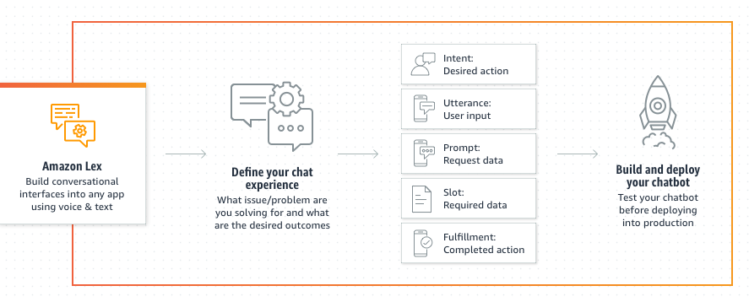

**TERMS IN AMAZON LEX:**

1. Intent: Think of intents as the “purpose” of what the user wants to do or achieve with the chatbot. For example, “OrderPizza” is an intent where the user wants to order a pizza.

2. Utterance: Utterances are the “sentences” or phrases that users say or type to interact with the chatbot. These are the input messages the chatbot receives, like “I want a large pepperoni pizza.”

3. Prompt: A prompt is the “response” or question the chatbot asks the user to collect specific information. For instance, when ordering a pizza, the chatbot might ask, “What size pizza would you like?”

4. Slot: A slot is like a “variable” that holds specific pieces of information the chatbot needs to fulfill the user’s request. In a pizza order, slots could be “PizzaSize” or “Toppings.”

5. Fulfillment: Fulfillment is the “action” the chatbot takes to satisfy the user’s request. It can involve processing the user’s input and providing a response or performing a specific task, like placing the pizza order.

**STEP 1:CREATE A CHATBOT**

1. From the AWS console navigate to Amazon Lex.
2. Click on create Chatbot and give the appropriate name and description to it.
3. Select the Create a role with basic Amazon Lex permissions and COPPA as No.
4. Leave the rest as default and click Next.
5. Choose the suitable language and voice according to your needs and click done.
6. We created the basic chatbot and now we will add intents to it.

**STEP 2: ADDING INTENTS**

1. Navigate to intents and ‘Add intent’.
2. Give the appropriate intent name and description.
3. Sample utterances are what user will say as a greeting,so add some sample utterances that you can think of,for eg:

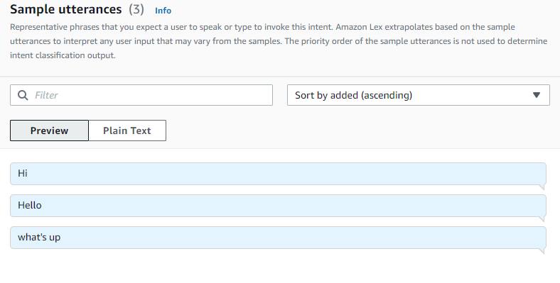

4. Closing response is what the bot will reply to the utterances.You can also add variations in it for different type of responses:

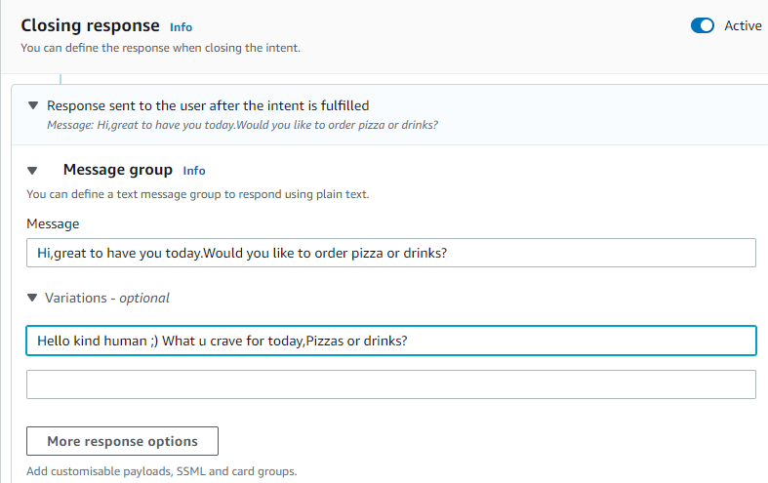

5. Save and build the intent.You are ready to test the intent now.

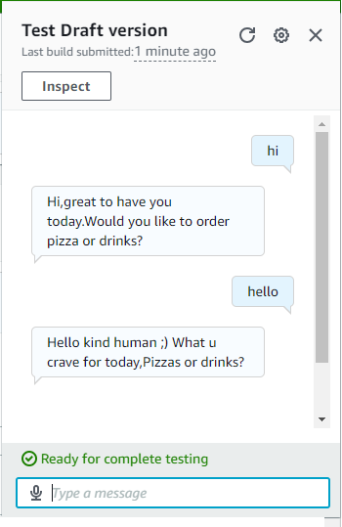

Similarly we can go on adding intents according to our preferences.

6. Lets add an intent for pizza ordering:

7. Create a new intent with suitable name and description.

8. Add the utterances according to your needs.For example:

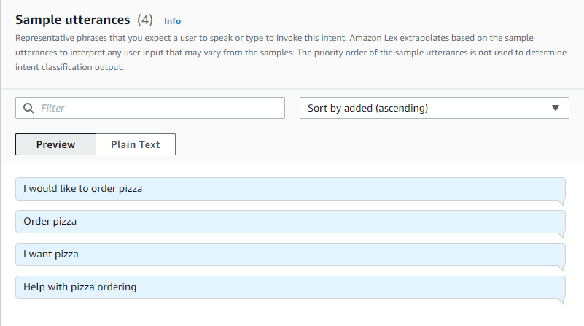

9. Add an initial response as what you want the bot to reply with.

10. Save this for now and navigate to slot types.We will need to add slots for the user to choose and hence create appropriate slot types for it.

11. Add a slot type with slot type values for pizza size: Small,medium and large or according to what you want.

12. Similarly create one for toppings.

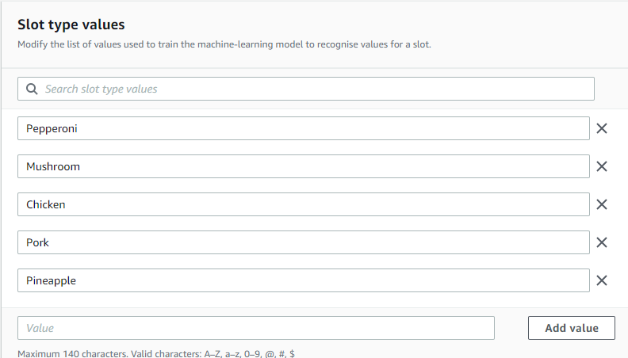

*#Never choose Pineapple as a topping (0~0)*

13.Navigate back to the intent and add the slots with the prompts.

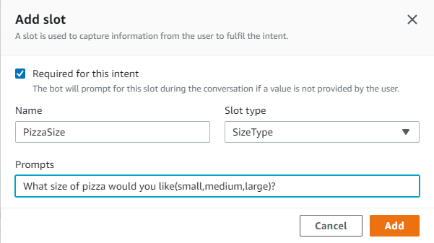

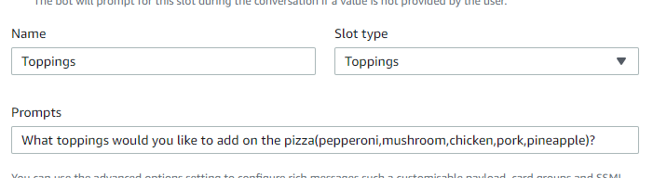

14. Add a confirmation prompt to make sure the user ordered accordingly and a decline response if the user disagrees.

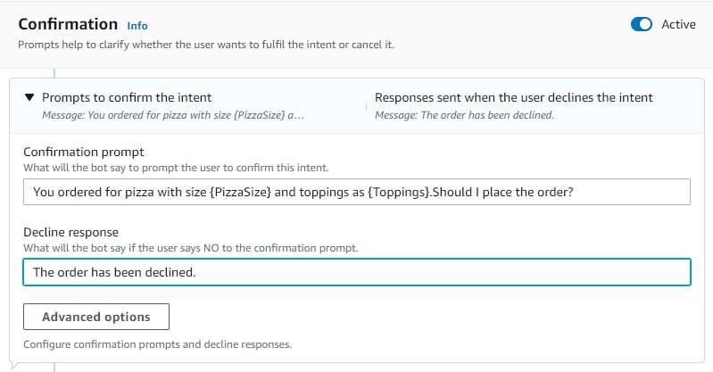

15. Add the Fulfillment so the user can order any else they want.

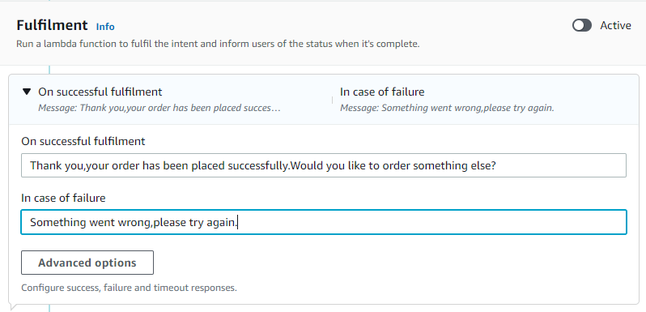

16. Save and build the intent and with this we are done.

We can go on adding intents and customizing the bot as much as we want.The similar steps can be followed to create an intent asking for drinks alongside pizzas.

Here is a sample conversation :

