Sequence-Based Prediction of Functional Impact of Missense TP53 Mutations
A PROJECT REPORT
Submitted by

Aditya Kundu BL.SC.U4AIE24004
Mani Chinniah BL.SC.U4AIE24025
Nachiket P Saonerkar BL.SC.U4AIE24028

for the course
22BIO211 – Intelligence of Biological System 2

Guided and Evaluated by
Dr. Vasavi CS,

Dept. of AI,

AMRITA SCHOOL OF COMPUTING, BANGALORE
AMRITA VISHWA VIDHYAPEETHAM
BANGALORE-560 035
January 2026
Sequence-Based Curation and Validation of TP53 Missense Mutations with Cross-Species Comparative Analysis

Abstract —

This study presents a computational framework for the systematic curation, validation, and comparative analysis of TP53 protein sequences. A biologically curated dataset of human missense mutations was generated using the NCBI reference wild-type p53 sequence (NP_000537.3). Each mutation was rigorously validated using global sequence alignment to ensure single-site substitution without insertions or deletions.
Additionally, cross-species TP53 protein sequences were retrieved from UniProt to study evolutionary conservation. Redundancy removal was performed using cosine similarity over k-mer encoded sequences to eliminate highly similar cross-species entries.
Global alignment analysis was conducted to compute alignment scores and percent identity relative to human wild-type p53. The final dataset integrates validated human missense mutations and non-redundant cross-species sequences, forming a biologically consistent dataset for downstream computational modeling and evolutionary analysis.

I. Introduction

The TP53 gene encodes the p53 tumor suppressor protein, often referred to as the “guardian of the genome.” The p53 protein regulates DNA repair, apoptosis, and cell cycle arrest. Missense mutations in TP53 are among the most frequent alterations observed in human cancers.to predict the functional consequences of missense TP53 mutations
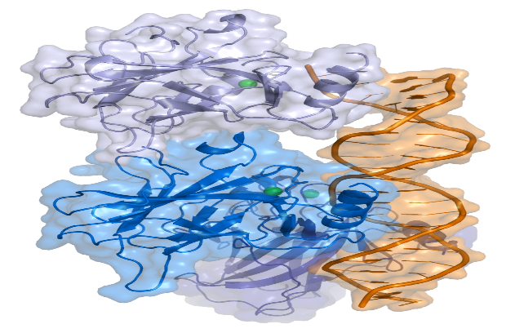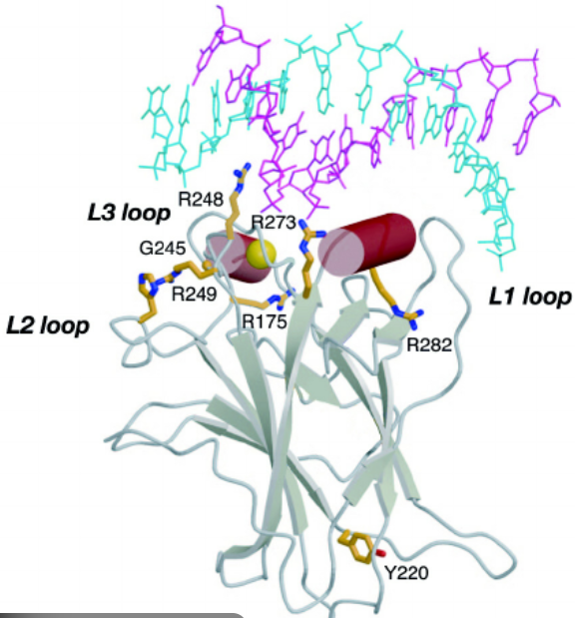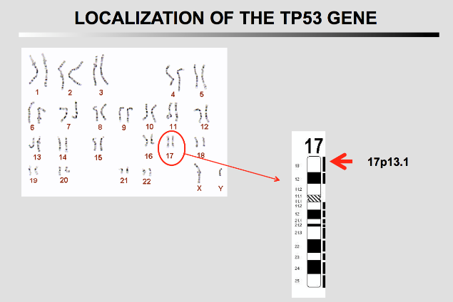

The human wild-type p53 protein:
- Length: 393 amino acids
- Reference accession: NP_000537.3
- Major mutation hotspots: R175, G245, R248, R249, R273, R282
Because experimental validation of each mutation is costly, computational validation and sequence-level verification are essential before downstream modeling.
This project focuses on:
- Generating a curated human missense mutation dataset
- Performing strict global alignment validation
- Collecting cross-species TP53 sequences
- Removing redundancy using cosine similarity
- Integrating datasets for comparative analysis

II. Dataset Acquisition and Curation

A. Human TP53 Missense Mutation Dataset

The wild-type human p53 sequence (NP_000537.3) was used as the template.
A curated list of biologically relevant missense mutations was constructed, including:
- Cancer hotspot mutations
- DNA-binding domain mutations (102–292)
- Tetramerization domain mutations
- Neutral mutations in flexible regions
Each mutation followed the format:
WT_AA + Position + Mutant_AA
Example: R175H
Each mutation was applied to the wild-type sequence to generate a full-length mutated sequence (393 aa).

B. Cross-Species TP53 Dataset Collection

Cross-species TP53 protein sequences were retrieved from UniProt using the REST API.
Filtering criteria:
- Gene name: TP53
- Format: FASTA
- Sequence length between 350–450 amino acids
- Duplicate sequence removal
A total of 280 cross-species TP53 protein sequences were collected.

C. Inclusion and Exclusion Criteria

Inclusion Criteria
- Missense (single amino acid substitution)
- Full-length sequence (393 aa for human)
- Valid biological residue match
- No insertions or deletions
Exclusion Criteria
- Frameshift mutations
- Nonsense mutations
- Indels
- Length mismatch sequences
- Alignment gaps

III. Sequence Validation Using Global Alignment

Global alignment was performed using Biopython’s PairwiseAligner implementation of the Needleman–Wunsch algorithm.
Parameters:
- Mode: Global alignment
- Substitution matrix: BLOSUM62
- Gap opening penalty: -10
- Gap extension penalty: -0.5
Validation criteria for human mutations:
- Length = 393 amino acids
- No alignment gaps
- Exactly one mismatch
- Wild-type residue must match mutation specification
All valid sequences satisfied:
- Hamming distance = 1
- No insertions/deletions
- Full-length integrity preserved
For cross-species sequences:
- Alignment score computed
- Percent identity relative to human WT calculated
This ensures biological correctness before dataset integration.

IV. Redundancy Removal

Redundancy removal was applied only to cross-species sequences.
Method:
- Convert sequences into 3-mer representations
- Encode using CountVectorizer
- Compute cosine similarity matrix
- Remove sequences with similarity ≥ 0.90
This prevents:
- Overrepresentation of closely related species
- Phylogenetic bias
- Artificial inflation of dataset size
Human mutation dataset was already non-redundant due to strict mutation-based uniqueness checks.

V. Final Combined Dataset

The final dataset consists of:
- Human missense mutation sequences
- Non-redundant cross-species TP53 sequences
Each entry includes:
- Sequence ID
- Mutation (for human entries)
- Amino acid sequence
- Label (0 = non-damaging, 1 = damaging)
- Sequence type (Human_Mutation / Cross_Species)
This dataset enables:
- Evolutionary conservation studies
- Mutation impact modeling
- Sequence similarity analysis
- Downstream machine learning applications

VI. Flow Diagram

The flow diagram represents the overall processing pipeline followed in the proposed system.

TP53 Reference Sequence
↓
Curated Missense Mutation List
↓
Mutation Application
↓
Global Alignment Validation
↓
Sanity Checks
↓
Cross-Species Sequence Retrieval (UniProt)
↓
Length Filtering
↓
Cosine Similarity-Based Redundancy Removal
↓
Dataset Integration
↓
Global Alignment Scoring
↓
Final Dataset Generation

VII Sanity Validation

Sanity checks performed:
- Wild-type sequence length = 393
- All mutated sequences = 393
- Exactly one mismatch per mutation
- No duplicate sequences
- Mutation format validation (regex check)
- Binary label validation (0 or 1)
All validation checks passed successfully.

IV. Conclusion

This study presents a biologically rigorous computational framework for TP53 dataset curation and validation. Human missense mutations were systematically generated and validated using global alignment to ensure structural integrity and single-site substitution accuracy.
Cross-species TP53 sequences were retrieved from UniProt and subjected to cosine similarity-based redundancy removal to eliminate highly similar entries. The final integrated dataset preserves biological correctness, eliminates redundancy, and maintains evolutionary diversity.
The resulting dataset forms a robust foundation for downstream computational modeling, evolutionary conservation analysis, and functional impact prediction studies.

