**Assignment M3, Health and Fitness Dashboard**

Manick Mahalingam (mmahalingam6@gatech.edu)

**Abstract**

Introducing a health/fitness/nutrition dashboard interface for Apple’s health monitoring and fitness application to track various human health focused activities including workouts, outdoors, sleep, eating, sitting, breathing and vitals including glucose, blood pressure, BMI, ECG, pulse rate, heart rate, respiration, mindfulness, and mental health. Enhanced Dashboard will help to view customized feed on a different spectrum of users in one touch based on factors, including age, fitness levels, medical conditions, help users to feel comfortable, confident and motivating to focus on their health and fitness, an ease-of-use interface, guided tutorials, additional health resources, customized nutrition plan.

**Brainstorming Plan**

The objective of this brainstorming plan is how to design the widgets that can be shown in the dashboard. The Enhanced dashboard will have three widgets which are health, fitness and nutrition customized for a different spectrum of users. A handful of ideas that was laid out based on the two hours of brainstorming. The dashboard can be purposeful on different demographics to view the user’s health and fitness metrics, log nutrition or metrics. It can be used with voice recognition, smart watches and phones, smart watches can be used to track sensory perception for health and fitness. The medical history of users can also be integrated so users get meaningful suggestion. Based on these objectives, User profiles should be the brainstorming plan that would best fit the use case. User profiles would help in defining ideas on health, fitness, and nutrition for a different spectrum of users, Timelines would help to decide on how fitness can be tracked. As mentioned by Osburne in 1957 and by Oxley, Dzindolet, Paulus in 1996, some of the rules followed in brainstorming are Expressiveness on different ideas, Quantitative effort on a handful of ideas, stay focused on the use case of designing widgets, non-evaluating all the ideas, but building only a few core ideas. These rules should help build an interface that has less cognitive load, narrowed the gulf and becomes invisible by design as day pass by.

**Brainstorming Execution**

Based on the brainstorming plan, user profiles would be used to define the design alternatives. Enhanced Dashboard focuses on having customized widgets for a different spectrum of users. Health, Fitness and Nutrition widgets can be used by users at different demographics, different context, having various goals/tasks on the interfaces. Sub-tasks would include adding data points for various metrics and that would reflect on the dashboard. Voice recognition while doing exercises or working on logging food, health, or fitness metrics.

***User Profiles***

The different user profiles that are intended to use the dashboard are fitness enthusiast, athletes, people at various professions like construction, hospital, banks, engineers, manufacturing, automobiles, farming, etc. who care about their fitness and healthy lifestyle and like to track them in an application.

Basic vitals like blood-pressure, heart-rate, oxygen level, glucose for health metrics, burnt calories, steps walked, sleep hours, exercise for fitness metrics, and calories consumed, protein, carbohydrates, fats, water intake for nutrition metrics can be tracked and viewed in three different widgets in the dashboard by default. These metrics are common across user profiles. Additional metrics on each widget could vary and be customized based on user needs.

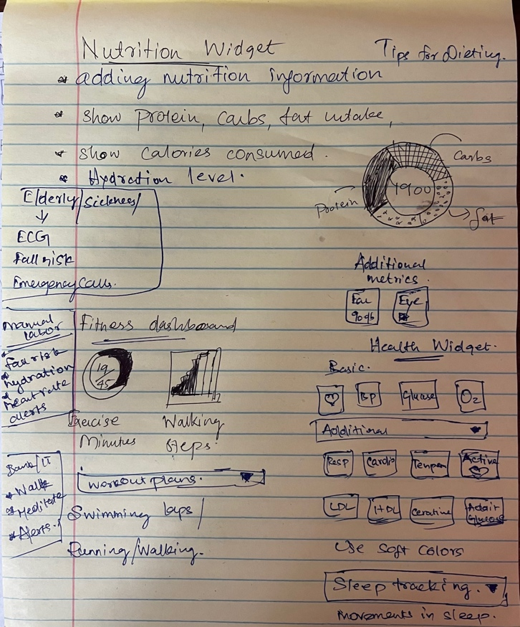

***Figue 1 --*** Picture showingBrainstorming Ideas.

Fitness enthusiast might be experts in using the dashboard as they focus on fitness and nutrition tracking more frequently than most other users. The wearables can help track the fitness regimes on workouts, running, swimming, cycling, etc, and at the same time log nutrition on foods they take throughout the day.

The same kind of tasks or goals can be done by different user profiles too. For example, a banker can be a fitness enthusiast and uses the application for monitoring, at the same time there could be another banker who focuses only on nutrition and health but less physical active. For those kinds of users, more customizations can be done with respect to nutrition and health.

For users with disabilities or sickness or elderly, monitoring on their vitals like blood pressure, glucose and heart rate and additional health metrics like respiratory rate, temperature, eye-health, ear-health is more important than others, so focusing on health widget would be more ideal. Additionally, fall risk, ECG, pulse rate, oxygen rate monitoring might be needed. These users typically not an expert in using the application, so more tutorials and tips might be needed.

Users’ profession that are physical intense, prone to fall risk and they could be moving more frequently, monitoring on their diet and hydration levels are essential, so adding alert for those users. Working Professionals who sit at a desk for a long time should be alerted on walking at least once an hour, do eye exercises, exercises on mindfulness and mental health because they get exhausted due to too much work at computers.

Gesture sensor-based tracking on running strides, exercise forms, swimming strides, Voice recognition on adding logs to health, fitness, and nutrition, and making emergency calls, Thirst sensors for maintain hydration level, Thermoception sensors to track body temperature are some of the additional features to be enabled for users of all dimensions. The wearables internal hardware can be enhanced to support these features.

Dashboard widgets can have additional features for newborns’ mother and mother-to-be to stay healthy. From previous evaluation of interfaces, application can help track nutrition, yoga, and meditation for a healthy pregnancy on diet plans, tracking food can be made easy with barcode scans, voice recognition or manually logging food.

**Selection Criteria**

Based on the brainstorming plan, the selected objectives would be to have three widgets, health, fitness, and nutrition for the dashboard. To design these widgets, prototyping would be needed. Based on needfinding execution’s data inventory on evaluation of existing interface, naturalistic observation and surveys, there are key requirements that were framed, design alternatives and brainstorming helped in deciding on certain prototypes that can be explored to be given as new features to the user.

Based on other environmental factors, and not to give too much cognitive load to users, pregnancy related metrics can be ignored for this iteration. Similarly, hardware needed for gesture-based sensing, thermception sensors, thirst sensors are not embedded into the wearables, it would be features for the future, so that can also be ignored.

The goals of the users are to stay healthy, and the tasks associated with those are tracking health, fitness, and nutrition metrics, interacting with the interface more frequently to get some useful insights, contribute to the interface by providing data points can help user get gulfs reduced and eventually a lesser cognitive load. Furthermore, these can be achieved through three *low fidelity prototypes,* including *paper, the wizard of oz and card-based prototype*. Paper based prototypes are already designed during the initial phases, the wizard of oz is for voice recognition during different context, since there would be various customization for users, card prototype would be more meaningful. When it comes to evaluation, these are more focused towards designing interface and carry functional meaning towards the design.

**Paper Prototype**

Paper prototyping helps in designing the interface with the necessary widgets that was laid out as part of the original requirement. This can be show to the user to evaluate on the customization they are looking for and can be changed easily before design the actual functional interface. There are three widgets used for health, fitness, and nutrition, some of the metrics are shown by default while some can be customized. Customization widgets can be shown in a different screen under card prototyping because that carries the screen and data inventory to different dimension.

Widgets on health shows default and highly used metrics like heart rate, respiratory rate, glucose is all shown with the option of editing to include or exclude additional health metrics. Fitness widgets would show essential fitness metrics like steps walked, exercise minutes, calories burnt, active energy and editing them would help add additional metrics like sleeping or track any sporting activity, workouts, and other outdoor activities. Eye health, Ear health, breathing exercises are some of the additional metrics that could be added for monitoring.

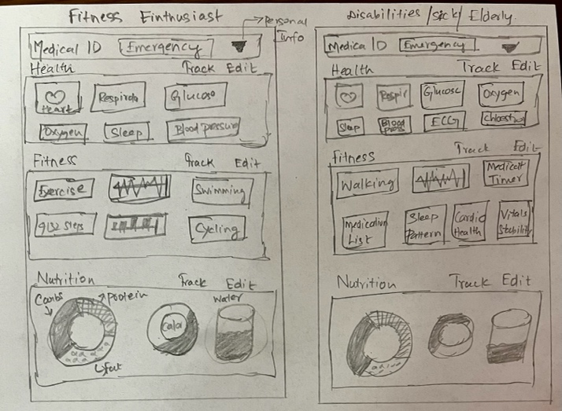

***Figue 2 --*** Paper prototype showing customized user dashboard.

Nutrition widget would show the calories consumed, protein, fat and carbohydrates content in a pie chart format and water intake by default. Additionally, food can be logged by scanning the food image with a camera or manual entry and diet history also can be viewed by clicking on Edit. Paper prototypes shows how the customization of the widget are done for each user profile; these can be present to the user to receive feedback which would help in designing the actual interface. Fitness enthusiast has more focus towards fitness parameters whereas sick or elderly has customized view for them to reduce their cognitive load and make use of the alerting system effectively.

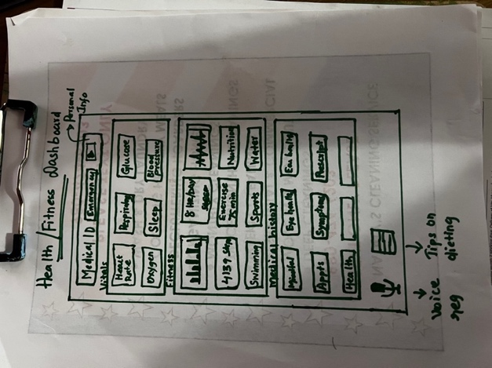

***Figue 3 --*** Paper prototype showing actual dashboard.

Sleep tracking is an additional tracking feature to keep track of sleeping motions, snoring patterns, deep sleep patterns, several hours slept and more. Good sleep is essential and track sleep would help user identify their concerns and fix them accordingly. Apple has a medical id for all their users, so that can be shown at the top along with emergency contact details.

**Wizard of Oz Prototype**

Wizard of Oz is a voice recognition prototype for Health, fitness, and a nutrition dashboard that provides various commands to interact with the interface. Siri can be integrated to the application to interact with the interface. Auditory perception helps in integrating all the commands required to talk to the interface. Some of the commands used during different contexts are listed below.

User prompts to add “32 oz of water to today’s hydration log”, this should add the metrics to hydration level and increase the water consumption for the day. Similarly, other voice commands could be “add 1000 calories for lunch”, “add carrot cake for snack”, “show dinner ketto diet food options”, “how many calories have I consumed today?”. This kind of voice integration can be done through Siri or wearables or headphones.

“Track current running to fitness log” should start tracking the current run to the fitness widgets, then announce the progress every 5 or 10 minutes, so the user won’t have to take the phone from the pocket frequently. Similarly, other voice commands for fitness tracking would be “track swimming exercise for next 30 minutes”, “track current workout”, “what is the number of steps I have walked today”, “how many hours of active energy”, “how many calories have I burnt today”. These voice commands are the tasks for the interfaces, some of them are stored as data points for the dashboard to update and some of them are announcing the outcomes of those stored data points apparently.

In health metrics, an user announces “what is my heart rate and oxygen level right now”, the device responds the numbers say 73 bpm and 97% saturation. This can be announced as a voice response or shown as notification in wearables and phone. Similarly, additional voice commands for health metrics are “add 140/80 to today’s blood pressure”, “add 100 to glucose level for today afternoon”, “how many hours of sleep I had yesterday”. These voice commands would help in tracking health metrics and parallelly when needed can be used to announce to the user.

Voice recognition can be highly effective for people with disabilities or sick or elderly people. They are highly vulnerable for fall risk; they would need emergency attention more than any other user profiles. For example, “Emergency call 911”, this command should immediately help the user to call first responders to attend users. Also, taking out the phone more often would be difficult for them, particularly for elderly, the cognitive load in understanding the interface is high, so it is better to deal most of the tracking with voice if possible.

The only caveat in this prototype is the kind of phrases or keywords to be used, so that the application interface identifies them in the back-end, annotates and performs the necessary execution. The phrases or keywords should be defined as requirement and users should be trained on those phrases to interact with the interface. The cognitive load on this exercise would be high and slowly transforms the interface to be invisible by design. The other limitation would be voice commands are limited to English and it could understand the most English speakers irrespective of the dialect, however, the interface cannot be used for voice commands if the user is not English speaking. User could be demographically located anywhere in the world.

**Card Prototype**

Like paper prototype, card prototype focuses on additional tasks that can be done through the interface. Paper prototype focuses on the home screen widget for health, fitness, and nutrition whereas card prototypes help in the subtasks of the interface in collecting data points through voice commands, manual entry, back-end integration with medical records and more.

As discussed in paper prototype, the core screen would show three widgets with high level information on each of the metrics which are mostly numbers. Card prototypes takes to the next level detailing where it helps to edit these widgets by adding or deleting metrics, logging food, health, or fitness metrics, viewing previous or current medical history, view medical history and additional metrics, achievements on workouts and more.

Attached are layouts on those cards for nutrition, fitness, medical history, customized view for a fitness enthusiast and an elderly user. Clicking on Edit from the home screen would take to a nutrition screen where calories can be logged, history of calories or nutrition records can be viewed and more. The fitness screen would show workout plans, swimming laps or charts, calories burnt and its history, sleep tracking as separate widget under it and more.

Medical history would help elderly people to keep track of all their medical conditions under one wing. Showing upcoming appointments, pharmacy details in a new screen along with eye-health, ear-health, alcohol usage, chronic or new symptoms recording and more.

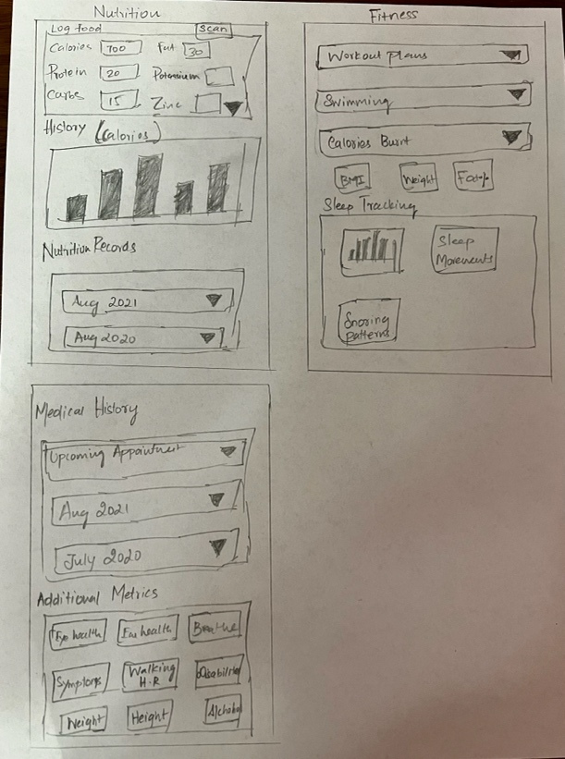

***Figue 4 --*** Card Prototype, showing additional screens from clicking on dashboard.

Additional cards can be shown to the user on customized view with different user profiles. However, these profiles can be modified using the Edit button whenever the user feels like to. Showing the card prototypes to the user would help them in cognitive learning upfront, understand the interface, makes gulf narrower even before the interface becomes functional.

As illustrated by the selection criteria, the core focus on this widget is to track health, fitness, and nutrition on a wide spectrum of users, but this is a short window to cover a long paradigm. So, some of the genuine use-cases like gesture sensor, women health had to be ruled out as it requires a more needfinding and brainstorming plan.

References

* <https://www.apple.com/ios/health/>
* <https://www.apple.com/apple-fitness-plus/>