**P1, Invisible Interfaces, Human Perception, Cognition**

Manick Mahalingam (mmahalingam6@gatech.edu)

**Question 1: Tasks during an hour**

During busy morning, everyone has a process in place in their subconscious for routines, for me, the day starts at 7 AM. I am choosing my first hour of the day (not brushing teeth) because it has 5 varied tasks with different interfaces, goals and tasks. Below are those 5 tasks,

|  |  |  |  |
| --- | --- | --- | --- |
| Task | Goal | Interface | Object |
| Checking Slack Messages | Work follow-up | Slack | Work Laptop |
| Week’s CS6750 tasks | Catching up Lessons | Canvas.gatech.edu | Personal Laptop |
| Brew Coffee | Drinking Coffee | Option buttons, pot, filter | Coffee maker |
| Blend Protein Shake | Drinking Protein | Blender blades, jar | Blender |
| Book Training Camp | Cross-fit training | Burn Boot Camp App | Cellphone |

**Task 1, Checking Slack Messages**

Checking Slack Messages is to follow-up on work and tasks from the previous day and plan my work for the day. Slack is an excellent application for work and a great example of Invisibility by design, where I can post private and group messages, create channels, make calls, @mentions, share screen in a huddle, pin or save attachments and messages. The cognitive effort on understanding the interface is about 20%, and that helps with a declarative learning on knowing the sub-tasks to reach goals, and interface became invisible in quick turn-around time. Direct Manipulation can be achieved on certain tasks through touchscreen like phone calls, checking messages and replying but sharing the screen, creating channels, new group messages could be not as directive as possible.

**Task 2, Week’s Lessons on Canvas**

As students, we are aware, Canvas is to focus on tasks for the week which includes watching Ed Lessons, reading Ed discussions, assignments, announcements, peer feedback, and reading books. Watching Ed Lessons is another great example of Invisibility by design. The task here is limited to watching lessons and understanding the topics for the week which would help in completing the assignment for the week(goal). These functionalities are performed in a laptop, due to the interface’s great design, navigation is quicker, and the gulfs are narrower. The cognitive load is mostly on understanding the lesson, so the interface becomes invisible quickly.

**Task 3, Brewing Coffee**

I have a coffee maker (*Appendix 5.1, Hamilton Beach Coffee maker)* with three buttons, the task here is to make coffee for the morning and goal is to boost my brain with caffeine. The coffee maker is a good example of Invisibility by learning, it is the process of a human’s ability on motor skills. Steps include visually measuring and pouring water, keep a filter in the tray with coffee grind (visually measure 3 spoons), the interface has 3 buttons, one button must be pressed thrice to make strong, then press a second button and coffee is ready. The cognitive effort is low as the process is stored in long term memory and becomes a muscle memory overtime to accomplish the task.

**Task 4, Book a training camp**

Everyday morning, I do a workout to stay fit, it is a cross-fit training where the trainer plans the day’s training (*Appendix 5.2, Burn Boot Camp Interface*) based on corporate protocol and the camp members follow it. Examples are metabolic conditioning, speed and agility, burst training. I have to book a camp based on its schedule, and my convenience, mine is at 8 am. The application does not have a great design as the gulf is wider because I had to navigate through many clicks to investigate protocol and book a camp. This is again a great example of invisibility by learning, procedural learning comes in to play on how to do something, directness is there in terms of booking it through touchscreen, but mostly there are flaws in the interface and had a learning curve initially.

**Question 2, Invisible by Learning, Mac OS**

Due to a recent job switch, I was forced to use MacOs which I have never used before. The operating systems are entirely different between Microsoft and Mac, though the alpha-numeric keys are similar between the OS, starting from basic tasks of copy paste, page up/down scrolling, copying file path, folder creation, finder options, installing software, setting up an environment for development everything has different interface, it uses different keys like control, option, and command. An example, control key in windows vs command key in MacOs, for searching the application, control + search in WindowsOs vs command space in MacOs.

Both Windows and Mac operating system have well-designed interface because the gulfs are narrower, however, novice users have interface adaptability, and a learning curve on both the OS. So, both invisibility by design and invisibility by learning contributed to make me focus on the task rather than worrying about the interface. This cognitive load was high initially because I had to do the execution and evaluation process in understanding the system, then the interface goes into a perceptual store, and short-term memory while performing the tasks more frequently and eventually becomes invisible.

One example of Invisibility by design is the finder section, it helps to create folder, drag and drop folders to other location, open tabs for different location, easy navigation, changing views, showing absolute path, all these can be narrowed out by identifying actions and executing the interface through easy clicks, and intellectual design.

One example of Invisibility by learning is dragging an application window from Main desktop to secondary, to perform this task, I must “restore windows” by clicking “minimize” icon, then restore the active window in a secondary screen and drag the window from main to secondary. The gulf here is wider, it is not easier for novice users to understand, iterative learning and guiding the motor skills helped in focusing the task and diluted the complexity in interface. The cognitive load is more initially and gradually reduces.

Direct Manipulation can be achieved through Trackpad which is a separate object, and it can be done in accomplishing some of the tasks as mentioned in the examples of lessons (*2.3: Direct Manipulation, 9. Making Indirect Manipulation Direct*) and the level of directness depends on different tasks that are performed. Consider assignments as example, I still must type and use the same command, control, options key to perform certain tasks while typing which is not as directive as we could think.

Redesigning the interface can be done by getting feedback from novice users than expert users, particularly with respect to the context, a WindowsOs user turned to a MacOs user, thinks more about the interface than performing the task until becomes an expert. One feedback I would recommend for redesigning is to have a standard framework across OS, this might have to be a corporate wide design, but designing basic tasks in getting into the OS can be done through a framework that can help user learn from the interface quickly. A framework is a template which would set some guidelines across OS to perform certain tasks, for example, why do we need control, command and option key in mac os vs alt, control key? define Their tasks standard and have a common functionality. “*Learn from the images*”, placing standard icons across OS with minimal variation, helps users to identify action quickly and execute the interface. Tips and tutorial should be efficiently accessed, if there is a gap in understanding the interface or provide guided tutorial for each task while using the interface.

**Question 3, Diet-tracking APP, Human Perception Types**

Diet Tracking application (*MyFitnessPal*) helps to track the food intake and its corresponding calories, most interfaces that are used today are based out of visual perception. User uses an application interface, provides basic information on height, weight, goals on fitness and in response the interface defines a plan to follow, then on each meal or snack, user types or scan food, and the interface process that information from millions of nutrition information in the database to provides calories as a response to the user, this is a repeated cycle to count the calorie intake (*Appendix 5.3, MyFitnessPal Interface*).

The *Visual perception* is the most common sensory user might be using here, every time they peak into the application interface to track the progress, but overtime, the user could get bored if they are doing the same process with the same interface. Introducing different design for frequently used tasks can engage the users, for example, add pictures of food, providing nutrition information in pictorial representation like charts rather than traditional table, show progress bar for the day on each nutrition like protein, fat, carbohydrates, potassium, etc., achievement awards or badges for personal goals, animation (like blasting fireworks, flying balloons) for completing their goals like hydration level with water intake and reaching targeted weight.

The sensation on *Auditory perception* is mostly secondary based on the context here, but still it can be used to inform the user on the progress, notifications on the phone with a unique sound that reminds the user to update food logs, or encourage the user in what they are trying to achieve, for example, while logging a healthy food, interface can announce standard phrases like “*nice work on staying healthy”, similarly, “you are well hydrated”, “great job on the progress”*, etc. This can be optional setting meaning the user can opt in/out based on their convenience. This gives motivation, stimulates happy hormones to the user to stay healthy, makes the application interface engaging, a win-win situation. While choosing a food and adding to the log, the visual and auditory can complement each other by announcing the calories or nutrition information until the task is completed, it can help people with vision disabilities. Changing language with both visual and auditory perception, ethnic or culture-based food choices can break demographic barriers.

The sensation on *Haptic perception* is mostly trying to make direct manipulation on the interview, like choosing food, zooming in/out of a scanned food to understand nutrition, trying to increase/decrease calories or other metrics by tapping or turning circles and try to work on the task as directive as possible. The other way is to complement the notification pushed to the phone or smart watch with a unique vibration sound. This makes it easier to understand that the notification is from the calorie tracking interface.

With respect to the context of the task, human perception can be sensed based on thirst, thermoception, tension sensors for diet tracking. *Thirst sensors* are to sense the user’s hydration level, track and notify the user to drink enough water. *Thermoception* *sensors* are capable of sensing heat and cold, this would help identify the temperature of the user to suggest foods that can cure illness if any. *Tension sensors* could sense muscle tension to identify if the user had a physical activity and suggest foods based on that. Of course, all these eventually passed to the user through haptic perception by notifying in smart watches/phones.

**Question 4, Tips on Cognitive Load Reduction in Interface**

**4.1, Emphasize essential content and minimize clutter, Pinterest**

Pinterest (*Appendix 5.4, Pinterest showing cluttering interface*) is one of the common application interfaces that can be used to find out home décor ideas like painting, wall decors, cabinets, landscaping, flooring and all most everything that a user would need for home improvement. For example, a user knows his intentions, he wants to build a landscape and wants to look for design in Pinterest, identifies action, which is going to be a search operation, executes the interface to find out that he receives too much information in the form of small window images that can be scrolled.

The gulf is wider here because perceiving and interpretation of the response is time consuming and the cognitive load in understanding what the interface provides is high. Users’ senses visual (inline animation, static images) and haptic perception (zoom in, touch image windows) to understand the interface but there is too much irrelevant information, some are advertisements which is understandable that an app must sustain the financial circumstances but still the responses are hard to interpret. They must click on various visuals to understand if the user is clicking on an advertisement or actual content, even if we click on a content, it goes to a third-party website and loads their website information which suppresses the task objective and eventually due to the cognitive load user could avoid using the application (I personally did not like it).

Redesigning the interface could help make the application work efficiently, run feedback cycles, use participant model to understand what user is expecting and make it clutter free. One example is to avoid too many advertisements, almost 80 percent of the output response has advertisements related to the search content. This makes the user feel the interface is not visually appealing and reduces its usage down, eventually to zero. Clicking on too many external links may lead to authenticity issues for users, they might think the link that is being clicked is not legitimate. Widen the database inventory by adding as many designs as possible for various home improvements, there is no directive impact, but helps in authenticity.

**4.2, Multiple Modalities, Wireless Charger Interface**

I own a wireless charger (*Appendix 5.5, Wireless Charger for Apple Gadgets*) that has magnetic safe charging for Apple iPhone, Airpods and smart watch. The task is very simple, the user must charge all gadgets at once which is possible in the interface. Once the devices are placed, there are visuals perceived in green color, that executes output to the user, so they are aware that the gadgets are charging. Ideally, notifications are in the phone about charging but I would rely on the device to notify me when I am away. The other flaw in the interface is it produces too much heat while charging for which there are not alerts visually or auditory.

One other similar interface is the Roborock vacuum cleaner, that announces phrasing like “starting to clean”, “charging”, “going back to the dock”. The wireless charger interface can be redesigned by learning it from vacuum cleaner. In response to the user placed the gadgets, it can give a unique sound or voice over saying, *“charging phone”, “charging airpods”, “charging complete”, “smart watch not charging”, “too much heat from phone battery” (a different lighting for visual perception)*. These could help the interface better and lets the cognitive load to as low as possible, any novice users can become experts in quick turn-around time as the context of the task is straight-forward.

**References**

* Myfitnesspal diet and fitness tracking application
* Pinterest application
* Burn Boot Camp Application
* Apple MacOs
* Hamilton Beach Coffee Maker
* Roborock Vacuum Cleaner

**Appendices**

**Appendix 5.1, Hamilton Beach Coffee maker**

Appendix 5.2, Burn Boot Camp Interface

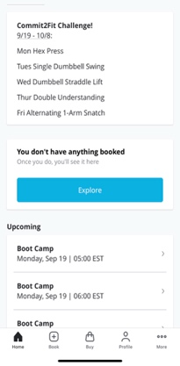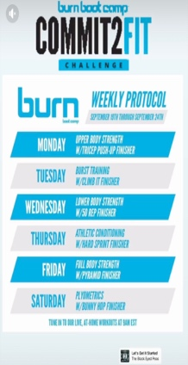

**Appendix 5.3, MyFitnessPal Interface**

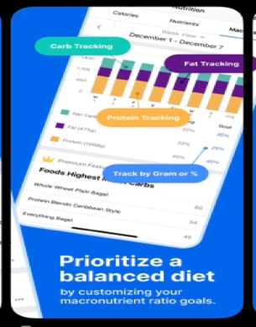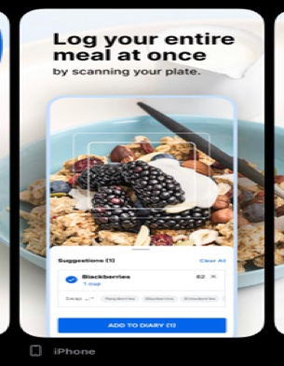

**Appendix 5.4, Pinterest showing cluttering interface**

**Appendix 5.5, Wireless Charger for Apple Gadgets**

