**P3, Design Principles and Heuristics**

Manick Mahalingam (mmahalingam6@gatech.edu)

**1. DESCRIBE FIVE DESIGN PRINCIPLES**

Bank of America mobile application is one of the great examples of having an invisible interface and could have been designed or design principles could be applicable to correlate the application interface.

**1.1 Discoverability**

When a user logs in to the bank application, the expectation is, ease of use for basic day-to-day transactions. Some tasks are automated and are performed in back-end, those transactions can be viewed in the Account Summary, however a user wants to perform Zelle transfer, bill pay, accounts balance, check deposit and investing. Despite the capabilities of performing multiple operations and using different accounts inside/outside of the application, it is discovered that above basic operations are most helpful tasks to users. Novice users could understand the process easily by looking at the icons and its intuitive use. The gulf becomes narrower due to the fact of making interface invisible by not distracting a user with redundant information. As Nielsen mentioned, it reduces cognition by providing appropriate user appeal and task smoothness in providing the user service. Gesture design for logging in using Face Id but considering the safety and sensitiveness of bank transactions, audio perception is restricted.

**1.2 Structure**

Like discoverability, the Bank of America has a very good interface with structured tasks that can be performed for a user to achieve his goal(s). Over the course of last 10 years, the application has gone through various dimensions in design by adding/removing features, but the core idea of organizing the list of accounts, statement balance, detailed account summary, bill pay, check deposit, remains the same. The structure of the application has a clear architecture, so that the cognition for a novice to expert users are easier. Gulf becomes narrower as the users could have adequate knowledge and just have add-on features to understand the application. Eventually, the interface becomes invisible, and user focuses on task needs to be performed, however, in certain situation, haptic or voice recognition could not be of much help due to data sensitivity.

**1.3 Consistency**

Bank of America’s application follows the consistency principle by having the same account summary and bill pay module. Showing the last 25 transactions in an account or adding and paying a payee under the bill pay module’s sequence of actions remains the same. Though the visual perception has changed by having different font styles or colors or trending UX, the design for internal/external components or behaviors did not change and the consistency is maintained throughout the years. This is a classic example of invisible by design where the user gets used to the interface due to its exceptional design and focus on their tasks or goals.

**1.4 Perceptibility, Ease and Comfort**

Accuweather application is an interface that can be considered example for the participant view of the user because of the nature of its context, the application is opened during different demographics, different users, but the underlying task is to check various metrics on the weather in a location. The *Perceptibility* principle helps in communicating the necessary information effectively to the user, for example, a user can be informed about a potential calamity like a storm, cyclone. Feedback provided instantly with enough information while driving to a location can help prepare the user on consequences. Due to the participant view of the user, *Ease and comfort* principle helps in providing essential information and not overwhelm. The user may be driving or trekking in the mountains or running outdoor, they won’t need weather behavior for the next 10 days, 4-hour metrics may be idle. The ease of design in the interface by having a clock shape with actual temperature, real feel, rain precipitation and comfort with notification or alerting through smart watch can help the user stay informed during the different context of participation.

**2. FACEBOOK WATCH – INTOLERANT OF ERRORS**

Lately Facebook has been frustrating on its interface of the video watch, the marketplace, or news feed. In fact, most of the application like Instagram, YouTube, follow the same in terms of predicting user behavior, and providing suggestion based on that. The machine learning algorithm that works behind to propose these suggestions needs some serious fixing. Any search done in a search bar becomes prey for all those machine learning algorithms across platforms and annoys users immediately with targeted advertisements or unintended suggestions on the same context. For example, the user enters a phrase by accident “fix kitchen sink faucet” instead of “fix kitchen cabinet”, this immediately provides the suggestion for videos, and its relevant suggestions pop-ups every time when opening Facebook or YouTube, the news feed bombards with local plumbers’ advertisements, FB group suggestions on plumbing fixes, and marketplace suggestion with faucets. Here the penalty for the user is to annoy with overloaded unintended information due to the *intolerance of error* user commits, which is supposed to be not an intended error.

As mentioned in lectures, there is no such as user error, users tend to make mistakes and those mistakes help in designing a better interface. In this situation, the user should be educated to avoid erroneous phrases, instead of focusing on algorithms on video or advertisement suggestion, FB can focus on search suggestion improvements. When a user types “fix kitchen” suggestion can be provided to show the list of kitchens fixing possibilities like cabinets, gas top, counter tops. This would help user be aware to choose the right phrase for searching. Continuous search on the same topics can be a cue for providing suggestion but not one time or accident searches. This *Constraint* principle can help improve the interface.

*Mapping* principle here could work based on the Internet of Things (IoT), though it is an accident search, it would make sense to show video suggestion on FB watch but showing it on the news feed or marketplace can be restricted by having proper mapping or annotating while designing the algorithm for the interface. Referring to Don Norman’s quote, mapping here is a technical term where it provides a relationship between the user input and algorithm that confirms the searches that are requested.

Similarly, the *affordance* principle as mentioned in the book by Don Norman, an object with an affordance tells the user with its design on how it meant to be used. This can be used to define the relationship between FB watch, search suggestion and the goal of a user. Then, it would help IoT to determine the algorithm-based suggestion could be restricted to FB watch and not go beyond that. Mapping and Affordance principles could go hand in hand here, both the principles help define FB watch suggestions can be restricted to its own and not go beyond to distract the user behavior in other modules.

**3. TENNIS CLASH – SLIPS AND MISTAKES**

Tennis clash is one of the games I usually play and that shares my interest with the actual sport too. This game as shown on the picture will choose players of the level I am in and play for 7 points. Levels are defined based on the agility, stamina, forehand, backhand, volley and serve. Racquets can be chose based on the prize money player has, money baggage and coins get accumulated based on rewards, the prize, and other supporting tasks.

Playing tennis, one of the common *slips* I make is mis-time the shot, be it forehand, backhand, volley or lob, due to the intensity of the game, there can be high chances it gets mis-timed. The game is played through a haptic perception sensation of swiping left, right, up, and down. These are action-based slip where I know exactly what action needs to be performed as most of the times, I rally the ball back and forth with the opponent, however, some shots get mis-timed which could lead me to loosing points. Of course, this is the nature of the game, as the opponent outperforms me in some of the shots, but a proper winner shot would be pleasant rather than me mistiming a shot. To avoid this slip, interface can be improved to provide target training on those shots that are mistimed, provide statistics on how the game performance was, like serve speeds, timing on the shots, the number of winners, errors, forehand shots and more.

One of the common mistakes I make while playing the game is not choosing the right proportion of skills for a player. Players are ranked with agility, stamina, forehand, backhand, serve or they can be upgraded to higher levels based on points collected. When I chose a player, though I make efforts to stabilize the skills based on the right proportion, the points or rewards that are collected won’t always match them. This could lead to lack of skills while playing and tend to lose points. This is a knowledge-based mistake, I knew the game and the interface to make the play but couldn’t match the right skills to make the game equally challenging with the opponent. This leads to a game being easily won or easily lost, the right proportion of challenging gets missed sometimes. This can be remediated with enough training on choosing the players and upgrading the skills in the interface.

Tennis is a game of skills, like actual sport, precision is vital in this online game. The challenge is focusing on the game, tide to the swiping moments and rally back and forth to win the points. Players should follow strategic approaches to win points like in the actual game. Skill levels are displayed upfront for a player and strategies can be placed based on that. For example, a player has a skill level of 18 points for backhand and 32 points for forehand, my strategy would be targeting their backhand to get winners or points, but if they are equally or highly skilled on all aspects, then it would be a real challenge.

**4. REPRESENTATION, GMAIL VS MAIL APPLICATION**

**4.1 Gmail Application, a good representation**

Gmail mobile application is an example of good representation, the interface helps in checking emails for different users after logged in. Users can compose mail, move mails to different folders, save in archive or drafts, navigate to other directories, and delete them. Moreover, the application can handle multiple accounts, search mails, change settings or notifications, and sending feedback. A menu icon, a search bar and an account icon with the picture is displayed at the top which are the essential details in representing an interface. It uses the 3 characteristics of good representation, including bringing objects and relationship together, excluding extraneous details and making relationship explicit.

The good representation criterion on bringing objects and relationship together is handled well in terms of showing the menu icon, a search bar, and an account icon. These 3 icons clearly represent the relationship and objects together because they have the actions that are meant to be, and it serves the user with their necessary task. The menu icon when clicked lists all the labels associated with the account, settings, inbox, sent, drafts, an object would be the icon and relationship would be to list labels and help navigate to appropriate directories. Similarly, a search bar meant to be searching any emails associated with that account. The account icon with a picture can easily relate to the person associated with the account, though the picture may not be clear, it could give a visual representation of who the account belongs to. These icons are in a way making the relationship explicit too.

Another criterion here for a good representation is excluding extraneous details. The interface can handle multiple accounts, and they can be selected or toggled or managed under the picture icon in the top right corner, however, if user adds multiple accounts, the interface is not going to show multiple labels or inboxes rather it restricts the account with one user by default. The interface leaves to the choice of user to toggle between multiple accounts. By default, it is not showing additional details or labels from different accounts, it excludes extraneous details and shows only the details needed for that user.

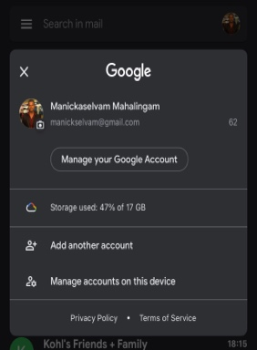

**4.2 Mail Application, a bad representation**

Contradictorily, Apple OS Mail application has different representation with a below par interface. It performs the same tasks as Gmail application. Users may login to various email accounts, check emails, move emails to different folders, archive or delete them, save in drafts and more. The user interface has representations to open individual accounts, view customization respect to their account, but the bad representation certainly not helping the user in completing their tasks. The gulf here gets wider due to the poor representation of the interface. Characteristics of good representation are not followed here, eventually it makes the design to be outdated or unusable for users due to its workflow cycle. For example, navigating to a particular inbox along with its associated labels should go through various clicks, back and forth between the main interface and individual directories, this falls behind on making relationship explicit with the interface.

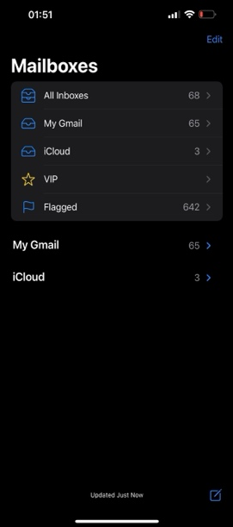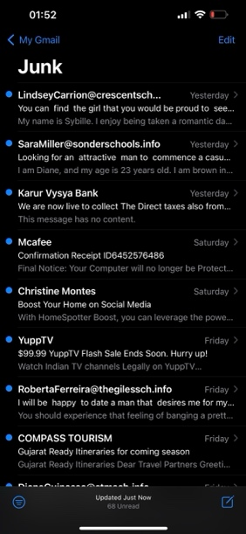

The first criterion of violating the characteristics of good representation is not bringing objects and relationship together. There is a home screen that displays all the accounts, once a user enters an individual folder, then to move to a different folder, they must navigate through 2 clicks. The relationship here is to open different folders or drafts or settings with single clicks, however the objects represent to move to home directory and then another click would lead to a different directory. This violates the characteristics and makes the gulf wider for a user to understand.

Similarly, home screen provides extraneous details. The user should be provided details with only their account or one individual account. Mail application shows all the list of email account inboxes registered and then shows toggled views of individual accounts underneath. This is a clear violation of showing extraneous details. User won’t need additional inboxes unless intent to, hiding them and making user aware of the action to open another inbox would make the interface better. Additionally, there are no signs of the preferences icon for the Gmail account or any account whatsoever.

References

* Mobile applications of
  + <https://www.bankofamerica.com/>
  + <https://www.accuweather.com/>
  + <https://www.facebook.com/>
  + <https://mail.google.com/>
  + Apple Mail
  + Tennis clash