P4, Task Analysis and Distribute Cognition

Manick Mahalingam (mmahalingam6@gatech.edu)

**1. GOMS MODEL, CONTACTING PROFESSOR**

*Figure 1,1 –* GOMS Model, showing contacting a professor for the explanation of grade

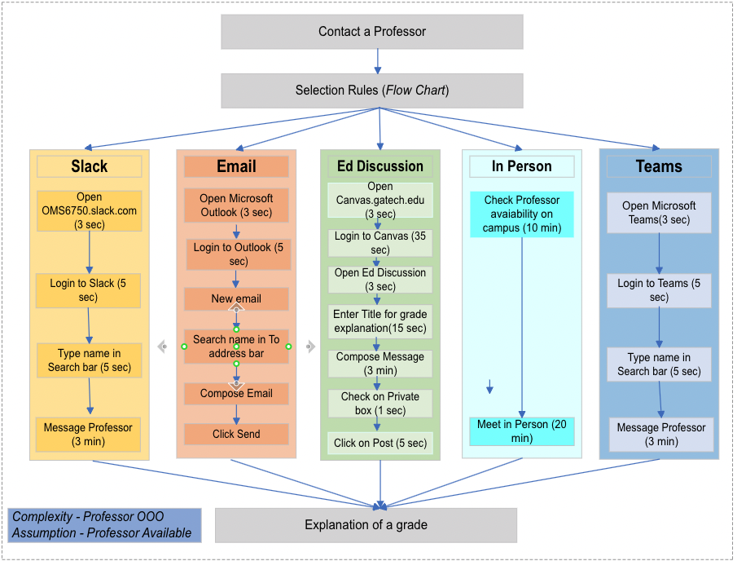

*Figure 1.2 –* Selection Rules Flowchart

**2. CANVAS ASSIGNMENT SUBMISSION, GRADE AND FEEDBACK**

Steps defined here are the hierarchical task analysis for submitting an assignment to Canvas and then receiving one’s grade and feedback. The assumption is the student completed the assignment based on rubrics and ready for submission.

**2.1 Assignment Submission**

* Access Canvas Dashboard
  + Enter canvas.gatech.edu in the browser,
  + Click on Canvas Login from landing page,
  + Login with credentials,
    - Enter GT Account and Password,
    - Click on Login,
    - Choose a Device for two-factor authentication,
    - Send Me a push to Duo mobile app,
    - Waiting for Approval in Duo,
  + Approve GT Access Request in Duo mobile app,
  + Login authentication successful ,
  + Automatically redirects to Canvas Dashboard landing page.
* Navigate to CS6750: Human-Computer Interaction
  + Click on CS6750 Widget box,
  + Screen redirects to home page,
  + Click on Assignments from left navigation,
    - Submit Assignment
      * From list of assignments scroll down to Assignment P4 for example,
      * Click Start Assignment,
      * Click Choose File from File Upload tab,
      * Choose a PDF File from the File Upload window,
      * Click Open and file gets uploaded,
      * Add comments in the text box for comments,
      * Click “I agree to the tools” checkbox,
      * Click Submit Assignment.

**2.2 Receive Grade and Feedback**

* Access Canvas Dashboard
  + Enter canvas.gatech.edu in the browser,
  + Click on Canvas Login from landing page,
  + Login with the credentials,
    - Enter GT Account and Password,
    - Click on Login,
    - Choose a Device for two-factor authentication,
    - Send Me a push to Duo mobile app,
    - Waiting for Approval in Duo,
  + Approve GT Access Request in Duo mobile app,
  + Screen authentication successful,
  + Redirects to Canvas Dashboard landing page.
* Navigate to CS6750: Human-Computer Interaction
  + Click on CS6750 Widget box,
  + Screen redirects to home page,
  + Click on Grades from left navigation,
    - View TA Feedback and Grades
      * From the list of assignments scroll down to Assignment P4 for example,
      * Observe the grades added as the 3rd column in the row for Assignment P4, the value would be anywhere from 0 to 20,
      * Observe a writing pad icon as the 5th column in the row of Assignment P4,
        + Click on the icon to view comments based on the rubric,
        + Scroll down each rubric to notice the marks allocated on the second column,
        + Notice comments wrapped below the mark’s column, which is the TA feedback,
        + Scroll down each rubric to notice points and TA feedback until Total points is observed.

**3. A DRIVE EXPLAINING DISTRIBUTED AND SOCIAL COGNITION**

To discuss about Distributed Cognition, considering the situation where a married couple is traveling from one state to another state with a map. The cognition is distributed to the driver, the passenger, the car, the map, and artifacts including road signs.

**3.1 Perception**

In terms of perception,

* The driver would be to focus on the drive which includes acceleration or breaks, adjusting lanes, watching for other cars, watching for the road, dashboard alerts on car health, and exit signs.
* The passenger would be to instruct the driver on the road with a map, communicate with the driver, help with food, playing songs, watching the road, signs, dashboard and exits.
* The car is to run, its cognition sticks to the scope of running the engine and streamline with other mechanical parts, watch for health checks on the car and alert the driver.
* The map is to show all the route information, visitor centers, rest areas in the paper map.

**3.2 Memory**

In terms of memory,

* The driver has a high cognitive load, so they have working memory on what road they are, speed limits, safe driving, sudden stops, lane changes, watch for accidents, pedestrian, gasoline level, dashboard alerts, road signs, drinking or eating.
* The passenger has a moderate cognitive load but must contribute more for driving, so they have a working memory too, like instruction about the road, finding routes from the map way ahead, road signs, warn or frequent reminders about dashboard alerts, socialize with the driver.
* The map has a short-term memory, they show route information, road names, exit signs in advance for a particular state or sometimes city, if they move to a different state then they would use a different map and there is no guarantee they are up to-date.
* The car has a long-term memory on how to keep all mechanical parts in motion with the engine, the engine communicating to the chassis, gasoline tank, steering-wheel. Dashboard sensors working on gathering fluid, filter and other mechanical alerts are all stored inside from the day the car was manufactured.

**3.3 Reasoning**

In terms of reasoning, it has direct impact on cognition and will shape clinical reasoning. The driver nature is to accomplish a goal and reason towards distribute cognition is to address how quick a task can be completed. The map has a reasoning of storing the route information to have its cognition better similarly the car pre-loaded all the manufacturing design which is a primary reason to work on any task.

**3.4 Action**

In terms of acting, the driver and to a certain extent passenger has situated action where they must react to a situation while driving. As per principle provided by Dr.Joyner, “The task doesn’t exist until the user gets started, and once they start they define the task”, driving brings a lot of situation in the road like accidents, change in traffic pattern, outdated map, car gets a malfunction and sudden lane changes by social drivers. All these contribute to situated action and could interrupt the actual goal, but driver/passenger should come up with contingent plan and change the nature of the task to accomplish the goal like taking an alternate route using map and passenger’s help, fixing the car, apply brake or change lane due to carelessness of other drivers.

**3.5 Compare and Contrast Human Values**

Comparing the same scenario with a lone driver using GPS navigator, the cognition is distributed among the GPS, car, and the driver. GPS navigator has its own distributed cognition to satellites in gathering route information, live traffic alerts from other sources of truth, share routes, accidents, or alerts from friends. The driver will have a high cognitive load in handling things on their own due to lack of a social relationship.

What does social cognition reveal about the situation that distributed cognition does not?

Distributed Cognition is more of materialistic in this situation where the communications are mostly one-way (dashboard alerts, road signs) or system generated voice commands (route information, route guiding, alerting on traffic, accidents, alternate route) and it lacks human emotions of sharing knowledge, socializing, presence of mind or any true human values. However, Social Cognition can be capitalized by different drivers sharing live traffic details on a route, connected with the social network, sharing a route map with friends, understanding nearby automobile centers, gas stations, restaurants, and other amenities. Everyone connected to the GPS application and the application itself contribute to the social cognition and help each other in accomplishing their goals.

How might the social relationships among the parts of the system affect the success of the system as a whole?

During the task of a driver traveling from point A to point B lonely with GPS, as mentioned above, the communication would one-way, the cognition depends on how matured the GPS application based on gulf and invisibleness. Does the driver need a learning curve? Is the application an easy transition from a paper map to GPS? How would the application react during situated action? These questions would rise for any user which could end up in a high cognitive load for the user, if the application is not meeting those standards, the working memory would be overloaded and could panic the driver. When a passenger shares their cognition, activity theory comes into play where we have subject (a couple engaged in an activity), an object (map and artifacts) held by the subject and motivates activity, give it a specific direction for the goal. Social cognition is a vital principle in communicating between other users, but Distributed cognition between the driver and the passenger would create a human bonding that would help a user accomplish the tasks much faster than other methodologies.

**4. DISTRIBUTED COGNITION AS A LENS**

Roborock is a smart computerized vacuum cleaner that helps to automatically clean the house with self-navigation. Like convention cleaner, it has spinning brushes and a vacuum to pick up dirt. The side-mounted flailing brush and rotating brushes pick up the dirt, directs to the vacuum, that sucks it and stores into a storage bin. Roborock has a two motor-driven tractor-style wheels with each running on its own electric motor and the power to drive on its own comes from its rechargeable battery pack that would run up to 75 minutes. There are numerous sensors to detect obstacles like collision, proximity, the cliff, optical navigation, and laser sensors. All these Lidar (Light detection and ranging, gives 3D view of surroundings) based sensors along with a computer chip inside works wonder in robot vacuum technology. It also provides simple voice commands to update status to the user. Human’s intervention is to configure the application interface to add virtual barriers, organize maps for the floors, zone cleaning, and of course, cleaning the vacuum as and when needed.

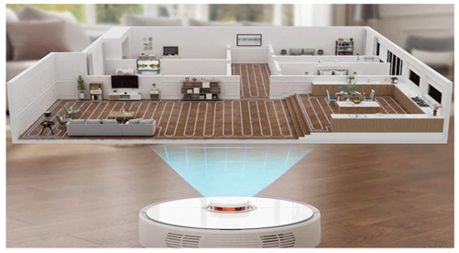

***Figure 4.1***– Robovac LIDAR sensing

This device is a stunning example of distributed cognition as a lens. The cognition is distributed to different components of the system and individual component works collectively to accomplish the goals. Given below the Roborock component’s perception that helps to understand Distributed Cognition,

* The traditional vacuum cleaner with its spinning brushes and hyper-force suction sucks all the dirt using a fan spinning at high speed channeled through an advance airflow system and stores it in a storage bin.
* The rechargeable battery pack to help run the vacuum on its own for up to 75 minutes, reach back to the dock when the cleaning is completed or low battery, like a mind on its own.
* The collision and proximity sensors use tractor type wheels, brushes, and its front bumper. This helps in navigating the house, creating walls and clean it in a straight line until an obstacle is met in the floor plan.
* The cliff sensors help the vacuum to avoid falling from the stairs
* The optical navigational sensor uses Lidar technology with night vision and an augmented lens. This aide the robot to where it is and where it needs to go and makes a high-quality navigation plan, stores it into the computer and uses the optimal floor plan next time.
* The smartphone interface to setup nuances on schedules, organize floor plans, add virtual barriers, zone cleaning, mop zones, which would need human intervention

When we investigate these individual component’s perception and tasks above, the central processor (or computer) along with the human’s trigger distributes the cognitive load to individual components and they work on their own to accomplish their task and eventually the system’s goal. Human’s role here is defined to be minimal like the initial setup of the system, frequently monitoring the floor plans, addressing any blocks for the system, cleaning the vacuum and storage bins, so they have a minimal cognitive load. The learning curve here is to understand the system and mobile application which could be weighed based on how the gulf and invisibleness.

In terms of *memory*, the *cloud platform* (information storage option widely used in application) has the long memory on storing the map, communicating to the application, status of the sensors and other metadata information. The *processor* has a short-term memory on receiving the map from the processor, sharing it with different sensors, voice controls, updates on the floor plans or obstacles received from the map. The *sensors* and the *traditional vacuum* have the working memory, while sensors work on watching for obstacles, executing the map, or updating the map, the traditional vacuum focuses on picking the dirt, suck it to the storage bin.

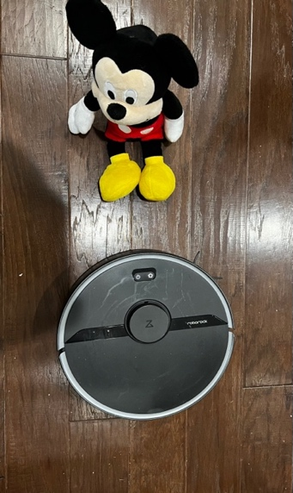

*Figure 4.3 Roborock AutomaticVacumm*

In terms of *action*, the situated action would be ideal for the sensors to look for change in floor plan or obstacles on the way, the vacuum to command a user on cleaning storage bin if it gets full while the cleaning is in progress. The concept of activity theory in this system is driven by human motives or systemic goals and consciousness on achieving those goals. The activity is complete the cleaning cycle as a system, which comprises of action, including a vacuum, auto-rolling, and technical aspects that are done through various operators like wheels, suction, sensors, and application interface.

References

* <https://us.roborock.com/blogs/blog/how-do-robot-vacuums-work>
* <https://www.explainthatstuff.com/how-roomba-works.html>