# Slueth and Zipkin

This will add the trace id and span id to ur logs

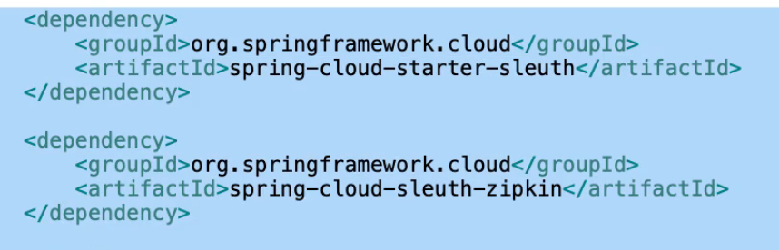

Default zipkin url is

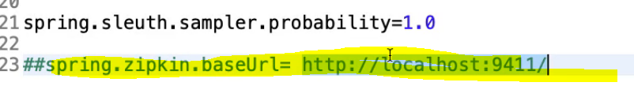

And u can see those in separate server

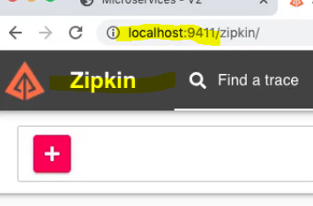

Import these projects

Here is the link to bookmark:

https://github.com/in28minutes/spring-microservices-v2/tree/main/04.docker