## Rest template hack

Populate a map and send the map to the rest template

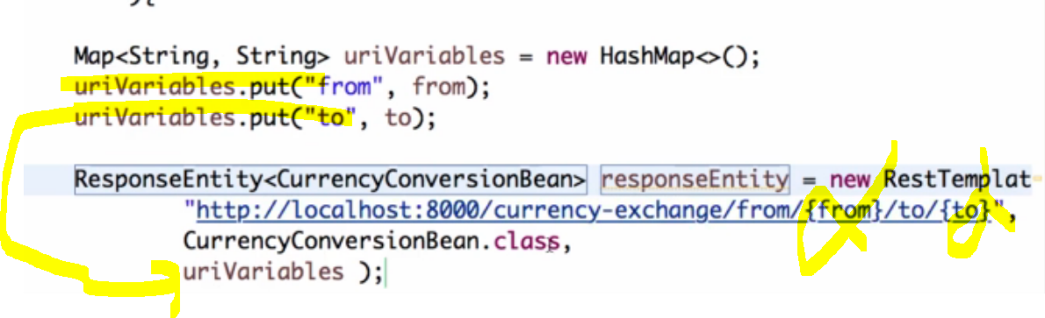

U can bind to a big decimal too

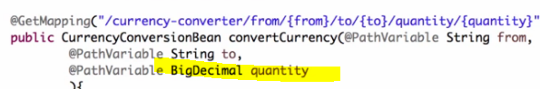

### Plain REST template

Without Feign client: - we can hardcode direct url or we can use the name of ms(url for that name will be given by eureka)

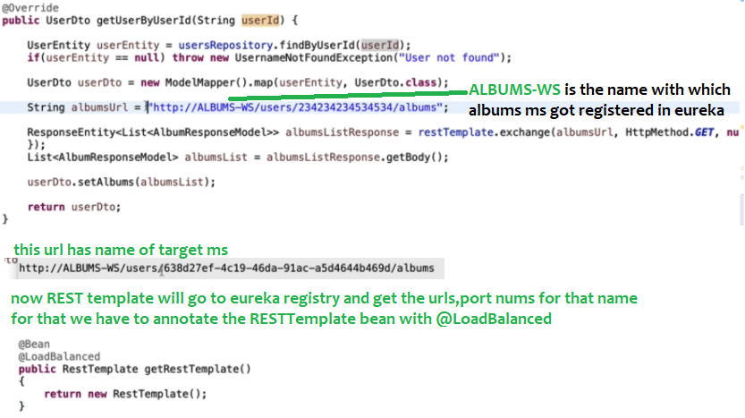

## **Feign client**

It is a declarative – we have to create the interfaces with annotations

and load balanced

1. @EnableFeignClient
2. Write interface alone, framework only will provide the implementation, same like jpa methods, we will just define

Those methods ,f/w will create implementation for those methods

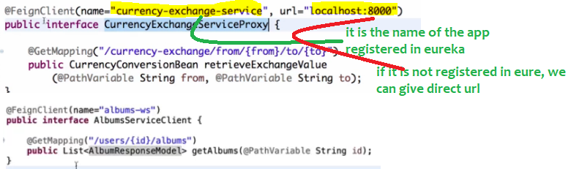

1st of all I hate this approach, instead of creating the interface and all, we can directly use RESTTemplate/Webclient

Instead of this declarative approach

Doubt

In this case u will send data like by passing that data to that interface method,

1. if u want to pass headers how u will pass?, u can pass to the method right?
2. Handling the exceptions is also difficult, we should use try-catch block

