## Nodes in udemy

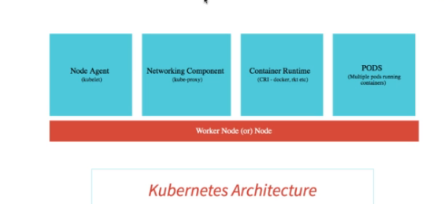

Node agent is responsible to see if any pod goes down , it will check the replica factor and if no of pods are lesser than expected, it will dynamically creates another one

Networking comp exposes the services such as load balancer service.

What happens if master node goes down, application will perfectly work as it is.

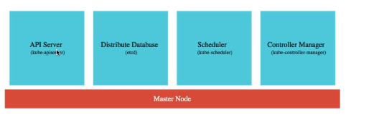

Kubernetes is itself having the service registry like eureka. No need of any other external svc registry.

### Creating an image

Maven build do with this command

With below command the docker image will be created with our code and will be built and will be pushed to remote docker repository

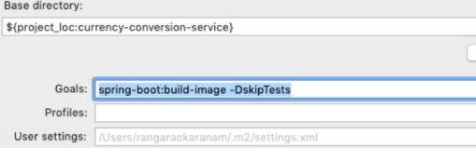

As below

### Push docker image to remote repository

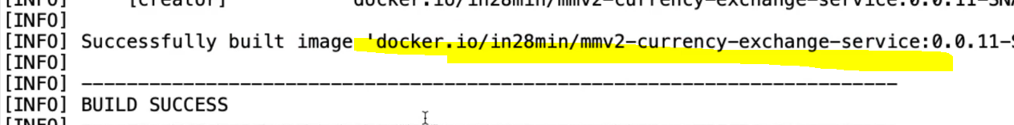

Once like above build is success , then goto kubectl and run below



### Sample Kubernetes commands

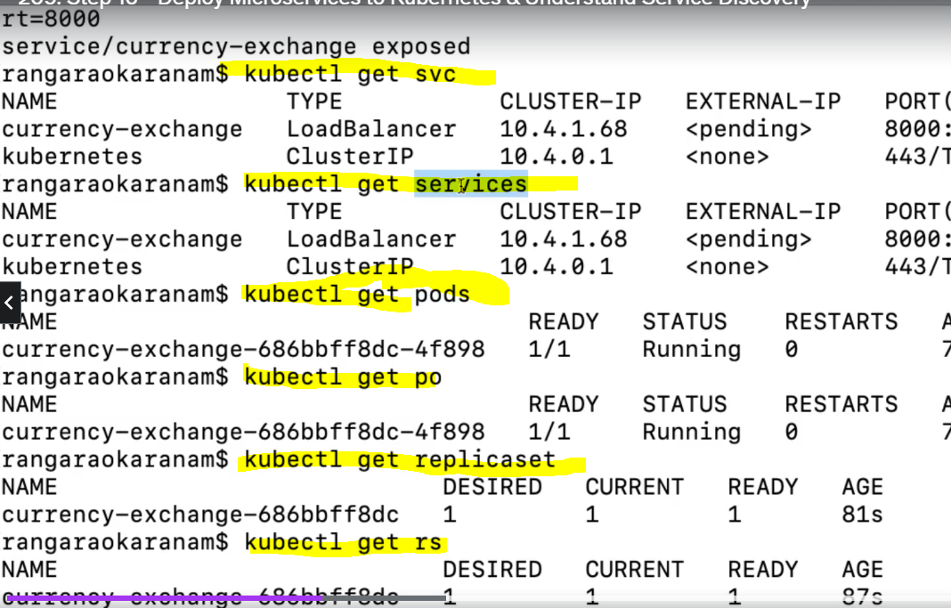

### Deploy that image to Kubernetes



### Create load balancer url for our appn



If u don’t do this , u will not get load balancer url, u will be having only individual VM url

### Hit the load balancer url

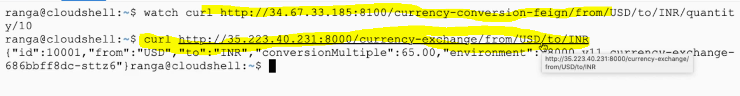

### Deploy using **deployment.yaml**

Before deploying first check what are the changes done to deployment.yml using

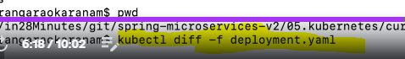

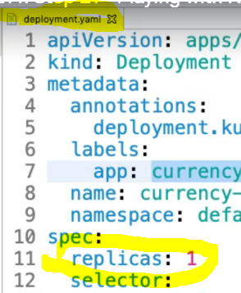

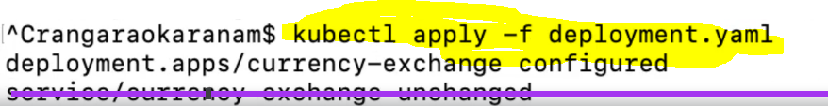

Lets say u want to increase the number of pods , instead of running commands to change the replica sets , just change the number in deployment.yml and run the above command

### Create custom environment variables in for other sevice url’s

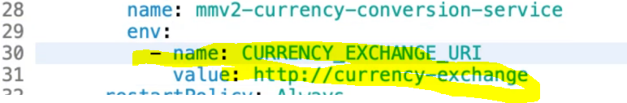

Config maps acts as centralized configuration in Kubernetes.

### To see all the pods

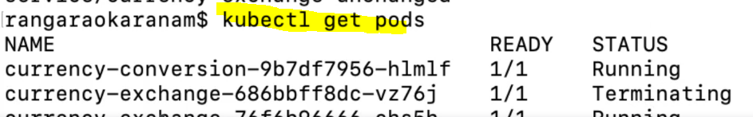

### Liveliness and readiness

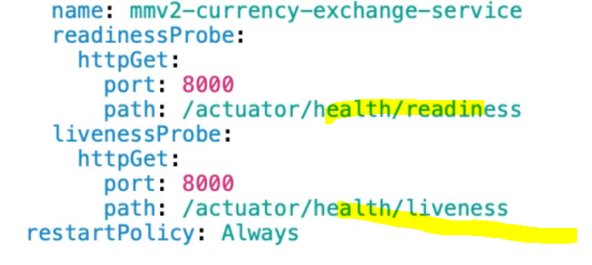

This will tell us if appn is ready to take the traffic or not.

## Autoscale based on the load

If u want to increase the no of pods based on the load

