Ef 2bvSalesforce recommends LWC for all new development
Env setup:-
- to work with lwc , 1st we should install salesforce cli https://developer.salesforce.com/tools/salesforcecli install this software in ur local machines
- INSTALL salesforce extension pack vs code plugin (after install type command “sfdx” if any error comes then run below command)
- Or do Npm install sfdx-cli –g
Terminologies
DX- means developer experience

References
to see all sf components- | https://developer.salesforce.com/docs/component-library/bundle/lightning-card/example  use this for css alternative- if u want some stylish cards, input boxes then use this sf lighning components  ex:- instead of plain html tags --<input type=”text” > use sf <lightning-input> tags and if u want card then refer thos
for css- use SLDS2  like margins | salesforce lightning design system  https://www.lightningdesignsystem.com/2e1ef8501/p/85bd85-lightning-design-system-2  ex:- when u are looking for css like when u want to apply some margin for ur div then use this SLDS 2  use this div <div class="slds-m-around_medium"></div>

Terminologies
Cp- command palette
Controller means- java script file

Aura vs LWC & interoperability
aura | LWC
aura uses only older ES5 JS  AURA will support LWC (old is supporting new)  but LWC wont support aura (as AURA is old ,new will never support old, , hence new LWC is not recommending aura at all)  Why Salesforce designed it this way?  Because:  - LWC is the future  - Salesforce wants one-way migration  - Prevents new apps from depending on Aura  Use Aura  - Maintaining legacy code  - Old managed packages  - Existing Aura apps  classic ui is old ui, lightning ui is the new ui | LWC is significantly faster than Aura  LWC uses all latest js features till es 2020  Use LWC  - New development  - High-performance UI  - Modern UI needs  - Career growth
👉 LWC structure is simpler and cleaner
.html → Template
.js → Logic
.css → Styles
.js-meta.xml

html
<template>
<p>{message}</p>
</template>
Aspect | Aura | LWC

Rendering | Server + client heavy |  | Client-side, faster

DOM handling | Virtual DOM | Native DOM

Speed | Slower | Much faster
Feature | Aura | LWC
Binding | Two-way | One-way (better control)
Syntax | {!v.name} | {name}

What does “Co-existence” mean?
Co-existence =
👉 Aura and LWC can live together in the same Salesforce org and same app/page
- You do NOT need to rewrite Aura immediately
- New features can be built in LWC
- Old features can remain in Aura
What does “Interoperability” mean?
- Interoperability =
👉 Aura and LWC can communicate with each other
- But ⚠️ ONLY in one direction fully supported
- Aura will support LWC (But LWC wont support AURA- new wont support old)
<aura:component>
<c:myLwcComponent message="Hello from Aura"/>
</aura:component>

Q: Can LWC and Aura coexist?
Yes, Aura and LWC can coexist in the same org and same Lightning page.
Q: Can Aura and LWC interoperate?
Yes, but only LWC can be embedded inside Aura; Aura cannot be embedded inside LWC.
Q: How does communication work?
Aura passes data to LWC via attributes, and LWC communicates back using custom events.
Aura components and Lightning web components share the same base Lightning components. Base Lightning components were already implemented as Lightning web components.
• Aura components and Lightning web components share the same underlying services (Lightning Data Service, User Interface API, etc.).

Annotations &shortcuts
to push all file to org | sf project deploy start (sfdx force:source:push)- to deploy code to org, before pushing we should ,

@AuraEnabled(cacheable=true) | To enable a method to be invocable from aura or LWC  @AuraEnabled makes Apex methods or variables accessible to UI layers:  public with sharing class AccountController {  @AuraEnabled  public static List<Account> getAccounts() {  return [SELECT Id, Name FROM Account LIMIT 10];  }  }

Fundamentals of lwc

Paths
to see all lightning pages | setup—lightning app builder (here we can see all lightning pages)

Comp ref guide
if u want a card | <lightning-card title="Hello"> </lightning-card>
input tags

SLDS 2 – HTML, css
applying margins
before margin vs after margin  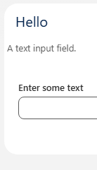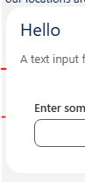 | https://www.lightningdesignsystem.com/2e1ef8501/p/51dd56-margin/b/788fe9/t/840d65a762  I wanted to move to my div  <lightning-card title="Hello">  <div class="slds-m-top_medium slds-m-bottom_x-large slds-m-around_small">
if u want some div with text  | <div class="slds-box">You have entered your name as {name}</div>

Component & Page
An LWC (Lightning Web Component) is a reusable UI unit built using:
- HTML (template)
- JavaScript (logic)
- Meta XML (configuration)( myComponent.js-meta.xml)

- Optional ├── myComponent.css & myComponent.svg & u can write any num of .js files and import
and component name must be lowercase camelCase, unique, and consistent across all component files.
Comp is collection of files like – html , js, meta xml file
1 way Data binding means - data flow from controller (js file ) to template ( html ) file (if I create a var in js file, that should be accessible In html file)
In html we should use {varNameDeclareInJsFile}

PascalCase for classes or
camelCase for variables;
kebab case means – instead of capital letter we should use hyphen (salesforce sales-force) used for comp reference and html attribute name

Component rules:- name (folder name) | each file name | JavaScript Class Naming Rule – variable,
- Must begin with a lowercase letter (use camel case folder)  - Contain only alphanumeric or underscore characters  - Must be unique in the namespace  - Can't include whitespace  - Can't end with an underscore  - Can't contain two consecutive underscores  - Can't contain a hyphen (dash) | accountList/  ├── accountList.html  ├── accountList.js  └── accountList.js-meta.xml  All files must have the exact same name as the folder | export default class AccountList extends LightningElement {  }  Rules  - Class name must be PascalCase  - Usually matches folder name (recommended)  - Must extend LightningElement  in js don’t declare the type of variable  export default class HelloAccenture extends LightningElement {  cityName = 'delhi';  changeHandler(event) {  this.name = event.target.value;  }  }
HTML Tag Naming Rule (CRITICAL)  In parent components, LWC is used as:  <c-account-list></c-account-list>  Conversion Rule  camelCase → kebab-case  Folder Name HTML Tag  accountList <c-account-list>  contactDetailPage <c-contact-detail-page>  in html file we should always write code inside  <template>  </template> | Namespace Rule  Org Type Tag Prefix  Custom component c  Managed package pkgname  <pkgname-account-list></pkgname-account-list> | always remember writing component is not enough ,  we need to enable  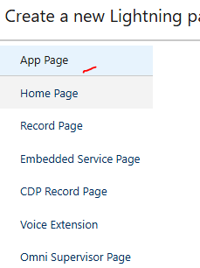  6. Component Visibility (Meta XML)  myComponent.js-meta.xml  <LightningComponentBundle xmlns="http://soap.sforce.com/2006/04/metadata">  <apiVersion>59.0</apiVersion>  <isExposed>true</isExposed>  <targets>  <target>lightning__RecordPage</target>  <target>lightning__AppPage</target>  </targets>  </LightningComponentBundle>  if u don’t expose then this comp will not be visible at all  The <targets> section controls WHERE your LWC can be used in Salesforce UI. There are 6 type of page as per above, so we should select the type of page , if u add all targets, then our comp will be available in all pages  In simple words:  It decides on which Lightning pages your component is allowed to appear.

App creation—page creation- comp deployment – comp assignment

App creation – | Home –setup-- app manager- new lightning app (while creating choose system admin profile- means only admin can see app -who can see the app – )  Select right profile – so that only those mem can see this app
to create page | create a page with layout - just creating page is not enough , u should map that page to an app  setup—lightning app builder –create page-- select page type (ex:- app page)- select layout (like 3 region layout) –save- map this page to an app (In lightning exp tab)  - note:- in page only layout will be there , we have to keep components in that page by drag and drop  - we have to map our page to an app  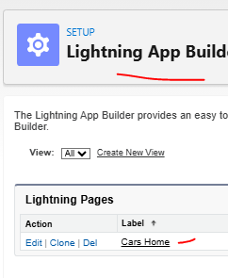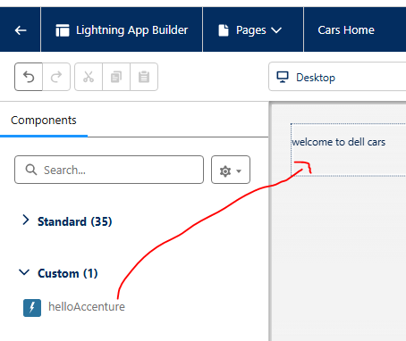 u can see all pages here – edit – and place ur comp in ur layout page is there , layout is there, u have to place ur component in any layout note:- in page only layout will be there , we have to keep components in that page we created a page, but we only need to map this page to an app 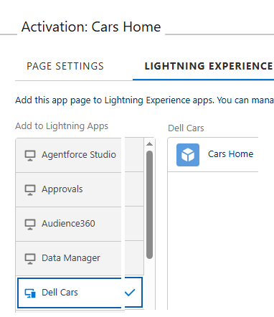 here I added my page to dell cars app (dell cars is my app name)
comp (which is reusable) | just creating a comp is not enough , we have to keep our components in pages only ,  after deploying components to org drag and drop that comp in our page layout

in js class u can declare variables as (no need to declare the type of each var,  no need of semi colon also for each line,  String variable can be In single or double quotes)  import { LightningElement } from 'lwc';  export default class MyComponent extends LightningElement {  name = 'Manideep';  count = 0;  isActive = true;  details= { name:”Mani”,  place:”Melbourne”  }  userList=[“a”,”B”]  } | In HTML ,  always write code in <template> </template>

Js class
Here functions doesn’t have return type
export default class HelloAccenture extends LightningElement {
message = 'Hello World';
count = 0;
changeHandler(event) {
this.name = event.target.value;
}

}

Declaring Variables in LWC (RULES)  ✅ Rule 1: Use let or const, NOT var  let count = 0;  const MAX_LIMIT = 10;  ❌ Never use var (bad scope, Salesforce doesn’t recommend it). | Rule 2: Class fields (most common in LWC)  export default class HelloAccenture extends LightningElement {  message = 'Hello World';  count = 0;  }  ✔ These are reactive by default  ✔ When value changes → UI updates  if u update entire variable then automatically it will be tracked
⚠️ Rule: Objects are mutable, but reactivity needs care  ❌ This may NOT update UI  this.user.name = 'New Name';  ✅ Correct way (spread operator)  this.user = {  ...this.user,  name: 'New Name'  };  ✔ Salesforce reactivity rule: reassign the object  Declaring Arrays  names = ['A', 'B', 'C'];  ❌ Avoid direct mutation –bec it will not tracked, it will be tracked only if u update arr variable not inner ele in a variable  this.names.push('D');  ✅ Correct  this.names = [...this.names, 'D'];  alternate is use @track names=[‘a’,’b’] to update array var else it will not be tracked  🔹 Using @track (IMPORTANT RULE)  Old rule (pre-2020):  @track user; and use import track from lwc package  New rule (current):  - ❌ DO NOT use @track  - ✔ All fields are reactive by default  - Use only spread operator and create a new copy of variable  Use reassignment instead.  note:- framework will monitor object,array var in 2 ways, 1) either by updating the whole variable ,not ad ding ele to arry , not adding/updating ele to obj  2) or use @track on arrays, objects- then those will be tracked by engine & then only those changes will be reflected into browser  why we are doing this ????  this.user = {  ...this.user,  name: 'New Name'  };  sf tracks only direct variable update ( like here sf tracks user variable updates only, it wont track fields inside object)  , so instead of updating a variable in user object , sf recommends to update whole object when u update the user variable, sf is already tracking it, so updates are auto reflected in ui, so that with this no need of @track annotation | Declaring Objects in LWC  ✅ Simple object  user = {  name: 'Manideep', // here u can use single or double quotes  age: 30  };  user={  "name":"Mani",  "city" :"Hyderabad"  }  both key values can be in double quotes no issue- but key can exist without quotes  ❌ Rule 3: Don’t declare variables outside class (unless constants)  const APP_NAME = 'My App'; // allowed (constant)  export default class MyComp extends LightningElement {  title = APP_NAME;  }  🔹 Constants vs Properties (rule)  Type Where Example  Constant Outside class const TAX = 18;  Reactive property Inside class total = 0;  Golden Rules (remember these)  - No var  - Reassign objects/arrays to trigger UI update  - Everything UI-related inside class  - Use getters for computed logic  - Avoid @track (legacy)

🔹 Declaring Methods  handleClick() {  this.count++;  }  ✔ Always use this.variableName inside methods  🔹 Declaring Getter (computed values)  get isAdult() {  return this.user.age >= 18;  }  Used in HTML:  <template if:true={isAdult}>  Adult  </template> | export default class Demo extends LightningElement {  title = 'LWC Basics';  count = 0;  user = {  name: 'Manideep',  age: 30  };  handleClick() {  this.count += 1;  this.user = { ...this.user, age: this.user.age + 1 };  }  get isAdult() {  return this.user.age >= 18;  }  }

Data binding (1,2 way )
1 way | 2 ways
sending data from js to html file is easy  declare the variables in js file like (let x=10)  in html file just use flower braces {varName} so that u can retrive variables  js- here we created var cityName- this is accessed in html file  export default class HelloAccenture extends LightningElement {  cityName = "delhi";  name = "";  changeHandler(event) {  this.name = event.target.value;  }  } | sf is not officially supporting sending data from html to js, but we can achieve using js  To pass data from HTML to js -- use js events like onKeyUp()..  so that when u type then automatically our js function will be invoked with data  on keyup this function will be exec with data  here to pass data from html to js, we are calling changeHandler js function  <template>  <h1> welcome to dell cars </h1>  <p> our locations are {cityName} </p>  <lightning-card title="Hello ">  <div class="slds-m-top_medium slds-m-bottom_x-large slds-m-around_xx-large">  <div class="slds-box">Your city name is {cityName}</div>  <div class="slds-p-around_medium lgc-bg">  <lightning-input type="text" label="Enter city Name" onkeyup={changeHandler}></lightning-input>  </div>  <div class="slds-box">You have entered your name as {name}</div>  </div>  </lightning-card>  </template>

@track

export default class HelloAccenture extends LightningElement {  cityName = "delhi";  name = "";  changeHandler(event) {  this.name = event.target.value;  }  } | <div class="slds-box">You have entered your name as {name}</div>  By default, only simple variables are tracked by lwc engine, so that if u update any variable, that new new variable content will be auto refreshed in browser  ex:- when changeHandler function ran , since var name is tracked by engine, when we update that variable,  then in browser that value will be refreshed automatically  but this behaviour is not applicable for object, objects are not defaulty tracked by lwc engine

