Report
Cab Fare Prediction

MANIDEEP RAMINENI

Contents

1 Introduction

1.1 Problem Statement

1.2 Data

2 Pre Processing

2.1 Missing Value Analysis

2.2 Outlier Analysis

2.3 Feature Engineering

2.4 Feature selection

2.5 Normality check

3 Exploratory Data Analysis

3.1 Plots

4 Model Development

4.1 Linear regression

4.2 Decision Tree

4.3 Random Forest

4.4 Improving accuracy

5 Conclusion

- INTRODUCTION

1.1 Problem statement

The goal of this project is to predict the cab fare. You are a cab rental start-up company. You have successfully run the pilot project and now want to launch your cab service across the country. You have collected the historical data from your pilot project and now have a requirement to apply analytics for fare prediction. You need to design a system that predicts the fare amount for a cab ride in the city.

1.2 Data

A dataset with 6 variables is provided, which should be used for applying the regression models that helps in predicting the target variable. Below are the variables which are used for prediction.

- pickup_datetime - timestamp value indicating when the cab ride started.
- pickup_longitude - float for longitude coordinate of where the cab ride started.
- pickup_latitude - float for latitude coordinate of where the cab ride started.
- dropoff_longitude - float for longitude coordinate of where the cab ride ended.
- dropoff_latitude - float for latitude coordinate of where the cab ride ended.
- passenger_count - an integer indicating the number of passengers in the cab ride.

2. Pre Processing

Pre processing the dataset is the mandatory part of data analysis. The messy data is converted to the required and understandable data to implement the data analysis techniques.This is called as Exploratory Data Analysis. Pre processing stage involves looking for outlier analysis, looking for missing values in the data, imputing missing values.

2.1 Missing value analysis

This analysis is done to check whether there are any missing values in the dataset. If they are present techniques like mean, median and KNN method should be used to remove the missing values. In our dataset missing values are present and have been imputed using statistical techniques.

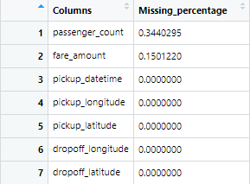

2.2 Outlier Analysis

Second step of pre processing is performing outlier analysis. Outliers mean the inconsistent data in the dataset. Remember, it can be performed only on numerical variables. Boxplots are used to detect the outliers. The data which is not between 25th percentile and 75th percentile is referred as outlier.

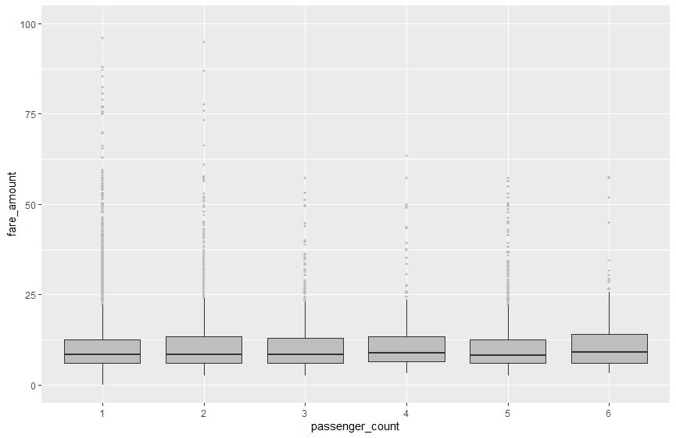

According to above visualizations there are outliers there are outliers present in fare_amount based on the passenger count. These outliers can be removed in R &Python.

2.3 Feature Engineering

Feature Engineering is used to derive new features from existing features.

For variables:

Used this timestamp variable and intoduced new variables to the dataset. Introduced features are pickup_year, pickup_month, pickup_hour. A variable named total_dis was also introduced which depicts the distance travelled by a customer in the cab based on the latitudes and longitudes given. Passenger count cannot be more than 6. So it is converted to a categorical variable as a process of feature engineering. After deriving the new variables unwanted variables are dropped.

2.4 Feature selection

In this step we would allow only to pass relevant features for analysis. I done this by some statistical techniques. We take features which will be helpful in predicting the target variable.

Correlation analysis :

This requires only numerical variables. Therefore, we filtered out only numerical variables and feed to correlation analysis. There should be no correlation between independent variables but there should be high correlation between independent variable and dependent variable. So, upon plotting the correlation plot, we can see the relation between variables.

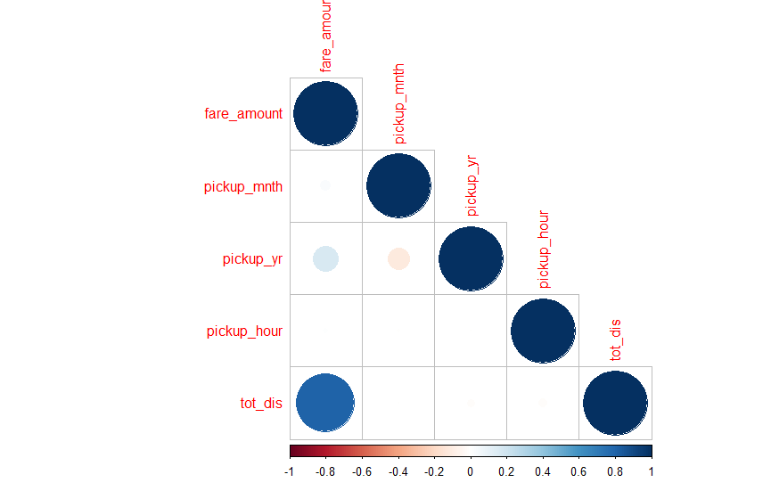
From below correlation plot we see that:
  - 'fare_amount' and 'tot_dis' are very highly correlated with each other.
  - As fare_amount is the target variable and ‘tot_dis’ is independent variable we will keep ‘tot_dis because it will help to explain variation in fare_amount.

Analysis of Variance(Anova) Test

It is carried out to check the dependency of categorical variable on target variable. After the ANOVA analysis results are found to be satisfactory. Attached the snippet of the results and it can be observed that P-valve is less tha 0.05. So null hypothesis is rejected.

Multi-collinearity :

This check is done to determine if there are any variables carrying the same information to predict the target. The results are found to be satisfactory and can be concluded that no two variables contain similar information.

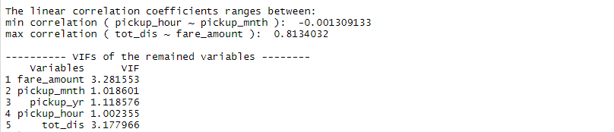

2.5 Normality check

Normality check has been done for the target variable using the plots qqnorm and histogram.

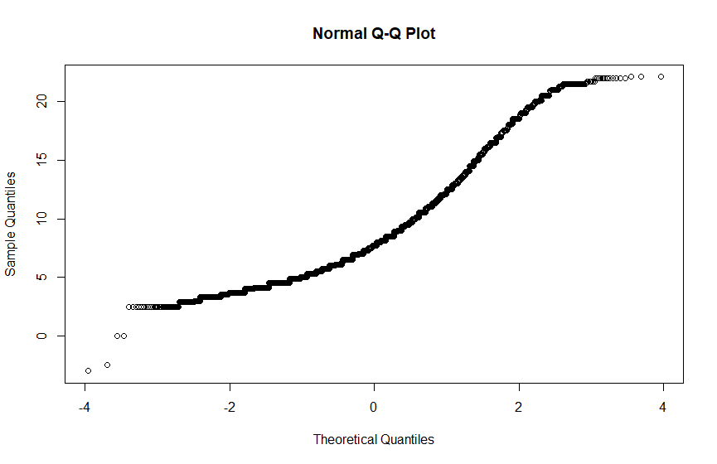

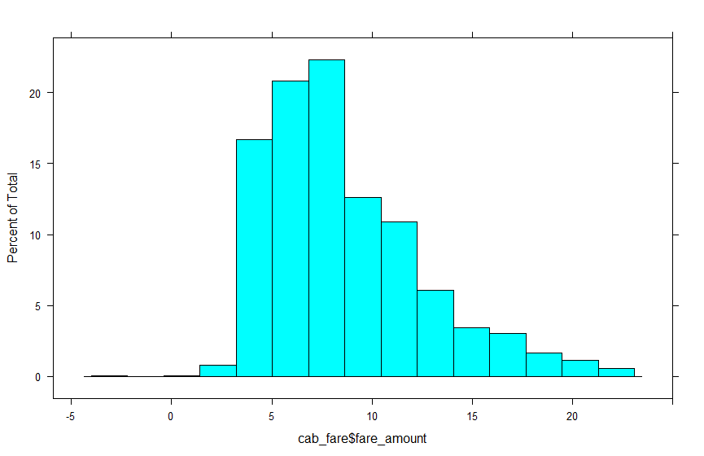

- Exploratory data analysis

3.1 Plots

Below is the distance plot of various variables present in the dataset. The y-axis is the corresponding probability values.

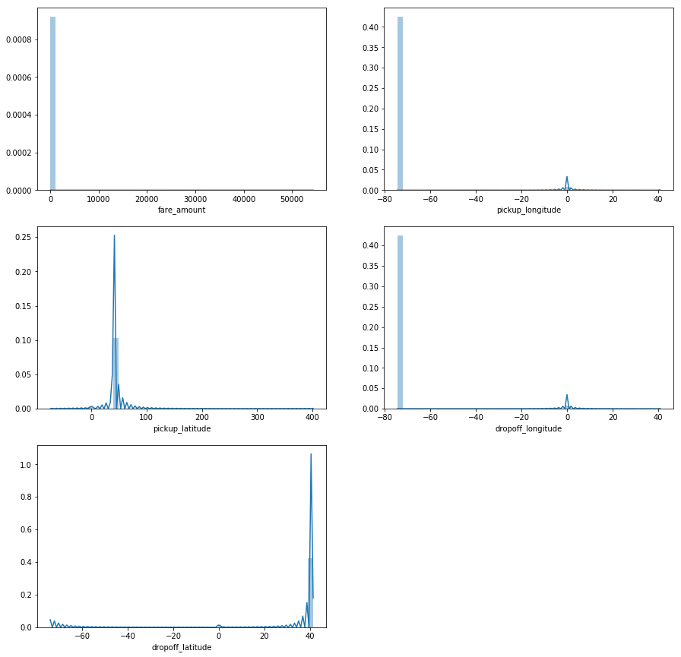

Joint plots play a major role in determining the linear relation between independent and the target variables. P-value determines the dependency levels.

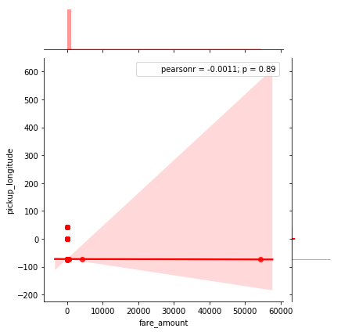

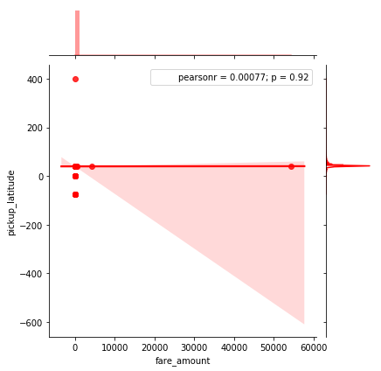

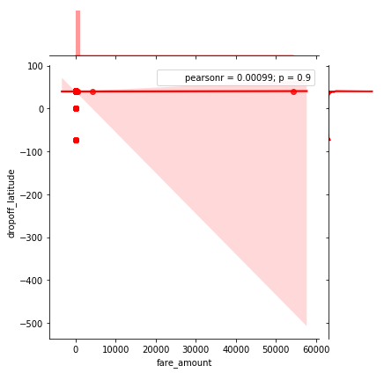

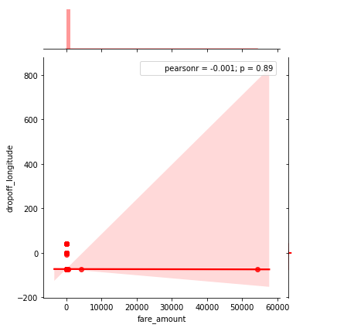

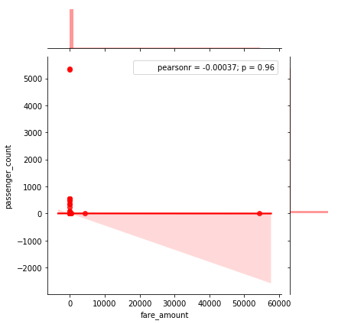

By observing the above plots a conclusion can be drawn that there is positive association as well as negative association with the target variable.

- Model Development

According to the problem statement cab fare should be predicted. Since the target variable is continuous, regression models are built in the project. Below mentioned algorithms are implemented.
.
- Linear regression
- Decision tree
- Random Forest

These methods are applied after dividing the data into train and test.

4.1 Linear regression

It is implemented as a initial modelling algorithm. Hyper parameter optimization is also done to find the best fit parameter using grid search. Evaluation metrics are considered with priority in deciding the efficient model.

Results :

- Tuned Decision reg Parameters: {'copy_X': True, 'fit_intercept': True} Best score is 0.6880111481676089
- MAPE:18.55136232247832
- MSE: 4.546509654664808
- RMSE: 2.1322545942416933

  - Decision tree

It is implemented as a second modelling algorithm. Hyper parameter optimization is also done to find the best fit parameter using grid search. Evaluation metrics are considered with priority in deciding the efficient model.

Results:

- Tuned Decision Tree Parameters: {'max_depth': 6, 'min_samples_split': 14} Best score is 0.7042534001860588
- MAPE:18.12832325169772
- MSE: 4.461758940393513
- RMSE: 2.112287608351077

  - Random Forest

It is implemented as a final modelling algorithm. 100 trees are used in implementing this algorithm. Hyper parameter optimization is also done to find the best fit parameter using random search. Evaluation metrics are considered with priority in deciding the efficient model.

Results:
- Tuned Random Forest Parameters: {'n_estimators': 100, 'min_samples_split': 2, 'min_samples_leaf': 2, 'max_depth': 7} Best score is 0.7195888560126104
- MAPE:17.517184217992533
- MSE: 4.269137523113804
- RMSE: 2.0661891305284237

  - Improving accuracy

As a part of improving accuracy an ensembling technique known as ‘XGBoost’ is implemented.

- MAPE:17.16949480786265
- MSE: 4.127115351323203
- RMSE: 2.0315302979092396
- Conclusion

Depending on the error metrics XGBoost is implemented on the final test data and saved the results in an excel sheet. Since, XGBoost technique is considered to be efficient that model is saved in the ‘SAV’ format for later use.

