Puppet:

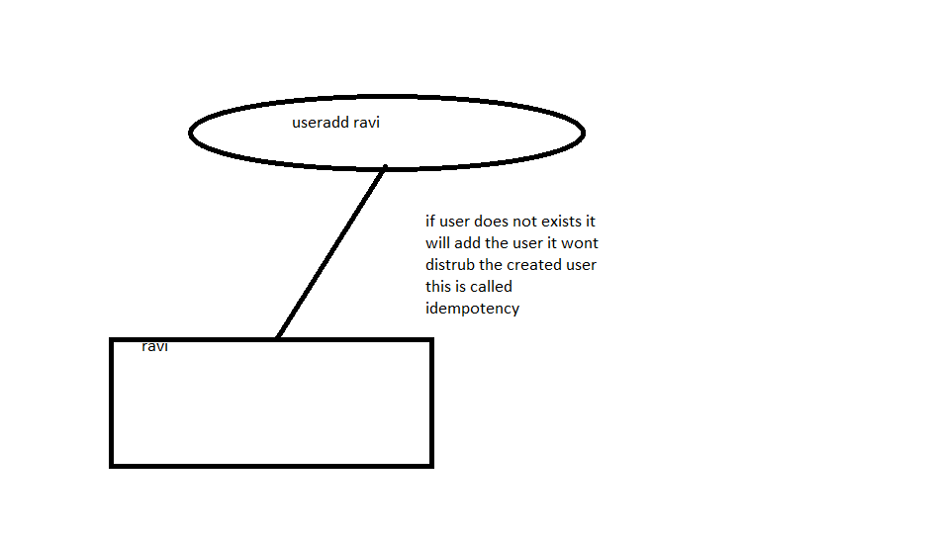

Pull configuration: push configuration:

Puppet: slave will push the data from master

Certificate will be exchanged wise versa between master and slave to exchange certificates.