**Chrome Extensions**

Can be used for enhancing the browsing experience.

**Architecture**

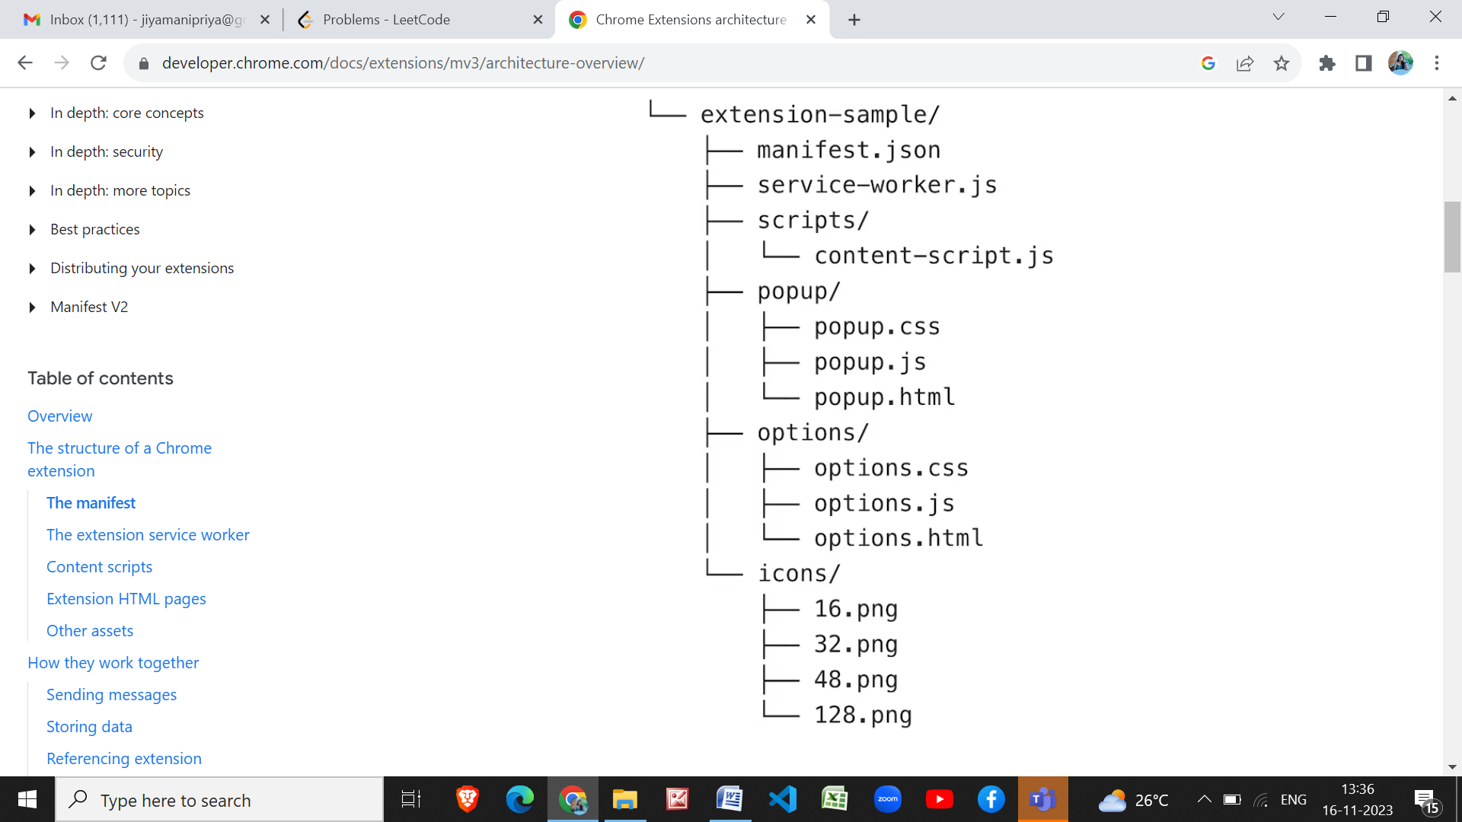

The manifest (manifest.json) is the configuration file of a Chrome extension. The extension's [manifest](https://developer.chrome.com/docs/extensions/mv3/manifest/) is the only required file that **must** have a specific file name: manifest.json . It also has to be located in the extension's root directory. The manifest records important metadata, defines resources, declares permissions, and identifies which files to run in the background and on the page.

**Content Scripts –** helps to inject code to the host page. They allow the extension to interact with and modify pages in the browser. For example, they can insert a new element on the page, change the style of a website, modify the [DOM](https://developer.mozilla.org/docs/Web/API/Document_Object_Model) elements, etc.

**\*\*\*Extension HTML Pages : They cannot include inline javascript**

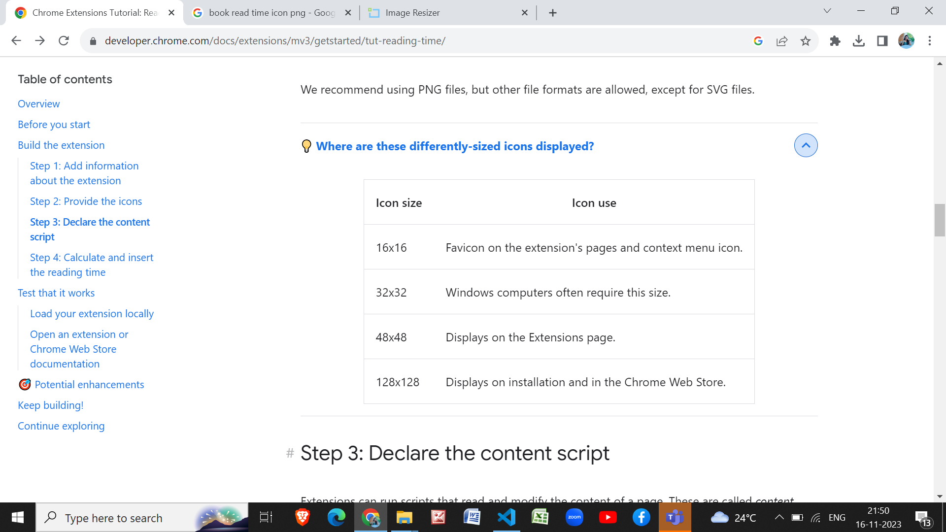

**Chrome Storage –** can be used to store, retrieve and track changes to user data. Even if the user clears the cache, the data persists.

**Background.js (Service-worker) –** works in background without affecting the page.

**Context Menus –** gives options while right clicking