SSL that is used to generate what is called the self-signed certificate.

Self-signed keys are not acceptable in the outside work.

But can be used for testing purpose for understanding the process of the secure communication between the client and server.

To create an SSl:

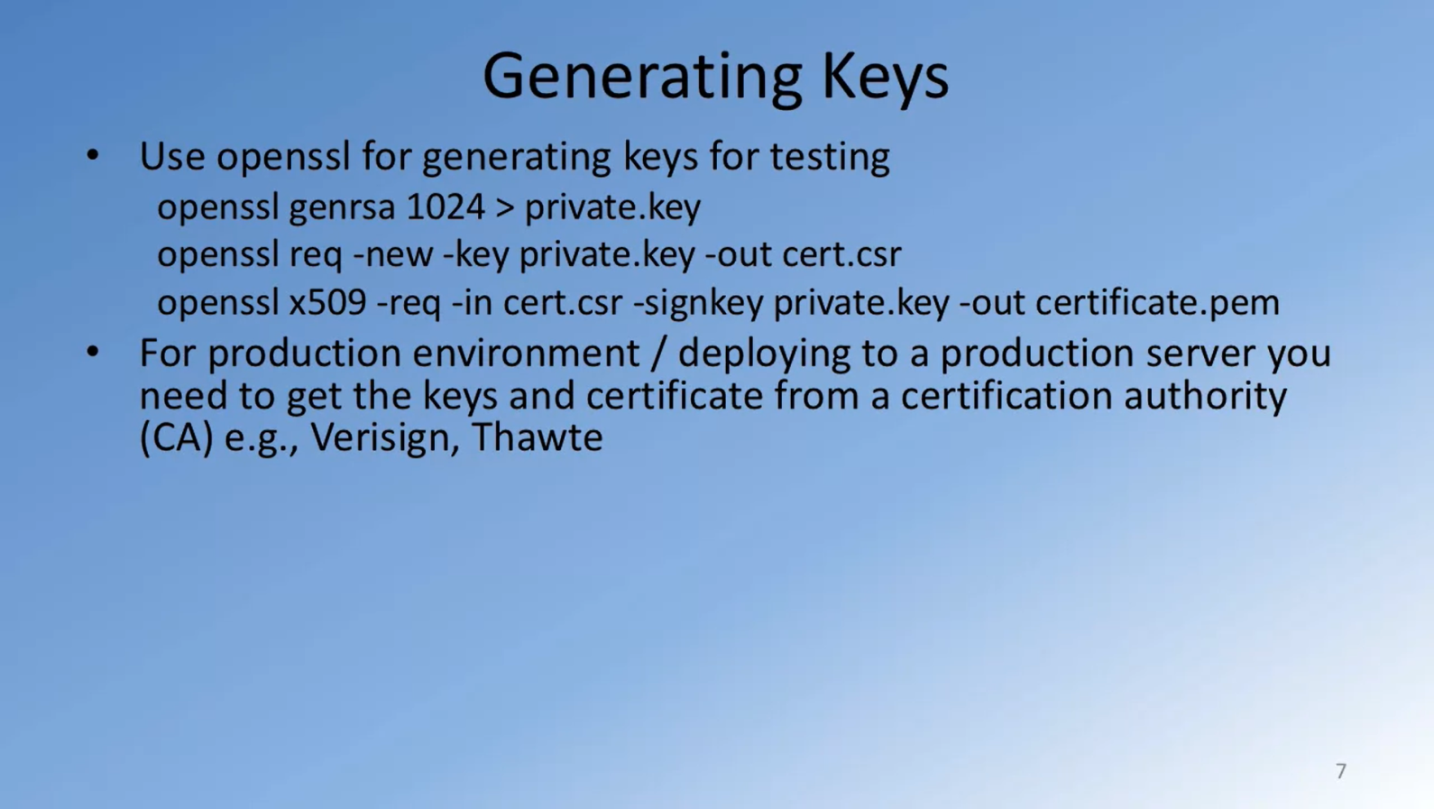

[how to make your own cert with OpenSSL on Windows](https://blog.didierstevens.com/2015/03/30/howto-make-your-own-cert-with-openssl-on-windows/) :

<https://blog.didierstevens.com/2015/03/30/howto-make-your-own-cert-with-openssl-on-windows/>