ASSIGNMENT 1

Q1:

Write a shell script which accepts length and breadth of a rectangle and calculates the area and perimeter of the reactangle

Code

read -p "Enter length : " len
read -p "Enter breadth : " br
area=$((len*br))
per=$((2*len+2*br))
echo "Area : $area"
echo "Perimeter : $per"

Input/ Output

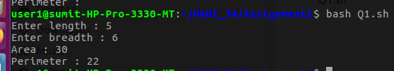

Q2:

Write a shell Script which accepts basic salary of an employee and calculates net salary and display the salary.

Code

read -p "Enter basic salary : " basic_sal
read -p "Enter DA percentage : " da

per=`echo "scale=2; (($basic_sal * $da) / 100) + $basic_sal" | bc`

echo $per

Input/ Output

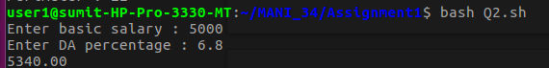

Q3:

Write a shell script which accepts a five digit number and prints the sum of its digits.

Code

read -p "Enter 5 digit number : " num
sum=0
while [ $num -gt 0 ]
do
rem=$num%10
num=$((num/10))
sum=$((sum+rem))
done
echo "Sum of digits : $sum"

Input/ Output

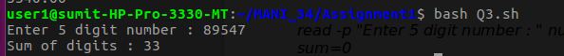

Q4:

Write a shell script which accepts a five digit number and reverse number.

Code

read -p "Enter a number : " num
cpy=$num
nod=0
while [ $cpy -gt 0 ]
do
nod=$((nod+1))
cpy=$((cpy/10))
done
cpy=$num
echo $nod
nod=$((nod-1))
rev=0
while [ $cpy -gt 0 ]
do
rem=$cpy%10
rem=$((rem*10**nod))
rev=$((rev+rem))
nod=$((nod-1))
cpy=$((cpy/10))
done
echo "Reversed : $rev"

Input/ Output

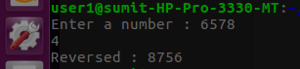

Q5:

The /etc/passwd file stores user account information it contains one entry per line for each user(user account) of the system. Each line contains seven fields which are separated by a colon(:) symbol. The fields are:
(i)Username
(ii) Password
(iii) User Id
(iv) Group Id
(v) User Id info
(vi) Home Directory
(vii) Login Shell

Write a shell script which accepts a user login name and diplays detail information about the users as available from the file/etc/passwd.

Code

`cd`
read -p "Enter username : " user
x=`cat /etc/passwd | grep $user`
g=`echo $x > file1`
echo "File created"
username=`cut -d ":" -f 1 file1`
echo "Username : $username"
echo "Password : `cut -d ":" -f 2 file1`"
echo "User ID : `cut -d ":" -f 3 file1`"
echo "Group ID : `cut -d ":" -f 4 file1`"
echo "User ID info : `cut -d ":" -f 5 file1`"
echo "Home Directory : `cut -d ":" -f 6 file1`"
echo "Login Shell : `cut -d ":" -f 7 file1`"
rm file1

Input/ Output

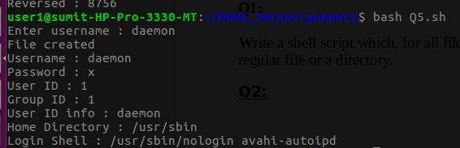

ASSIGNMENT 2

Q1:

Write a shell script which, for all files in present directory displays whether it is a regular file or a directory.

Code

lines=`ls -l | wc -l`
for (( i=2; i<=lines; i++ ))
do
temp=`ls -l | head -$i | tail -1`
line=`echo $temp > file`
echo -n `cut -d " " -f 9 file`
echo -n " : "
test=`cut -c 1 file`
if [ $test = "d" ]
then
echo "directory"
else
echo "file"
fi
`rm file`
done

Input/ Output

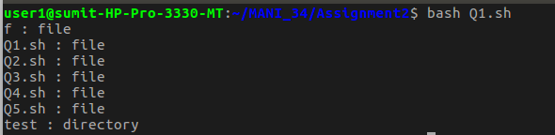

Q2:

The PATH variable is an environment variable that contains an ordered list of paths that Linux will search for executables when running a command. Write a shell script to display all the directories in the PATH variable in a simple way i.e., one line per directory. In addition, display information about each directory, such as the permissions and the modification times.

Code

IFS=:
for path in $PATH;
do
echo "Directory : $path"
x=`ls -ld $path | cut -d " " -f 1`
echo "Permissions : $x"
y=`ls -ld $path | cut -d " " -f 8`
echo "Modification time : $y"
done

Input/ Output

user1@sumit-HP-Pro-3330-MT:~/MANI_34/Assignment2$ bash Q2.sh
Directory : /home/user1/bin
ls: cannot access '/home/user1/bin': No such file or directory
Permissions :
ls: cannot access '/home/user1/bin': No such file or directory
Modification time :
Directory : /home/user1/.local/bin
ls: cannot access '/home/user1/.local/bin': No such file or directory
Permissions :
ls: cannot access '/home/user1/.local/bin': No such file or directory
Modification time :
Directory : /usr/local/sbin
Permissions : drwxr-xr-x
Modification time : 7
Directory : /usr/local/bin
Permissions : drwxr-xr-x
Modification time : 7
Directory : /usr/sbin
Permissions : drwxr-xr-x
Modification time : 9
Directory : /usr/bin
Permissions : drwxr-xr-x
Modification time : 9
Directory : /sbin
Permissions : drwxr-xr-x
Modification time : 2
Directory : /bin
Permissions : drwxr-xr-x
Modification time : 7
Directory : /usr/games
Permissions : drwxr-xr-x
Modification time : 7
Directory : /usr/local/games
Permissions : drwxr-xr-x
Modification time : 7
Directory : /snap/bin

Q3:

Write a shell script which dispalys vendor_id, model name, cpu Mhz, cache size information about the processor present in your computer. Hint : most of this information can be obtained by reading the file /proc/cpuinfo.

Code

`cd`
echo `cat /proc/cpuinfo | grep "vendor_id" | head -1`
echo `cat /proc/cpuinfo | grep "model name" | head -1`
echo `cat /proc/cpuinfo | grep "cpu MHz" | head -1`
echo `cat /proc/cpuinfo | grep "cache size" | head -1`

Input/ Output

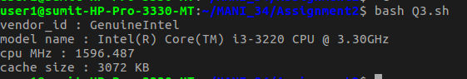

Q4:

Write a shell script to show your home directory, Operating System type, version, release number, kernel version and current path setting. Hint : use uname command or use content of /proc/sys/kernel/osrelease file.

Code

echo "Home directory : `pwd`"
echo "Operating System : `uname -o`"

echo "Release No. : `uname -r`"
echo "Kernel Version : `uname -v`"

echo "Current Path Setting : `echo $PATH`"

Input/ Output

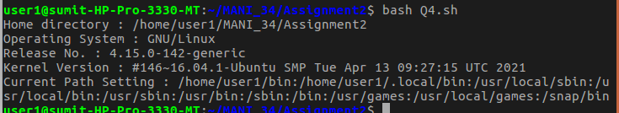

Q5:

Write a shell script to display a summary of the disk space usage for each directory argument(and any subdirectories), both in terms of bytes and kilobytes or megabytes(whichever is appropriate). [du -b]

Code

lines=`du -b | wc -l`
for (( i=1; i<=lines; i++ ))
do
line=`du -b | head -$i | tail -1`
`echo $line > temp`
byte=`cut -d " " -f 1 temp`
dire=`cut -d " " -f 2 temp`
if [ $dire == "." ]
then
dire="Current Directory"
fi
echo "$dire is of size $byte bytes"
rm temp
done

Input/ Output

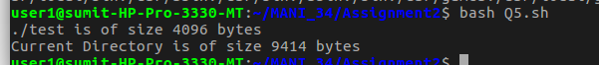

ASSIGNMENT 3

Q1:

Write a shell script that reads a input file that contains three integers in each line. The script should display the sum of all integers in each line.

Code

read -p "Enter file name : " file
sum=0
while read -r lines
do
sum=$((sum+lines))
done < $file
echo "Sum of numbers of file is : $sum"

Content of File -> Q1.txt

5
8
4

Input/ Output

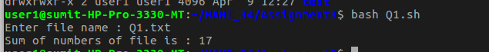

Q2:

Write a shell script that find out how many file and directory are there in the current directory. Also list the file directory names separately.

Code

echo "No of files : `ls -l | egrep -c '^-'`"
echo "****Files****"
for i in *
do
if [ -f $i ]
then
echo "$i"
fi
done
echo "No of directories : `ls -l | egrep -c '^d'`"
echo "****Directories****"
for i in *
do
if [ -d $i ]
then
echo "$i"
fi
done

Input/ Output

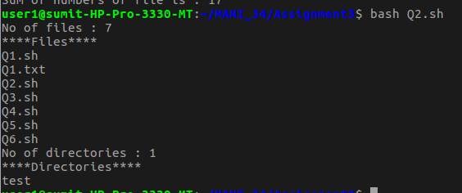

Q3:

Write a shell script that adds up the sizes reported by the ls command for the files in the current directory. The script should print out only the total number of bytes used.

Code

size=0
for i in *
do
if [ -f $i ]
then
field=`ls -l $i | cut -d " " -f 5`
echo "$i : $field"
size=$((size+field))
fi
done
echo "Total size bof the files in this directory : $size"

Input/ Output

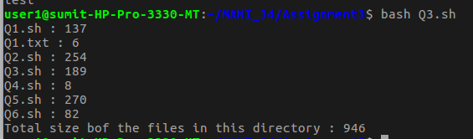

Q4:

Write a shell script that deletes all temporary files(end with ~) in the current directory.

Code

`rm *~`

Q5:

Write a shell script to rename file having extension .sh to .exe.

Code

files=`ls *.sh`
for file in $files
do
filename=`echo $file | cut -d "." -f 1`
filename+=".exe"
`mv $file $filename`
done

echo `ls`

for file in *
do
if [ -f $file ]
then

filename=`echo $file | cut -d "." -f 1`
filename+=".sh"
`mv $file $filename`
fi
done

Input/ Output

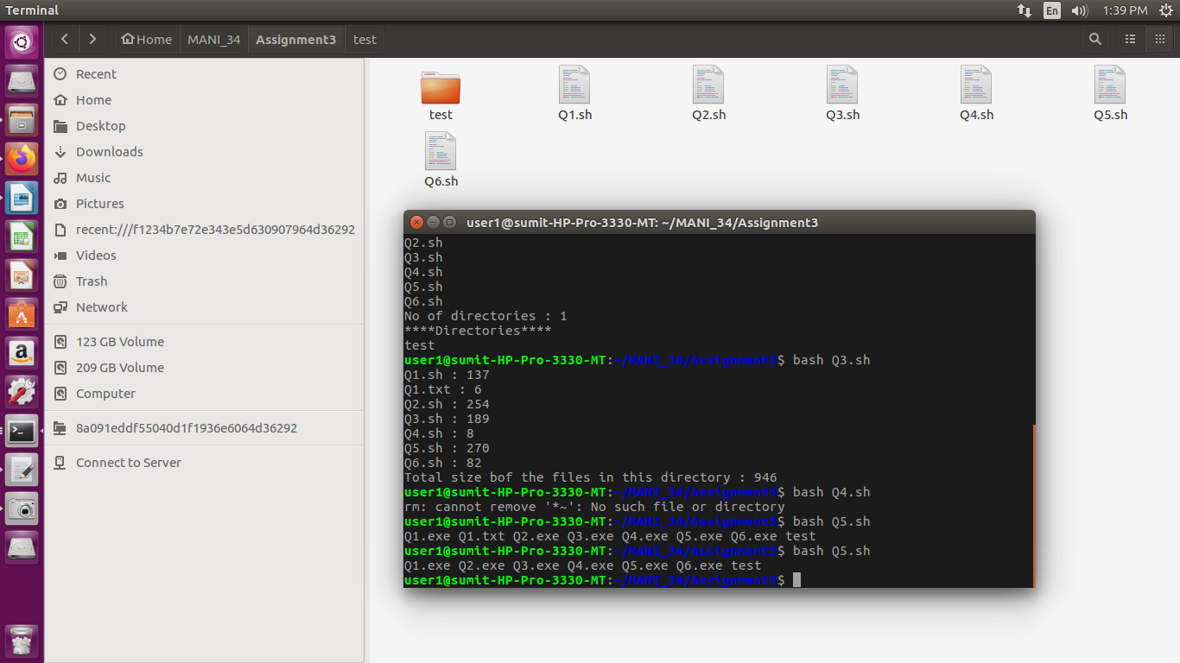

Q6:

Write a shell script to count number of shell scripts with .sh extension present in the current directory.

Code

echo -n "Number of files with .sh extension is : "
x=`ls -l *.sh | wc -l`
echo $x

Input/ Output

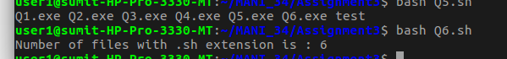

ASSIGNMENT 4

Q1:

Write a C program to create a child process. The parent process must wait until the child finishes. Both the processes must print their own pid and parent pid. Additionally, the parent process should print the exit status of the child.

Code

#include<stdio.h>
#include<unistd.h>
#include<stdlib.h>
int main()
{
int cstatus;
printf("The pid of parent is : %d(before creating a child process)\n",getpid());
int x = fork(); //x will be 0 if it is a children process else it will be >0
if(x==0)
{

printf("Children Process : %d, my parent id : %d\n",getpid(),getppid());

}
else
{
int pid = wait(&cstatus); //this will wait untill the children process gets executed
if(pid==x)
{
printf("Child %d finished with status %d\n",x,cstatus);
printf("Parent process : %d, my parent id : %d\n",getpid(),getppid());
}
}

}

Input/ Output
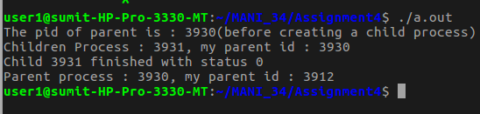

Q2:

Write a C program which prints prime numbers between the range 1 to 1000000 by creating ten child processes and subdividing the task equally among all child processes i.e., the first child should print prime numbers in the range 1 to 100000, them second child in the range 100001 – 200000. The child processes must run in parallel and the parent process must wait until all the child processes finish.

Code

#include<stdio.h>
#include<unistd.h>
#include<stddef.h>
#include<stdlib.h>
int prime(int num)
{
if(num<=1) return 0;
for(int i=2;i<=num/2;i++)
{
if(num%i==0)
return 0;
}
return 1;
}
void range(int start, int end)
{
for(int i=start;i<=end;i++)
{
if(prime(i))
printf("%d ",i);
}
}
int main()
{
int cstatus,start=1,brk=100;
pid_t pid,cpid;
for(int i=0;i<10;i++)
{
pid=fork();
if(pid==0)
{
printf("Child %d\n",i+1);
range(start,brk);
printf("\n");
exit(0);
}
else if(pid<0)
{
perror("fork");
exit(1);
}
else{
start=brk+1;
brk=brk+100;
}
}
for(int j=0;j<10;j++)
wait(NULL);
return 0;
}

Output

Child 1
2 3 5 7 11 13 17 19 23 29 31 37 41 43 47 53 59 61 67 71 73 79 83 89 97
Child 2
101 103 107 109 113 127 131 137 139 149 151 157 163 167 173 179 181 191 193 197 199
Child 3
211 223 227 229 233 239 241 251 257 263 269 271 277 281 283 293
Child 4
307 311 313 317 331 337 347 349 353 359 367 373 379 383 389 397
Child 5
401 409 419 421 431 433 439 443 449 457 461 463 467 479 487 491 499
Child 6
503 509 521 523 541 547 557 563 569 571 577 587 593 599
Child 7
601 607 613 617 619 631 641 643 647 653 659 661 673 677 683 691
Child 8
701 709 719 727 733 739 743 751 757 761 769 773 787 797
Child 9
809 811 821 823 827 829 839 853 857 859 863 877 881 883 887
Child 10
907 911 919 929 937 941 947 953 967 971 977 983 991 997

