I created a EC2 instance(bunny) with EC2_Full_access role attached to it.The EC2_Full_access role should have a Administrator_Full_access policy attached to it.

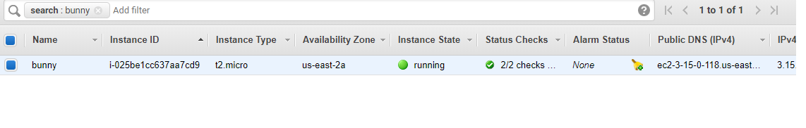

Now,ssh into this EC2 instance and run the following commands to install Terraform:

*sudo yum install -y zip unzip (if these are not installed)*

*wgethttps://releases.hashicorp.com/terraform/0.12.5/terraform_0.12.5_linux_amd64.zip*

*unzip terraform_0.12.5_linux_amd64.zip*

*sudo mv terraform /usr/local/bin/*

Confirm terraform binary is accessible: *terraform --version*

*Now,write down two files.*

1. *ec2.tf*
2. *variables.tf*

*ec2.tf*

*security_group_ids = ["${aws_security_group.sg_http_ssh.id}"]vpc_security_group_ids = ["${aws_security_group.sg_http_ssh.id}"]*

*region = "us-east-2"*

*}*

*resource "aws_instance" "example" {*

*ami = "ami-0d8f6eb4f641ef691"*

*instance_type = "t2.micro"*

*count = "${var.instance_count}"*

*tags = {*

*Name = "<instance_name>-${count.index + 1}"*

*}*

*vpc_security_group_ids = ["${aws_security_group.sg_http_ssh.id}"]*

*}*

*resource "aws_security_group" "sg_http_ssh" {*

*name = "sg_http_ssh"*

*description = "Web Security Group"*

*ingress {*

*from_port = 80*

*to_port = 80*

*protocol = "tcp"*

*cidr_blocks = ["0.0.0.0/0"]*

*}*

*ingress {*

*from_port = 22*

*to_port = 22*

*protocol = "tcp"*

*cidr_blocks = ["0.0.0.0/0"]*

*}*

*egress {*

*from_port = 0*

*to_port = 0*

*protocol = "-1"*

*cidr_blocks = ["0.0.0.0/0"]*

*}*

*}*

*Variables.tf*

*variable "instance_name" {*

*description = "Name to be used on all resources as prefix"*

*type = string*

*}*

*variable "instance_count" {*

*description = "Number of instances to launch"*

*type = number*

*default = 2*

*}*

*Now,perform the following commands one by one.*

*terraform init*

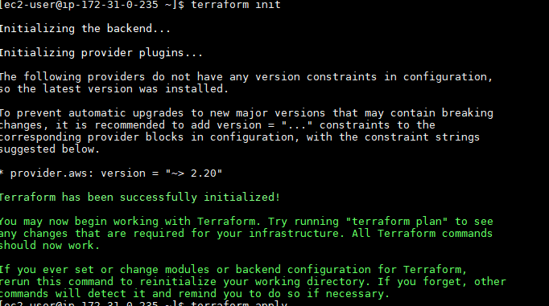

*terraform plan*

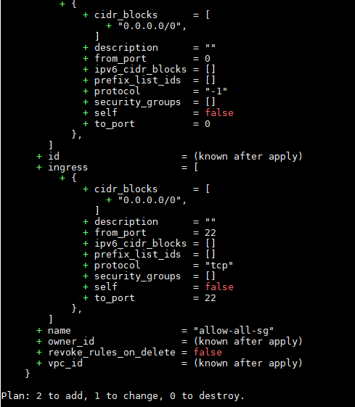

*terraform apply*

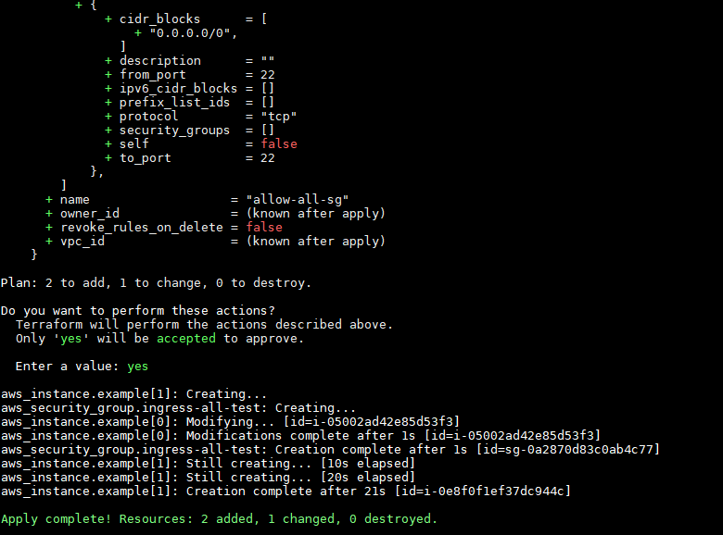

*In the aws console,when I see,my 2 instances are created.*



