Create three ec2-instances one master and two slaves.



SSh into these instances and install genkins in them with following commands.

sudo yum update -ysudo yum update -y

sudo wget -O /etc/yum.repos.d/jenkins.repo http://pkg.jenkins.io/redhat/jenkins.repo

sudo rpm --import https://pkg.jenkins.io/redhat/jenkins.io.key

sudo yum install jenkins -y

sudo service jenkins start

 http://*your-server-address*:8080, you will be prompted to unlock Jenkins:

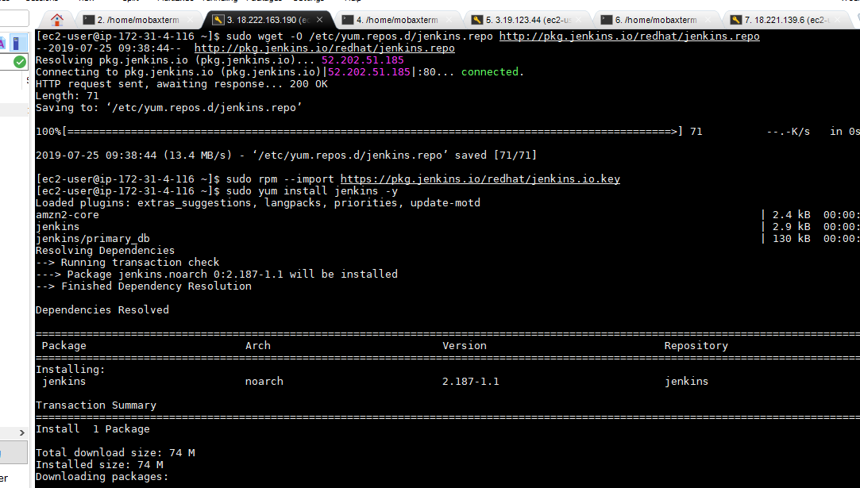

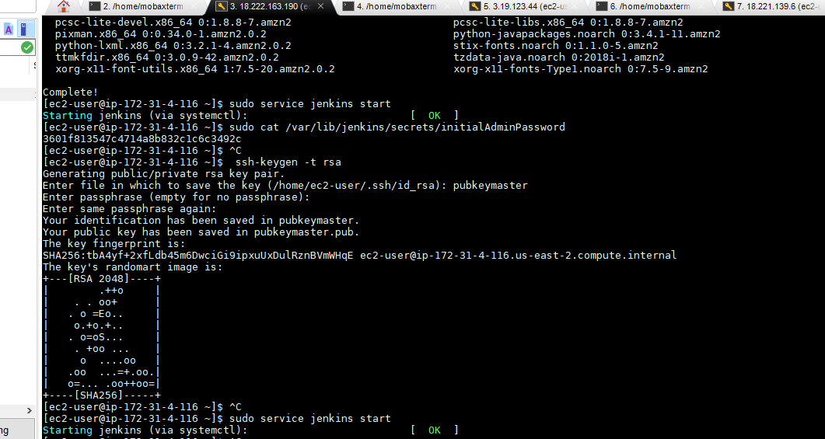

And install java in all the three instances using the following command

Sudo yum install java-1.8.0-openjdk-dlevel

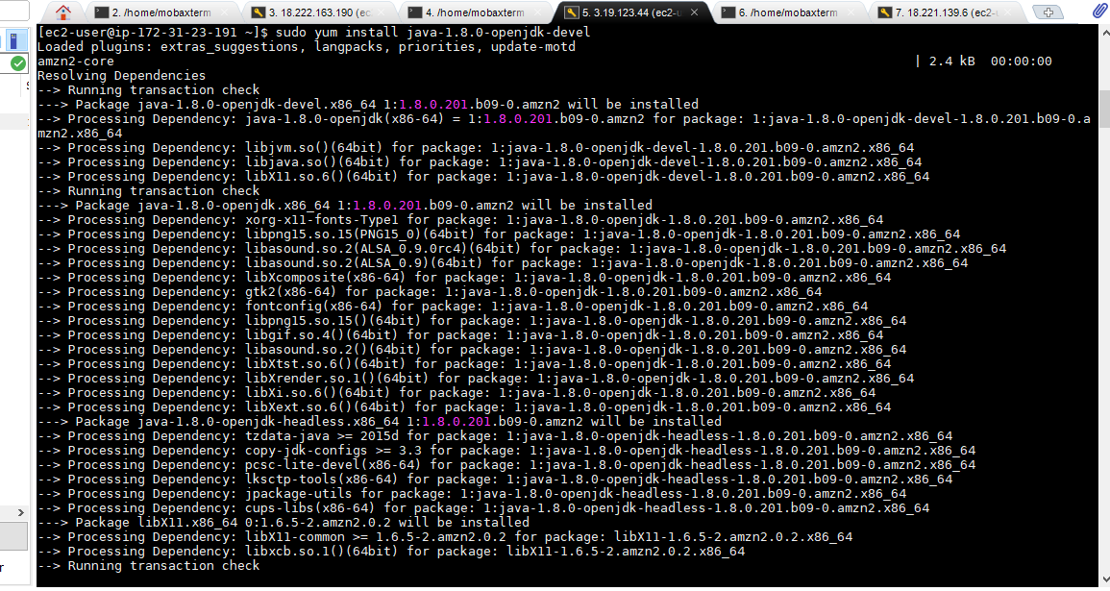

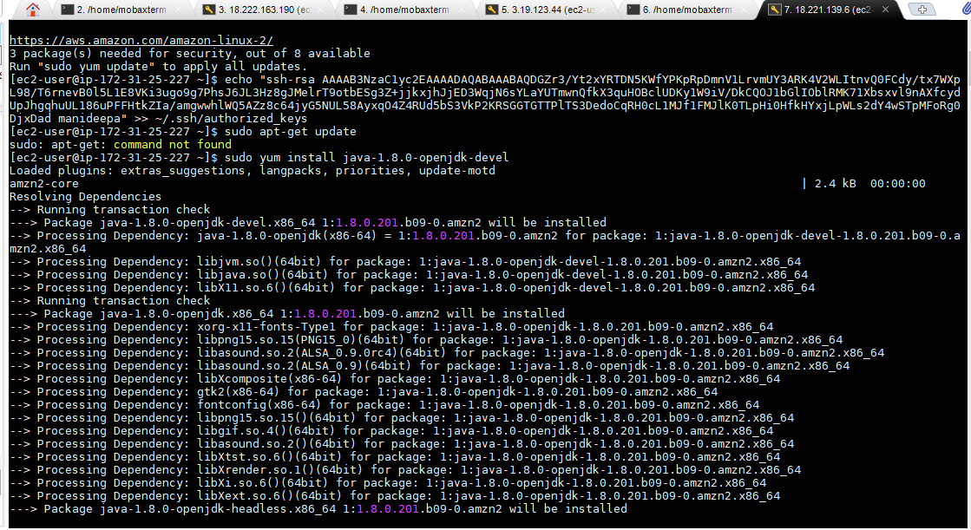

Now,login to jenkins dashboard and create a master node and two slave nodes.

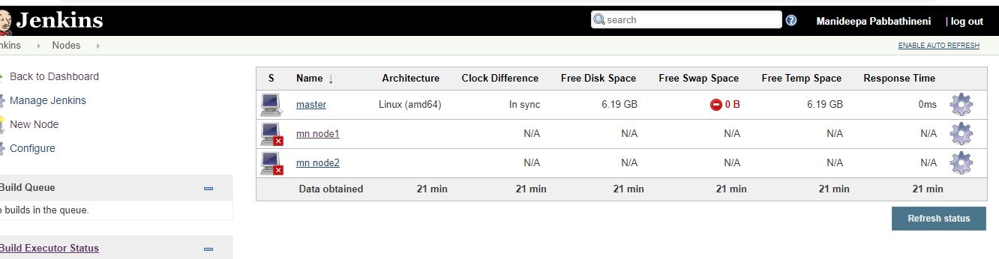

Create three jobs.

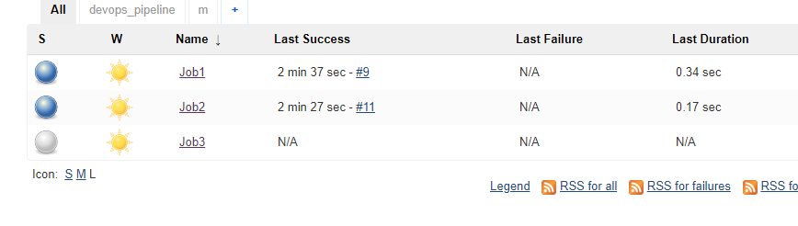

In the first job,provide the directory link to be downloaded in job1 and to be uploaded to s3 bucket in job2.

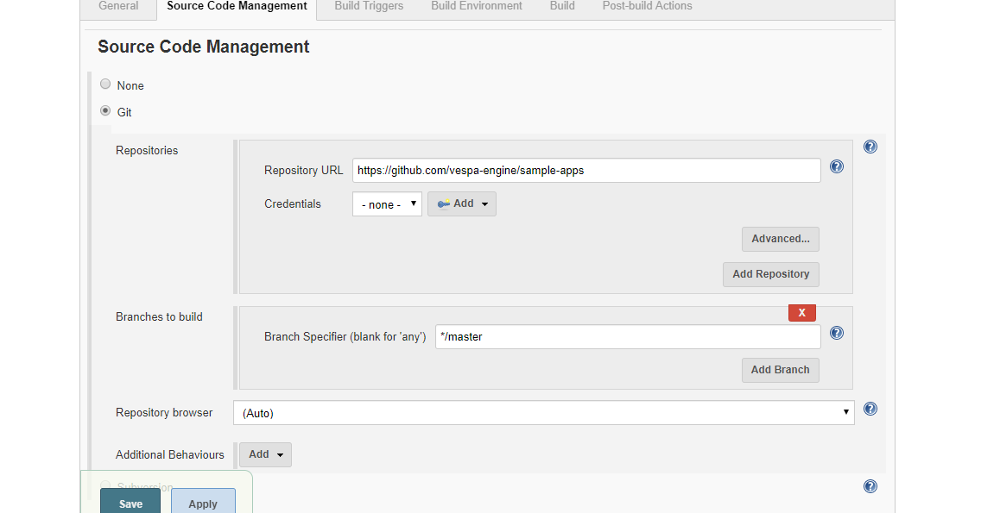

In the build section,select copy artifract from another project to enable job2 to access the files in the workspace of job1.

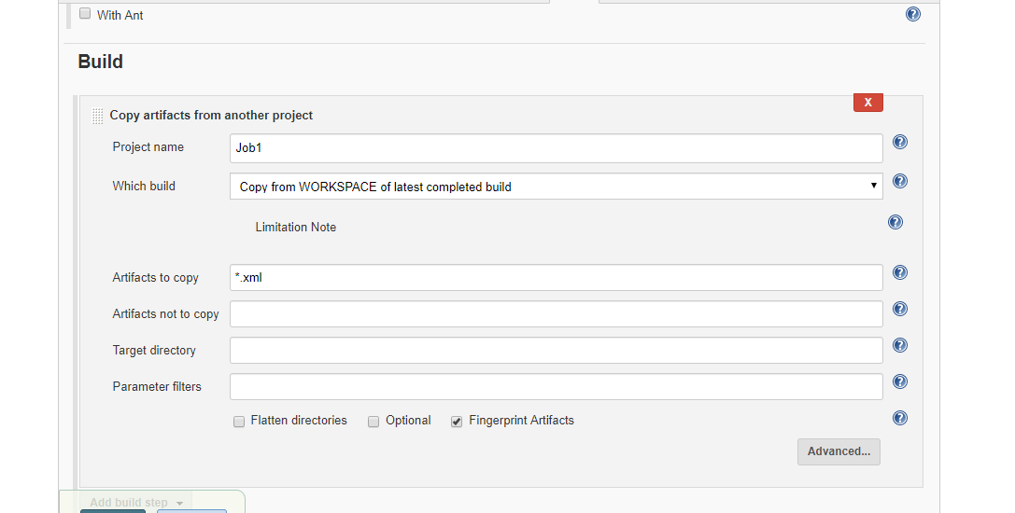

In job2 ,go to configure and provide the details of the file to be uploaded and the bucket in which it should be uploaded.

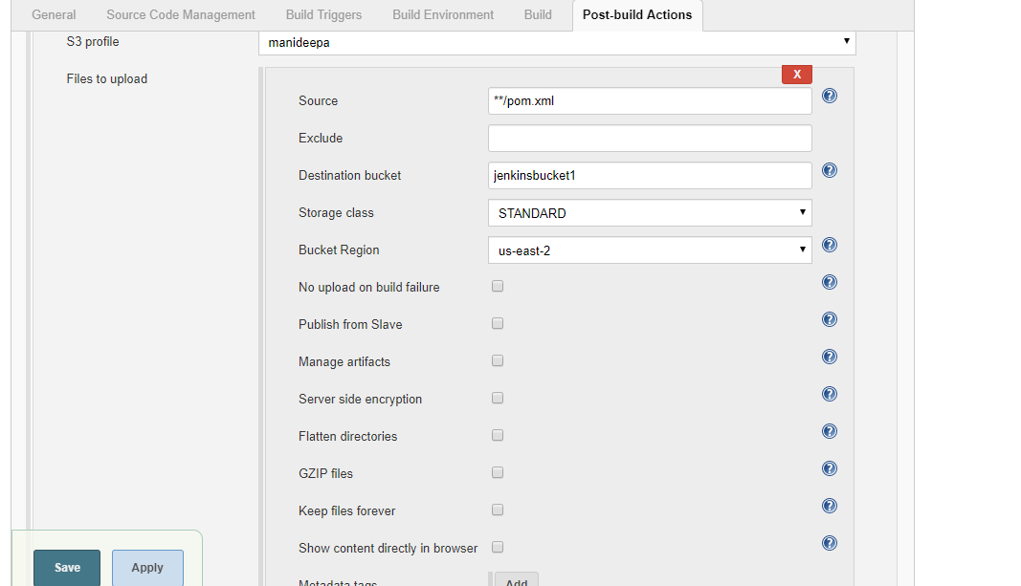

Now,build the firstjob.

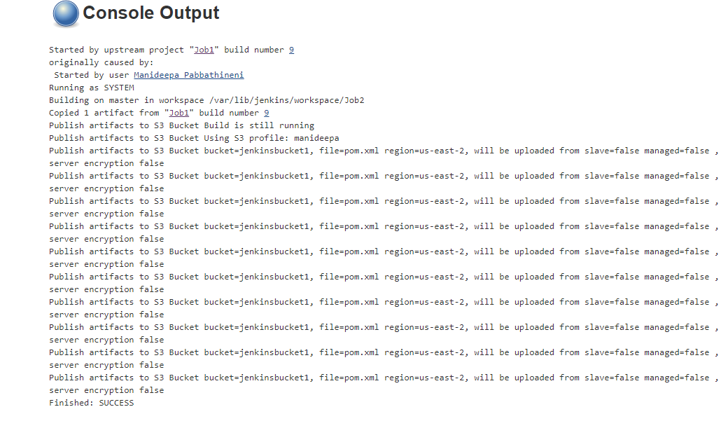

As we can see when we build the job,the files are uploaded to the bucket.

