Code for dockerfile

FROM ubuntu:16.04

MAINTAINER Manideepa

RUN apt-get update \

&& apt-get install -y nginx \

&& apt-get clean \

&& rm -rf /var/lib/apt/lists/* /tmp/* /var/tmp/* \

&& echo "daemon off;" >> /etc/nginx/nginx.conf

RUN echo 'HII WELCOME' > /usr/share/nginx/html/index.html

EXPOSE 80

CMD ["nginx"]

To bash into container

docker exec -it 178204187bd6<container_name> /bin/bash

ctrl+p+ctrl+q

To install nano inside the container

docker exec -it 178204187bd6<container_name> apt-get install nano<command>

To install docker-compose

sudo curl -L "https://github.com/docker/compose/releases/download/1.24.1/docker-compose-$(uname -s)-$(uname -m)" -o /home/ubuntu/docker-compose

sudo chmod +x /home/ubuntu/docker-compose

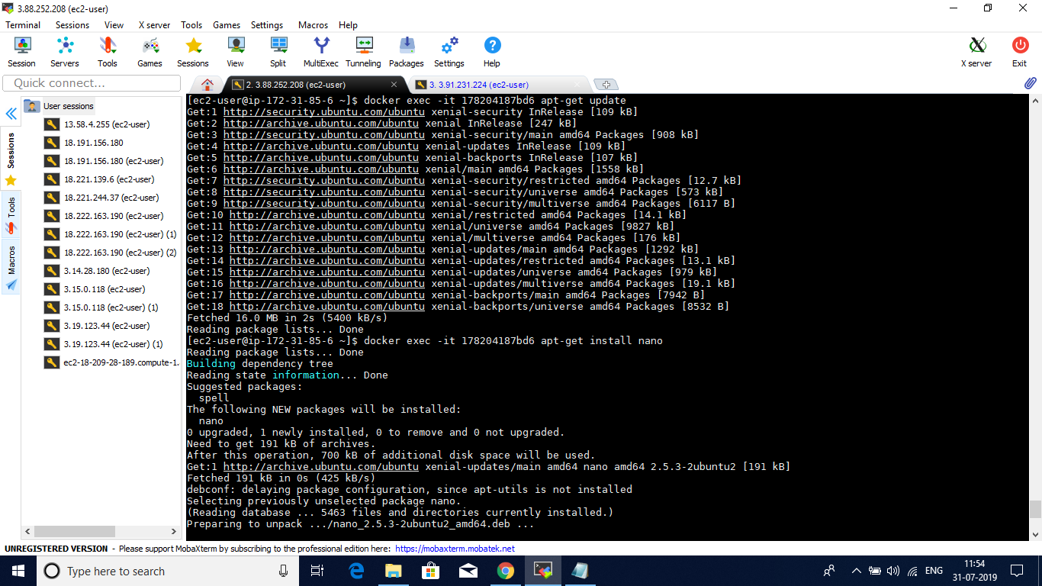

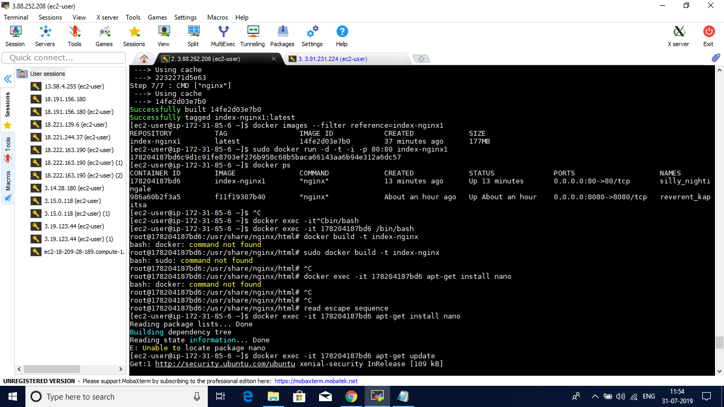

PUSHING INTO DOCKER REPOSITORY

docker login

docker images

Here,you will be able to see the image id and other details.

Tag your image.

docker tag 14fe2d03e7b0 manideepapabbathineni28/munny:firsttry

docker push manideepapabbathineni28/munny

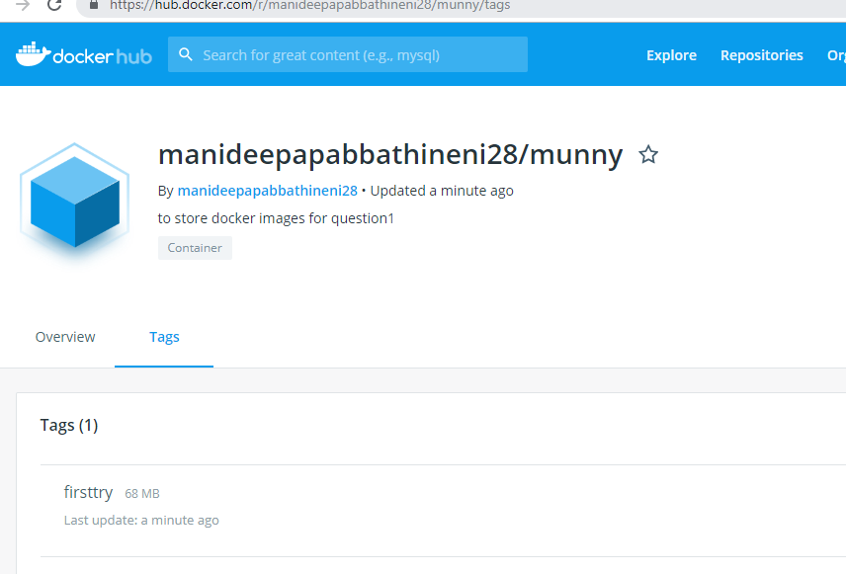

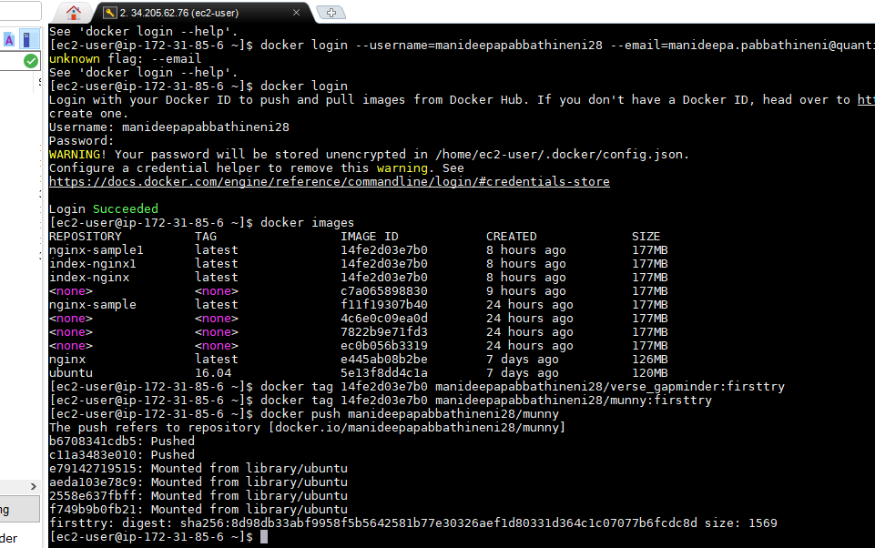

PUSHING INTO ECR

Install awscli on ec2 instance

awscli --upgrade --user

pip3 install --upgrade --user awscli

aws ecr create-repository --repository-name hello-repository --region us-east-1

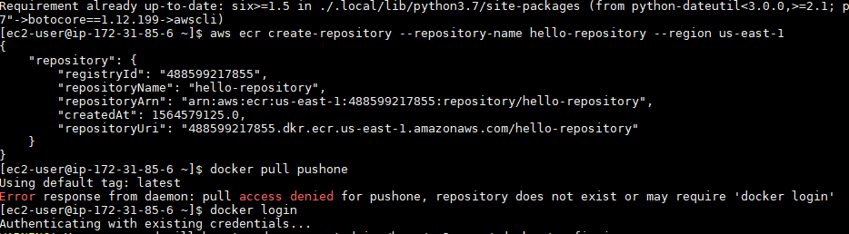

docker tag nginx-sample1 488599217855.dkr.ecr.us-east-1.amazonaws.com/hello-repository

docker push 488599217855.dkr.ecr.us-east-1.amazonaws.com/hello-repository"

PUSHING INTO GCR

Tag the local image with the registry name by using the command:

docker tag 14fe2d03e7b0 gcr.io/pe-training

/nginx-sample1

Push the tagged image to Container Registry by using the command:

docker push gcr.io/pe-training/nginx-sample1

gcloud container images list-tags gce.io/pe-training/nginx-sample1