Create a ubuntu instance with security groups with inbound rules as follows:

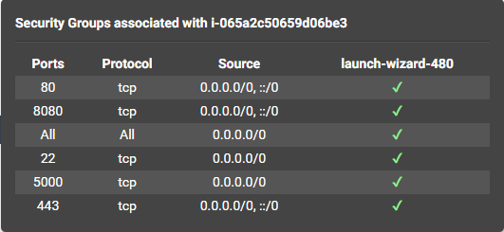

Now,ssh into that instance through Mobaxterm and run the following commands.

1. Install Python using the following command

sudo apt install python3

1. Update the packages using the following command

Sudo apt-get update -y

1. Now,install docker

Sudo apt install docker.io

1. Install docker-compose

Sudo apt install docker-compose

1. Create four files in the current working directory.

app.py

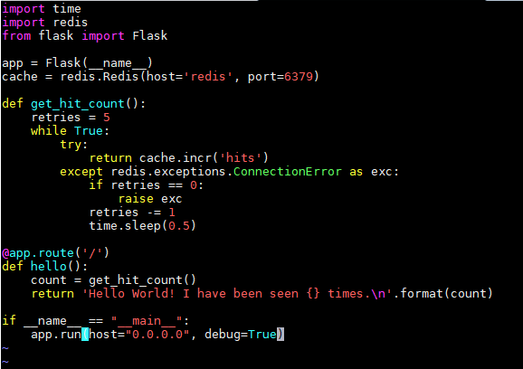

Dockerfile

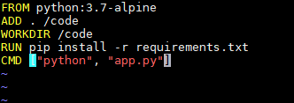

Docker-compose.yaml

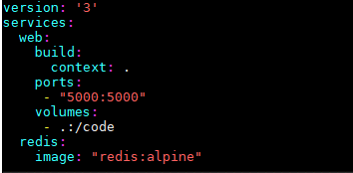

requirements.txt

redis

Flask

1. Now go to root user

sudo su

1. Run

Docker-compose up

These files get run and in the browser run

<http://localhost:5000>

For my instance,it is

<http://54.211.198.196:5000>

When I run this,the output is

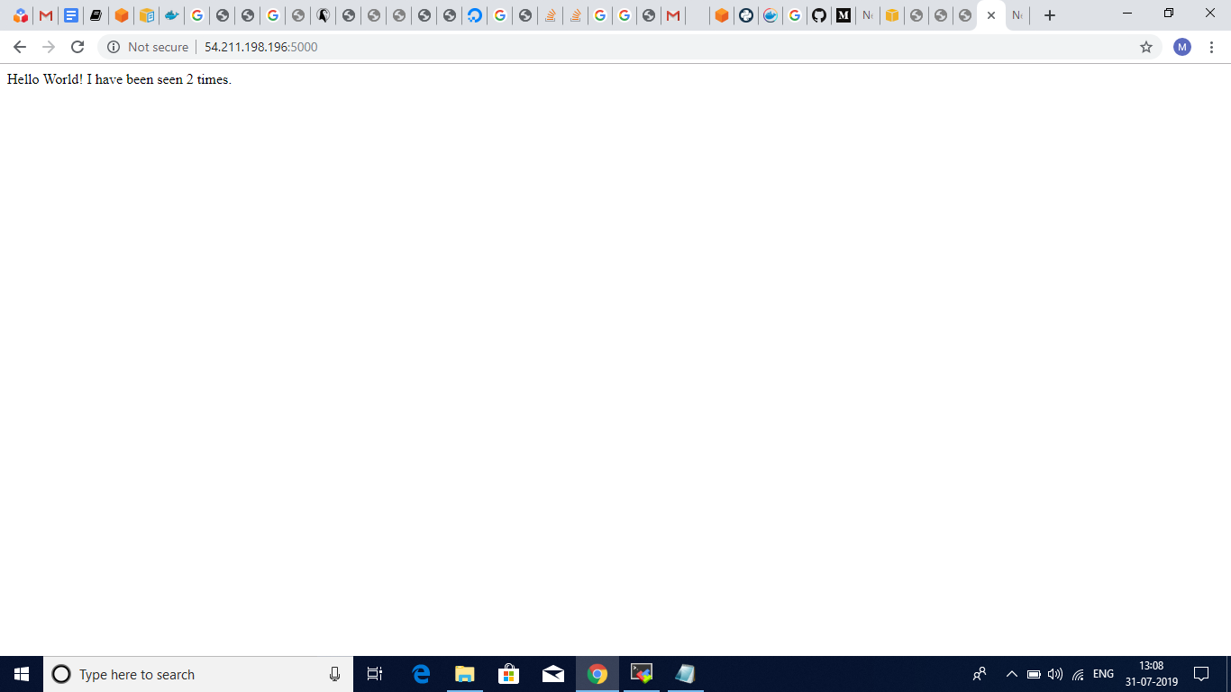

The above output is when I ran two times.

When I refresh again,the output displays 3 times

