All the files are same as the before problem,except docker-compose.yaml

Docker-compose.yaml

version: ‘3’

services:

web:

build:

context: .

ports:

-”5000:5000”

volumes :

- . :/code

redis:

image: “redis:alpine”

Here,we are creating a volume,mounting it and configuring it in docker-compose.yaml file.

Now,run <http://localhost:5000>

For my instance it is

<http://54.211.198.196:5000>

The output is

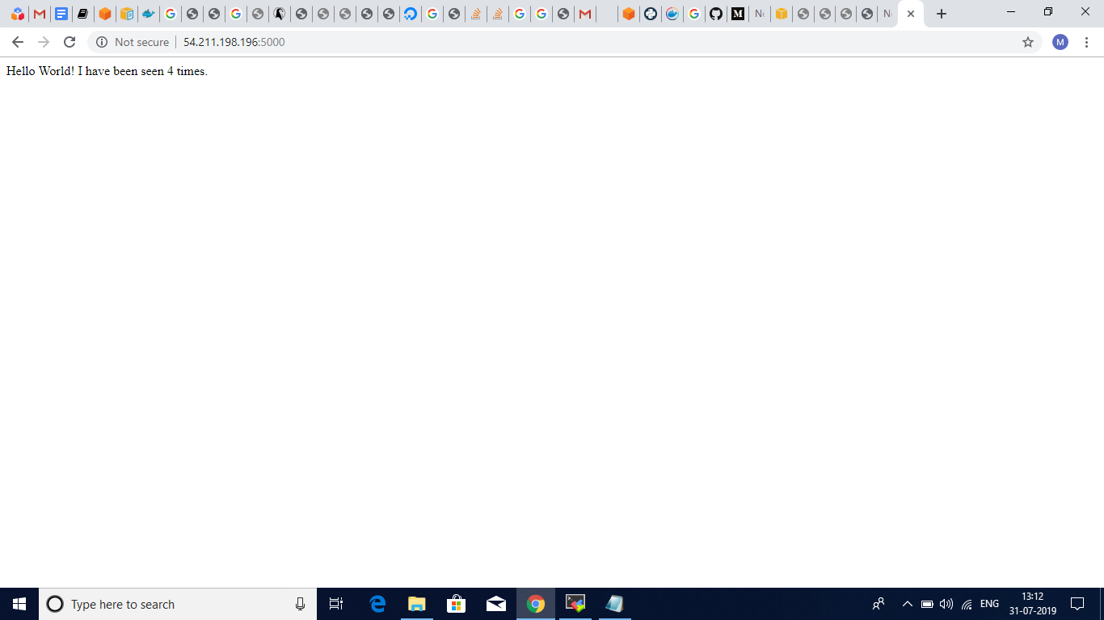

I have run it 3 times in the previous question and now when you run it it shows 4 times.