Create two instances in the same vpc(default)

One instance with no External Ip (bunny1) and the other instance with External Ip(bunny2)

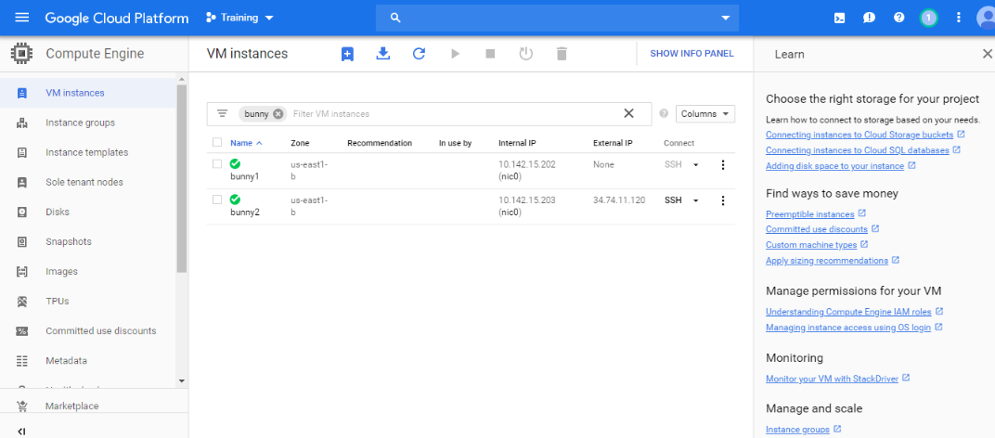

Now,ssh through bunny2 and run the commans

ssh bunny1

Ping 8.8.8.8(to connect to google)

It does not show anything.

When you create a NAT gateway it gets connected to internet.

Create two instances in the same vpc(default)

One instance with no External Ip (bunny1) and the other instance with External Ip(bunny2)

Now,ssh through bunny2 and run the commans

ssh bunny1

Ping 8.8.8.8(to connect to google)

It does not show anything.

When you create a NAT gateway it gets connected to internet.

