CONFIGURING WORKSPACE

1}Create a gcp project.

2}I have created a project named Quickstart.

3}Create a Workspace.(add your project to a workspace)

4}Go to stackdriver monitoring console and select monitored accounts.

5}Add an aws account.Note the accountid and Externalid.

The accountid and externalid of my aws account are

accountid:314658760392

externalid:sd7138670

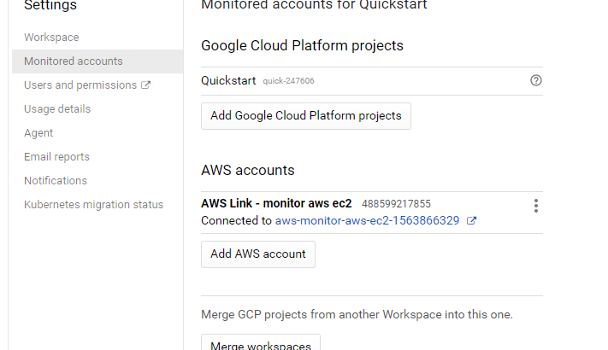

6}CREATING AWS ROLE

Give Readonlyaccess policy to AWS role.

7}CONNECTING AWS ACCOUNT

Add aws account with the accountid and externalid noted down.

Attach arn of the role created here.

8}AWS connector projects

When you connect to an AWS account, Monitoring creates an AWS connector project for you. The Monitored accounts page in your Workspace settings now includes the ID for this project:

Your AWS account description [YOUR_AWS_ACCOUNT_NUMBER]

Connected to [CONNECTOR_PROJECT_ID]

9}Create a Service Account

--To create the service account, go to the IAM & Admin > Service accounts page for your connector project.

--Select the AWS connector project (named AWS Link...) for your AWS account.

--In the Role field, add both of the following values:

Monitoring > Monitoring Metric Writer

Logging > Logs Writer

The service account's private-key file is downloaded to your workstation with a name such as Downloads/[PROJECT_NAME]-[KEY_ID].json

10}

Execute the following command

CREDS="Downloads/[PROJECT_NAME]-[KEY_ID].json"

11}

From your workstation, copy the Stackdriver private-key credentials file to your AWS EC2 instance and save it in a file named temp.json. In the scp command, specify the path to key.pem, your AWS SSH key pair file, and provide your AWS credentials:

KEY="/path/to/key.pem"

scp -i "$KEY" "$CREDS" AWS_USERNAME@AWS_HOSTNAME:temp.json

12}

On your EC2 instance, move the credentials to /etc/google/auth/application_default_credentials.json:

GOOGLE_APPLICATION_CREDENTIALS="/etc/google/auth/application_default_credentials.json"

sudo mkdir -p $(dirname "$GOOGLE_APPLICATION_CREDENTIALS")

sudo mv "$HOME/temp.json" "$GOOGLE_APPLICATION_CREDENTIALS"

13}

Using Stackdriver services with AWS

Create an uptime check

Create an alerting policy

Add Notifications

Create a dashboard and chart

View your logs

The logs of your aws-connector-project contains aws logs.