I created a vm instance (munny) and added a startup script in automation section to install apacheserver.

startup script

#! /bin/bash

apt-get update

apt-get install -y apache2

cat <<EOF > /var/www/html/index.html

<html><body><h1>Manideepa</h1>

</body></html>

EOF

Now,through chrome browser, type http://[external_ip_of_the_created_instance]

external ip of my instance is 34.74.92.115

when i ran http://34.74.92.115 it displayed myname(Manideepa) on my browser.

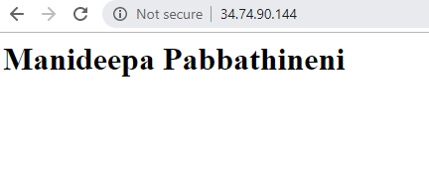

Now,through cli,

TO STOP THE INSTANCE

gcloud compute instances stop <instance_name>

By running this command,my instance(munny) has stopped.

Again,

TO START THE INSTANCE

gcloud compute instances start <instance_name>

By running this command,my instance(munny) has started again.

The externalip is changed.

Now,again run http://[external_ip_of_the_created_instance]

new external ip=http://35.231.237.170

run http://35.231.237.170

It will display my name on the browser.

