11
Commands to enable change tracking:

SELECT *
FROM sys.change_tracking_databases
WHERE database_id=DB_ID('M3FDBGRD')

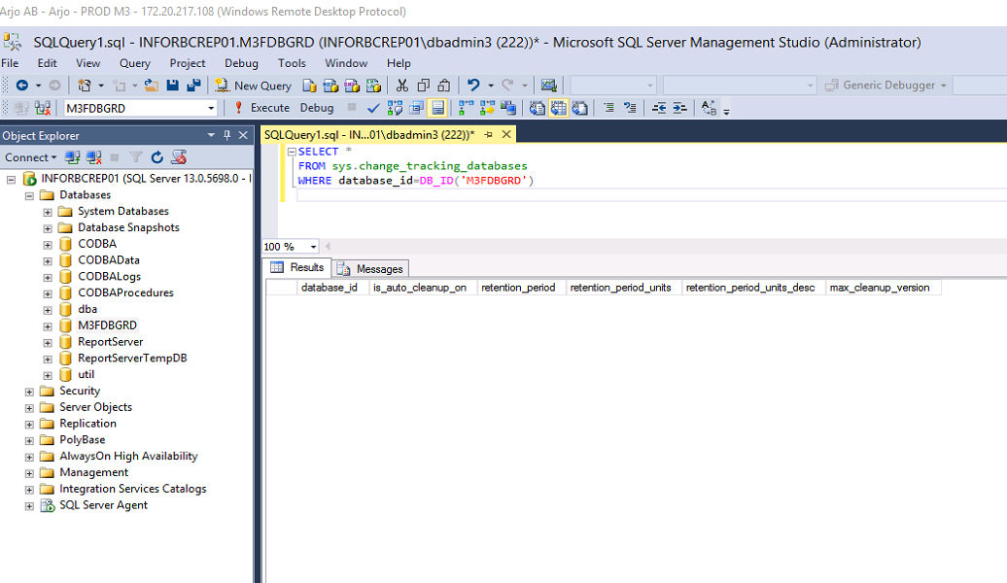
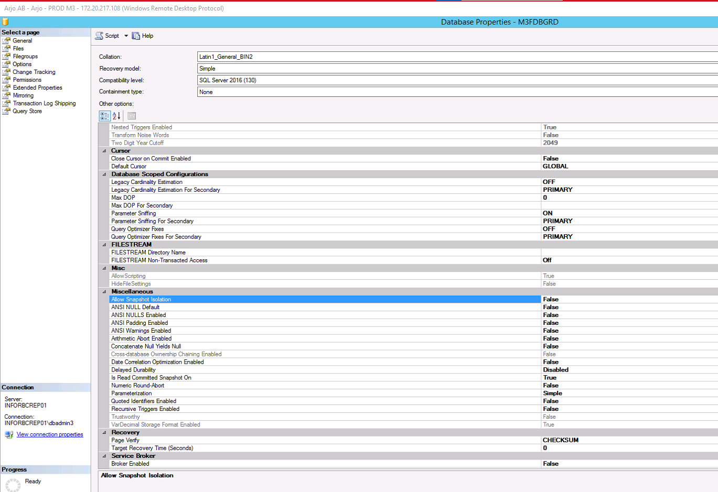

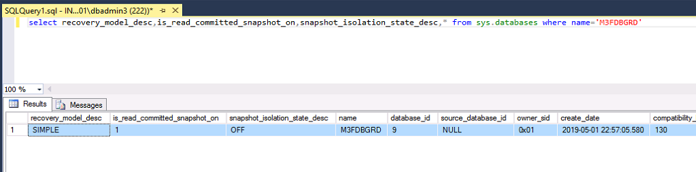

USE master;
-- Enable snapshot isolation
ALTER DATABASE M3FDBGRD
SET READ_COMMITTED_SNAPSHOT ON
GO

ALTER DATABASE M3FDBGRD
SET ALLOW_SNAPSHOT_ISOLATION ON
GO

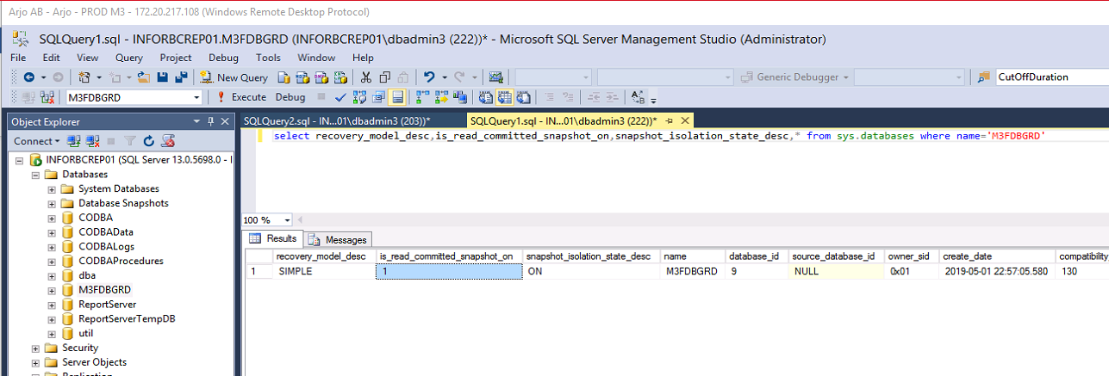

use M3FDBGRD;

ALTER DATABASE M3FDBGRD
SET CHANGE_TRACKING = ON
(AUTO_CLEANUP = ON)

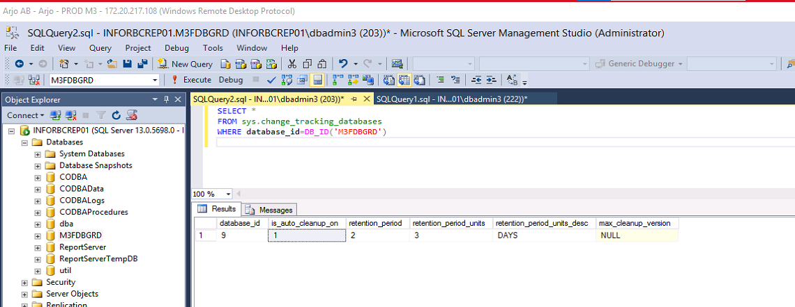

SELECT * FROM sys.change_tracking_tables

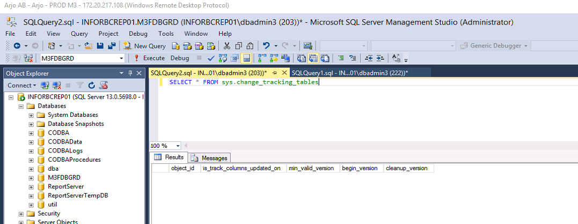

ALTER TABLE MVXJDTA.MITLOC ENABLE CHANGE_TRACKING
WITH (TRACK_COLUMNS_UPDATED = OFF)

ALTER TABLE MVXJDTA.MITPLO ENABLE CHANGE_TRACKING
WITH (TRACK_COLUMNS_UPDATED = OFF)

ALTER TABLE MVXJDTA.MITSTA ENABLE CHANGE_TRACKING
WITH (TRACK_COLUMNS_UPDATED = OFF)

ALTER TABLE MVXJDTA.SINACC ENABLE CHANGE_TRACKING
WITH (TRACK_COLUMNS_UPDATED = OFF)

ALTER TABLE MVXJDTA.SPMINF ENABLE CHANGE_TRACKING
WITH (TRACK_COLUMNS_UPDATED = OFF)

ALTER TABLE CUSJDTA.ZSASTD ENABLE CHANGE_TRACKING
WITH (TRACK_COLUMNS_UPDATED = OFF)

ALTER TABLE CUSJDTA.ZZAGLI ENABLE CHANGE_TRACKING
WITH (TRACK_COLUMNS_UPDATED = OFF)

SELECT * FROM sys.change_tracking_tables

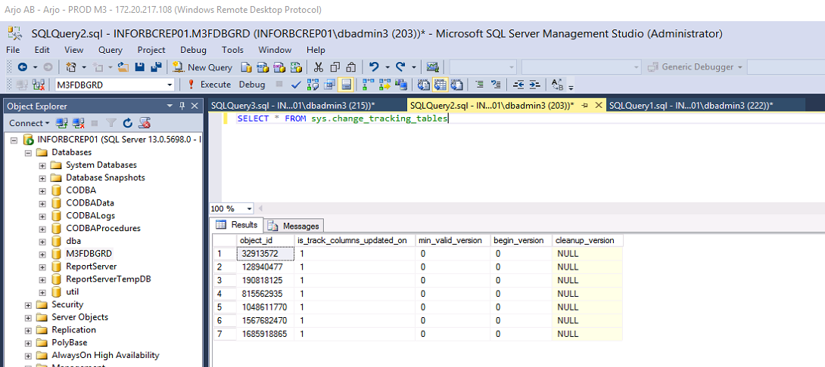

Commands to disable change tracking:

Disable change tracking at table level:
ALTER TABLE MVXJDTA.MITLOC DISABLE CHANGE_TRACKING
ALTER TABLE MVXJDTA.MITPLO DISABLE CHANGE_TRACKING
ALTER TABLE MVXJDTA.MITSTA DISABLE CHANGE_TRACKING
ALTER TABLE MVXJDTA.SINACC DISABLE CHANGE_TRACKING
ALTER TABLE MVXJDTA.SPMINF DISABLE CHANGE_TRACKING
ALTER TABLE CUSJDTA.ZSASTD DISABLE CHANGE_TRACKING
ALTER TABLE CUSJDTA.ZZAGLI DISABLE CHANGE_TRACKING

Disable change tracking at database level:
ALTER DATABASE M3FDBGRD
SET CHANGE_TRACKING = OFF

