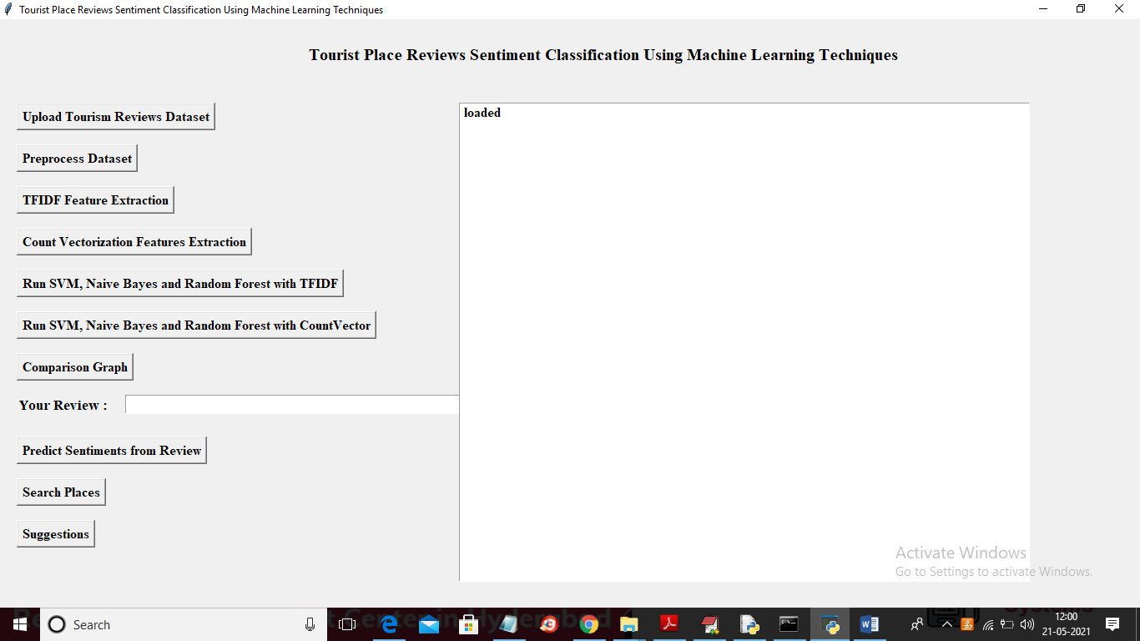
In above screen click on ‘Upload Tourism Reviews Dataset’ button to upload dataset
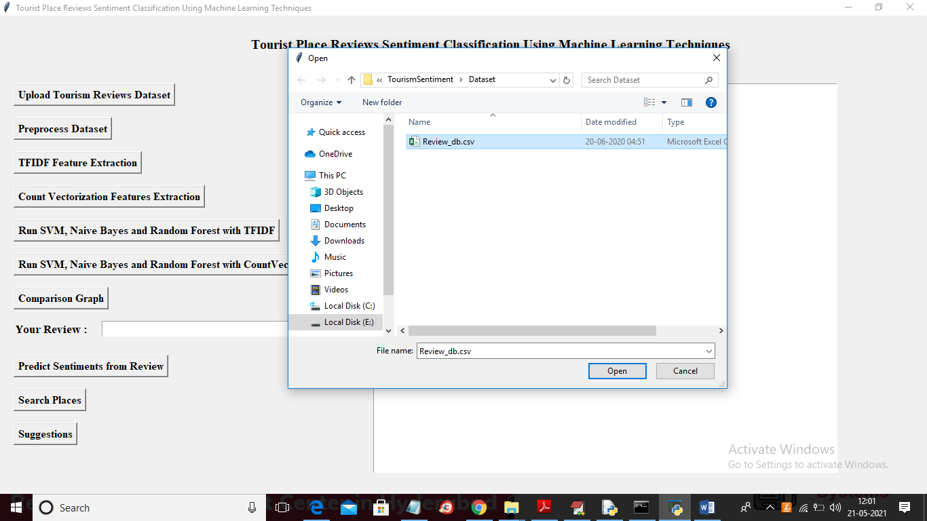
In above screen selecting and uploading reviews dataset and then run all button as previous code. Now see below dataset screen
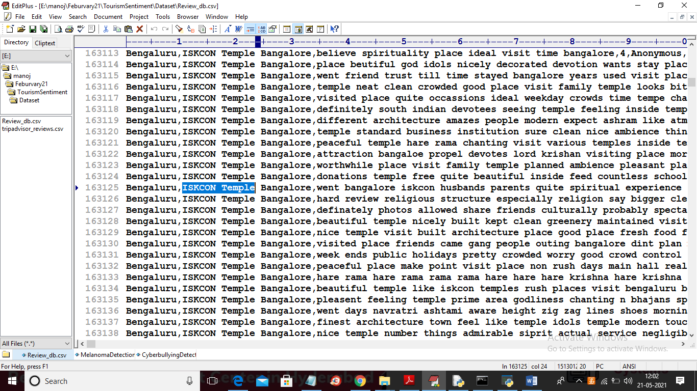
In above dataset screen select any place and then click on ‘Search Places’ field to get below screen
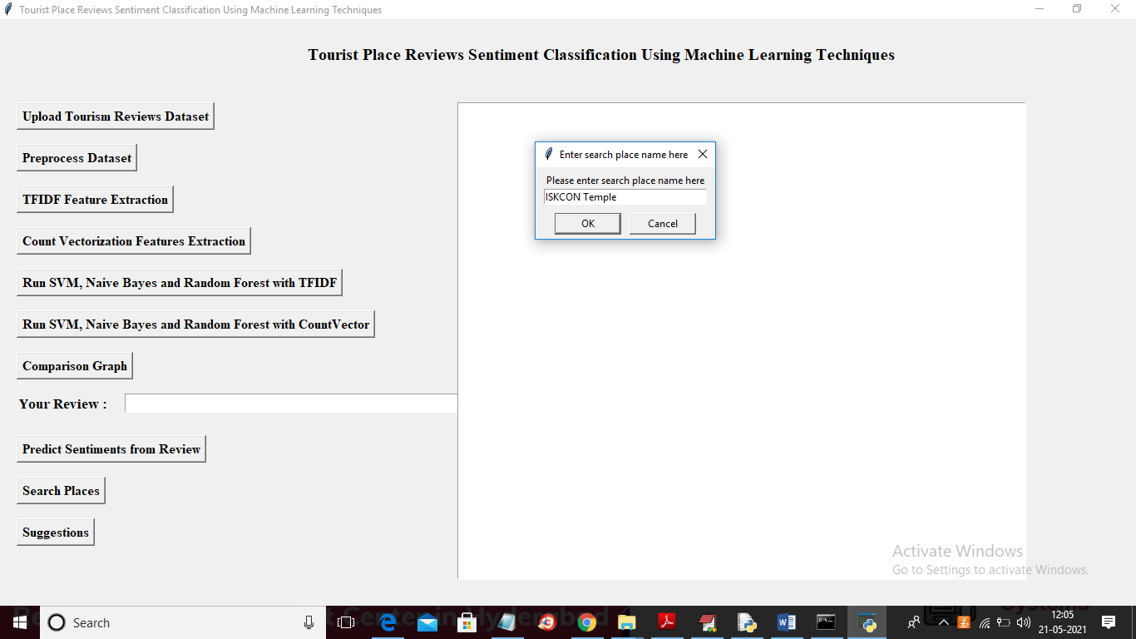
In above screen enter you place name in dialog box and click ‘OK’ button to get below output and this dataset contains more than 15 lacs record so I am using first 5 lacs records and if we use all system will hang
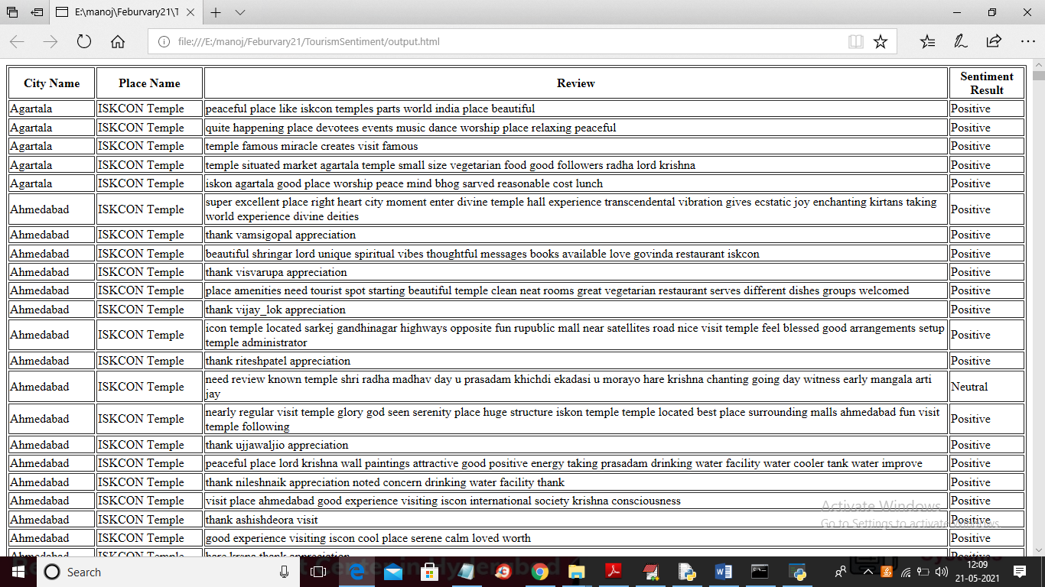
In above screen all search result we can see in tabular format and in below screen we can see overall percentage of sentiments
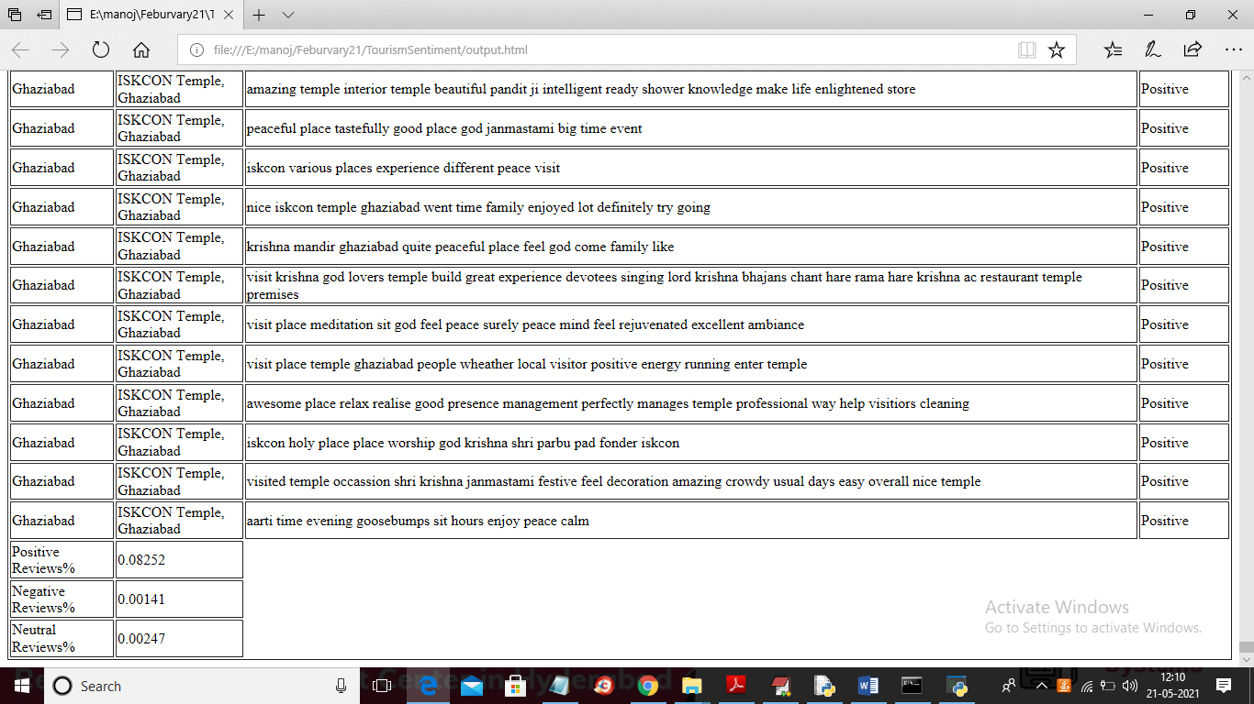
In above screen in last 3 lines you can see overall % and now test with other search

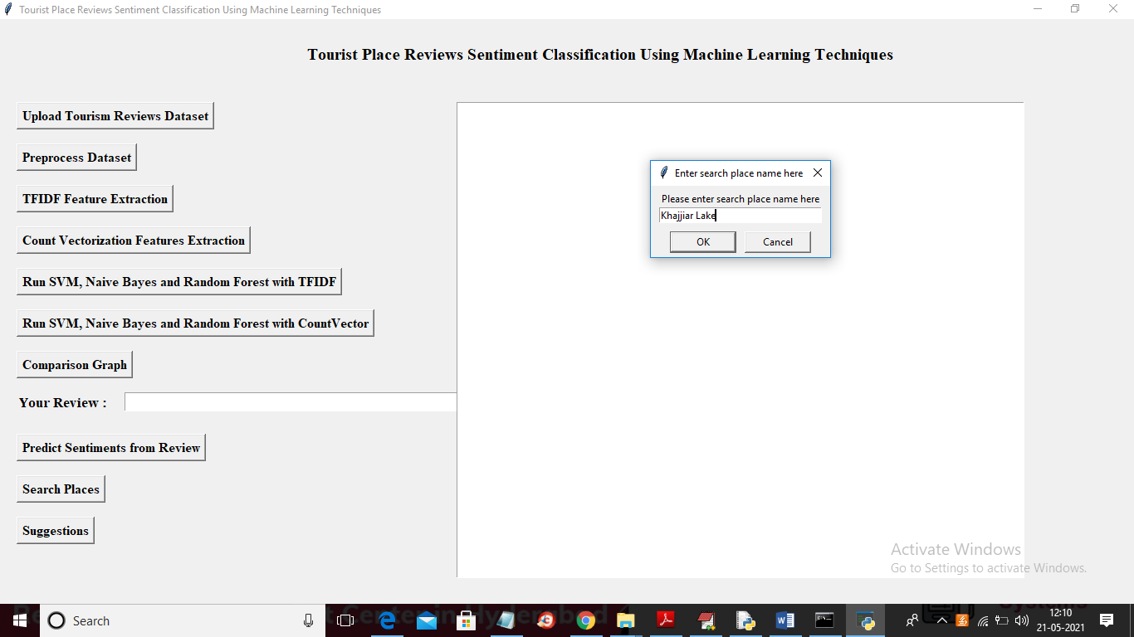
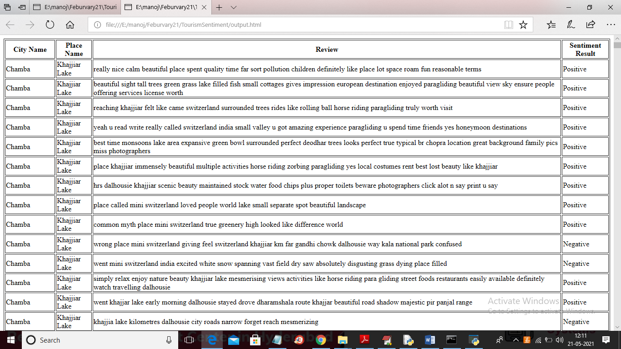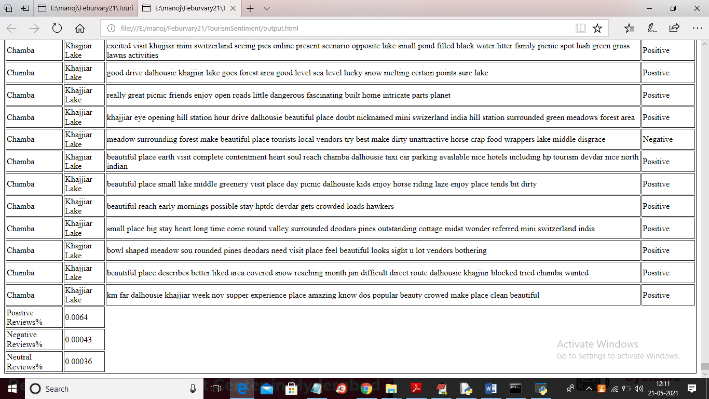
Similarly you can serach for other places also and now you can save you suggestion by clicking on ‘Suggestions’ button
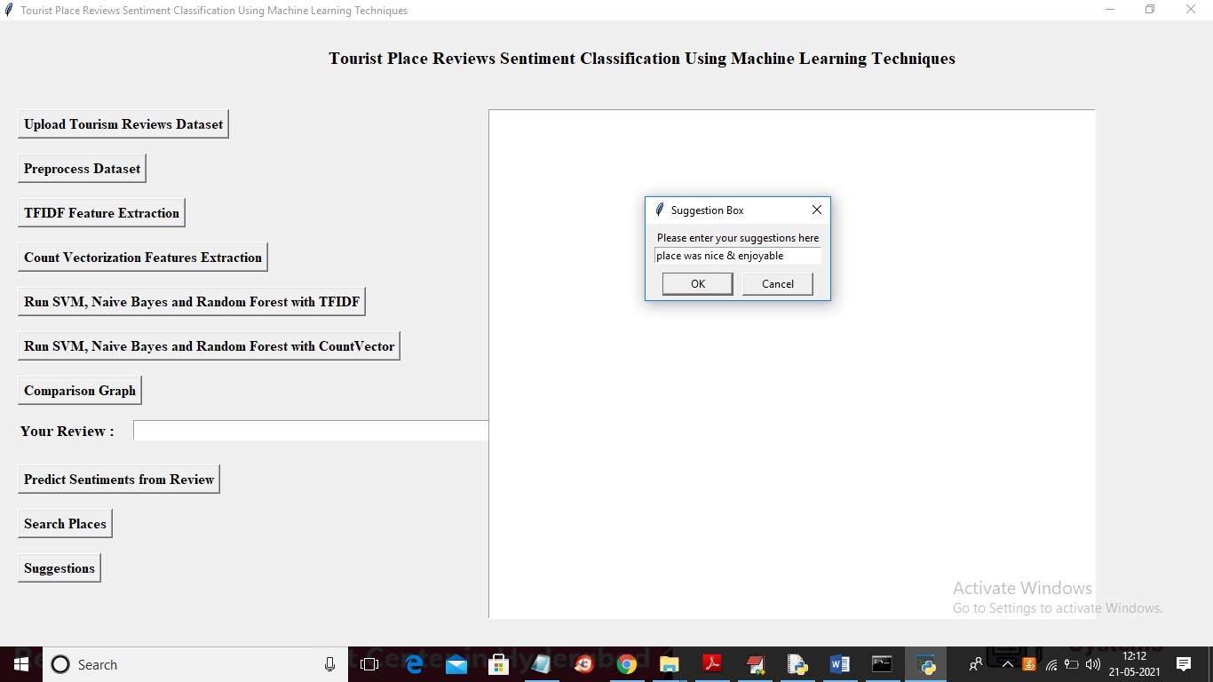
Now in above screen click ‘OK’ button to save suggestion

