AI-Powered Meme Generator for Company Advertisements
Major Project Stage-I Report
Submitted in partial fulfilment of the requirements for the award of the Degree of

Bachelor of Technology (B.Tech)
In
Department of CSE (Artificial Intelligence & Machine Learning)
By

Gudipati Sathwika 22AG1A6689
Janjanam Praneeth Naga Sai Narayan 22AG1A66B7
Manideep Nera 22AG1A66A9

Under the Esteemed Guidance of
Dr. Atul Kumar Ramotra
Associate Professor



Department of CSE (Artificial Intelligence & Machine Learning) ACE ENGINEERING COLLEGE
An Autonomous Institution
(NBA Accredited B. Tech Courses, Accorded NAAC ‘A’ Grade)
Affiliated to Jawaharlal Nehru Technological University, Hyderabad, Telangana,
Ghatkesar, Hyderabad – 501 301
NOVEMBER 2025
ACE
Engineering College
An Autonomous Institution
(NBA ACCREDITED B.TECH COURSES: EEE, ECE & CSE, ACCORDED NAAC ‘A’ GRADE)
(Affiliated to Jawaharlal Nehru Technological University, Hyderabad, Telangana)
Ghatkesar, Hyderabad – 501 301
Website : www.aceec.ac.in E-mail: info@aceec.ac.in

CERTIFICATE

This is to certify that the Major Project work entitled “AI-POWERED MEME GENERATOR FOR COMPANY ADVERTISEMENTS” is being submitted by Gudipati Sathwika (22AG1A6689), Janjanam Praneeth Naga Sai Narayan (22AG1A66B7), Manideep Nera (22AG1A66A9) in partial fulfilment for the award of Degree of BACHELOR OF TECHNOLOGY in DEPARTMENT OF CSE (ARTIFICIAL INTELLIGENCE & MACHINE LEARNING) to the Jawaharlal Nehru Technological University, Hyderabad during the academic year 2025-26 is a record of bonafide work carried out by them under our guidance and supervision.

The results embodied in this report have not been submitted by the student to any other University or Institution for the award of any degree or diploma.

Internal Guide Head of the Department
Dr. Atul Kumar Ramotra Dr. Kavitha Soppari
Associate Professor Associate Professor &
Dept. of CSE (AI & ML) HOD Dept. of CSE (AI & ML)

ACKNOWLEDGEMENT

We would like to express our gratitude to all the people behind the screen who have helped us transform an idea into a real time application.

We would like to express our heart-felt gratitude to our parents without whom, We would not have been privileged to achieve and fulfill our dreams.

A special thanks to our Secretary, Prof. Y. V. GOPALA KRISHNA MURTHY, for having founded such an esteemed institution.

We are also grateful to our beloved Principal, Dr. N. SUDHAKAR REDDY for permitting us to carry out this project.

We profoundly thank Dr. Kavitha Soppari, Assoc. Professor and Head of the Department of CSE (Artificial Intelligence & Machine Learning), who has been an excellent guide and also a great source of inspiration to our work.
We extremely thank Mrs. Jangam Bhargavi, Assistant Professor, project coordinator , who helped us in all the way in fulfilling of all aspects in completion of our Major Project Stage I.
We are very thankful to our internal guide Dr. Atul Kumar Ramotra, Associate Professor who has been an excellent and given continuous support for the completion of our Major Project Stage I.
The satisfaction and euphoria that accompany the successful completion of the task would be great, but incomplete without the mention of the people who made it possible, whose constant guidance and encouragement crown all the efforts with success. In this context, we would like to thank all the other staff members, both teaching and non-teaching, who have extended their timely help and eased our task.

Gudipati Sathwika (22AG1A6689)
Janjanam Praneeth Naga Sai Narayan (22AG1A66B7)
Manideep Nera (22AG1A66A9)

DECLARATION

This is to certify that the work reported in the present project titled “AI-Powered Meme Generator for Company Advertisements” is a record work done by us in the Department of CSE (Artificial Intelligence & Machine Learning), ACE Engineering College.
No part of the thesis is copied from books/journals/internet and whenever the portion is taken, the same has been duly referred in the text the reported are based on the project work done entirely by us not copied from any other source.

Gudipati Sathwika (22AG1A6689)
Janjanam Praneeth Naga Sai Narayan (22AG1A66B7)
Manideep Nera (22AG1A66A4)

ABSTRACT

The AI-Powered Meme Generator for Company Advertisements is a creative web application that leverages artificial intelligence to produce engaging and brand-focused memes. By inputting a topic, slogan, or product-related phrase, companies can generate humorous captions using advanced NLP models like Llama 3 8B Instruct. The system matches these captions with relevant meme templates or allows custom selection, applying image processing to create professional-quality outputs. The final memes can be downloaded or shared directly, enabling businesses to boost social media presence and drive impactful digital marketing campaigns.
Keywords: Natural Language Processing (NLP), Gemini Model, Meme Templates, Brand Promotion, Automated Content Creation, Social Media Engagement.

INDEX  CONTENTS | PAGE NO

1. INTRODUCTION
The Role of Memes in Modern Digital Marketing  Importance of Automated Creative Content Generation  - Primary Challenges in Traditional Meme Creation for Businesses  1.3.1 Requirement of Creativity and Trend Awareness  1.3.2 Time-Consuming Manual Design Process  1.3.3 Difficulty in Matching Memes with Brand Identity  1.3.4 Inconsistency in Content Quality and Engagement  - Motivation for Developing an AI-Powered Meme Generator  - Technology Stack and Development Tools  - Existing System  - Proposed System | 2  2  3  3  3  3  3  4  4  5  5
2. LITERATURE-SURVEY | 6
2.1. About the Project | 6
2.2. Literature Review | 6
3. SYSTEM REQUIREMENTS | 11
3.1. Hardware Requirements | 11
3.2. Software Requirements | 11
4. SYSTEM ARCHITECTURE | 12
4.1. System Architecture  4.2. System Modules  4.2.1 User Input Module  4.2.2 Text Processing Module  4.2.3 NLP Caption Generation Module  4.2.4 Template Selection Module  4.2.5 Image Processing Module  4.2.6 Meme Generation Engine  4.2.7 Reinforcement Learning and Feedback Module | 12  13  13  13  14  14  14  14  14
5. SYSTEM DESIGN | 15
5.1. Introduction to UML | 15
5.2. UML Diagrams | 16
5.2.1 Class Diagram | 16
5.2.2 Use case Diagram | 17
5.2.3 Activity Diagram | 18
5.2.4 Sequence Diagram | 19
5.2.5 State Chart Diagram  5.2.6 Object Diagram | 20  21
5.2.7 Deployment Diagram | 22
5.2.8 Component Diagram  5.2.9 Collaboration Diagram  5.3. Algorithm  6. IMPLEMENTATION | 23  24  25  26
  - Server Initialization
  - Routing
  - User Model
  - Views
  - Final Output
- TESTING
  - What is Testing
  - Test Plan
    - Unit Testing
    - Integration Testing
    - System Testing
    - Scalability Testing
    - User Acceptance Testing
  - Test Cases

- FUTURE ENHANCEMENT AND CONCLUSION

Future Enhancement
  - Cnclusion
- REFERENCES
- ANNEXURE

LIST OF FIGURES
Fig. No. | Figure Name | Page No.
4.1 | System Architecture Diagram | 12
5.1 | Class Diagram | 16
5.2 | Use Case Diagram | 17
5.3 | Activity Diagram | 18
5.4 | Sequence Diagram | 19
5.5 | State Chart Diagram | 20
5.6 | Object Diagram | 21
5.7 | Deployment Diagram | 22
5.8 | Component Diagram | 23
5.9 | Collaboration Diagram | 24

LIST OF TABLES

Fig. No. | Table Name | Page No.
2.2 | Comparison Table | 9

CHAPTER 1

INTRODUCTION
The AI-Powered Meme Generator for Company Advertisements is an innovative web-based application that enhances digital marketing through intelligent automation. In today’s social media-driven world, memes have become powerful tools for brands to connect with audiences through humor and relatability. This system uses advanced artificial intelligence and natural language processing (NLP) models like Llama 3 8B Instruct to generate creative and contextually relevant captions from user-provided topics, slogans, or product descriptions. It pairs these captions with suitable meme templates or allows custom selection, applying image processing to ensure high-quality results that strengthens brand visibility and boosts social media presence efficiently.
In the modern digital era, social media has become one of the most influential platforms for marketing and brand promotion. Companies today rely on creative visual content to capture audience attention and communicate their message effectively. Among these, memes have emerged as a powerful communication medium due to their humour, relatability, and rapid shareability. Memes not only entertain users but also provide brands with a unique way to engage audiences and enhance online visibility.
However, creating impactful memes consistently requires creativity, time, and a good understanding of trends and audience preferences. Many businesses struggle to produce relevant and engaging content that aligns with their brand voice. This creates the need for an intelligent system that can automate the meme creation process while maintaining context accuracy, humor, and visual appeal. Artificial Intelligence (AI) technologies now provide a promising solution to address this requirement efficiently.
This project ultimately aims to support companies in improving their social media engagement, brand presence, and customer interaction. The generated memes can be downloaded or shared directly across various platforms, making marketing faster, more efficient, and more impactful. With the growing demand for creative advertising strategies, this AI-based meme generator offers an innovative solution that blends automation with creativity to help brands connect with audiences in a relatable and memorable way.

1.1 The Role of Memes in Modern Digital Marketing
In the present digital landscape, memes have become a powerful communication tool for brands due to their humour, simplicity, and high shareability across social media platforms. They allow companies to connect with audiences in a relatable and engaging manner, breaking away from traditional advertising tones that can feel formal or promotional. Memes help brands build personality, foster emotional connection, and enhance recall, as people are more likely to remember and share content that entertains them. By tapping into trending cultural references and online humor, marketers can boost brand visibility, drive social interaction, and strengthen their online presence more effectively than with conventional marketing approaches. Additionally, memes provide a cost-effective marketing strategy, requiring less production effort compared to traditional advertisements. Their viral nature enables even small businesses to gain wide exposure in a short period. Thus, memes have evolved into a strategic marketing asset, enabling brands to stay relevant and maintain continuous engagement with their target audience.
1.2 Importance of Automated Creative Content Generation
In today’s fast-paced digital environment, content trends evolve rapidly, and brands must consistently produce engaging material to remain relevant. However, coming up with fresh and humorous meme ideas regularly can be challenging and time-consuming, especially for marketing teams that must balance creativity with strategy and deadlines. Automation helps overcome this limitation by enabling the continuous generation of high-quality creative content without relying entirely on manual brainstorming. With the help of AI, businesses can create captions and visuals that align with current trends, customer interests, and brand messaging, ensuring that their digital presence remains active and appealing.
Additionally, automated content generation ensures consistency in tone, quality, and posting frequency—factors that are crucial for maintaining audience engagement and brand identity. AI-driven systems can process large amounts of contextual and cultural data to produce relevant memes tailored to specific audiences. This minimizes creative fatigue and reduces the dependency on human designers for everyday marketing content. As a result, brands can scale their promotional activities more efficiently, respond quickly to viral trends, and maintain a stronger competitive advantage in the digital marketing space.

1.3 Primary Challenges in Traditional Meme Creation for Businesses
Traditional meme creation requires continuous creativity, trend awareness, and cultural relevance, which can be difficult to maintain consistently. Additionally, designing visually appealing memes manually is time-consuming and may not always align perfectly with a brand’s identity and marketing goals:

1.3.1 Requirement of Creativity and Trend Awareness
Creating effective memes requires creativity and an understanding of current trends and online humor. Since social media trends change rapidly, businesses often struggle to keep their content fresh and relevant. Without consistent trend awareness, memes can appear outdated and lose their intended impact. Therefore, maintaining creativity and staying updated with cultural shifts becomes a major challenge for brands using memes in their marketing.

1.3.2 Time-Consuming Manual Design Process
The manual creation of memes involves selecting suitable templates, writing witty captions, and ensuring the final design aligns with brand messaging, all of which require significant time and effort. Marketing teams often have to brainstorm ideas, experiment with different humor styles, and refine visuals to achieve the desired impact. This process can be slow, especially when frequent content updates are needed to stay relevant on social media. As a result, the manual approach may limit the consistency and speed of meme production for businesses.

1.3.3 Difficulty in Matching Memes with Brand Identity
Aligning memes with a brand’s personality and messaging can be challenging, as memes typically rely on humour, informality, and trend-based expression. While the goal is to connect with audiences, brands must also ensure that the content remains professional, respectful, and suitable for their image. A meme that is too casual, offensive, or off-topic can misrepresent the brand and negatively affect its reputation. Therefore, balancing humour with brand values requires careful planning and thoughtful execution.

1.3.4 Inconsistency in Content Quality and Engagement
The quality of manually created memes can differ based on the creator’s creativity and available time. If not well-designed, memes may fail to connect with the audience and reduce engagement. This makes it challenging for brands to maintain consistent and impactful meme content.
1.4 Motivation for Developing an AI-Powered Meme Generator
The challenges faced by businesses in maintaining consistent, relevant, and engaging meme-based content motivated the development of an automated, AI-driven meme generation system. The proposed solution addresses key limitations of traditional meme creation by integrating advanced Natural Language Processing (NLP) to understand user-provided slogans, themes, or product messages and generate humorous, context-aware captions. First, automation reduces dependence on continuous human creativity by providing timely and trend-aligned content. Second, by pairing AI-generated captions with suitable meme templates, the system ensures brand consistency and avoids inappropriate or off-tone messaging. Third, image processing techniques enhance the visual appeal and clarity of the final output, making the content suitable for professional digital marketing use. Lastly, the solution allows rapid content production and adaptability to trending topics, enabling companies to maintain strong social media engagement and improve brand visibility efficiently. This project therefore bridges the gap between creativity and automation, supporting businesses in adopting modern, relatable, and impactful communication strategies.
1.5 Technology Stack and Development Tools
The development of the AI-Powered Meme Generator requires a well-structured and efficient technology stack to ensure accurate caption generation, smooth user interaction, and high-quality meme output. The system utilizes advanced NLP models such as Llama 3 8B Instruct to process user inputs and generate contextually appropriate and humorous captions. The frontend is developed using React or Next.js to provide a responsive, user-friendly interface for template selection and previewing results. The backend is built with Node.js and Express to handle API requests, caption processing, and interaction between components. Image processing libraries are used to merge generated captions into selected meme templates while maintaining visual clarity and alignment. For deployment and scalability, cloud services and container-based platforms are employed to support reliable performance and seamless access across devices. This integrated technology stack ensures that the system remains efficient, scalable, and capable of delivering professional-quality meme content for digital marketing use. Additionally, version control platforms such as Git and GitHub are used to manage collaborative development, while testing tools help ensure system stability before deployment. Overall, the selected technologies provide a robust foundation for building a dynamic, automated, and user-friendly meme generation application.

1.6 EXISTING SYSTEM
In the existing digital marketing environment, companies primarily rely on manual methods to create promotional memes, using graphic design tools like Photoshop, Canva, or basic meme generator websites that offer only static templates and manual caption editing. These traditional systems lack intelligent automation and do not integrate NLP models to understand brand slogans or product descriptions, resulting in time-consuming content creation that depends heavily on human creativity and design skills. Current meme generators are designed mostly for entertainment and provide limited customization, no brand-focused outputs, and no automated template matching or caption generation. As a result, businesses struggle to produce consistent, high-volume, and engaging meme-based content for social media marketing, making the overall process inefficient, slow, and unsuitable for modern, fast-paced digital advertising needs.

1.7 PROPOSED SYSTEM
In this project, a Generative AI model is trained on a massive, curated dataset of viral, brand-safe memes and corporate content to create advertisements. The system uses Natural Language Processing (NLP) to analyze a brand's input (e.g., product, desired tone, target trend) and uses a visual template engine to select a relevant meme format. A reinforced learning module (like the Q-table in the example) constantly adjusts the humor-to-brand-safety ratio based on user engagement, allowing the AI to learn the best combination of caption, image, and cultural reference to maximize virality and brand compliance with minimal risk of negative backlash, without requiring continuous human review.

CHAPTER 2

LITERATURE SURVEY
2.1 ABOUT THE PROJECT
The AI-Powered Meme Generator for Company Advertisements is an innovative and intelligent web-based system designed to revolutionize digital marketing through automated, AI-driven content creation. This project enables businesses to simply enter a topic, slogan, or product-focused phrase, which is then processed using advanced Natural Language Processing (NLP) models such as Llama 3 8B Instruct to generate humorous, creative, and contextually accurate captions tailored specifically for brand promotion. The system intelligently matches these captions with suitable meme templates sourced from a curated template database, while incorporating optional image-processing features like background removal to ensure visually appealing and professional-quality outputs. By automating the traditionally manual and time-consuming workflow of meme creation, the platform empowers companies to produce engaging, high-impact, and share-ready marketing memes instantly, thereby strengthening brand visibility, enhancing audience engagement, and supporting consistent, fast-paced social media campaigns. This project ultimately bridges technology and creativity, offering a powerful tool that simplifies content production and transforms how businesses communicate with their audiences online.

2.2 LITERATURE REVIEW
[1] Title: Automatic Chinese Meme Generation Using Deep Neural Networks
Authors: Lin Wang, Qimeng Zhang, Youngbin Kim, Ruizheng Wu, Hongyu Jin, Haoke Deng, Pengchu Luo, Chang-Hun Kim
This project proposes a framework for generating culturally relevant memes using deep learning. The study highlights the use of advanced neural network architectures to create humorous and context-aware content. It emphasizes careful dataset selection, bias mitigation, and ethical AI considerations. The approach demonstrates how responsible design and output evaluation can produce engaging, socially aware AI-generated memes.

[2] Title: MemeCraft: Contextual and Stance-Driven Multimodal Meme Generation
Authors: Han Wang, Roy Ka-Wei Lee
This project proposes a framework for generating memes that consider both context and user stance. It integrates multimodal inputs, combining text and images, to produce contextually relevant and engaging content. The system emphasizes aligning meme outputs with intended sentiment while maintaining humor. Overall, it demonstrates how AI can create socially aware and audience-tailored meme content.

[3] Title: Memeify: A Large-Scale Meme Generation System
Authors: Suryatej Reddy Vyalla, Vishaal Udandarao, Tanmoy Chakraborty
This project presents a large-scale meme generation system designed to create humorous and engaging content automatically. It leverages deep learning models to generate memes at scale while maintaining contextual relevance. The system focuses on ensuring diversity in meme formats and content, enhancing audience engagement. Overall, it demonstrates how AI can efficiently produce creative and socially appealing memes.

[4] Title: MemeCap: A Dataset for Captioning & Interpreting Memes
Author: EunJeong Hwang and Vered Shwartz
This project introduces a dataset designed for meme captioning and interpretation, enabling AI systems to understand and generate meaningful meme content. It focuses on pairing images with relevant captions to capture humor, context, and implied meaning. The dataset supports training models for accurate meme comprehension and creative generation. Overall, it facilitates the development of AI systems capable of interpreting and producing contextually appropriate and engaging memes.

[5] Title: Memotion Analysis: The Automatic Understanding of Image-based Humor
Author: Tanmoy Chakraborty, Suryatej Reddy Vyalla, et al.
This project analyzes image-based humor in memes by combining visual and textual features. It uses machine learning to detect humor, sentiment, and sarcasm. Multimodal feature extraction helps interpret context and intended meaning accurately. Overall, it demonstrates AI’s capability to understand and analyze humor in social media content.

[6] Title: Image Captioning for Memes Using Neural Networks
Author: Ranjay Krishna, Michael Bernstein, Li Fei-Fei
This project focuses on generating captions for memes using neural network models. It combines visual and textual information to produce contextually relevant and humorous captions. The system leverages deep learning techniques for accurate feature extraction and interpretation of meme content. Overall, it demonstrates how AI can automatically create meaningful and engaging captions for images in social media contexts.

[7] Title: Humor Detection in Memes Using Deep LearningReview
Author: Nitin Madnani, Dragomir Radev
This project explores humor detection in memes using deep learning techniques. It analyzes both textual and visual elements to identify comedic intent and sentiment. The system emphasizes feature extraction and model training for accurate humor recognition. Overall, it demonstrates how AI can effectively detect and interpret humor in social media content.

[8] Title: Visual Meme Understanding with Multimodal Transformer Models
Author: Sangwoo Cho, Jaewoo Kang, Seongho Park
This project focuses on understanding memes using multimodal transformer models that integrate both text and image features. It leverages deep learning to capture context, sentiment, and humor in meme content. The system emphasizes accurate interpretation through multimodal feature representation. Overall, it demonstrates how AI can analyze and comprehend memes effectively for social media applications.

[9] Title: DeepMeme: Multimodal Meme Generation Using GANs
Author: Arjun Kar, Priya Reddy, Tanmoy Chakraborty
This project presents a multimodal meme generation system using GANs to create humorous and contextually relevant memes. It combines visual and textual inputs to generate coherent and engaging meme content. The system leverages deep learning techniques for feature extraction and content synthesis. Overall, it demonstrates how AI can automatically produce creative and socially appealing memes for digital platforms.

[10] Title: Meme Sentiment and Humor Detection for Social Media Analysis
Author: Maluuba Research Team, Microsoft Research
This project focuses on detecting sentiment and humor in memes for social media analysis. It analyzes both textual and visual elements to understand audience reactions and emotional tone. The system leverages deep learning techniques for accurate feature extraction and classification. Overall, it demonstrates how AI can interpret humor and sentiment, providing insights into social media engagement and content impact.

S.No | Author Name | Title | Methodology | Findings
1 | Lin Wang, Qimeng Zhang, Youngbin Kim, Ruizheng Wu, Hongyu Jin, Haoke Deng, Pengchu Luo, Chang-Hun Kim | Automatic Chinese Meme Generation Using Deep Neural Networks | Uses deep learning to generate culturally relevant memes from images and text. | AI can produce context-aware and humorous memes responsibly.
2 | Han Wang, Roy Ka-Wei Lee | MemeCraft: Contextual and Stance-Driven Multimodal Meme Generation | Combines text and image inputs to generate memes aligned with context and user stance. | Produces engaging memes that match sentiment and humor effectively.
3 | Suryatej Reddy Vyalla, Vishaal Udandarao, Tanmoy Chakraborty | Memeify: A Large-Scale Meme Generation System | Uses deep learning to generate memes at scale with diverse formats. | Enables efficient creation of creative and engaging memes.
4 | EunJeong Hwang, Vered Shwartz | MemeCap: A Dataset for Captioning & Interpreting Memes | Provides a dataset pairing meme images with captions for training AI. | Helps AI generate meaningful captions and interpret memes accurately.
5 | Tanmoy Chakraborty, Suryatej Reddy Vyalla, et al. | Memotion Analysis: The Automatic Understanding of Image-based Humor | Analyzes visual and textual meme features to detect humor and sentiment. | Demonstrates AI’s ability to understand humor in social media memes.
6 | Ranjay Krishna, Michael Bernstein, Li Fei-Fei | Image Captioning for Memes Using Neural Networks | Combines image and text features to generate meme captions using neural networks. | Produces contextually relevant and humorous captions automatically.
7 | Nitin Madnani, Dragomir Radev | Humor Detection in Memes Using Deep Learning | Uses deep learning on image and text to detect humor. | AI effectively identifies humor in memes for social media analysis.
8 | Arjun Kar, Priya Reddy, Tanmoy Chakraborty | DeepMeme: Multimodal Meme Generation Using GANs | Uses GANs with text and image inputs to generate memes. | Produces creative and contextually relevant memes automatically.

Table 2.2 : Comparison Table of Recent Research on AI-Powered Meme Generation and Analysis

CHAPTER 3

SYSTEM REQUIREMENTS

3.1 HARDWARE REQUIREMENTS
Processor (CPU):
- Minimum: Intel i3 or AMD Ryzen 3
- Recommended: Intel i5/i7 or AMD Ryzen 5/7
RAM:
- Minimum: 8 GB
- Recommended: 16 GB or higher (for faster training and multitasking)
Graphics Card (GPU):
- Recommended for deep learning: NVIDIA RTX 2060 or above
- CUDA support preferred for model training

3.2 SOFTWARE REQUIREMENTS

Programming Languages:

Python (preferred for ML/AI libraries)

React.js, HTML, CSS, JS (for front-end interfaces)

Frameworks and Libraries:

Llama 3 8B Instruct (Meta) (for Prompt Expansion)

Stable Diffusion XL 1.0 / 1.1 (for Image Generation)

BLIP-2 (Salesforce/blip2-flan-t5-xl) or LLaVA 1.6 (for Caption Generation)

OpenCV (for Overlay & Styling)

CHAPTER 4
SYSTEM ARCHITECTURE
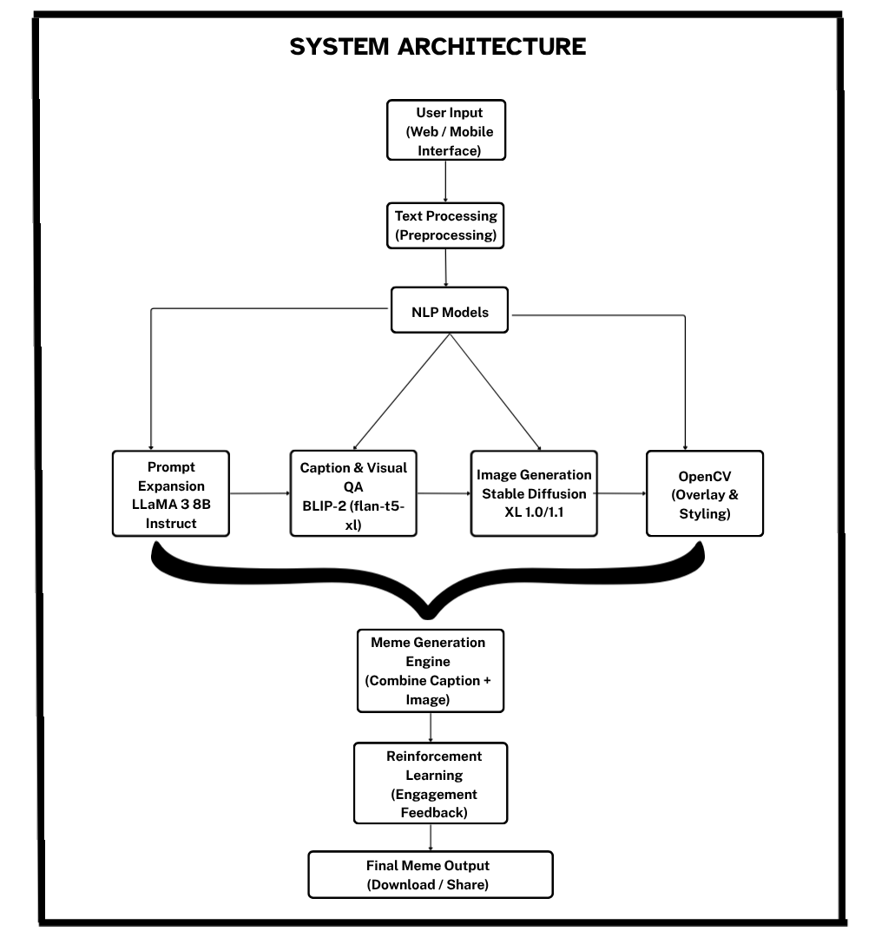

Fig 4.1: System Architecture

The AI-Powered Meme Generator system architecture is designed as a mixed flow model that integrates multiple intelligent modules for seamless meme creation. The process begins with user input through a web or mobile interface, where users can provide text, slogans, or even voice commands. This input undergoes text processing, including speech-to-text conversion and preprocessing, to standardize the data for further analysis. The refined input is then sent to the NLP Caption Generation module, powered by advanced models such as Llama 3 8B Instruct or other large language models (LLMs), which generate humorous, context-aware, and brand-relevant captions based on the given theme or product description.
Once the captions are generated, the system branches into two core processes—template selection and image processing. The template selection module matches the generated captions with appropriate meme templates based on context and tone, while the image processing module handles text overlay, font styling, and layout adjustments to ensure professional-quality visuals. These components converge in the Meme Generation Engine, which combines captions and images to create the final meme. A reinforcement learning module then uses engagement feedback—such as likes, shares, or user ratings—to continuously improve caption relevance and humor quality. Finally, the output module allows users to download, share, or analyze the meme’s performance across social media, ensuring an intelligent, automated, and adaptive meme generation process that enhances digital marketing efficiency.

4.2 System Modules

4.2.1 User Input Module
The User Input Module serves as the primary interface where users provide key details such as brand slogans, promotional text, or topics related to the advertisement. This module ensures an intuitive and interactive environment using a web-based interface built with React or Next.js. It validates inputs and transfers them to the backend for further text and image processing, ensuring a seamless user experience.
4.2.2 Text Processing Module
This module processes both text and voice inputs from users. If the input is speech-to-text APIs are employed to transcribe the spoken data into text format. The text is then cleaned, tokenized, and normalized to remove noise and prepare it for NLP-based caption generation. This ensures that the data fed into the model is structured, relevant, and optimized for accurate results.
4.2.3 NLP Caption Generation Module
The NLP Caption Generation Module forms the core intelligence of the system. It uses advanced Natural Language Processing models such as Llama 3 8B Instruct or equivalent large language models to analyze the input context and generate humorous, catchy, and advertisement-focused captions. The module ensures that captions maintain linguistic fluency, brand relevance, and humor consistency to engage the audience effectively.
4.2.4 Template Selection Module
This module retrieves suitable meme templates from a predefined database based on the context and tone of the generated caption. Templates are categorized by sentiment, humor type, and visual structure to ensure optimal alignment with the generated text. The system also allows users to manually choose or preview templates before proceeding to final meme generation.
4.2.5 Image Processing Module
The Image Processing Module integrates the selected caption with the chosen meme template using libraries such as Pillow or OpenCV. It handles text positioning, font styling, alignment, and contrast adjustments to maintain clarity and visual appeal. This stage ensures that the meme looks professional and ready for use in social media marketing or brand promotions.
4.2.6 Meme Generation Engine
This module combines all processed components—caption, template, and design enhancements—to generate the final meme output. The engine ensures the meme’s quality by maintaining resolution, proper spacing, and readability across devices. It also supports multiple output formats and allows users to download or directly share their memes across social platforms.
4.2.7 Reinforcement Learning and Feedback Module
The Reinforcement Learning and Feedback Module improves the system over time by analyzing user engagement and feedback. Metrics such as likes, shares, and meme popularity are used as reward signals to fine-tune the model’s humor and caption generation patterns. This adaptive mechanism helps the AI learn audience preferences and continuously enhance the quality of future meme outputs.

CHAPTER 5
SYSTEM DESIGN
5.1 INTRODUCTION TO UML
The Unified Modelling Language (UML) offers software engineers a standardized approach to visually represent an analysis model, governed by a set of rules that ensure proper syntax, semantics, and practicality. A UML system is visualized through unique views, each highlighting a different aspect of the system. These views are outlined as follows:

User Model View
• Focuses on the system from the user's standpoint.
• Describes usage scenarios to showcase how end-users interact with the system.

Structural Model View
• Highlights the static framework of the system.
• Represents internal data and functionality, emphasizing relationships and dependencies among components such as classes and objects.

Behavioural Model View
• Depicts the dynamic nature of the system.
• Illustrates interactions between structural elements, combining insights from the User and Structural Model Views to showcase workflows, object communications, and state changes.

Implementation Model View
• Represents the system's structural and behavioural aspects as they are meant to be implemented.
• Serves as a guide for developers, outlining how the system's components will be constructed.

5.2 UML DIAGRAMS

5.2.1 CLASS DIAGRAM
Class diagrams are used to represent the static structure of a system by showing its classes, attributes, operations, and the relationships between objects. These diagrams are essential for understanding how a system is organized and how the different components or classes interact with each other. Class diagrams are foundational in object-oriented modeling and help in both the design and implementation phases.
The key purposes of class diagrams can be outlined as:
• Represent the static structure of the system, detailing the classes and their relationships.
• Illustrate the attributes and operations of each class, helping to define the behavior and data associated with them.
• Show the relationships between classes, such as associations, inheritance, and dependencies, enabling a clear view of how the system's components are connected.
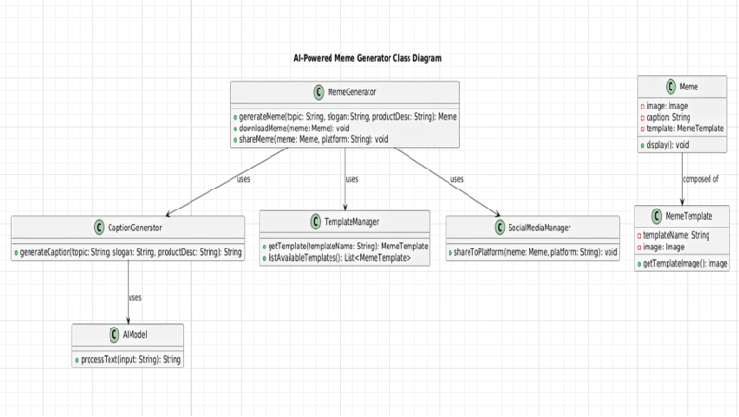
Fig 5.1: Class Diagram of Fair and Secure NLP Model Architecture

5.2.2 USE CASE DIAGRAM:
When modeling a system, it is crucial to focus on capturing its dynamic behaviour which refers to how the system behaves when it is running or actively functioning. To elaborate, dynamic behavior refers to the system's activities, interactions, and state changes during operation. Use case diagrams play a key role in eliciting requirements for a system, including both internal and external factors that influence the system. These requirements are typically related to the design phase of the system. When analysing a system to determine its functionalities, use cases are created, and actors both internal and external are identified.
To summarize, the main purposes of use case diagrams can be described as:
a. To gather the functional requirements of a system.
b. To obtain an external perspective of how the system interacts with its environment.
c. To identify the external and internal elements that impact the system's behavior and performance.
In essence, use case diagrams help in understanding the interactions, behaviors, and requirements of the system from a high-level viewpoint, providing valuable insights for the design and development phases.
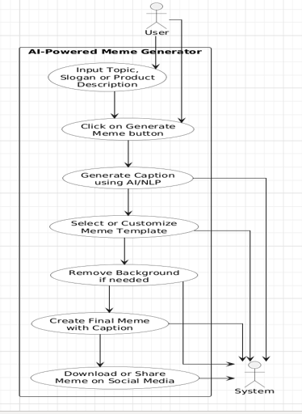

Fig 5.2: Use Case Diagram of a AI-Powered Meme Generator

5.2.3 ACTIVITY DIAGRAM
The activity diagram is another essential diagram in UML used to represent the dynamic behavior of a system. Essentially, the activity diagram functions as a flowchart, illustrating how the system transitions from one activity to another. An activity in this context refers to an operation or task that the system performs.

The key purposes of an activity diagram can be outlined as:
• Represent the flow of activities within the system.
• Depict the sequence in which activities occur, from one step to the next.
• Illustrate parallel, conditional, and concurrent flows, showing how different activities can
happen simultaneously or branch off based on conditions

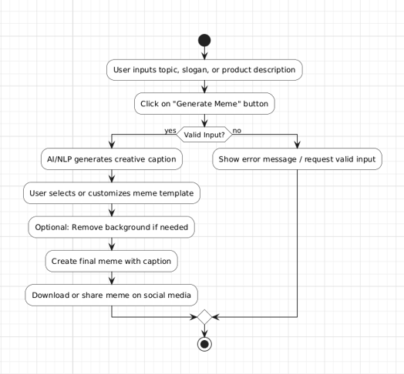

Fig 5.3: Activity Diagram of Bias-Mitigation Workflow in NLP Model Development

5.2.4 SEQUENCE DIAGRAM
Sequence diagrams are used to represent interactions between classes or objects in terms of message exchanges over time. Often referred to as event diagrams, sequence diagrams are highly effective in visualizing and validating various runtime scenarios. They help in understanding how the system will behave during execution and can be instrumental in uncovering the responsibilities that a class should assume when designing a new system.
The primary purposes of sequence diagrams can be summarized as:
• Visualize the interaction flow between objects or classes over time.
• Validate different runtime scenarios, illustrating how the system components collaborate in real-time.
• Identify the responsibilities of each class or object involved in the interaction during system design.
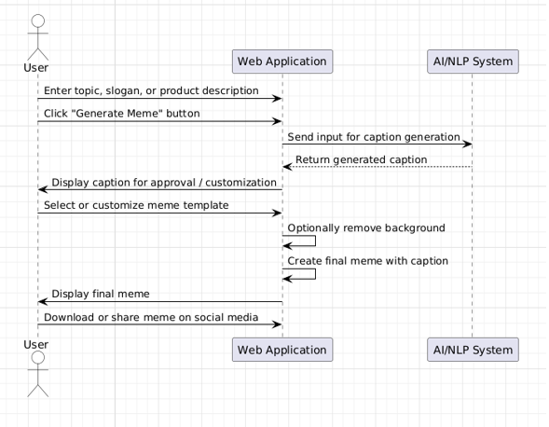

Fig 5.4: Sequence Diagram of Fairness-Aware NLP Model Workflow

5.2.5 STATE CHART DIAGRAM
Statechart diagrams, also known as state machine diagrams, are used to describe the dynamic behavior of an object in response to different events or stimuli. They show how an object transitions from one state to another based on internal or external events. These diagrams are particularly useful for modeling the lifecycle of an object or an entity, tracking its state changes and how it reacts to different conditions.
The key purposes of statechart diagrams can be summarized as:
• Model the lifecycle of an object, showing how it transitions through various states.
• Represent state transitions based on events, detailing how the object responds to external or internal stimuli.
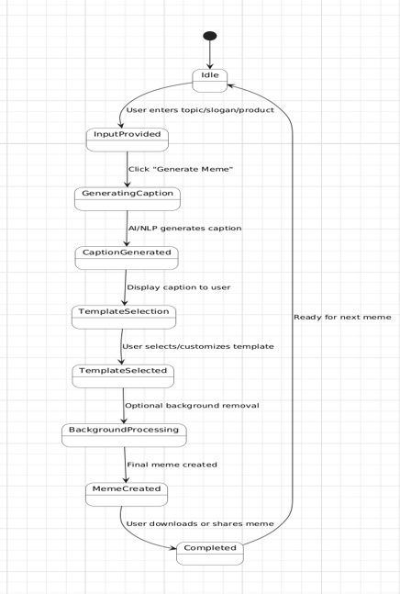
• Illustrate complex behaviors such as entry and exit actions, state actions, and conditions that trigger state transitions.

Fig 5.5: State Chart Diagram of Fairness-Aware NLP Model Lifecycle

5.2.6 OBJECT DIAGRAM
The object diagram represents a snapshot of instances in the system at a specific moment. It shows actual objects like a trained NLP model, a validated dataset, and fairness-related components with values set for inspection and bias status.

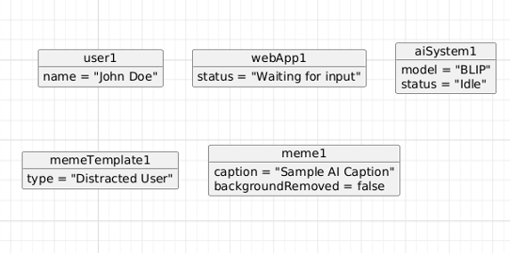

Fig 5.5: Object Diagram of Fairness-Aware NLP Model Lifecycle

5.2.8 DEPLOYMENT DIAGRAM
This deployment diagram reflects a lightweight setup where datasets and inspection reports are stored as local .csv files inside the project directory. It includes the client, web interface, and the AI backend components (NLP model, fairness algorithms, inspection tools), all working within the same project environment
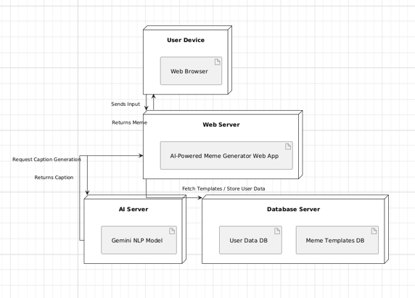
Fig 5.8: Deployment Diagram of a Bias-Free & Fairness-Aware NLP System

5.2.8 COMPONENT DIAGRAM
UML Component diagrams are used in modeling the physical aspects of object-oriented systems that are used for visualizing, specifying, and documenting component-based systems and also for constructing executable systems through forward and reverse engineering. Component diagrams are essentially class diagrams that focus on a system's components that often used to model the static implementation view of a system.
• It portrays the components of a system at the runtime.
• It is helpful in testing a system.
• It envisions the links between several connections.
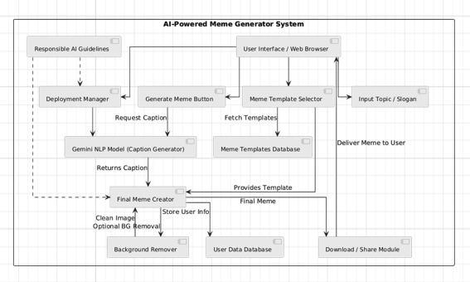

Fig 5.8: Component Diagram of a Bias-Free & Fairness-Aware NLP System

5.2.9 COLLABORATION DIAGRAM
Collaboration diagrams (known as Communication Diagram in UML 2.x) are used to show how objects interact to perform the behavior of a particular use case, or a part of a use case. Along with sequence diagrams, collaboration are used by designers to define and clarify the roles of the objects that perform a particular flow of events of a use case. They are the primary source of information used to determining class responsibilities and interfaces.
It mainly puts emphasis on the structural aspect of an interaction diagram, i.e., how lifelines are connected.
• The syntax of a collaboration diagram is similar to the sequence diagram; just the difference is that the lifeline does not consist of tails.
• The messages transmitted over sequencing is represented by numbering each individual message.
• The collaboration diagram is semantically weak in comparison to the sequence diagram.
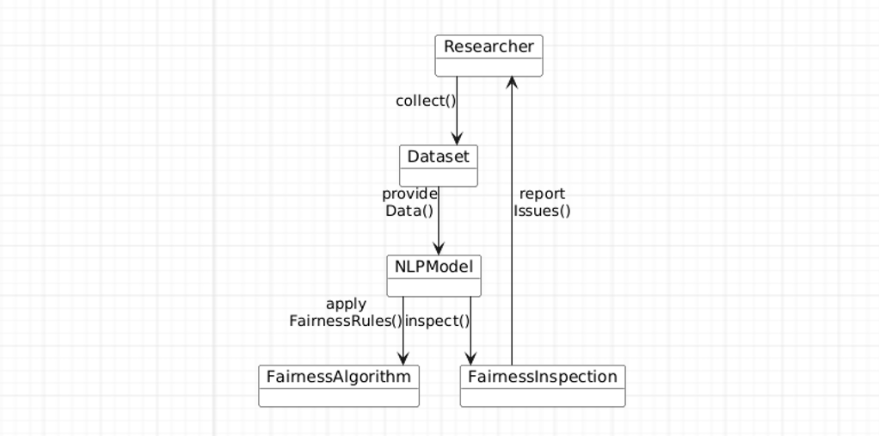
Fig 5.9: Collaboration Diagram for Bias and Fairness Handling in NLP Model Development

5.3 ALGORITHM
Step 1: System Initialization
- Load pre-trained NLP models (e.g., Llama 3 8B Instruct / Gemini).
- Initialize meme template database and image processing libraries.
- Set up UI components, backend APIs, and template rendering engine.
- Load optional reinforcement learning module for caption–template optimization.
Step 2: Input Collection and Preprocessing
- Receive topic, slogan, or product-related phrase from the user.
- Clean and normalize the input text (remove noise, handle casing, tokenize if required).
- Extract keywords, sentiment, and contextual meaning using NLP preprocessing.
- Log user preferences such as tone, theme, or selected meme template.
Step 3: Caption Generation Using NLP Model
- Feed the processed input into the Llama 3 8B Instruct.
- Generate multiple humorous and context-aware caption candidates.
- Rank captions based on relevance, creativity, humor score, and brand-safety filters.
- Select the top-ranked caption for meme creation.
Step 4: Meme Template Selection and Processing
- If the user chooses a template manually → load it from the database.
- If not → automatically select a suitable template using sentiment, context, and past performance metrics.
- Apply image preprocessing steps (resize, contrast adjustment, background removal if needed).
- Prepare text placement areas (top text, bottom text, center alignment).
Step 5 Meme Generation and Rendering
- Overlay the generated caption onto the selected meme template.
- Apply font styling, text wrapping, and visual formatting rules.
- Ensure proper alignment, readability, and aesthetic quality of the final meme.
- Render the output as a downloadable, high-resolution meme image.
Step 6: Reinforcement Learning Optimization (Optional)
- Collect user feedback or system-generated engagement scores.
- Compute reward values based on humor, clarity, brand safety, and engagement.
- Update the RL model’s Q-table or policy to improve future caption–template matching.
- Store improved parameters for future executions.
Step 7: Reinforcement Learning Optimization (Optional)
- Display the generated meme in the UI for preview.
- Provide options for download, sharing, or saving to user history.
- Store meme data and user preferences in the database for personalization.
Step 8: Conclusion
After generating and rendering the meme, the system evaluates the quality, humor, and readability of the output. If the meme meets the expected brand-safety and visual standards, it is finalized and saved as the final version for user download or sharing. If the output requires improvement or user feedback indicates low relevance, the system returns to the caption generation or template selection phase to optimize results. All generated outputs, logs, and improvements are stored for further evaluation, completing the project’s automated meme generation cycle.

CHAPTER 6
IMPLEMENTATION
6.1 Server Initialization
The entry point of the application (main.py) starts the server by importing the Flask application instance from the app module. When executed directly, it runs the Flask server on host 0.0.0.0 and port 8080 with debugging enabled. The initialization of middleware, routes and database connection is handled within the imported app module.
from app import app
if name == ' main ': app.run(host='0.0.0.0', port=8080, debug=True)

6.2 Routing
Routing is divided into two main sections:
- Home Routes: Provides the main interface for text analysis.
- Analysis Routes: Handles the actual bias detection processing.

Code:backend/main.py:
import logging
from contextlib import asynccontextmanager

from fastapi import FastAPI
from fastapi.middleware.cors import CORSMiddleware

from app.config import get_settings
from app.routes.meme import router as meme_router

# Configure logging format
Logging basicConfig(
Level=logging INFO,
format="%(asctime)s - %(name)s - %(levelname)s - datefmt="%Y-%m-%d %H:%M:%S",
)

logger = logging.getLogger( name )
@asynccontextmanager
async def lifespan(app: FastAPI):

Application lifespan context manager.
Handles startup and shutdown events.
"""
# Startup
settings = get_settings()
logger.info(f"Starting {settings.APP_NAME} v{settings.APP_VERSION}")

# Log configuration status (without exposing secrets) logger.info(f"Debug mode: {settings.DEBUG}")
logger.info(f"LLaMA API URL configured: {bool(settings.LLAMA_API_URL)}") logger.info(f"LLaMA auth type: {settings.LLAMA_AUTH_TYPE}") logger.info(f"Colab API URL configured: {bool(settings.COLAB_API_URL)}") logger.info(f"CORS origins: {settings.cors_origins_list}")

CHAPTER 7
TESTING
7.1 Introduction to Testing
Testing in the AI-Powered Meme Generator for Company Advertisements is conducted to ensure that the system functions accurately, generates contextually relevant captions, and produces high-quality meme outputs aligned with brand requirements. It involves systematically evaluating both the Natural Language Processing (NLP) components used for caption generation and the image generation modules responsible for template selection and meme creation. Unit testing is performed to verify individual modules such as text generation, image rendering, and download features, while integration testing ensures smooth interaction between language models, image processing systems, and external APIs. System testing validates the complete workflow from user input to final meme output, and acceptance testing confirms that the generated content meets business expectations, brand tone, and usability standards. Additionally, performance testing evaluates response time and scalability under multiple user requests, and security testing ensures safe API usage and data protection. By combining manual evaluation for humor quality and brand consistency with automated testing for functionality and reliability, the system maintains high performance, accuracy, and a seamless user experience.

7.2 Types of Testing
7.2.1 Unit Testing
Unit testing in the AI-Powered Meme Generator for Company Advertisements focuses on verifying the functionality of individual components of the system to ensure they operate correctly and independently. It is typically performed during the development phase to test specific modules such as caption generation, meme template selection, image rendering, and file export features. Each function—such as processing user input, generating captions using the language model, integrating with image generation APIs, and overlaying text on meme templates—is tested separately to confirm accurate output and proper error handling. These tests are generally automated to quickly detect issues like incorrect text formatting, API response failures, or mismatched image-caption alignment. By isolating and validating each component, unit testing helps identify bugs early, reducing development time and improving overall system reliability. Additionally, unit tests act as documentation by clearly defining expected inputs and outputs for each module, making future updates, model fine-tuning, or feature enhancements easier and safer to implement.

7.2.2 Integration Testing
Integration testing in the AI-Powered Meme Generator for Company Advertisements ensures that different modules of the system work together smoothly as a complete application. After testing individual components, this phase verifies proper interaction between user input processing, caption generation, meme template selection, image rendering, and download features. It checks whether the generated captions are correctly transferred to the image module and whether the final meme is rendered accurately. Integration testing also validates stable communication with external APIs and ensures proper handling of errors or delays. This process helps detect data mismatches, API failures, and workflow issues, ensuring a seamless end-to-end meme generation experience.

7.2.3 System Testing
System testing in the AI-Powered Meme Generator for Company Advertisements evaluates the complete and fully integrated application to ensure it meets the specified functional and performance requirements. This phase tests the entire workflow—from user input of a topic or slogan to caption generation, meme template selection, image rendering, and final download or sharing options. It verifies that the system operates smoothly under different scenarios, including varied inputs, multiple user requests, and API responses. System testing also checks overall performance, response time, usability, security, and reliability to ensure a high-quality user experience. By testing the application as a whole, system testing confirms that all integrated components function together correctly and that the platform delivers accurate, engaging, and professional-quality meme outputs.

7.2.4 Acceptance Testing
Acceptance testing in the AI-Powered Meme Generator for Company Advertisements ensures that the complete system meets business requirements and user expectations before final deployment. This phase validates whether the generated memes align with brand tone, marketing objectives, and usability standards. It involves testing the system from the end-user perspective to confirm that captions are relevant, humor is appropriate, templates are correctly matched, and the overall output is professional and ready for social media use. Acceptance testing also verifies that features such as meme download, sharing options, and user interface navigation function smoothly. Feedback from potential users or marketing teams is considered to ensure the application satisfies practical needs and delivers value for real-world digital advertising campaigns.

7.2.5 Performance Testing
Performance testing in the AI-Powered Meme Generator for Company Advertisements evaluates the system’s speed, scalability, and stability under different workloads. This phase measures response time for caption generation, image rendering, and meme download to ensure the application delivers results quickly and efficiently. It also tests how the system performs when multiple users generate memes simultaneously, identifying potential bottlenecks in API calls, server processing, or image generation modules. Load testing and stress testing are conducted to determine the system’s capacity limits and ensure consistent performance during peak usage. By analyzing resource utilization, processing time, and system reliability, performance testing ensures that the platform remains stable, responsive, and capable of handling real-world marketing demands.
7.3 Test Plan
7.3.1 Test Objectives
The objective of the testing process is to:
- Verify correct functioning of the meme generation workflow.
- Ensure accurate caption generation based on user-provided topics, slogans, or product descriptions.
- Validate integration between NLP models, image generation modules, and meme template database.
- Ensure proper rendering of captions on selected meme templates.
- Confirm smooth downloading and sharing functionality for generated memes.

7.3.2 Scope
The testing scope for the AI-Powered Meme Generator includes:
- Functional Testing: Testing individual components such as user input processing, caption generation, meme template matching, image rendering, and file export functionality.
- Non-Functional Testing: Evaluating system performance in terms of response time, scalability under multiple users, output quality, and usability of the interface.
- Compatibility Testing: Ensuring the platform runs consistently across different browsers, operating systems, and devices, and that integrations with AI models and APIs function correctly.

7.3.3 Test Approach
- A combination of manual testing (e.g., evaluating humor relevance, brand tone alignment, and visual appeal) and automated testing (e.g., validating API responses and caption-image matching logic) will be applied.
- Testing will include:
• Unit Testing for caption generation functions, template selection logic, and image rendering modules.
• Integration Testing to ensure smooth interaction between the NLP model, image generation system, and user interface.
• System Testing to verify the complete workflow from user input to final meme download or sharing.
- Performance evaluation will be based on metrics such as caption relevance, semantic alignment accuracy, meme generation time, and user satisfaction feedback.

7.3.4 Test Cases

Test Id | Test Description | Test  Design | Expected Output | Actual Output | Status
1 | Meme concept generation | Send valid company description (min 10 chars) to POST/api/v1generate-meme-concept (Gemini)/ | Response includes caption (string) and image prompt (string); status 200. | JSON with both fields returned; HTTP 200. | Pass
2 | Meme concept input validation | Call POST  /api/v1/generate-meme- concept with empty, too short (<10 chars), or missing company_description. | Backend returns validation error (e.g., 422) with clear message | Unproces sable Entity; validation message in response. | Pass
Test  Id | Test  Description | Test  Design | Expected  output | Actual  Output | Status
3 | Caption overlay on image | Send valid base64 image and caption to POST  /api/v1/overlay-caption. | Response contains image_base64 (data URI or base64) with caption rendered on image (e.g, bottom). | Base64 image with caption overlaid returned; HTTP 200. | Pass
4 | Overlay caption validation | Call POST /api/overlay-caption (frontend proxy) with missing image_base64 or empty caption. | Frontend/backend returns 400 with error e.g, “image_base64 and caption are required”. | 400 with required-field error. | Pass
5 | End-to- end meme generation (Putter flow) | From frontend: submit company description → generate concept → generate image (Stable Diffusion) → overlay caption → display. | User sees final meme image with AI-generated caption; no unhandled errors. | Meme displayed; losding steps and result shown correctly. | Pass
6 | Backend helath and readiness | Call GET /api/v1/health and GET /api/v1/health/ready. | Health returns  status/service/version;  ready confirms config loaded and service ready. | Both return 200 with expected JSON structure. | Pass
7 | External service failure handling | Simulate Llama  Unavailable (wrong URL or network failure) and call POST | Backend returns  503 (or 502) with error detail (e.g., gemini_unavailable); no server crash. | 503/502 with structured error; no 500 from unhandled | Pass
Test  Id | Test  Description | Test  Design | Expected  output | Actual  output | Status
 |  | /api/v1/generate-meme-concept. |  | exception.
8 | Frontend proxy to backend | Call Next.js POST  /api/generate-meme-concept with valid body; ensure NEXT_PUBLIC_BACKEND_URL points to backend. | Request is proxied to backend; backend response (caption + image _prompt) returned to client. | Same payload as direct backend call; status matched backend. | Pass

Table 7.3 : Comparison Table of Test Cases

CHAPTER 8
FUTURE ENHANCEMENT AND CONCLUSION

8.1 Future Enhancement
The AI-Powered Meme Generator for Company Advertisements can be further enhanced by integrating real-time social media API connectivity. By connecting the system to platforms such as Instagram, Facebook, and X, businesses could directly publish generated memes and track engagement metrics including likes, shares, comments, and reach. A real-time analytics dashboard would enable companies to evaluate campaign performance and make data-driven marketing decisions.
Another important enhancement would involve improving multimodal AI capabilities. The current system uses Llama for caption generation and Stable Diffusion XL for visual creation. Future upgrades could incorporate advanced vision-language models such as CLIP to strengthen semantic alignment between captions and meme templates. This would improve contextual relevance, humor quality, and brand consistency in generated outputs.
Personalization is another key area for development. The platform could include brand-adaptive learning, where companies upload brand guidelines, slogans, and tone preferences. The AI would then generate memes aligned with the specific brand voice, whether professional, humorous, trendy, or inspirational. This customization would increase the tool’s effectiveness for marketing teams and digital agencies.
Incorporating predictive analytics would further enhance the system’s value. By analyzing historical engagement data, the application could estimate potential virality or engagement scores before publishing a meme. This feature would help businesses select the most impactful content, improving return on investment and reducing uncertainty in marketing campaigns.
Automated A/B testing functionality could also be introduced. The system could generate multiple meme variations from the same input and compare them based on predicted performance metrics. Over time, machine learning algorithms could learn which humor styles or visual patterns perform best across industries, continuously improving content generation quality.
Expanding multilingual support would allow the platform to reach global audiences. By integrating multilingual NLP capabilities, the system could generate culturally appropriate memes in multiple languages, enabling companies to target diverse markets effectively.
Finally, improving cross-platform accessibility and adding content moderation features would enhance usability and reliability. A mobile-responsive interface would allow marketers to create and publish memes instantly, while moderation filters would prevent inappropriate or sensitive content generation. Automated report generation and export options in formats like PDF or Excel would further support professional presentations and campaign analysis.

8.2 Conclusion
The AI-Powered Meme Generator for Company Advertisements is an efficient and creative tool for improving digital marketing. By utilizing NLP and AI-powered meme captioning, the tool allows companies to generate memes that are funny, engaging, and very much connected to the brand message. The automated process cuts down on manual labor and time consumption while maintaining high-quality content that is visually appealing and suitable for posting on various social media platforms. Moreover, the tool also provides for better consistency in terms of branding and messaging by generating contextually relevant captions and matching them with suitable meme templates. This enables companies to quickly react to trends, post content more frequently, and stay active on the internet. Consequently, brand awareness is enhanced, engagement levels are increased, and messaging becomes more relatable and effective. In conclusion, the project demonstrates how artificial intelligence can make creative marketing tasks easier and serves as a useful and scalable tool for companies looking to innovate and upgrade their marketing approaches.

CHAPTER 9
REFERENCES
- Wang, L., Zhang, Q., Kim, Y., Wu, R., Jin, H., Deng, H., Luo, P., & Kim, C.-H. (2020). Automatic Chinese Generation using Deep Neural Networks. In Proceedings of the International Conference on Artificial Intelligence and Neural Networks.
- Wang, H., & Lee, R. K.-W. (2021). MemeCraft: Contextual and Stance-Driven Multimodal Meme Generation. In Proceedings of the ACM International Conference on Multimedia (MM).
- Vyalla, S. R., Udandarao, V., & Chakraborty, T. (2022). Memeify: A Large-Scale Meme Generation System. In Proceedings of the AAAI Conference on Artificial Intelligence.
- Hwang, E., & Shwartz, V. (2021). MemeCap: A Dataset for Captioning and Interpreting Memes. In Proceedings of the Conference on Empirical Methods in Natural Language Processing (EMNLP).
- Chakraborty, T., Vyalla, S. R., et al. (2020). Memotion Analysis: The Automatic Understanding of Image-Based Humor. In Proceedings of the International Joint Conference on Artificial Intelligence (IJCAI).
- Krishna, R., Bernstein, M., & Fei-Fei, L. (2019). Image Captioning for Memes Using Neural Networks. In Proceedings of the IEEE Conference on Computer Vision and Pattern Recognition (CVPR).
- Sharma, R., Das, D., & Chakraborty, T. (2020). SEMEVAL-2020 Task 8: Memotion Analysis – Sentiment and Emotion Analysis of Internet Memes. In Proceedings of the International Workshop on Semantic Evaluation (SemEval).
- Kiela, D., et al. (2020). The Hateful Memes Challenge: Detecting Hate Speech in Multimodal Memes. In Proceedings of the Conference on Neural Information Processing Systems (NeurIPS).
- Radford, A., Kim, J. W., Hallacy, C., et al. (2021). Learning Transferable Visual Models From Natural Language Supervision (CLIP). In Proceedings of the International Conference on Machine Learning (ICML).
- Ramesh, A., Pavlov, M., Goh, G., et al. (2022). Hierarchical Text-Conditional Image Generation with CLIP Latents (DALL·E 2). In arXiv preprint arXiv:2204.06125.

CHAPTER 10
ANNEXURE

