**Cleaning Process followed for blinkit_dataset**

1. 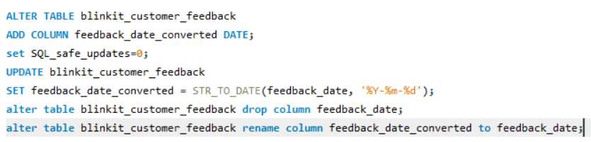Datatype changed from string to date in blinkit_customer_feedback table
2. Checking for null values in every column in every table
3. Blank column in blinkit_delivery_performance table is replaced with ‘-‘

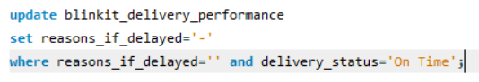

1. Deleting unnecessary columns in tables

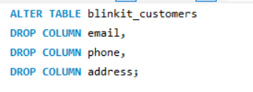

1. Updating columns with primary and foreign keys to the tables to provide interconnection

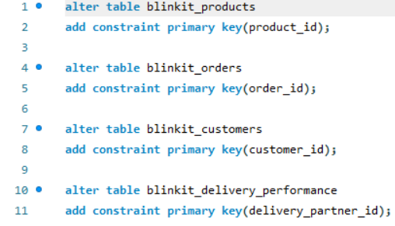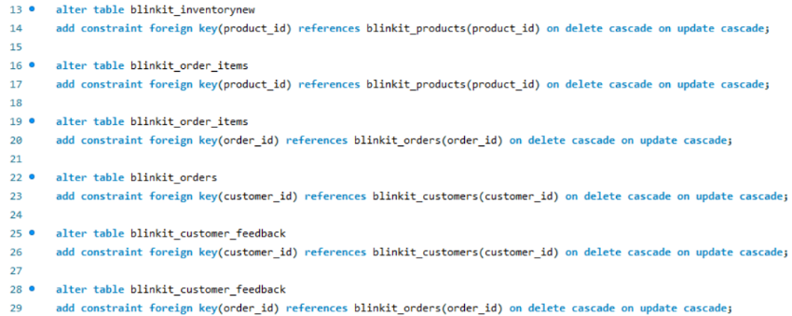

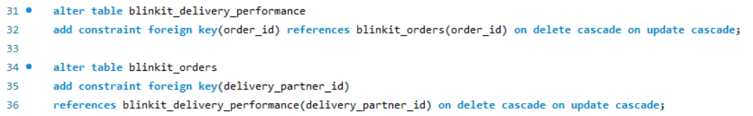

**Insights and KPI’s of Blinkit_dataset**

1. What products blinkit selling (unique products)?

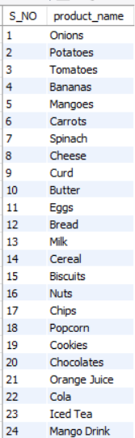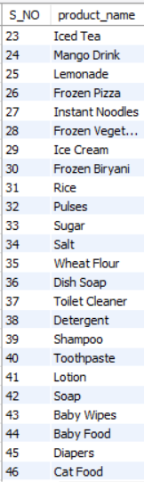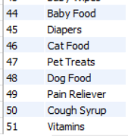

1. Find top 10 most sold-out products?

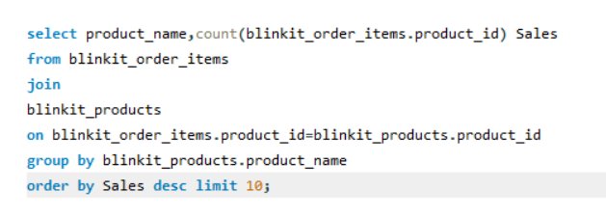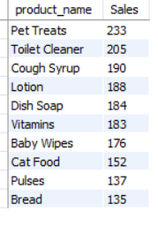

1. Find top 10 least sold-out products?

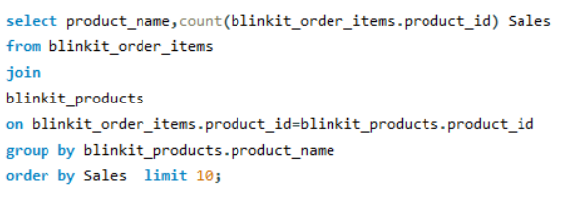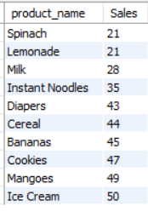

1. Total sales from march 2023 to November 2024



1. Total revenue generated



1. Average order value

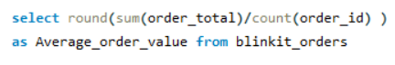

1. Month wise sales count, revenue generated and profit gain

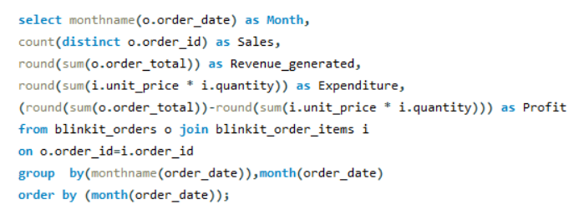

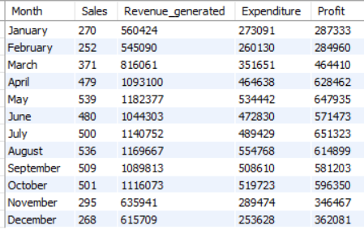

1. Which time has highest orders and lowest orders like peak hours

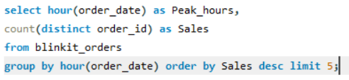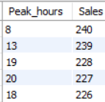

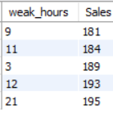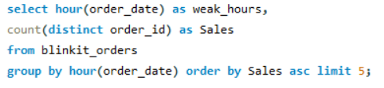

1. Which day has most and least sales

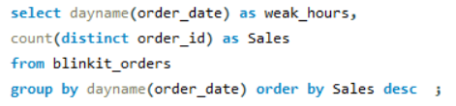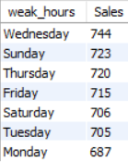

1. Orders delivered by delivery status

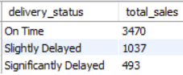

1. Payment ways done on orders

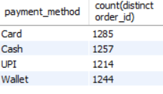

1. Average delivery delay Time

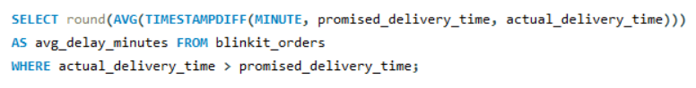

1. Average promised delivery time from ordered time



1. Average delivery time from ordered to delivered



1. Total profit generated

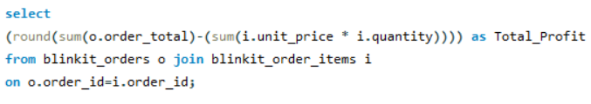

1. Highest Sold-out categories and lowest sold-out categories

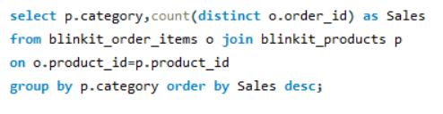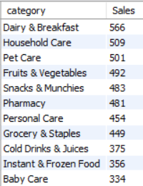

1. Profit generated by campaigns

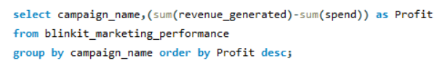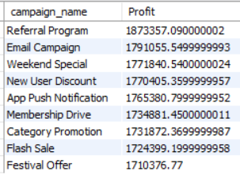

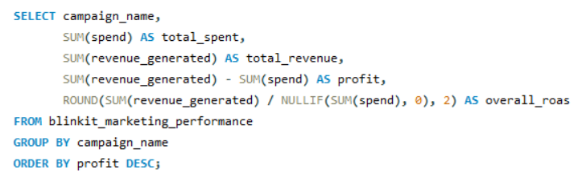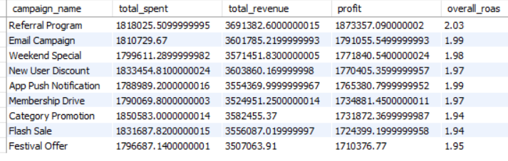

ROAS=Return on Advertising Spend (ROAS=Revenue from Ads​/Ad Spend)

1. Customers registered from march 2023 to November 2024

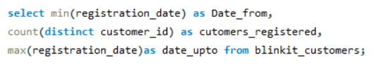



1. Sales area wise

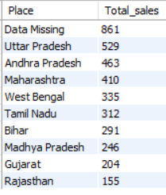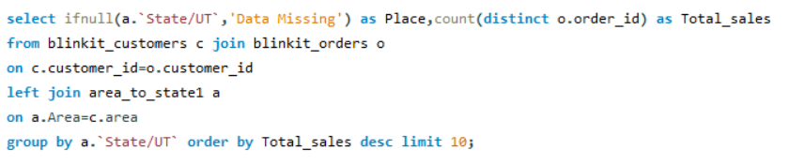

1. Feedback Rating category wise

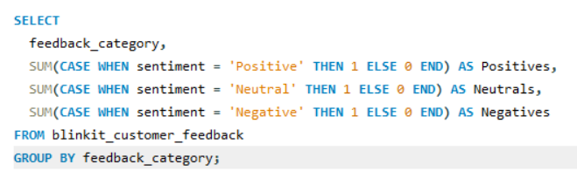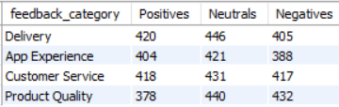

1. People given negative feedback

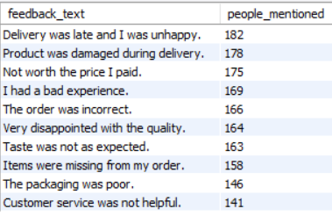

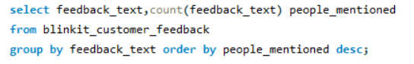

1. Margin percentage by product category

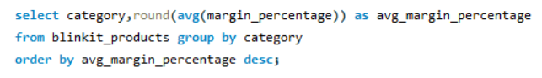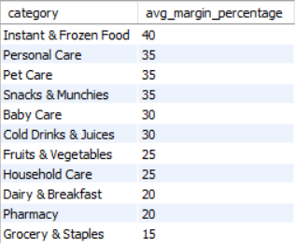

1. Category wise products maximum shelf-life days

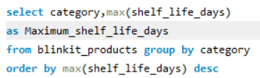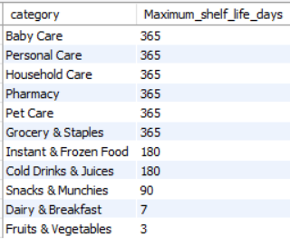

1. Most common delivery delay reasons

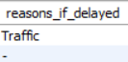

1. Average customer rating

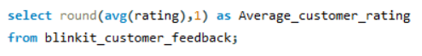

1. Customer ratings

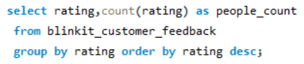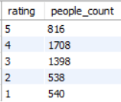

1. Stock received vs damaged

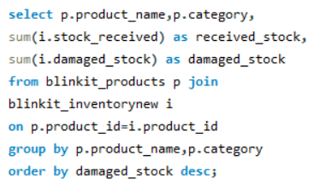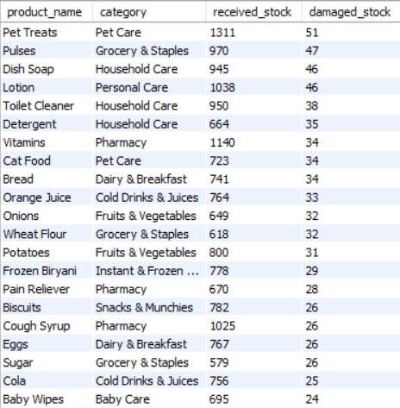

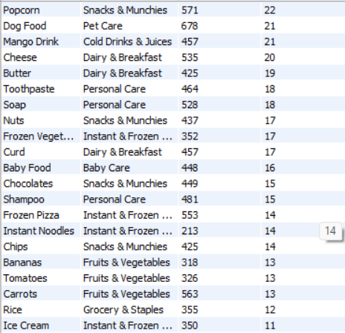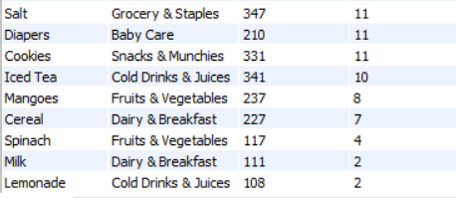

1. Efficient way of marketing

