**Project Specification Document**

Interview Chatbot

Vvsv sai manideep(E17cse001)

B.vasanth(E17cse032)

Pratheek Yatham(E17cse068)

Bijin Rao Bongu(E17cse074)

**Table of Contents**

Section Page

1. Project Vision and Objectives 1

1.1 Project Scope and Vision 1

1.2 Project Goals and Objectives 2

2 Project Planning 3

2.1 Project Lifecycle 3

2.2 Project Setup 3

2.3 Stakeholders 3

2.4 Project Resources 4

3 Requirements (User Stories) 5

3.1 Overall Description 5

3.2 Users and Roles 5

3.3 Use Case Diagrams 6

3.4 User Stories (Requirements) 6

3.5 Constraints and Limitations 13

Definitions and Acronyms 14

# Project Vision and Objectives

## Project Scope and Vision

Many undergraduate students are facing problem to prepare for the interview. As they need to search a lot and lot of information from internet which might not be very efficient. But with the help of our chat bot Students can gain knowledge and experience of how the interviews will be taken place. So that the students can easily crack the interviews . The final delivery will be at the final presentation in early May.

## Project Goals and Objectives

Our main objective is to provide a mock interview for the applicants and students who are prepping for interviews.

|  |  |
| --- | --- |
| **#** | **Goal or Objective** |
| 1 | Make the system extensible – for the future updates we r trying to introduce a basic voice I/O system to be user friendly . |
| 2 | Make the system easy to support – instead of going through many sites for accurate answers our interface provides the accurate answers in the available topics ,there will no complications for the users as it is just simple ask question and get answer type. |
| 3 | Make the system very easy to use – instead of typing in all the questions ,we are trying to introduce the voice I/O system which enables the user not to get irriated for insertiong all the questions he needs to know |
| 4 | Build a prototype that demonstrates the user interface by 12/05/2019 - in order to get early feedback from the customer/users |

# Project Planning

## Project Lifecycle

The team will use an agile approach. Our team will gather requirements and create a high level development plan at the onset of the project and then implement the gathered requirements over three iterations. The team will follow a SCRUM-like approach with an emphasis on frequent meetings and collaboration.

## Project Setup

|  |  |
| --- | --- |
|  | **Decision Description** |
| 1 | Windows 8, python, Tkinter , tensor flow ,tensor layer and gtts. |
| 2 | Standards that must be followed . |
| 3 | Special access privileges needed, nondisclosure forms, release to open source, etc. |

## Stakeholders

|  |  |
| --- | --- |
| **Stakeholder** | **Role** |
| Anurag goswami | Mentor |
| Vvs manideep | Back end Developer |
| Bandlamudi Vasanth | System Designer |
| Pratheek Yatham | Project Manager |
| Bijin rao bongu | Front end Developer |

## 

## Project Resources

|  |  |  |
| --- | --- | --- |
| **Resource** | **Resource Description** | **Quantity** |
| Dataset | A dataset prepared by own | 1 |
| Python 3.7(64 bit) | We develop our project using this Software. | 1 |
| Tensor flow | It is a software library used in machine learning applications. | 1 |
| Windows computer | An computer to be used as test hardware for the computer of the software. | 1 |

# Requirements (User Stories)

## Overall Description

This project is an attempt to apply deep learning using Recurrent neural network(RNN) and we use seq2seq model which is used to generate the answer for user. We are constrained towards specific topic such as data structures ,algorithms and operating systems .

So basically our project is to provide a chat bot for undergraduates to help them prepare for interviews.

## Users and Roles

|  |  |
| --- | --- |
| **User** | **Description** |
| Developer | A capstone team member or mentor who is tasked with managing the test data, creating initial machine learning models, and ultimately generating a firm process for applying these techniques to future user data. This is used for sub-stories and task needed to fulfill the true end user use cases. |
| Student | A person who uses the application service to prepare for their interview using the functionalities provided by the chat bot. |

## Use Case Diagrams

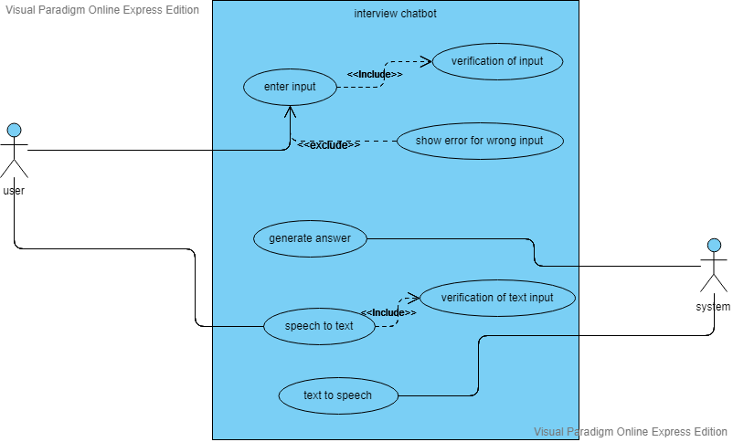

## User Stories (Requirements)

1)As a end user, I want to get answers to the questions so that I can prepare for the interview.

Acceptance criteria: Given ,I am a end user, when I ask for the required question, then I get required output without errors.

2)As a end user, I want to get the output in voice form ,so that it makes some interest towards learning.

Acceptance criteria :Given, I am a end user when I give the input in voice form then the system also gives output in the form of voice .

3)As a developer, I want the user to be satisfied with my software,so that he can use the software again and again.

Acceptance criteria: Given ,I am a developer ,the software need to answer the questions in efficient way then the users will use the software frequently when required.

**Sample User Stories:** *This sample assumes SPRINT 2 is completed. For SPRINT 3, user stories are already planned along with* ***Acceptance Criteria*** *and* ***Verification Description****.* ***Tasks*** *will be added when SPRINT 3 is completed.*

**SPRINT 1**

**Estimated User Story Points:** 2

**Actual Completed User Story Points:** 2

|  |  |  |  |  |  |  |  |
| --- | --- | --- | --- | --- | --- | --- | --- |
| **ID** | **Added** | **Description** | **Status** | **Story Points** | **Actual Equivalent Story Points** | | **% Completed** |
| 100 | Onset | **As a user I want to get answers to the questions so that I can prepare for the interview.** | **C** | **2** | **3** | | **100%** |
| **Acceptance Criteria** | | | **Verification** | | | | |
| **110** | Given ,I am a end user, when I ask for the required question, then I get required output without errors | | **Create a test case to verify the answer is correct or not.** | | | | |
| **111** | Given, I am a end user when I give the input in voice form then the system also gives output in voice form. | | **Create test case to verify the output in voice form.** | | | | |
| **112** | Given ,I am a developer ,the software need to answer the questions in efficient way then the users will use the software frequently when required. | | **Create test case to verify the answer.** | | | | |
| **ID** | **Tasks** | | | | | **Resource** | |
| 1 | To make the software give answers with at least 50% accuracy | | | | | **manideep** | |
| 2 | To create the interface so, that the users can interact with the software | | | | | **Bijin rao** | |
| 3 | To design schedule for performing daily tasks. | | | | | **Pratheek yatham** | |
| 4 | To design how the interface should be and how the software should work. | | | | | **Vasanth bandlamudi** | |

**SPRINT 2**

**Estimated User Story Points:** 8

**Actual Completed User Story Points:** 8

|  |  |  |  |  |  |  |  |
| --- | --- | --- | --- | --- | --- | --- | --- |
| **ID** | **Added** | **Description** | **Status** | **Story Points** | | **Actual Equivalent Story Points** | **% Completed** |
| 200 | Onset | **As a** user I want to ask a question so that I can prepare well for the interview  As a user I want to give the input in speech form so that it becomes easy for me. | **C** | **8** | | **8** | **100%** |
| **Acceptance Criteria** | | | **Verification** | | | | |
| **210** | The text should be meaningful. | | **Create test cases to verify the text is clear or not.** | | | | |
| **211** | The voice should be clear | | **Create a test case to verify the clarity of the voice.** | | | | |
| **212** | The answer given by the system should be meaningfula | | **Create test cases to check the output .** | | | | |
| **ID** | **Tasks** | | | | **Resource** | | |
| 1 | Improve the accuracy to some extent. | | | | **Vvs manideep** | | |
| 2 | Convert speech to text | | | | **Vasanth bandlamudi** | | |
| 3 | Convert text to speech | | | | **Pratheek yatham** | | |
| 4 | Improve the front end. | | | | **Bijin rao** | | |