–––––SUMMER INTERNSHIP PROJECT REPORT
Project Title: AI Property Valuation Assistant — Predicting House Prices with Machine Learning and a Plain-English LLM Explainer
Validate the final project title with your mentor before submission.
Student Name(s): P Sai punshuk Reddy,
T Jayadev Reddy
B teja Narayana
Manidhar Reddy
Aarnav Agarval
Course / Batch and Institute Name: _______________________________________________
Project Guide / Mentor Name: Devjothi Dutta
Period of Internship: 18th May 2026 – 31st July 2026
Report submitted to: IDEAS – Institute of Data Engineering, Analytics and Science Foundation, ISI Kolkata

HOW TO USE THIS SCAFFOLD. This is the official ISI report structure with project-specific guidance added. Each section has two parts: a grey guidance block telling you what to write, and a [Write here] placeholder where you write it. Delete every guidance block and this box before you submit. A group may write one shared report, but each intern must upload it separately and fill the individual Google Form. Keep your numbers honest — report what your notebook actually produced, not the example shapes shown here.

1. Abstract
What ISI wants: a brief about the project in maximum 10 sentences.
For our project: state the problem (estimate a house's sale price from its features), the data (Ames, Iowa housing dataset), the two models you compared (Linear Regression vs Random Forest), the metric you judged them on (R² / RMSE / MAE), which model won, and the role of the LLM layer (it explains the estimate in plain English and parses a natural-language house description — it does not predict the price). Write this section last, once your results are final.
[Write here]

2. Introduction

Purpose of project:
- Building a model which valuates the house based on its characteristics.
- Integrating LLM into the model which only explains the price given by Model.
Project’s Relevanace:
- Buying and selling a property involves many factors making valuation challenging.
- Manual valuation requires professional judgment etc… which can be time-consuming.
- This calls for Machine Learning which can analyze housing data to estimate price of property more efficiently and less time consuming.
Technologies used:
- Python programming
- Github
- Google Colab
- Matpltolib
- Numpy
- Pandas
- Scikit-learn
- Groq API(still not used)

House prediction problem is classic ML because of comparing Linear regression and Random Forest Algorithms.There is so much to learn this from this such as ML algorithms,Cleaning and preprocessing the data,Integrating the LLM to analyze the result to give the explanation into this problem is also great thing to learn.

Training topics covered in the first two weeks:
- EDA
- Data Visualization
- Cloud computing
- Git,Github,AWS
- Streamlit
- Machine learning
- LLM fundementals
- Deep Learning
- Agentic Workflow
- Compuer Vision
- Communication skills

3. Project Objective
- Develop a reliable ,clean and reproducible machine learning pipeline for accurate house prediction Using Ames Housing Dataset.
- Train and compare two regression models — a Linear Regression baseline and a Random Forest — to predict SalePrice.
- Evaluate both models on a held-out test set using R², RMSE, and MAE, and select the better model.
- Identify which house features most influence the predicted price (feature importance).
- Add an LLM layer (Groq) that explains a prediction in plain English and turns a free-text house description into a prediction — without ever inventing the price itself.

4. Methodology

4.1 Data source:
This Project uses the Ames Housing Dataset ,a Public available dataset containing property sales from Ames. This data contains 2930 Rows and 85 attributes including location ,Area of House and Many other.it was obtained from Kaggle website which serves as source for useful dataset for ML problems.

4.2 Tools and libraries.:
This project was implemented in Python in Google colab.The libraries used includes Numpy,Matplotlib,Pandas for data Visualization and Scikit learn for data pre-processing,Model building and evalution,and Groq API for integrating LLM interface layer.
4.3 Data cleaning and feature selection. [Describe: removing the extreme outliers (very large Gr Liv Area houses that distort the fit); selecting your working subset of features (numeric features + Neighborhood); handling missing values.]:

4.4 Pre-processing:
Numerical feauters are standardized using StandardScaler while Categorical Feautes are handled using One hot encoding.These steps are done using Scikit pipeline to ensure consistent data transformation during training and testing.
4.5 Train/test split
The processed dataset was divided into 80% training data and remaining 20%data is used for testing and random_state was fixed.This step was done before fitting to not show bias while test for either models.

4.6 Models.
Two models are implemented in this Project ,One is Linear regression Model which is baseline model while other is RandomForest Model.
4.7 Model selection and validation
Model Performanace was evaluated on test dataset using Mean absolute error and Root Mean Squares error and R square Score. These metrics were used to compare the prediction accuracy and determine the better performing model.

4.8 LLM explainer layer. [Explain how the Groq LLM is used: it receives the model's numeric prediction and the house features and writes a plain-English explanation; it can also parse a free-text house description into features for the model. State the guardrail: the LLM is instructed never to change or invent the price.]
4.9 Analysis flow chart.
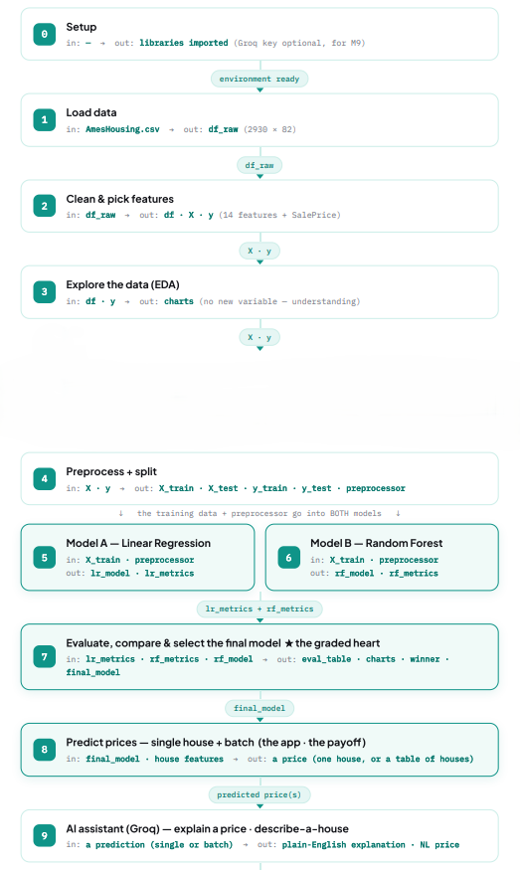
4.10 Code repository.
GitHub link: https://github.com/manidharc7/ISI-2026-Group1-Property-Valuation.git

5. Data Analysis and Results

5.1 Descriptive analysis (EDA). [Distribution of SalePrice; relationships between key features and price; correlation findings; the visualisations you generated. Paste your charts as screenshots.]
Distribution of sale Price:

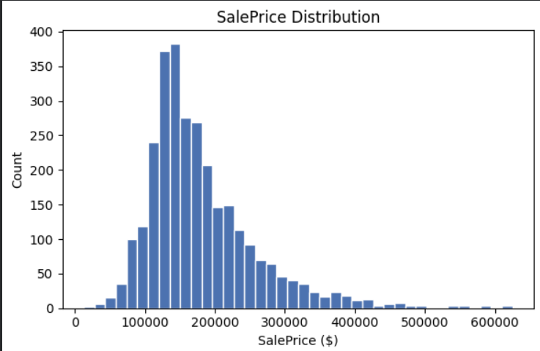
The SalePrice distribution Distribution Density is mostly concentrated in 10,000-20,000$ Range,relatively lesser in the Higher price region (50000$ or higher).Histogram shows that this is right skewed.

Correlation analysis:

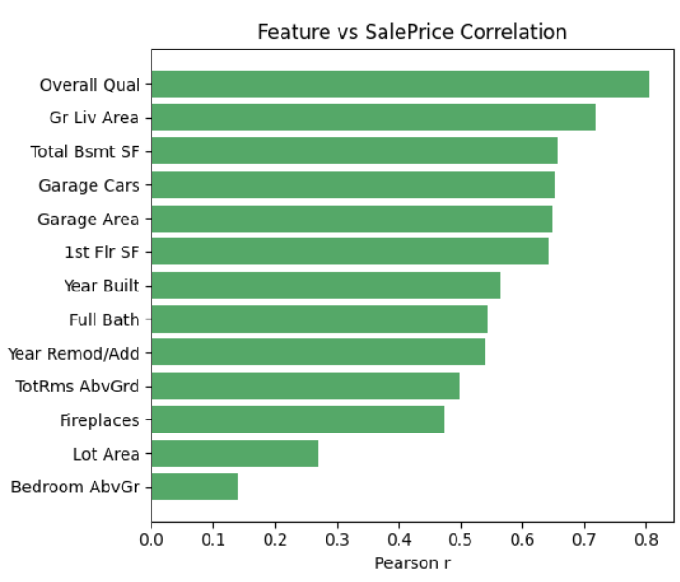

Pearson r correlation analysis was performed to examine the relation between features and Sale price . Overall Quality showed strongest co relation with Sale Price followed by Ground floor Living area and Total Basement SF .Garage Capacity for Cars and its area and 1st floor area also showed closer to salePrice than others.This shows Overall Quality and Garage Characterstics and Ground floor and first floor Living Areas are important factors in Predicting Saleprice.(does not means other are not effecting much,these affect Price the Most)
5.2 Model comparison
Model | RMSE | MAE | R²
Linear Regression (baseline) | $29,581 | $19153 | 0.877
Random Forest | $24,011 | 15,547 | 0.919

Random Forest performed better than Linear Regression. Random Forest achieved an R² score of 0.919 compared to 0.877 for Linear Regression. It also reduced RMSE from $29,581 to $24,011 and MAE from $19,153 to $15,547. This indicates that Random Forest captures the relationship between housing features and SalePrice more effectively.
5.3 Feature importance
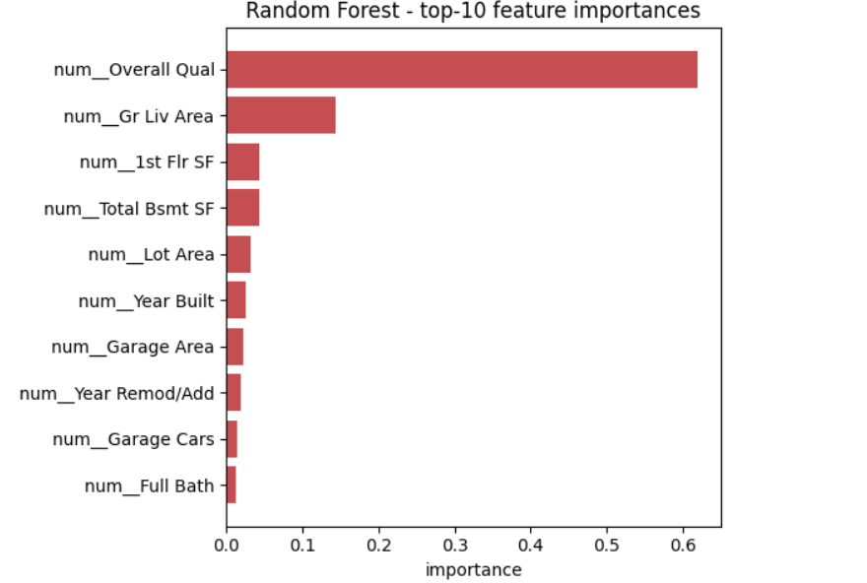
The feature importance analysis shows that Overall Quality is most influential feature in the random forest model followed by Ground living area with significant difference .First floor area and basement area also contribute to predictions.Thus telling that Overall quality and living space of property are major factors influencing the model’s predicted housing price.
5.4 Prediction examples
Single house prediction:
For a house with overall quality of 7,Ground living area of 1500sq.ft,Year built 2005,2 garage cars,2 full bathrooms and 3 bed rooms,the model estimated $188,295.
Batch prediction:
Overall Qual GrLiv Area Neighborhood predicted_price
6 1456 NPkVill 147271.577143
9 2728 NridgHt 488953.836667
7 1665 Somerst 202667.603333
6 1252 ClearCr 170255.320000
5 1904 NAmes 147434.906667

6. Conclusion
What ISI wants: the conclusions drawn from the work, justified by quoting your findings. May include recommendations for future work.
For our project, address: which model you would use and why (quote the R²/RMSE numbers); what the most important price drivers turned out to be; the honest limitations (the LLM does not predict; the model is trained on US Ames data, so it will not transfer directly to Indian prices); and future work (re-train on an Indian/Bengaluru dataset with the same pipeline; try other models; apply the same recipe to other prediction problems such as customer churn or loan default).
[Write the conclusion here]

7. Appendices
Create a separate appendix for each that applies:
Appendix A — References. [Papers, articles, websites, and documentation you referred to — e.g. the Ames Housing dataset paper by Dean De Cock, scikit-learn documentation, the Groq quickstart.]
Appendix B — Survey Questionnaire. Not applicable — no survey was conducted.
Appendix C — GitHub link for the code developed. _______________________________________________
Appendix D — Other document links. [A copy of this report, the dataset, and your presentation should be kept in GitHub / Google Drive — paste those links here.]

