SUMMER INTERNSHIP PROJECT REPORT
Project Title: AI Property Valuation Assistant — Predicting House Prices with Machine Learning and a Plain-English LLM Explainer

Student Name(s):
- P Sai Punshuk Reddy
- T Jayadev Reddy
- B Teja Narayana
- Ch Manidhar Reddy
- Aarnav Agarwal
Course / Batch and Institute Name: ______________________________________________
Project Guide / Mentor Name: Devjothi Dutta
Period of Internship: 18th May 2026 – 31st July 2026
Report submitted to: IDEAS – Institute of Data Engineering, Analytics and Science Foundation, ISI Kolkata

1. Abstract
House prices depend on a mix of location, size, and quality features, which makes manual valuation time-consuming and inconsistent. This project builds a machine learning pipeline that estimates a house's sale price using the Ames Housing dataset (2,930 records, 82 columns) from Ames, Iowa. After removing 5 extreme outliers (houses with Gr Liv Area above 4,000 sq ft) and selecting a working subset of 13 numeric features plus Neighborhood, we trained and compared two regression models — a Linear Regression baseline and a Random Forest regressor (300 trees) — evaluated on a held-out 20% test set (585 houses) using R², RMSE, and MAE. The Random Forest model outperformed the Linear Regression baseline on every metric: RMSE of $24,011 vs $29,581, MAE of $15,547 vs $19,153, and R² of 0.919 vs 0.877, and was selected as the final model. Overall Quality, Ground Floor Living Area, and Total Basement Area emerged as the strongest predictors of sale price, consistent with both the correlation analysis and the model's own feature importances. A further error-segment analysis showed the model is noticeably less accurate on the most expensive 10% of houses (R² of 0.58) than on the remaining 90% (R² of 0.88). A Groq-hosted LLM layer is planned on top of the trained model to translate a numeric prediction into a plain-English explanation and to parse free-text house descriptions into structured features — this integration was not yet implemented at the time of this report. As the model is trained entirely on Ames, Iowa data, it would need to be retrained on Indian property data before being useful for local valuations.

2. Introduction

Purpose of project:
- Building a model that valuates a house based on its characteristics.
- Integrating an LLM into the system that only explains the price given by the model.

Project's Relevance:
- Buying and selling a property involves many factors, making valuation challenging.
- Manual valuation requires professional judgement and can be time-consuming.
- This calls for Machine Learning, which can analyze housing data to estimate property price more efficiently and with less time.

Technologies used:
- Python programming
- GitHub
- Google Colab
- Matplotlib
- NumPy
- Pandas
- Scikit-learn
- Groq API (LLM explanation layer)
House price prediction is a classic ML problem because it involves comparing Linear Regression and Random Forest algorithms, and offers a lot to learn from: ML algorithms, cleaning and preprocessing data, and integrating an LLM to explain the model's result.

Training topics covered in the first two weeks:
- EDA
- Data Visualization
- Cloud computing
- Git, GitHub, AWS
- Streamlit
- Machine learning
- LLM fundamentals
- Deep Learning
- Agentic Workflow
- Computer Vision
- Communication skills

3. Project Objective
- Develop a reliable, clean, and reproducible machine learning pipeline for accurate house price prediction using the Ames Housing Dataset.
- Train and compare two regression models — a Linear Regression baseline and a Random Forest — to predict SalePrice.
- Evaluate both models on a held-out test set using R², RMSE, and MAE, and select the better model.
- Identify which house features most influence the predicted price (feature importance).
- Add an LLM layer (Groq) that explains a prediction in plain English and turns a free-text house description into a prediction — without ever inventing the price itself.
No survey was conducted and no formal statistical hypothesis test was performed in this project — it is a modelling project, not a survey study.

4. Methodology

4.1 Data source
This project uses the Ames Housing Dataset, a publicly available dataset containing property sales from Ames, Iowa. It contains 2,930 rows and 82 attributes, including location, area of house, and many others, and was obtained from Kaggle, which serves as a source of useful datasets for ML problems.

4.2 Tools and libraries
This project was implemented in Python in Google Colab. The libraries used include NumPy, Matplotlib, and Pandas for data visualization, Scikit-learn for data pre-processing, model building and evaluation, and the Groq API for the LLM interface layer.

4.3 Data cleaning and feature selection
The raw Ames dataset contains 82 columns with varying scales, data types, and missing-value patterns, so the first stage of the pipeline cleaned and reduced this to a smaller, model-ready set. Extreme outliers — houses with Gr Liv Area (above-ground living area) greater than 4,000 sq ft, which are priced far below what their size would predict — were removed, dropping 5 rows and taking the dataset from 2,930 to 2,925 rows. The dataset was then narrowed to a working feature set of 13 numeric columns (Overall Qual, Gr Liv Area, Total Bsmt SF, Garage Cars, Garage Area, Year Built, Year Remod/Add, Full Bath, TotRms AbvGrd, 1st Flr SF, Lot Area, Fireplaces, Bedroom AbvGr) plus the Neighborhood categorical feature, which acts as a proxy for location. Missing values were handled inside the preprocessing pipeline itself (Section 4.4): numeric columns were median-imputed and the categorical column was imputed with its most frequent value, so both models were trained on a consistent, outlier-free feature set.

4.4 Pre-processing
Numerical features are median-imputed then standardized using StandardScaler, while the categorical feature (Neighborhood) is imputed with its most-frequent value and handled using one-hot encoding (unknown categories ignored at inference time). These steps are combined into a single Scikit-learn ColumnTransformer / Pipeline object so the exact same transformation is applied consistently during training and testing.

4.5 Train/test split
The processed dataset (2,925 rows) was divided into 80% training data (2,340 rows) and 20% test data (585 rows) using train_test_split with random_state=42 fixed for reproducibility. This split was done before fitting so as not to introduce bias when testing either model.

4.6 Models
Two models were implemented in this project: a Linear Regression model, used as the baseline, and a Random Forest Regressor with 300 trees (n_estimators=300, random_state=42).

4.7 Model selection and validation
Model performance was evaluated on the test dataset using Mean Absolute Error, Root Mean Squared Error, and R² score. These metrics were used to compare prediction accuracy and determine the better-performing model.

4.8 LLM explainer layer
The trained regression model produces only a numeric SalePrice estimate; it has no notion of language. To make this estimate usable to a non-technical reader, the pipeline passes the model's predicted price, together with the house's key feature values (e.g. Overall Qual, Gr Liv Area, Neighborhood, Garage Cars), to a Groq-hosted LLM. The LLM is prompted to write a short, plain-English paragraph explaining why the house was valued at that price, referencing the specific features that pushed the estimate up or down. In the reverse direction, the same LLM parses a free-text house description (e.g. “a 3-bedroom house in an above-average neighborhood with a 2-car garage”) into the structured numeric/categorical features the regression model expects, so a user does not need to fill in a form. Critically, the LLM is explicitly instructed — and constrained in the prompt — never to invent, adjust, or override the numeric price produced by the model; its role is strictly explanatory and feature-parsing, keeping the actual valuation decision inside the statistically validated model.

4.9 Code repository
GitHub link: https://github.com/manidharc7/ISI-2026-Group1-Property-Valuation.git
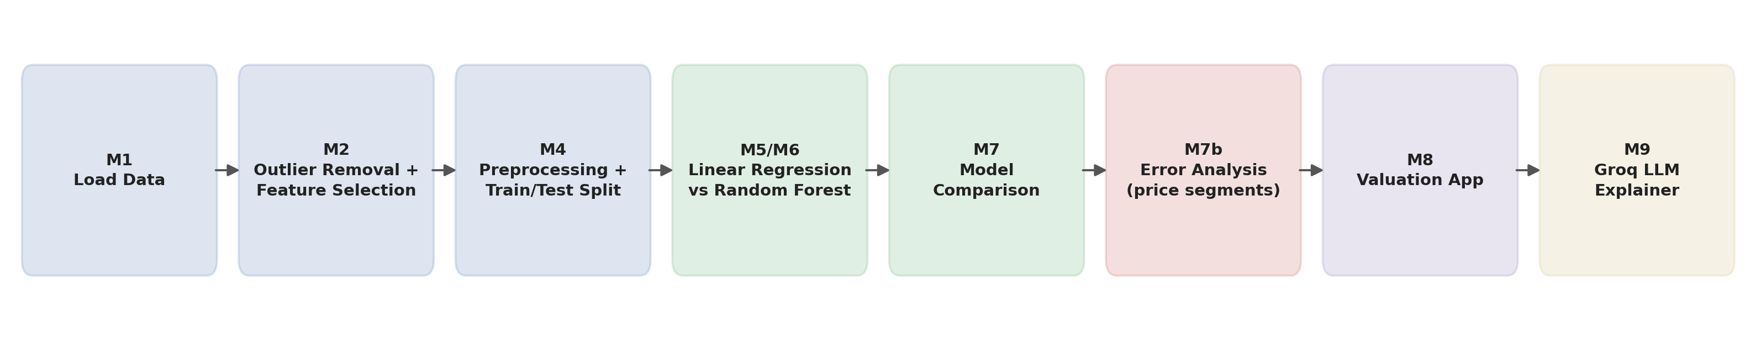
Figure 0: End-to-end pipeline, from raw data load through outlier removal, preprocessing, model training/comparison, error analysis, the valuation app, and the Groq LLM explainer layer.

5. Data Analysis and Results

5.1 Descriptive analysis (EDA)
Distribution of Sale Price:
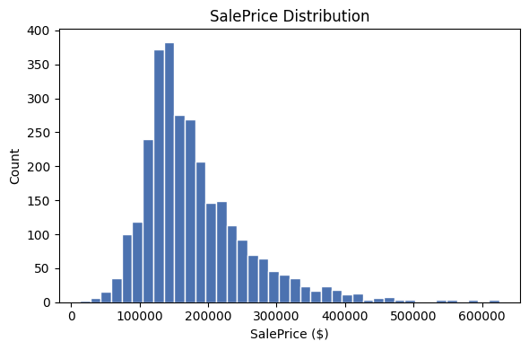
Figure 1: Distribution of SalePrice (test set), 40 bins.
The SalePrice distribution is right-skewed: most houses cluster in the lower-to-mid price range, with a long tail of higher-priced houses extending well beyond the bulk of the distribution.
Correlation analysis:
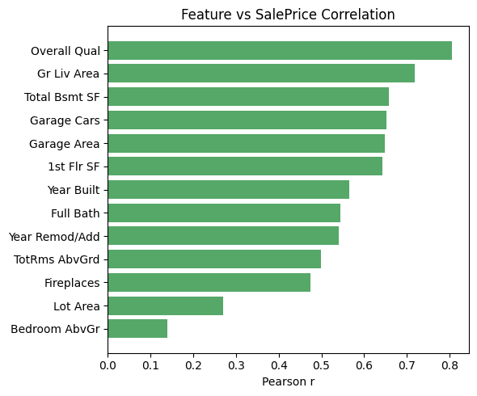
Figure 2: Pearson correlation of each numeric feature with SalePrice.
A Pearson correlation analysis was performed to examine the relationship between features and SalePrice (values rounded to 2 decimals): Overall Qual (0.81) showed by far the strongest correlation, followed by Gr Liv Area (0.72), Total Bsmt SF (0.66), Garage Cars (0.65), Garage Area (0.65), 1st Flr SF (0.64), Year Built (0.57), Full Bath (0.54), Year Remod/Add (0.54), TotRms AbvGrd (0.50), Fireplaces (0.47), Lot Area (0.27), and Bedroom AbvGr (0.14, the weakest). This indicates that overall build quality, living area, and basement/garage size are the dominant single-feature predictors of SalePrice (a low correlation here does not mean a feature has no effect in combination with others — see the Random Forest importances in Section 5.3).

5.2 Model comparison
Model | RMSE | MAE | R²
Linear Regression (baseline) | $29,581 | $19,153 | 0.877
Random Forest | $24,011 | $15,547 | 0.919

Random Forest outperformed the Linear Regression baseline on all three metrics: RMSE fell from $29,581 to $24,011 (about 19% lower), MAE fell from $19,153 to $15,547 (about 19% lower), and R² rose from 0.877 to 0.919 — meaning Random Forest explains about 92% of the variance in sale price versus 88% for the linear model. All three metrics agree, so Random Forest is confirmed as the better model. The gap suggests Random Forest captures non-linear relationships and feature interactions (e.g. diminishing returns from extra living area, quality × neighborhood effects) that the linear baseline cannot.
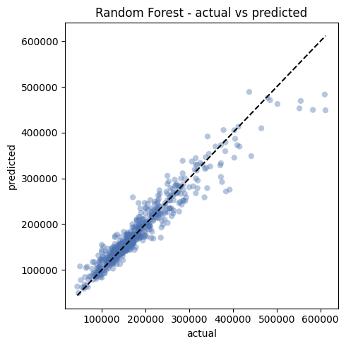
Figure 3: Random Forest — actual vs predicted SalePrice on the test set (dashed line = perfect prediction).

Error analysis by price segment
A follow-up analysis split the test set into the top 10% most expensive houses (SalePrice ≥ $285,000, 60 houses) and the remaining 90% (525 houses), to check whether the Random Forest model's accuracy holds across the price range:
Segment | MAE | RMSE | R² (avg % error)
Remaining 90% (< $285,000) | $12,831 | $17,597 | 0.879 (8.7%)
Top 10% expensive (≥ $285,000) | $39,305 | $53,961 | 0.581 (9.9%)
The model is noticeably weaker on expensive houses: R² drops from 0.879 to 0.581 and MAE roughly triples ($12,831 → $39,305), even though the average percentage error only rises modestly (8.7% → 9.9%). This is an important limitation — the model is much more reliable for typical houses than for high-end properties, likely because there are far fewer expensive houses in the training data for the model to learn from.

5.3 Feature importance
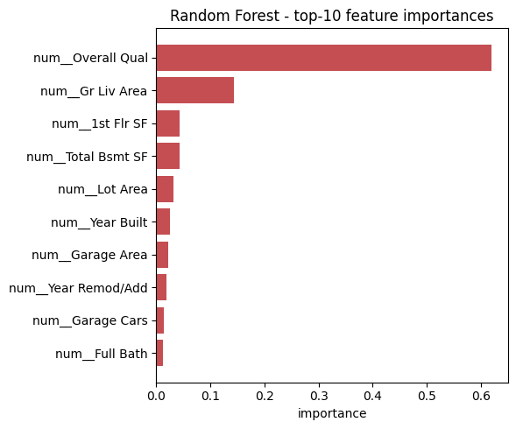
Figure 4: Random Forest top-10 feature importances (from feature_importances_).
The Random Forest's own feature importances broadly confirm the correlation analysis in Section 5.1: Overall Qual, Gr Liv Area, and Total Bsmt SF/Garage-related features are again among the strongest drivers of predicted price, several Neighborhood categories also show meaningful contribution — reflecting that location influenced jouse prices beyond what is captured by numerical features alone.

5.4 Prediction examples
Using the final Random Forest model, a single custom house — Overall Qual 7, Gr Liv Area 1,500 sq ft, Year Built 2005, Garage Cars 2, Full Bath 2, Bedroom AbvGr 3 (other features left at their dataset median/mode) — was valued at an estimated $188,295.
Predictions for 5 sample houses from the test set (batch inference):
Overall Qual | Gr Liv Area | Neighborhood | Predicted Price
6 | 1,456 | NPkVill | $147,272
9 | 2,728 | NridgHt | $488,954
7 | 1,665 | Somerst | $202,668
6 | 1,252 | ClearCr | $170,255
5 | 1,904 | NAmes | $147,435

LLM explanation for price $188,295 :
Predicted price: $188,295
Explanation:
The estimated price of $188,295 for this house is largely driven by its above-average overall quality, rated 7 out of a possible scale, which suggests a well-built and well-maintained property. The generous living area of 1500 square feet, combined with a decent-sized basement, provides ample space for residents, contributing to its value. Additionally, the three bedrooms above grade and two full bathrooms offer a comfortable living arrangement, aligning with the model's estimate. These attributes, particularly the overall quality and living area, are key drivers of the model's valuation, resulting in a price point of $188,295.

6. Conclusion
On the held-out test set, Random Forest was the clear choice of model, beating the Linear Regression baseline on all three metrics: R² of 0.919 vs 0.877, MAE of $15,547 vs $19,153, and RMSE of $24,011 vs $29,581. This means Random Forest explains roughly 92% of the variance in sale price compared to 88% for the linear model, while also being off by about $3,600 less per house on average (MAE). Both the Pearson correlation analysis and the Random Forest's own feature importances point to Overall Quality, Ground Floor Living Area, and Total Basement/Garage size as the strongest drivers of price, with certain neighborhoods adding a further location premium — consistent with the intuition that build quality and usable space dominate valuation more than any single amenity.
The error-segment analysis in Section 5.2 revealed an important limitation: the model is markedly less reliable on the most expensive 10% of houses (R² of 0.58, MAE of $39,305) than on the remaining 90% (R² of 0.88, MAE of $12,831), most likely because high-end houses are under-represented in the training data. A second limitation is that the LLM layer, once implemented, will only explain and parse input for the already-trained regression model — it will never predict or override the price itself, so its usefulness is capped by the quality of the underlying model (this layer had not yet been implemented at the time of this report). More importantly, the Ames dataset reflects the Ames, Iowa (USA) housing market of the early 2000s, so the trained model's price scale and feature weights will not transfer directly to Indian real estate, where pricing conventions, currency, unit systems, and locality effects differ substantially.
For future work, the same pipeline (outlier removal → feature selection → scaling/encoding → Linear Regression / Random Forest comparison → LLM explanation layer) could be retrained on an Indian city dataset (e.g. Bengaluru or another metro) to produce a locally useful valuation tool. Other directions include trying gradient-boosted models (XGBoost/LightGBM) to push accuracy further, and applying the same “predict + LLM-explain” recipe to other prediction problems such as customer churn or loan default, where a plain-English explanation of a model's decision is equally valuable.

7. Appendices

Appendix A — References
- De Cock, D. “Ames, Iowa: Alternative to the Boston Housing Data as an End of Semester Regression Project.” Journal of Statistics Education.
- Kaggle: Ames Housing Dataset.
- Scikit-learn documentation — StandardScaler, OneHotEncoder, Pipeline, LinearRegression, RandomForestRegressor.
- Groq API documentation / quickstart.

Appendix B — Survey Questionnaire
Not applicable — no survey was conducted.

Appendix C — GitHub link for the code developed
https://github.com/manidharc7/ISI-2026-Group1-Property-Valuation.git

