GOVERNMENT OF NCT OF DELHI
  - Integrated Financial Management System

Material Management Module
  - Step-by-Step Workflow-Wise User Manual
Version 1.0 | Based on Application Build V3.0 | FY 2026–27

Document Attribute | Value
Document type | End-user and workflow training manual
Application | IFMS – Material Management Module
Source reviewed | ifms_material_management_V3.html
Environment | UAT / Demo
Application version | 3.0
Manual version | 1.0
Prepared date | 24 September 2026
Intended users | Operational users, approvers, finance users, auditors, administrators and trainers

Control / caution: The uploaded HTML is a browser-based demonstration prototype. It stores changes in browser localStorage and simulates integrations. It is not a production substitute for authenticated APIs, PostgreSQL persistence, digital signatures, or live financial posting.

Document Control
Version | Date | Description | Status
1.0 | 24-Sep-2026 | Initial workflow-wise manual prepared from the uploaded V3 application | Draft for UAT / Training

Approval and Distribution
Role | Name / Designation | Responsibility
Business owner | Finance / Administrative Department | Approve business procedures and controls
Module owner | Material Management / Procurement Cell | Validate operational workflow
IT owner | IFMS Project Team | Maintain application and user access
Training coordinator | Department Nodal Officer | Conduct role-wise user training
End user | Authorized departmental user | Follow role permissions and record accurate data

Document Conventions
Convention | Meaning
Menu → Submenu | Navigation path in the left sidebar
Bold field/button | Field or action visible on the screen
Expected result | System behaviour after successful action
Control / caution | Mandatory rule, segregation-of-duties point, or data risk
Worked example | Illustration using the sample data supplied in the application

Table of Contents

1. Purpose and Scope
This manual explains how authorized users operate the IFMS Material Management V3 application from material creation and requisition through procurement, work order, receipt, inspection, inventory, billing, warranty, disposal, stock audit, forecasting, reporting, and administration. Instructions are organized by business workflow and use the roles, screens, controls, and sample records present in the uploaded application.

The manual covers:
- Application startup, navigation, role switching, notifications, global search, and local data persistence.
- Role-wise transaction processing and maker-checker controls.
- End-to-end transaction chain: Material → Requisition → Tender/Quotation → Work Order → Delivery → GRN → Inspection → Stock → Invoice → Finance/Payment.
- Exception workflows: return for correction, rejection, return to vendor, matching exception, warranty escalation, disposal, and stock adjustment.
- Reports, audit trail, requirement traceability, administrative parameters, interfaces, and reset procedures.

Out of scope
- Production login, SSO, digital-signature certificates, and external identity management.
- Live connection to Budget, Treasury, Finance, GeM, CPPP, GNCTD e-Procurement, PostgreSQL, or document-management services.
- Department-specific policy instructions that differ from the configured sample workflow and DFPR limits.

2. Application Startup
Step 1 — Save the application file
Keep the uploaded HTML file in a working folder. Do not rename linked resources because the build is a self-contained single HTML file.
Step 2 — Open the application
Double-click the HTML file or right-click it and choose a modern browser such as Microsoft Edge, Google Chrome, or Firefox.
Expected result: The Executive Dashboard opens and the top bar displays UAT / Demo, financial year, role, notifications, and user profile.
Step 3 — Confirm data-store mode
Check the sidebar footer. It displays “Data: localStorage” when browser persistence is available; otherwise it displays an in-memory session.
Expected result: With localStorage, user-created and changed demonstration records survive a browser refresh.
Step 4 — Select financial year
Choose FY 2026-27, FY 2025-26, or FY 2024-25 from the top bar. The prototype is seeded primarily for FY 2026-27.
Step 5 — Select role
Use the role selector in the top bar. The current user, menus, pending cases, and permissions change to the selected demonstration role.
Control / caution: Role switching simulates separate logins for training. In production, each role must be assigned to a separately authenticated user. The application prevents the Auditor from creating, changing, or approving records.
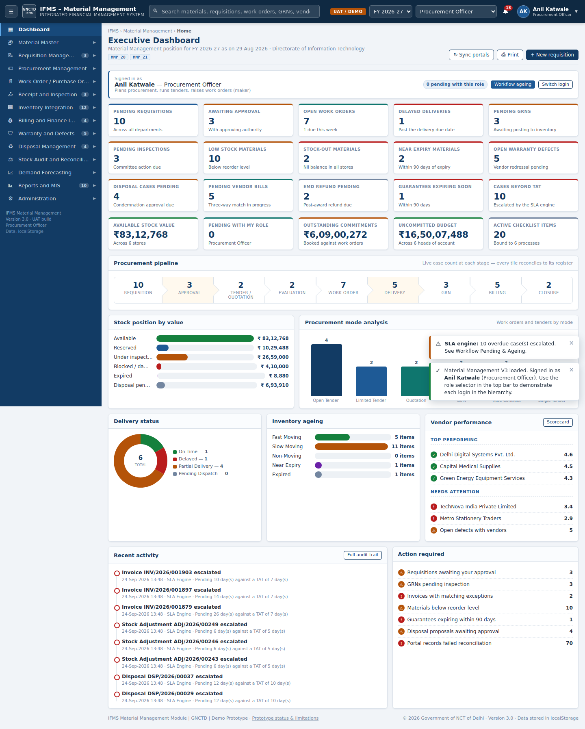
Figure 1 — Executive Dashboard and role-based navigation in the uploaded V3 application

3. User Interface
Area | Purpose | How to use
Top bar | Global search, environment, financial year, role, notifications, profile | Search by material, requisition, work order, GRN, tender, vendor, or invoice; select role for workflow training.
Left sidebar | Module-wise menus and pending counters | Select a group to expand it, then select a submenu. A lock indicates that the current role cannot access the screen.
Page header | Breadcrumb, screen title, description, FR tags, actions | Use action buttons such as Add, Export, Print, Sync, or Back.
Filter bar | Search and narrow register data | Enter criteria and select Search; use Reset to restore the full dataset.
Data grid | Sort, paginate, select, and act on records | Select column headings to sort; choose rows for permitted bulk actions; use row action buttons.
Modals | Create, view, approve, return, reject, and confirm | Complete required data, enter reason where requested, then confirm or cancel.
Toast messages | Immediate confirmation, warning, or error | Read the result at the lower right; correct validation errors before retrying.
Footer | Version, environment, role, and storage mode | Confirm that the intended build and role are active before processing.

Global search
- Enter at least two characters in the top search box.
- Review matches grouped by record type.
- Select a result to open its corresponding register.
- Use the register filter to locate the exact record when multiple results exist.

Notifications
- Select the bell icon.
- Review unread alerts such as invoice exceptions, expiring guarantees, delayed deliveries, stock-outs, inspections, or warranty escalations.
- Select a notification to open its related screen.
- Use Mark all as read when appropriate.

Table operations
- Search filters affect the screen register, while the top-bar search scans several transaction types.
- CSV export downloads the currently supplied register dataset; confirm browser download permission.
- Print uses the browser print dialog and hides navigation controls in the print layout.
- Pagination supports 10, 25, 50, or 100 rows per page where the table component is used.

4. Roles and Responsibilities
Role | Demonstration user | Primary responsibility
Indenting Officer | V. Sharma | Raise requisitions; issue/return requests; report defects.
Store Officer | R. Meena | Receive material, prepare GRN, transfer/issue/return stock, initiate disposal, and support stock verification.
Procurement Officer | Anil Katwale | Procurement plan, tender, quotation, evaluation, comparative statement, work order, delivery follow-up, securities, and vendor coordination.
Inspection Officer | S. Bansal | Inspect receipts and record acceptance/rejection.
Head of Office | P. Kaur | Level-1 approval, stock adjustment, audit scheduling, and operational oversight.
Head of Department | Dr. A. Rao | Higher approval under DFPR; disposal and stock-adjustment authority.
Finance Wing | M. Iqbal | Budget concurrence, three-way matching, bill scrutiny, payment, and security actions.
DDO | N. Gupta | Post accepted GRN quantity to stock ledger and initiate matched bills.
Administrative Secretary | L. Chawla | Approve high-value requisitions/orders under the configured hierarchy.
Finance Department | FD-II Desk | Concurrence for values beyond departmental powers.
Condemnation Board | J. Singh (Chair) | Approve disposal within configured authority.
Master Data Administrator | T. Joshi | Maintain masters, roles, workflows, checklists, notifications, parameters, and interfaces.
Auditor | D. Menon | Read-only access to all screens and audit trail.

Control / caution: Maker-checker control applies. A record creator must not approve the same record. Approval is resolved by workflow configuration, transaction value, procurement mode, and the DFPR matrix.

5. End-to-End Workflow
Stage | Primary role | Input | Main action | Output / next stage
1. Material master | MDA / Store / Procurement | Approved material specification | Create or update material | Active material code
2. Requisition | Indenting Officer | Need, stock position, budget head | Save draft and submit | Submitted requisition
3. Requisition approval | HoO / HoD / Finance / AS / FD | Submitted requisition | Approve, forward, return, or reject | Approved requirement
4. Procurement plan | Procurement / Approver | Approved requisitions and forecasts | Create and approve plan | Approved procurement package
5. Tender / quotation | Procurement | Approved plan | Publish, receive bids, evaluate | Approved comparative statement / vendor
6. Work order | Procurement / Approvers | Award decision and budget | Create, commit, approve, issue | Issued work order
7. Delivery and GRN | Vendor / Store | Issued order and challan | Record delivery and goods receipt | GRN pending inspection
8. Inspection | Inspection Officer | GRN and goods | Accept, accept with deviation, or reject | Inspection result
9. Inventory posting | DDO | Accepted GRN quantity | Post GRN | Updated stock ledger
10. Issue / transfer / return | Store / Indentor | Available stock | Move, issue, or return stock | Stock movement entries
11. Invoice matching | Finance / DDO | PO, accepted GRN, invoice | Run three-way match and resolve exceptions | Matched bill
12. Bill and payment | DDO / Finance | Matched invoice | Send to finance and record payment | Paid invoice
13. Warranty | Indentor / Store / Procurement | Asset or receipt under warranty | Raise, update, escalate, resolve | Closed complaint
14. Disposal | Store / Board / Approvers | Obsolete/damaged/expired material | Approve and record disposal | Disposed/closed record
15. Audit and forecast | Store / HoO / Procurement | Stock and movement history | Verify, reconcile, forecast | Adjustment or replenishment action

Worked example: Laptop procurement chain already present in the sample data: material MAT-IT-0001 → requisition MR/DIT/2026/000340 → tender TND/2026/10042 → work order WO/DIT/2026/000098 → GRN/DIT/2026/000245 → invoice INV/2026/001879. The invoice is intentionally available as an exception scenario for three-way matching training.

6. Material Master
Navigation: Material Master → Create Material or Material Register.
Step 1 — Choose an authorized role | Role: MDA / Store / Procurement
Select Master Data Administrator, Store Officer, or Procurement Officer.
Step 2 — Open the form
Select Material Master → Create Material.
Step 3 — Enter identity and classification
Complete material code, name, descriptions, status, make, brand, model, material group, category, subcategory, material type, stock/non-stock, consumable, capital/revenue, and asset eligibility.
Step 4 — Enter units and controls
Select primary, purchase, stock, and issue UOM; enter conversion factor, minimum/maximum stock, reorder level, reorder quantity, lead time, standard rate, and accounting dimensions.
Step 5 — Enter tracking requirements
Configure batch, serial, manufacturing date, expiry, shelf life, warranty, and disposal category.
Step 6 — Save or submit
Select Save draft to retain incomplete data or Submit for approval for controlled activation.
Expected result: The material appears in Material Register and becomes available to transaction forms according to status.
Worked example: Use MAT-IT-0001 — Laptop Computer, 14 Inch, Business Class; UOM Nos; capital item; asset eligible; serial tracking enabled; standard rate ₹68,500; default head 2059 – Office Expenses.
Control / caution: Do not create duplicate material codes for the same specification. Use Material-BoQ Mapping for tender descriptions and Bulk Upload only under the Master Data Administrator role.

7. Material Requisition
Navigation: Requisition Management → Create Requisition.
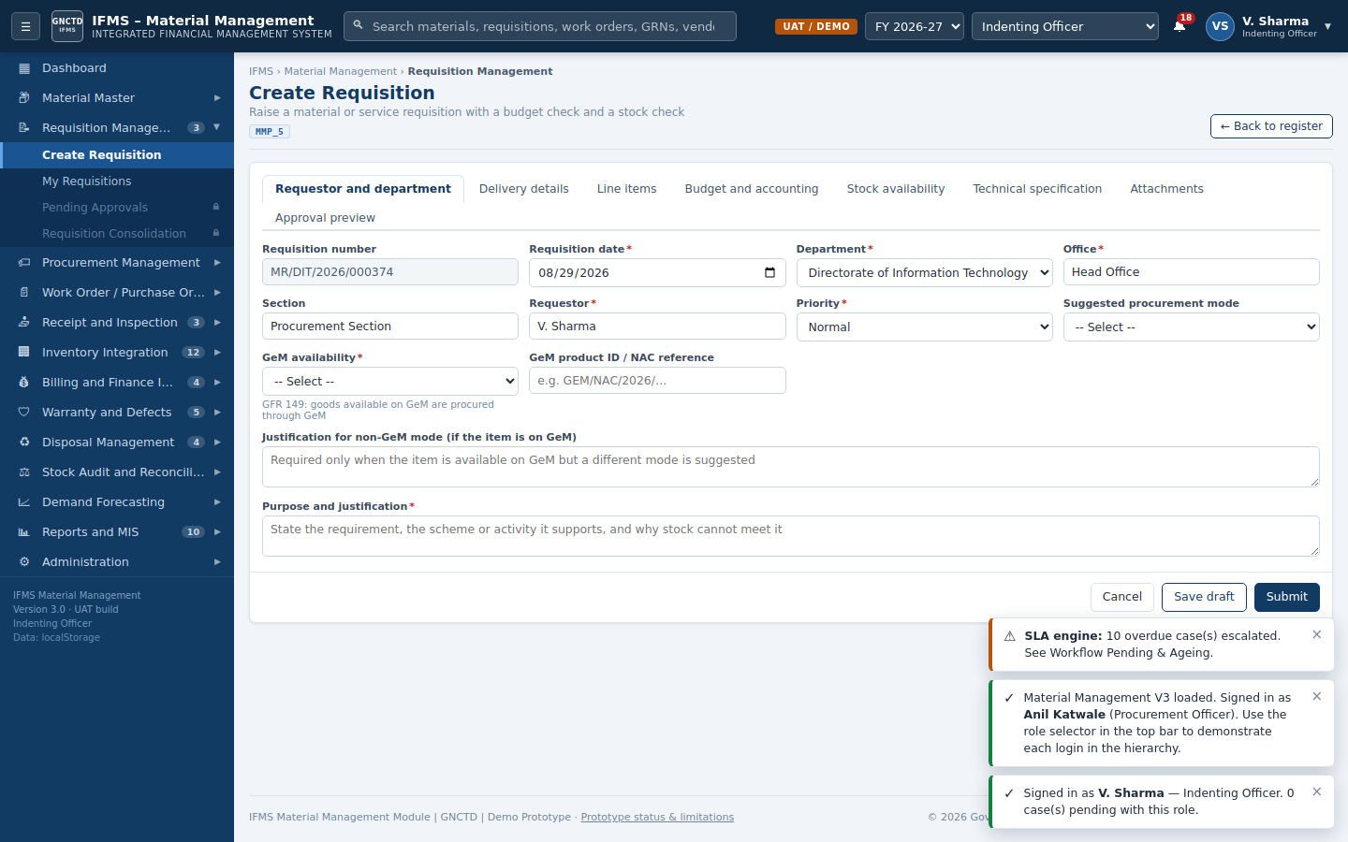
Figure 2 — Requisition entry with tabs for requestor, delivery, line items, budget, stock, specification, and attachments
Step 1 — Sign in as the maker | Role: Indenting Officer
Select Indenting Officer. The example login is V. Sharma.
Step 2 — Complete Requestor and department
Verify the auto-generated requisition number and date. Select department, office, section, requestor, priority, procurement mode, and GeM availability. Enter non-GeM justification when applicable.
Step 3 — Enter purpose
Provide a meaningful purpose and justification describing the activity, scheme, and why available stock cannot meet the requirement.
Step 4 — Enter delivery details
Select delivery location, required-by date, contact person, and address.
Step 5 — Add line items
Open Line items and select Add material or Add service. Choose the material, enter quantity, rate, make, and technical specification. Add at least one line.
Step 6 — Check stock
Select Check stock. Review whether stock is Available, Partially Available, or Not Available. Use store stock first where policy requires.
Step 7 — Enter budget dimensions
Select budget head/COA, fund, scheme, project, and cost centre. Enter or verify available budget, then select Check budget.
Step 8 — Attach documents
Attach specification, sanction, estimate, GeM/NAC reference, or supporting approval metadata as applicable.
Step 9 — Save draft
Select Save draft when the requisition is incomplete.
Expected result: Status becomes Draft and the record appears under My Requisitions.
Step 10 — Submit
Select Submit. Complete the submission checklist and confirmation.
Expected result: A workflow chain is generated from configuration and value. Status becomes Submitted/Under Review/Budget Validation Pending according to stage.
Worked example: For MAT-IT-0001, request 10 laptops at ₹68,500 each for replacement of end-of-life assets, delivery to IT Store – Delhi Secretariat, head 2059 – Office Expenses, fund State Plan Fund, scheme Digital Delhi Mission, and project e-Office Rollout Phase III.
Control / caution: Submission is blocked when required data, at least one line, valid justification, future required-by date, budget check, or mandatory checklist evidence is missing.

8. Requisition Approval
Navigation: Requisition Management → Pending Approvals.
Step 1 — Select the current approver role | Role: Configured approver
Use Head of Office, Head of Department, Finance Wing, Administrative Secretary, or Finance Department according to the Pending With field and chain preview.
Step 2 — Open Pending Approvals
Review department, value, budget head, available balance, aging, and current workflow level.
Step 3 — Open the record
Review header, line items, stock result, budget result, attachments, checklist, and workflow history.
Step 4 — Approve and forward
Select Approve, enter a reason, and confirm. When another level exists, the record is forwarded automatically.
Expected result: Status remains Under Review or changes to Budget Validation Pending; Pending With changes to the next role.
Step 5 — Final approve
The final competent authority selects Approve (final).
Expected result: Status becomes Approved and the requirement is released for procurement planning.
Step 6 — Return if correction is required
Select Return, enter mandatory remarks, and confirm.
Expected result: Status becomes Returned for Correction and responsibility returns to the requestor.
Step 7 — Reject if not admissible
Select Reject, enter mandatory grounds, and confirm.
Expected result: Status becomes Rejected; the workflow ends unless a separately authorized reopening procedure is introduced.
Control / caution: Approval is blocked for insufficient uncommitted budget, wrong workflow role, maker-checker conflict, or failed mandatory checklist. Bulk approval skips cases not at the selected role’s level or failing controls.

9. Procurement Planning
Navigation: Procurement Management → Procurement Plan.
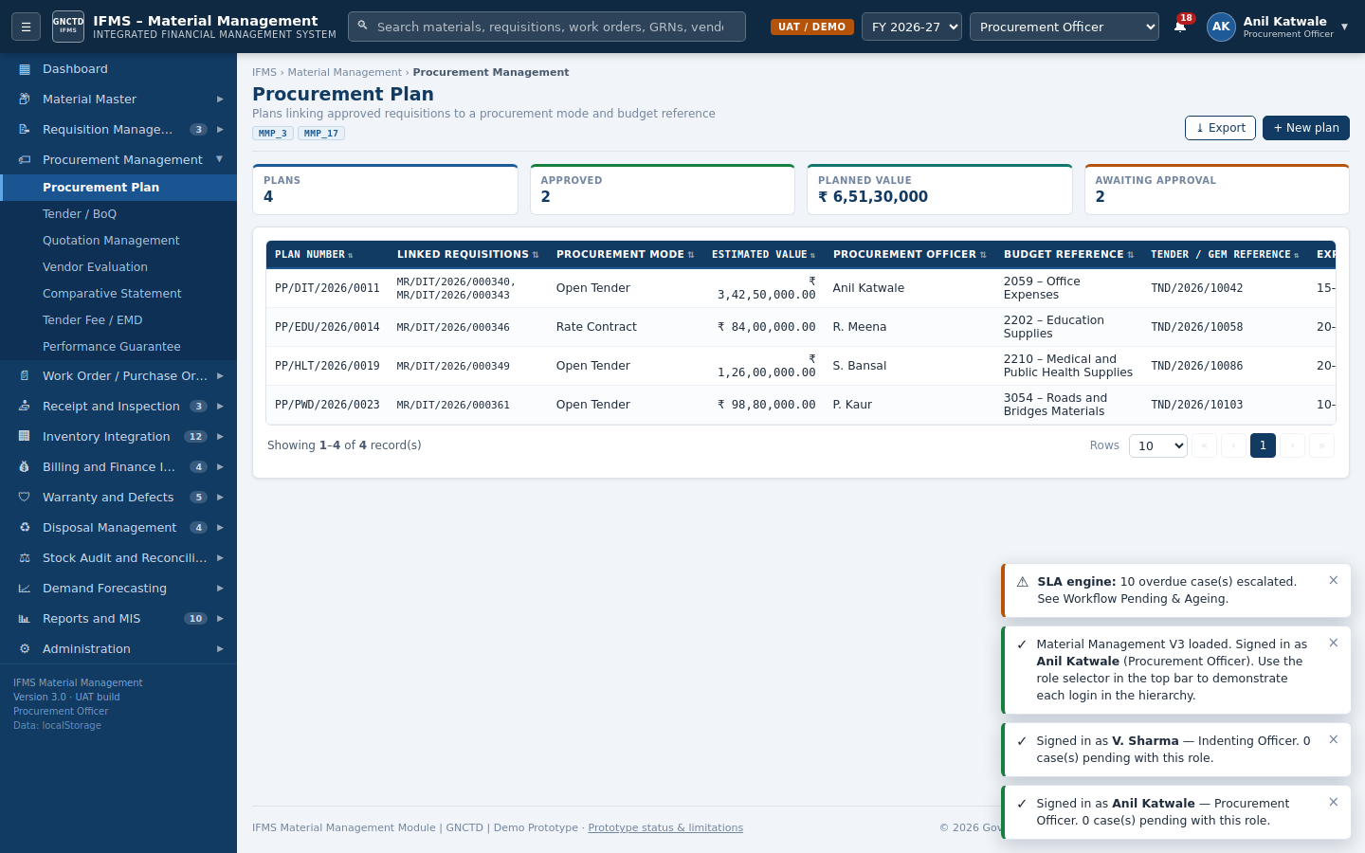
Figure 3 — Procurement plan register and planning actions
Step 1 — Review approved requirements | Role: Procurement Officer
Switch to Procurement Officer and open approved requisitions or consolidation.
Step 2 — Consolidate where appropriate
Use Requisition Consolidation to group compatible demand by material, category, department, period, or procurement route.
Step 3 — Create the plan
Open Procurement Plan and select New plan. Define period, requirement value, procurement mode, target dates, and responsible officer.
Step 4 — Submit the plan
Save the plan and route it for approval.
Step 5 — Approve the plan
Switch to Head of Office or Head of Department and select Approve Plan.
Expected result: Status becomes Approved.
Step 6 — Convert to tender
Return to Procurement Officer and select Create Tender / Plan to Tender.
Expected result: A tender record is generated and linked to the plan/requisition.
Worked example: Consolidate laptop requirements and convert the approved plan into tender TND/2026/10042 — Supply of laptop computers and accessories, Open Tender, estimated value ₹3,42,50,000.

10. Tender and BoQ
Navigation: Procurement Management → Tender / BoQ and Material Master → Material-BoQ Mapping.
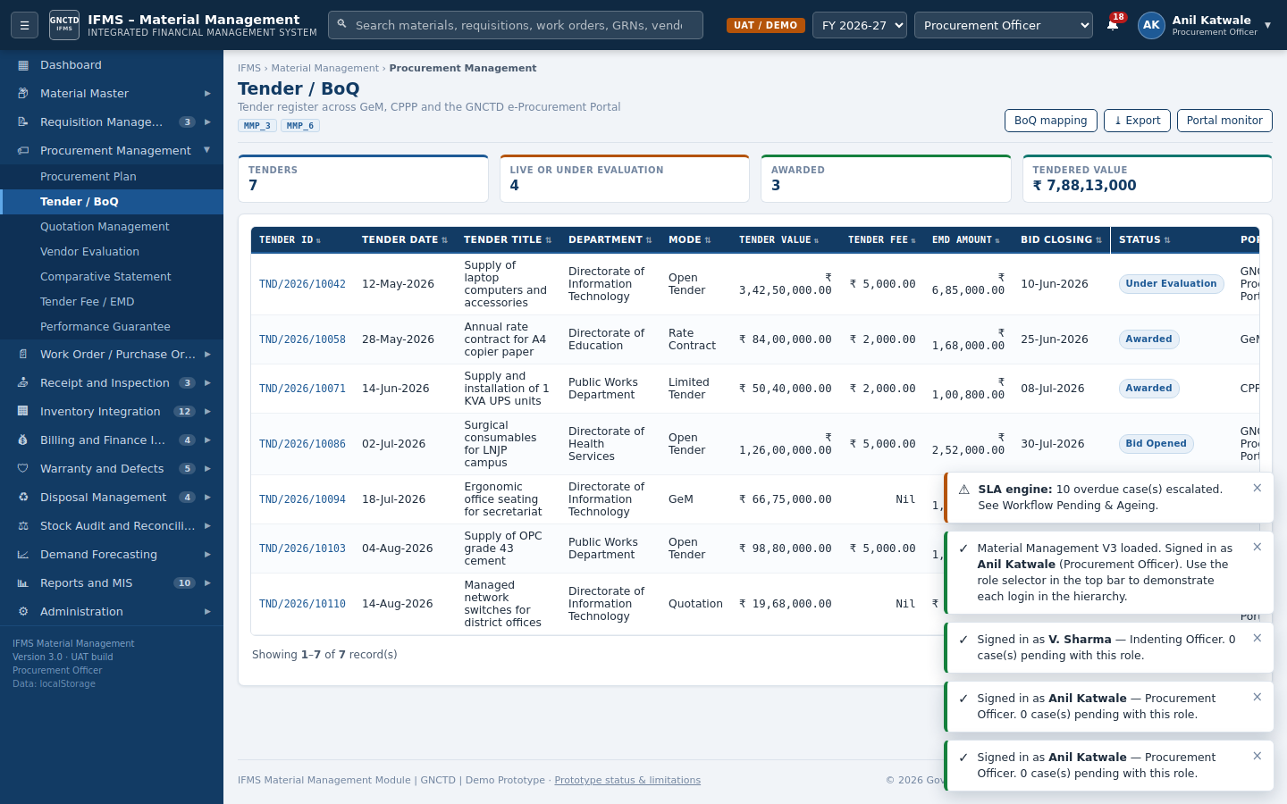
Figure 4 — Tender register, portal status, BoQ access, export, and synchronization
Step 1 — Review tender header
Confirm tender number, title, department, mode, estimated value, fee, EMD, closing date, portal, and status.
Step 2 — Map BoQ lines
Open BoQ mapping. Match each tender description to an active material code and confirm tender UOM, inventory UOM, and conversion factor.
Step 3 — Resolve unmapped/non-standard lines
Use Auto Suggest, Map, Mark Non-Standard, or Create New Material as permitted.
Step 4 — Publish or synchronize
Use the portal monitor or Sync Now to simulate integration with GeM, CPPP, or GNCTD e-Procurement.
Expected result: Portal counters and integration audit entries are updated.
Worked example: Tender TND/2026/10042 line 1 maps “Notebook PC 14 inch i5 16GB 512GB” to MAT-IT-0001 with quantity 500 and conversion factor 1.
Control / caution: Mapping must preserve quantity and UOM traceability. A non-standard item should not bypass material-master governance.

11. Quotation and Evaluation
Navigation: Procurement Management → Quotation Management → Vendor Evaluation → Comparative Statement.
Step 1 — Record quotation | Role: Procurement Officer
Select Record quotation. Choose tender and vendor; enter bid number, dates, line, quantity, basic rate, tax, freight, insurance, installation, other charges, discount, delivery, warranty, payment terms, deviations, and remarks.
Step 2 — Save quotation
Select Save quotation.
Expected result: The system calculates total quoted value and records the bid as Under Review.
Step 3 — Evaluate technical bid
Open Vendor Evaluation, select the tender, load bids, and record eligibility, documents, certification, delivery capacity, past performance, score, and qualification status.
Step 4 — Complete evaluation
Select Complete evaluation and enter the reason.
Expected result: Tender status moves to Under Evaluation and qualified bids become available for financial comparison.
Step 5 — Calculate L1
Open Comparative Statement, choose the tender, and select Calculate L1.
Expected result: Qualified bidders are ranked using evaluated/landed cost.
Step 6 — Record negotiation if applicable
Enter vendor, negotiation date, negotiated amount, committee, and minutes/justification.
Step 7 — Submit recommendation
Select a vendor, split award, re-tender, or submit comparative statement for approval as appropriate.
Expected result: The award decision becomes available for work-order preparation.
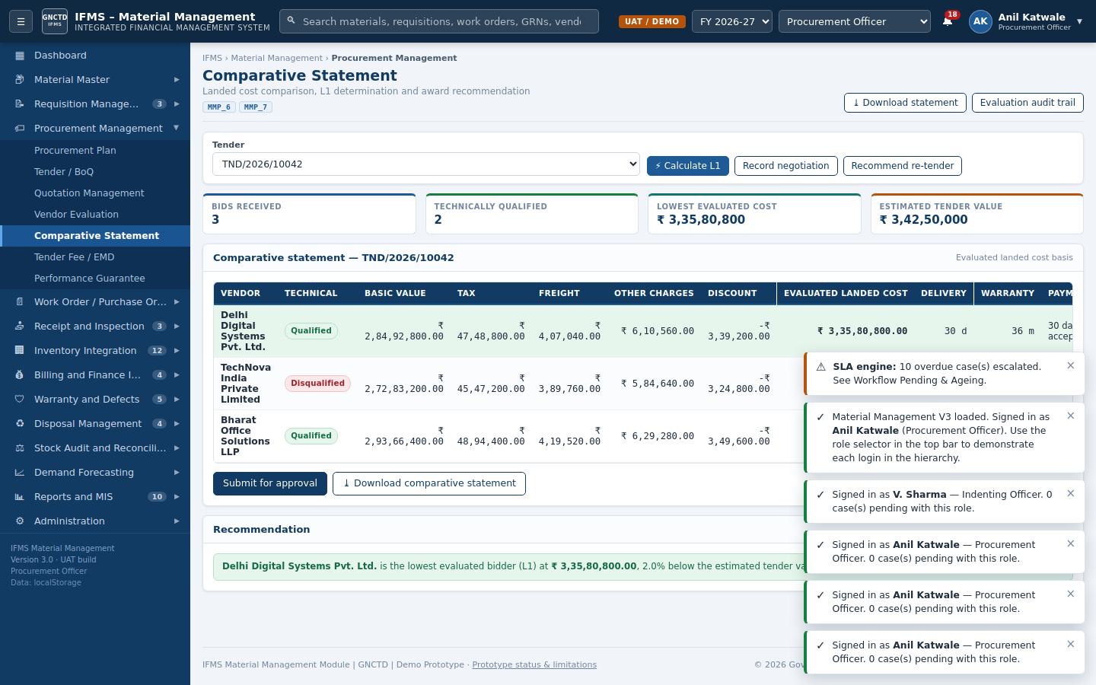
Figure 5 — Comparative statement with landed-cost ranking and award actions
Worked example: For TND/2026/10042, compare Delhi Digital Systems Pvt. Ltd., TechNova India Private Limited, and Bharat Office Solutions LLP. Disqualified technical bids must not be considered for L1 selection.

12. Work Order
Navigation: Work Order / Purchase Order → Create Work Order and Work Order Register.
Step 1 — Open Create Work Order | Role: Procurement Officer
Switch to Procurement Officer. Select award/tender and accepted bid where applicable.
Step 2 — Enter header
Verify work-order number/date, department, procurement mode, requisition, tender/award, vendor, contract number, consignee, due date, delivery schedule, inspection authority, warranty, AMC, payment, LD, PG, retention, terms, and budget head.
Step 3 — Add lines
Select Add line or Pull lines from requisition. Enter material, quantity, rate, and tax percentage. The form calculates basic, tax, and total.
Step 4 — Check and commit budget
Select Check budget and commit funds.
Expected result: The available head is checked and a commitment is created for the order value.
Step 5 — Save draft
Select Save draft.
Expected result: The order appears in the register with Draft status.
Step 6 — Submit for approval
Open the draft and select Submit for approval. Enter reason and confirm.
Expected result: The DFPR-based chain is generated and status becomes Pending Approval.
Step 7 — Approve through each level
Switch to the role shown in Pending With. Select Approve and forward until final approval.
Expected result: Status becomes Approved.
Step 8 — Issue to vendor
Switch back to Procurement Officer and select Issue.
Expected result: Status becomes Issued, budget commitment remains active, and delivery tracking starts.
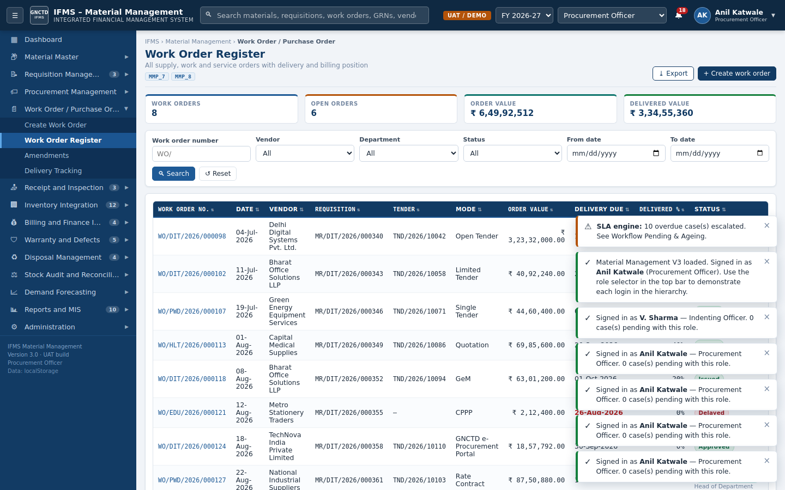
Figure 6 — Work Order Register with workflow and issue actions
Worked example: WO/DIT/2026/000098 is linked to TND/2026/10042 and MR/DIT/2026/000340 for MAT-IT-0001. The seeded order quantity is 400 at ₹68,500 plus 18% tax, with delivery due 15-Sep-2026.
Control / caution: The order cannot be issued before final approval. Return of an order releases its budget commitment and resets it to Draft. The issuing user must verify year-end cut-off and performance-security controls.

13. Delivery Tracking
Navigation: Work Order / Purchase Order → Delivery Tracking.
Step 1 — Review open orders | Role: Procurement / Store
Filter by vendor, order, due date, or status.
Step 2 — Record dispatch
Select Record dispatch and enter dispatched quantity, dispatch date, challan number, and transporter.
Expected result: Delivery status and delivered quantity update.
Step 3 — Monitor delay
Review due dates and delayed records. Select Raise delay alerts for overdue orders.
Expected result: Notifications and audit entries are created for follow-up and LD review.
Step 4 — Create GRN from delivery
For received goods, continue to Goods Receipt Note and use the linked order/delivery.
Control / caution: Dispatch is not inventory receipt. Stock becomes available only after GRN inspection and DDO posting of accepted quantity.

14. Goods Receipt Note
Navigation: Receipt and Inspection → Goods Receipt Note.
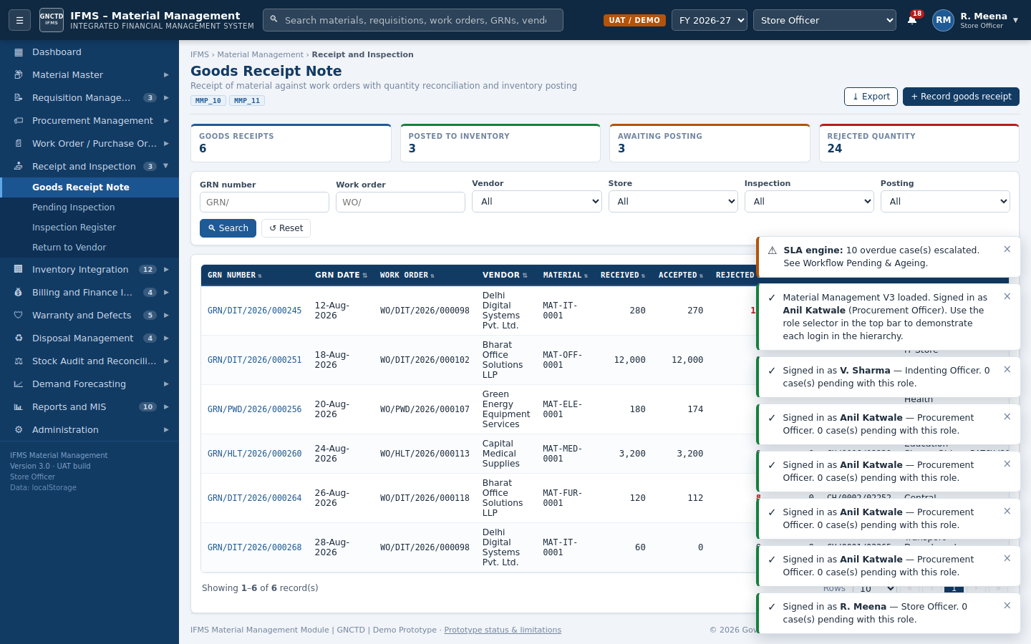
Figure 7 — GRN register showing inspection and posting status
Step 1 — Switch to Store Officer | Role: Store Officer
Open Goods Receipt Note and select Record goods receipt.
Step 2 — Select work order
Choose the issued work order. Vendor and order data populate automatically.
Step 3 — Enter receipt header
Confirm GRN number/date, receiving store, challan number/date, bin/location, and received by.
Step 4 — Enter quantities
Record received, accepted, rejected, damaged, short, and excess quantities. Add batch, manufacturing date, expiry date, serial numbers, and remarks where required.
Step 5 — Save receipt
Select Save goods receipt.
Expected result: A GRN is created with Pending/Under Inspection and posting Pending. An inspection task is generated where inspection is required.
Worked example: GRN/DIT/2026/000245 is for WO/DIT/2026/000098 and MAT-IT-0001: received 280, accepted 270, rejected 10, inspection Accepted, posting Posted.
Control / caution: At initial receipt, accepted quantity may remain provisional until Inspection Officer action. Serial-tracked assets require serial details; batch/expiry-controlled material requires batch and expiry details.

15. Inspection and RTV
Navigation: Receipt and Inspection → Pending Inspection / Inspection Register / Return to Vendor.
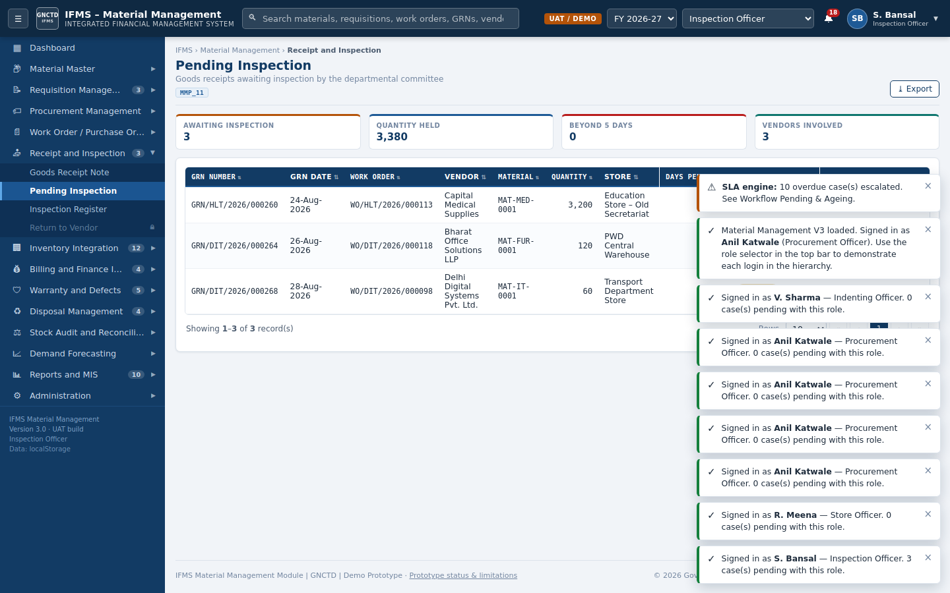
Figure 8 — Pending Inspection worklist for the Inspection Officer
Step 1 — Open pending inspection | Role: Inspection Officer
Switch to Inspection Officer and open Pending Inspection.
Step 2 — Select GRN
Review order specification, received quantity, samples, documents, and prior observations.
Step 3 — Enter inspection data
Enter authority, date, accepted/rejected quantity, result, certificate number, observations, non-conformity, and recommendation.
Step 4 — Record acceptance
Select Record acceptance for compliant goods.
Expected result: Inspection becomes Accepted or Accepted with Deviation and the GRN becomes eligible for DDO posting.
Step 5 — Reject consignment
Select Reject consignment for non-conforming goods.
Expected result: Rejected quantity becomes eligible for Return to Vendor and is not posted as available stock.
Step 6 — Process RTV
Switch to Store/Procurement and open Return to Vendor. Review replacement, refund, open, and closed cases; record replacement or refund action.
Control / caution: The Inspection Officer cannot post stock. The DDO posts only the accepted quantity after inspection, maintaining maker-checker separation.

16. Inventory Posting
Navigation: Receipt and Inspection → Goods Receipt Note.
Step 1 — Switch to DDO | Role: DDO
Filter GRNs with inspection Accepted/Accepted with Deviation and posting Pending.
Step 2 — Review evidence
Open the GRN and review PO, receipt quantity, accepted/rejected quantity, certificate, batch/serial details, and audit trail.
Step 3 — Post to inventory
Select Post to inventory and confirm.
Expected result: Posting becomes Posted; accepted quantity is added to the relevant store stock and a Receipt movement/audit entry is created.
Control / caution: Pending or rejected inspection cannot be posted. Repeat posting is blocked. Rejected and damaged quantities are excluded from available stock.

17. Stock Operations
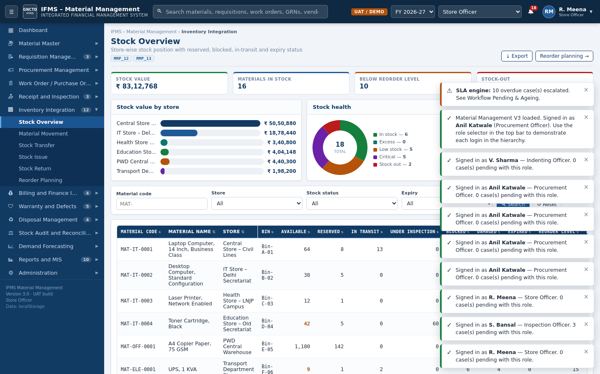
Figure 9 — Stock Overview with available, reserved, blocked, inspection, damaged, and expired positions

17.1 Stock Transfer
Step 1 — Create transfer | Role: Store Officer
Store Officer opens Inventory Integration → Stock Transfer and selects New transfer.
Step 2 — Enter transfer
Select material, quantity, from store, to store, approving authority, challan, and reason; select Create transfer.
Expected result: Transfer is Pending/Approved according to configuration.
Step 3 — Despatch
Select Despatch.
Expected result: Quantity leaves available stock at source and status becomes In Transit.
Step 4 — Receive
At destination, select Receive.
Expected result: Destination stock increases and status becomes Received.

17.2 Stock Issue
Step 1 — Create issue | Role: Store / Indenting Officer
Open Stock Issue → New issue. Enter issue number/date, requisition, material, store, quantity, department, indentor, recipient, gate pass, and purpose.
Step 2 — Save issue
Select Record issue.
Expected result: Issue is Pending until Store confirmation where applicable.
Step 3 — Confirm issue
Store Officer selects Confirm Issue.
Expected result: Available stock reduces and an Issue movement is recorded.

17.3 Stock Return
Step 1 — Record return
Open Stock Return → Record return. Select issue, material, quantity, store, department, condition, and reason.
Step 2 — Decide disposition
Store Officer selects Restock Return for serviceable material or Condemn Return for unusable material.
Expected result: Serviceable quantity increases stock; condemned quantity enters disposal processing.

17.4 Reorder Planning
Step 1 — Review below-reorder items
Open Reorder Planning and review stock, reorder level, pending orders, consumption, and suggested quantity.
Step 2 — Convert to requisition
Select Create Requisition for valid replenishment recommendations.
Expected result: A draft requisition is created for review and submission.

18. Invoice and Finance

18.1 Record Invoice
Step 1 — Open Invoice Register | Role: Finance / DDO / Procurement
Switch to Finance Wing, DDO, or Procurement Officer and select Record invoice.
Step 2 — Select posted GRN
Choose a GRN with Posted status. Vendor and work order populate.
Step 3 — Enter invoice data
Enter invoice number, vendor invoice number, invoice/received dates, amount, retention, Income Tax TDS, GST TDS, and liquidated damages.
Step 4 — Record and match
Select Record invoice and run match.
Expected result: The invoice is saved and PO–GRN–Invoice matching is executed.

18.2 Three-Way Match
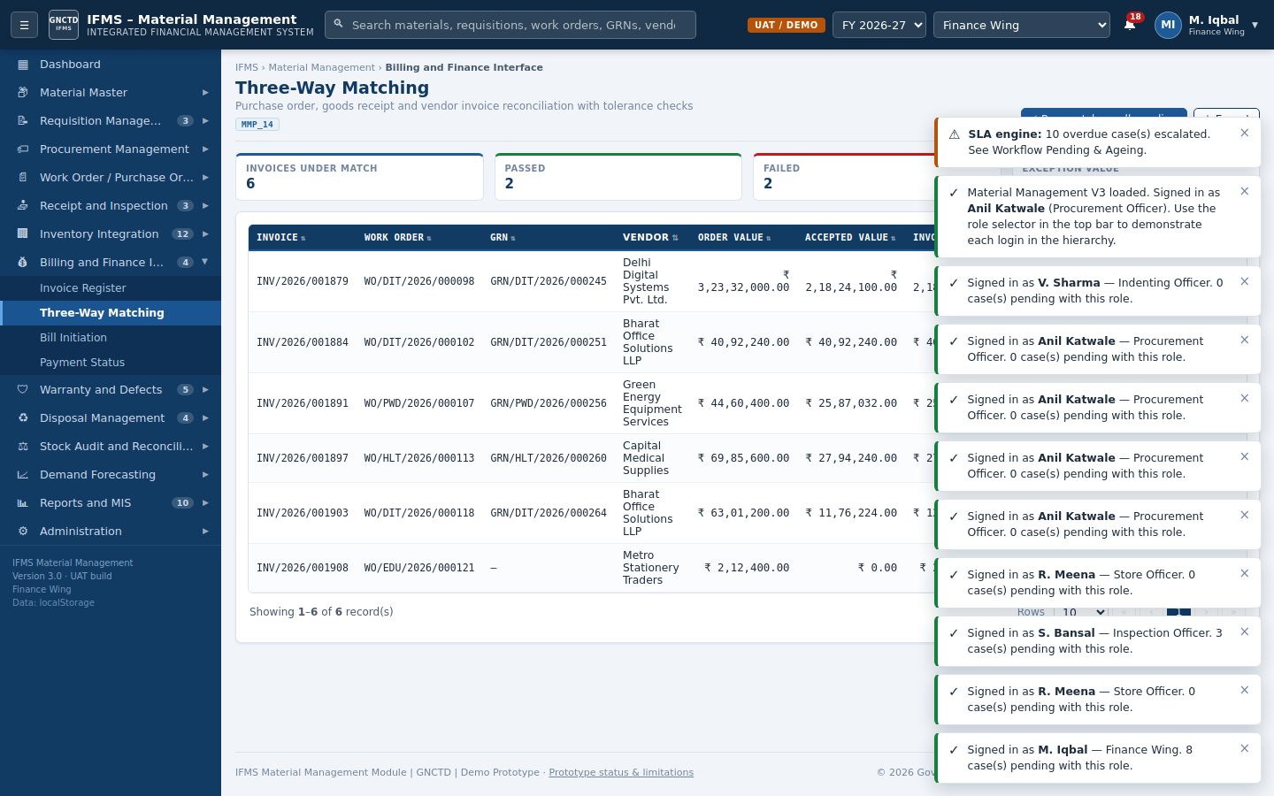
Figure 10 — Three-Way Matching workbench with matched and exception cases
Step 1 — Review match | Role: Finance / DDO
Open Billing and Finance Interface → Three-Way Matching.
Step 2 — Run match
Select Run match for one invoice or Run match on all pending.
Expected result: The application compares vendor/order, accepted quantity, rate, and total within configured tolerances.
Step 3 — Resolve exception
Finance Wing opens an exception and selects an authorized resolution: accept with deviation approval, restrict payment to accepted value, return invoice, or reject as applicable. Enter authority and justification.
Step 4 — Send matched bill
DDO opens Bill Initiation, selects matched invoices, and selects Send selected to finance.
Expected result: Finance status advances for scrutiny/payment.
Step 5 — Record payment
Finance Wing opens Payment Status and records/refreshes payment.
Expected result: Payment becomes Paid and the audit trail is updated.
Worked example: INV/2026/001879 is linked to WO/DIT/2026/000098 and GRN/DIT/2026/000245. It is supplied as an Exception scenario; open Detail to compare order, receipt, and invoice and then follow the authorized exception-resolution workflow.
Control / caution: Only matched invoices can be sent to Finance. The default prototype parameters use 1% rate tolerance and 2% value tolerance; an administrator/finance user may change parameters for training, but production values must follow approved instructions.

19. Warranty and Defects
Navigation: Warranty and Defects → Warranty Register / Defect Complaints / Repair & Replacement / Vendor Escalation.
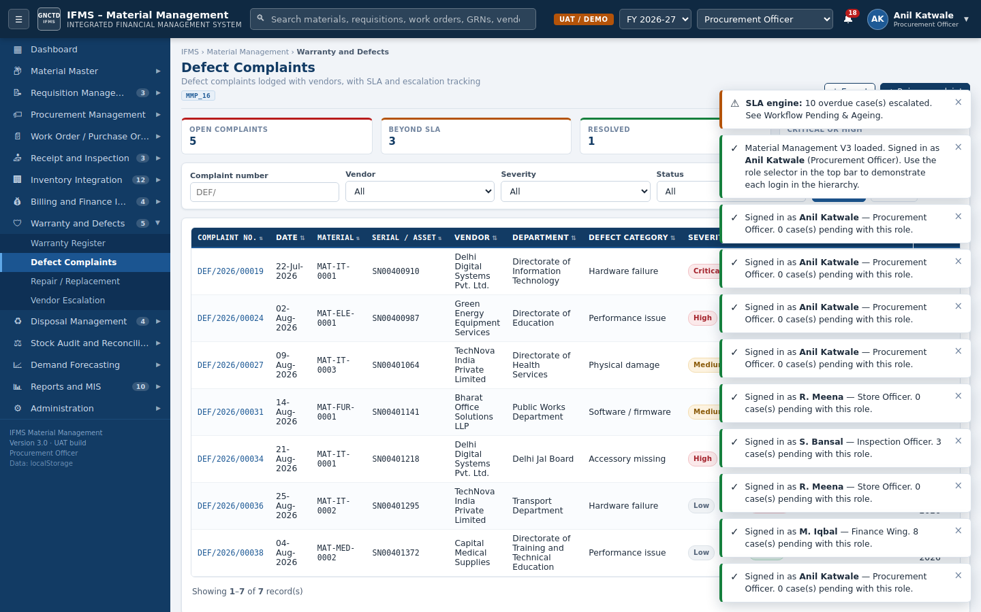
Figure 11 — Defect Complaint register with severity, SLA, warranty, and vendor status
Step 1 — Verify coverage | Role: Indenting / Store / Procurement
Open Warranty Register and confirm warranty start/end, asset/serial, vendor, and SLA.
Step 2 — Raise complaint
Open Defect Complaints → Raise complaint. Enter complaint date, material, serial/asset tag, department, location, category, warranty status, SLA due date, severity, description, and vendor response.
Step 3 — Lodge with vendor
Select Lodge complaint with vendor.
Expected result: Status becomes Vendor Notified/Open and the SLA begins.
Step 4 — Update repair
Procurement or Store records vendor response, repair status, replacement details, and notes.
Step 5 — Escalate
If the vendor breaches SLA, select Escalate.
Expected result: Status becomes Escalated and a notification/audit entry is created.
Step 6 — Resolve
Record repair/replacement evidence and select Mark resolved.
Expected result: Status becomes Resolved; the complaint can then be closed.
Worked example: DEF/2026/00019 concerns MAT-IT-0001, vendor VEN-0001, Critical severity, Under Warranty, and Escalated status. Use it to demonstrate vendor escalation and audit history.

20. Disposal
Navigation: Disposal Management → Disposal Proposal → Condemnation Register → Auction / Scrap Sale → Disposal Register.
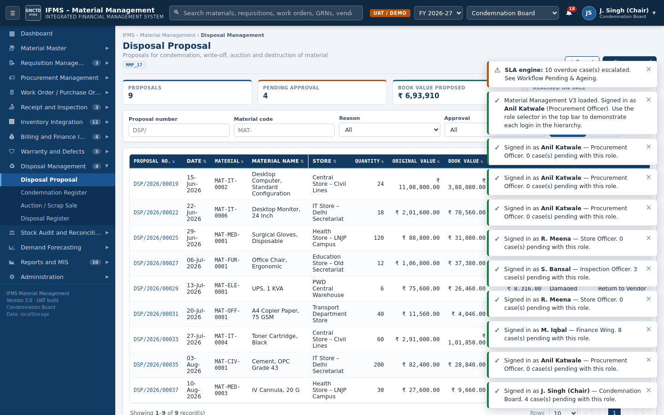
Figure 12 — Disposal Proposal register and role-based approval actions
Step 1 — Create proposal | Role: Store Officer
Store Officer selects New proposal and enters material, store, quantity, reason, method, committee, original/book/residual value, batch, and justification.
Step 2 — Submit
Select Submit for condemnation approval.
Expected result: Status/approval becomes Pending or Under Review; a value-based approval chain is generated.
Step 3 — Inspect and recommend
Condemnation Board reviews condition, valuation, method, committee evidence, and stock availability.
Step 4 — Approve or forward
Select Approve. If value exceeds current authority, the application forwards to the next role.
Expected result: Final status becomes Approved, or Rejected when grounds are recorded.
Step 5 — Conduct disposal
Open Auction / Scrap Sale as applicable and record buyer/agency, realized value, remittance challan, and remarks.
Step 6 — Complete disposal
Select Record disposal/Complete.
Expected result: Stock is reduced, disposal status becomes Completed/Closed, and the financial/audit record is updated.
Worked example: DSP/2026/00019 is for 24 units of MAT-IT-0002, reason Obsolete, method E-Auction, approval Approved, and status Auction Scheduled. DSP/2026/00025 illustrates an expired medical-material case pending review.
Control / caution: Do not physically dispose of material before approval. Quantity, book value, realized value, method, and remittance reference must remain traceable.

21. Stock Audit
Navigation: Stock Audit and Reconciliation → Physical Verification → Stock Reconciliation → Stock Adjustment.
Step 1 — Schedule verification
Store Officer or Head of Office selects Schedule verification and enters number, type, department, store, category, period, team, and dates.
Step 2 — Record physical counts
During verification, enter book and physical quantities for selected materials and note condition/variance.
Step 3 — Reconcile
Open Stock Reconciliation and review shortages, excesses, blocked, damaged, expired, and value differences.
Step 4 — Post variances for adjustment
Select Post variances for adjustment.
Expected result: Pending adjustment records are generated.
Step 5 — Approve adjustment
The workflow-assigned Head of Office/Head of Department/Finance role approves or rejects with reason.
Expected result: Approved adjustments update stock and create an immutable audit record.
Step 6 — Close audit
Head of Office closes the verification after all variances are disposed of.
Control / caution: An adjustment is not a substitute for investigation. Significant shortages, excesses, expired stock, or suspected loss require departmental action outside the prototype in addition to system adjustment.

22. Demand Forecasting
Navigation: Demand Forecasting → Consumption Analysis → Demand Forecast → Suggested Reorder.
Step 1 — Review consumption | Role: Procurement / Store / HoO
Compare 3-, 6-, and 12-month consumption, average usage, stock, open requisitions, open POs, and goods in transit.
Step 2 — Recalculate
Open Demand Forecast and select Recalculate forecast.
Expected result: Forecast, safety stock, stock-out date, and recommended quantity are recalculated using the selected method and configured controls.
Step 3 — Review exceptions
Prioritize Critical Reorder Required, Reorder Required, Excess Stock, Slow Moving, and Watch List.
Step 4 — Apply justified override
Where business knowledge requires an override, enter quantity and justification.
Step 5 — Create requisition
Convert an approved suggestion to a draft requisition.
Expected result: Demand flows into the controlled requisition workflow rather than directly changing stock.

23. Reports and MIS
Report | Purpose | Typical user action
Procurement MIS | Monitor requisitions, tenders, work orders, deliveries, GRNs, and invoice position | Filter, review KPIs, export CSV, print.
Inventory MIS | Review stock value, aging, blocked/damaged/expired stock, and movements | Drill to Stock Overview or movements.
Vendor Performance | Compare rating, delivery, defects, returns, and responsiveness | Use for evaluation and escalation.
Workflow Pending & Ageing | Identify pending cases, TAT breaches, escalation role, and age | Switch to responsible role and process case.
Budget Utilisation & Phasing | Review provision, commitments, expenditure, balance, and phasing | Investigate over-commitment or year-end concentration.
Requirement Traceability (RTM) | Map MMP and governance requirements to implemented screens/functions | Use during UAT and audit.
Gap Closure Register | Review identified prototype gaps and applied controls | Confirm closure evidence and residual gaps.
Audit Trail | Review immutable action history by module, record, user, role, field, old/new values, and reason | Filter, export, and investigate.

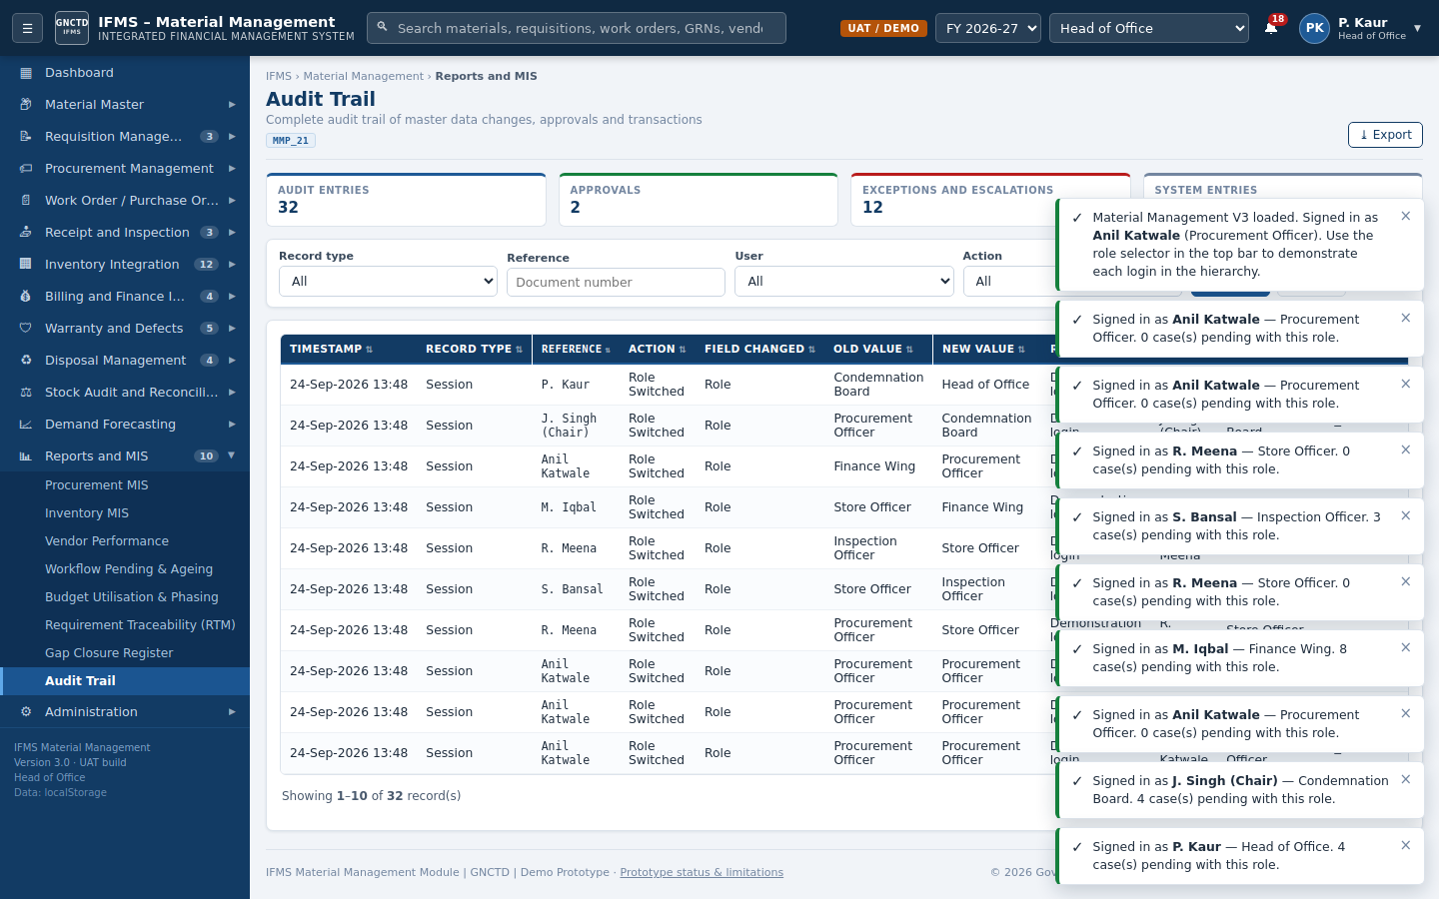
Figure 13 — Audit Trail report with user, role, field, old/new value, source, and reason
Step 1 — Open report
Select Reports and MIS and choose the required report.
Step 2 — Apply filters
Enter department, status, date, vendor, material, or reference criteria as available.
Step 3 — Review totals
Confirm that totals and statuses match the operational registers.
Step 4 — Export or print
Select Export for CSV or Print for a controlled copy.
Control / caution: CSV and print output reflect demonstration data in the browser. Official reporting requires production database controls, authorization, report versioning, and reconciliation to finance ledgers.

24. Administration
Screen | Authorized role | Purpose
Workflow Configuration | MDA / oversight roles | Maintain module, level, role, value range, TAT, escalation, and active status.
Approval Limits | MDA / oversight roles | Maintain DFPR limits by role and procurement mode.
Notification Rules | MDA / Finance | Configure event, channel, recipient, frequency, and status.
Integration Monitor | MDA / Finance | Review portal/interface counts, failures, pending records, and reconciliation.
User Role Mapping | MDA / Finance | Map user, employee code, role, department, stores, limit, and status.
Checklist Master | MDA | Maintain automatic/manual checklist items and source reference.
Procurement Parameters | MDA / Finance | Maintain matching tolerance, LD, EMD, inspection TAT, posting TAT, cut-off, and phasing controls.
Interface Register | All roles read; controlled maintenance | Review source, destination, object/event, direction, frequency, and interface status.
Prototype Status & Logins | All roles | Review demo users, responsibilities, limitations, and version.

Control / caution: Configuration changes immediately affect workflow or validation behaviour in the browser. Record an approved change request before altering production-equivalent parameters.

25. Worked Example
This section demonstrates one complete laptop-procurement scenario using transaction references already seeded in the application. It can be used for role-based UAT or classroom training.
Step | Role | Reference / example | Expected result
1 | Procurement/MDA | Confirm MAT-IT-0001 is Active, UOM Nos, serial tracked, standard rate ₹68,500 | Material selectable in requisition.
2 | Indenting Officer | Open or create MR/DIT/2026/000340 for laptop replacement | Draft/submitted requisition with line and budget dimensions.
3 | Approver chain | Review budget, stock, specification, and checklist; approve/forward | Final status Approved.
4 | Procurement Officer | Use TND/2026/10042 for laptop supply; verify BoQ mapping to MAT-IT-0001 | Tender ready for bid processing.
5 | Procurement Officer | Review recorded bids; complete evaluation and L1/comparative statement | Award recommendation recorded.
6 | Procurement + approvers | Process WO/DIT/2026/000098, commit budget, approve, and issue | Issued order for 400 units.
7 | Store Officer | Review delivery and GRN/DIT/2026/000245 | Received 280; accepted 270; rejected 10.
8 | Inspection Officer | Confirm inspection and certificate | Accepted result recorded.
9 | DDO | Post accepted GRN | 270 accepted units posted to inventory.
10 | Finance/DDO | Open INV/2026/001879 and run three-way match | Exception/match result shown with PO–GRN–Invoice detail.
11 | Finance Wing | Resolve exception using competent-authority justification or restrict payment | Invoice becomes matched or remains returned/rejected.
12 | DDO/Finance | Send matched invoice to finance and record payment | Payment status updated.
13 | Indentor/Procurement | Open DEF/2026/00019 to demonstrate warranty escalation | Complaint processed and eventually resolved.

Role-by-role training sequence
- Start as Indenting Officer and review/create the requisition.
- Switch to the role shown in Pending With; approve and forward at each level.
- Switch to Procurement Officer for tender, evaluation, award, work order, and issue.
- Switch to Store Officer for delivery and GRN.
- Switch to Inspection Officer for acceptance/rejection.
- Switch to DDO for inventory posting and bill initiation.
- Switch to Finance Wing for match exception and payment.
- Switch to Auditor and confirm that all actions are read-only while history remains visible.

26. Status Reference
Business object | Typical statuses | Meaning / next action
Requisition | Draft; Submitted; Under Review; Budget Validation Pending; Returned for Correction; Approved; Procurement Initiated; Partially/Fully Procured; Rejected | Maker submits; approvers process; procurement converts; request closes after fulfilment.
Tender | Published; Bid Opened; Under Evaluation; Awarded; Re-Tender Recommended | Record bids, evaluate, approve award, or re-tender.
Work order | Draft; Pending Approval; Approved; Issued; Delayed; Delivered; Closed; Cancelled | Commit/approve, issue, monitor delivery, then close.
GRN inspection | Pending; Under Inspection; Accepted; Accepted with Deviation; Rejected | Inspection Officer records outcome.
GRN posting | Pending; Posted | DDO posts accepted quantity once.
Transfer | Pending; Approved; In Transit; Received | Create, despatch, and receive between stores.
Issue | Pending; Approved; Issued | Store confirms issue and stock reduces.
Invoice match | Pending; Matched; Exception; Rejected | Run matching, resolve exception, or reject.
Invoice finance/payment | Under Review; Approved; Returned; Pending; Paid | DDO sends; Finance scrutinizes and pays.
Defect | Open; Vendor Notified; Under Repair; Replacement Pending; Escalated; Resolved; Closed; Out of Warranty | Track warranty SLA and final resolution.
Disposal | Draft; Under Review; Approved; Rejected; Auction Scheduled; Sold; Completed | Approve before physical disposal and financial closure.
Adjustment | Pending; Approved; Rejected | Competent authority processes stock variance.

27. Validation and Controls
- Required fields display validation messages and prevent submission until corrected.
- Requisitions require at least one material/service line, valid dates, purpose, GeM declaration/justification, budget check, and checklist completion.
- Budget availability is checked before requisition approval and work-order submission; work-order submission creates a commitment.
- Workflow approver is determined at runtime from module configuration, value range, procurement mode, and DFPR limits.
- Maker-checker rules prevent self-approval and separate Store, Inspection, DDO, Finance, and Audit duties.
- GRN posting requires an acceptable inspection result and cannot be repeated.
- Only matched invoices can proceed to Finance.
- Rejection, return, exception override, and key approvals require reasons and generate audit entries.
- Auditor is read-only on every screen.
- Administrative reset is confirmed before clearing demonstration data.

28. Audit and Traceability
The application records date/time, module, reference, action, field, old value, new value, reason, user, role, department, approval reference, source, and a demonstration IP address for controlled events. Important workflow actions also create notifications and update pending/ageing indicators.
Step 1 — Open audit trail
Select Reports and MIS → Audit Trail.
Step 2 — Filter
Search by module, record reference, action, user, role, or date as available.
Step 3 — Compare values
Review old and new values and the reason for the change.
Step 4 — Trace chain
Open the related operational register and compare its workflow history, checklist evidence, and current status.
Step 5 — Export
Download CSV for UAT evidence or review, observing data-handling controls.
Control / caution: Browser localStorage is user-controlled and is not tamper-evident. The audit features demonstrate required behaviour; a production audit trail must be enforced server-side and protected from update/delete operations.

29. Reset and Recovery
Step 1 — Open user menu
Select the profile area in the top-right corner.
Step 2 — Select Reset demo data
Review the warning that every created or changed demonstration record will be discarded.
Step 3 — Confirm reset
Select Reset everything.
Expected result: The application clears its key, reloads original sample data, reruns escalation, rebuilds menus, returns to Dashboard, and records the reset activity.
Control / caution: Reset is irreversible for unsaved demonstration changes. Export evidence or data before reset if it is needed for UAT.

If the screen appears inconsistent
- Refresh the browser once.
- Confirm the selected role has access.
- Close any modal with Cancel, ×, or Escape.
- Reset filters on the register.
- Check browser download/pop-up settings for export/print.
- If test data is corrupted, export required evidence and use Reset demo data.

30. Troubleshooting
Issue | Likely cause | Resolution
Menu item shows a lock | Current role is not authorized | Use the role shown in the access dialog or contact the administrator.
Action is denied | Segregation of duties, read-only role, or wrong workflow level | Switch to the assigned operational/approver role; do not bypass maker-checker.
Submit button fails | Missing required fields, line items, dates, budget, or checklist | Review inline errors and each form tab.
Approval blocked for budget | Uncommitted balance is below transaction value | Arrange re-appropriation/additional provision, then rerun budget validation.
Work order cannot be issued | Not finally approved or year-end control failed | Complete all approval levels and required checks.
GRN cannot be posted | Inspection not accepted, wrong role, or already posted | Use Inspection Officer, then DDO; verify posting status.
Invoice cannot be sent | Three-way match is pending/exception | Run match and resolve exception through Finance Wing.
Export does not download | Browser blocked downloads | Permit downloads for the local page and retry.
Changes disappear after closing | Browser storage unavailable/private mode | Use a normal browser session with localStorage or export data before closing.
Auditor cannot edit | Expected read-only restriction | Switch to an authorized operational role; Auditor should remain read-only.
Counts seem overdue | SLA engine evaluates seeded dates against the current date | Use Workflow Pending & Ageing to review/escalate; reset demo data if required.

31. UAT Checklist
Test ID | Scenario | Role sequence | Pass condition
UAT-MM-01 | Create active material | MDA → reviewer | Material appears in register/dropdowns with audit data.
UAT-MM-02 | Submit requisition | Indenting Officer | Required fields/checklist enforced; workflow generated.
UAT-MM-03 | Approve requisition | HoO/HoD/Finance/AS/FD | Correct next role; maker cannot approve; budget enforced.
UAT-MM-04 | Tender to award | Procurement | BoQ mapped; bids evaluated; L1 excludes disqualified bids.
UAT-MM-05 | Work-order approval and issue | Procurement → approvers → Procurement | Budget committed; DFPR chain completed; issued only after final approval.
UAT-MM-06 | GRN and inspection | Store → Inspection → DDO | Only accepted quantity posted; repeat posting blocked.
UAT-MM-07 | Transfer/issue/return | Store / Indentor | Source/destination/available quantities change correctly.
UAT-MM-08 | Invoice match | Finance/DDO | PO–GRN–invoice result, exception resolution, and finance routing work.
UAT-MM-09 | Warranty escalation | Indentor/Store/Procurement/HoO | SLA, escalation, resolution, and history recorded.
UAT-MM-10 | Disposal | Store → Board → approver | Value-based approval, realization, stock reduction, and closure recorded.
UAT-MM-11 | Stock audit | Store/HoO → approvers | Variance adjustment follows workflow and updates stock.
UAT-MM-12 | Auditor controls | Auditor | All screens visible; all create/change/approval actions blocked.
UAT-MM-13 | Reports and export | Authorized users | Filters, totals, CSV, print, RTM, and audit trail function.
UAT-MM-14 | Persistence/reset | Any operational role | Changes survive refresh; reset restores original data.

Appendix A — Menu Reference
Menu group | Screens
Dashboard | Executive Dashboard
Material Master | Material Register; Create Material; Material Category; UOM Master; Material-BoQ Mapping; Bulk Upload
Requisition Management | Create Requisition; My Requisitions; Pending Approvals; Requisition Consolidation
Procurement Management | Procurement Plan; Tender / BoQ; Quotation Management; Vendor Evaluation; Comparative Statement; Tender Fee / EMD; Performance Guarantee
Work Order / Purchase Order | Create Work Order; Work Order Register; Amendments; Delivery Tracking
Receipt and Inspection | Goods Receipt Note; Pending Inspection; Inspection Register; Return to Vendor
Inventory Integration | Stock Overview; Material Movement; Stock Transfer; Stock Issue; Stock Return; Reorder Planning
Billing and Finance Interface | Invoice Register; Three-Way Matching; Bill Initiation; Payment Status
Warranty and Defects | Warranty Register; Defect Complaints; Repair / Replacement; Vendor Escalation
Disposal Management | Disposal Proposal; Condemnation Register; Auction / Scrap Sale; Disposal Register
Stock Audit and Reconciliation | Physical Verification; Stock Reconciliation; Stock Adjustment
Demand Forecasting | Consumption Analysis; Demand Forecast; Suggested Reorder
Reports and MIS | Procurement MIS; Inventory MIS; Vendor Performance; Workflow Pending & Ageing; Budget Utilisation & Phasing; RTM; Gap Closure Register; Audit Trail
Administration | Workflow Configuration; Approval Limits; Notification Rules; Integration Monitor; User Role Mapping; Checklist Master; Procurement Parameters; Interface Register; Prototype Status & Logins

Appendix B — Example Data
Type | Reference | Description / purpose
Material | MAT-IT-0001 | Laptop Computer, 14 Inch, Business Class; Dell Latitude 5450; ₹68,500.
Material | MAT-OFF-0001 | A4 Copier Paper, 75 GSM; JK Copier Plus; ₹289 per ream.
Material | MAT-ELE-0001 | UPS, 1 KVA; Luminous Zelio 1100; ₹12,600.
Tender | TND/2026/10042 | Supply of laptop computers and accessories.
Work order | WO/DIT/2026/000098 | Laptop supply linked to tender and requisition.
GRN | GRN/DIT/2026/000245 | Laptop receipt; accepted and rejected quantities available.
Invoice | INV/2026/001879 | Three-way match exception training case.
Defect | DEF/2026/00019 | Critical warranty escalation for laptop material.
Disposal | DSP/2026/00019 | Obsolete desktop units proposed for e-auction.

Appendix C — Prototype Limitations
- Transactions are stored in browser localStorage or an in-memory fallback, not PostgreSQL.
- Integration with procurement portals, budget, and payment systems is simulated.
- Attachments store/display metadata rather than enterprise document binaries and virus-scanning results.
- Role switching is a demonstration convenience rather than SSO authentication.
- Audit entries demonstrate the required fields but are not server-side immutable.
- Email, SMS, digital signature, treasury posting, and vendor-facing communication are not live.
- Sample names, dates, amounts, identifiers, and vendors are for UAT/training and must not be treated as production records.
- Production deployment requires API security, database transactions, row-level access, workflow persistence, backup, disaster recovery, and approved accounting interfaces.

