**Assignment 5**

**Q1.1)** We need to decide if separate state has actual capital punishment or not. Different states have different murder rates and in some sates rates may change yearly and some may stay constant and we require additional information to know if the death penalty is implemented by respective states.

**Q1.2)**

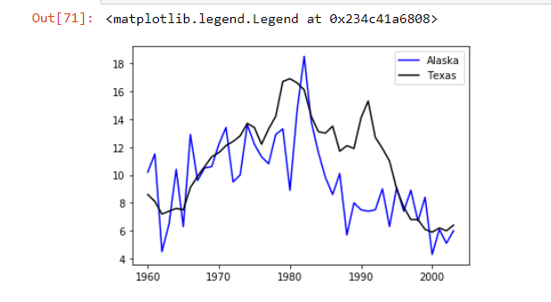

The graph shows the murder rates for two states Alaska and Texas

Q1.3)

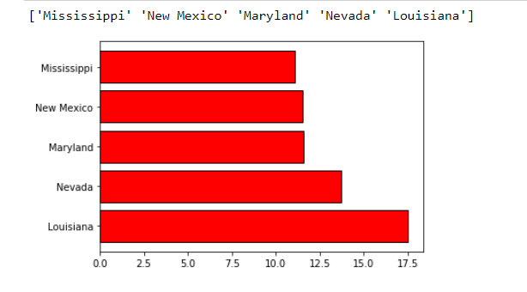

Q1.4)

There are 391 people who are murdered in Texas state

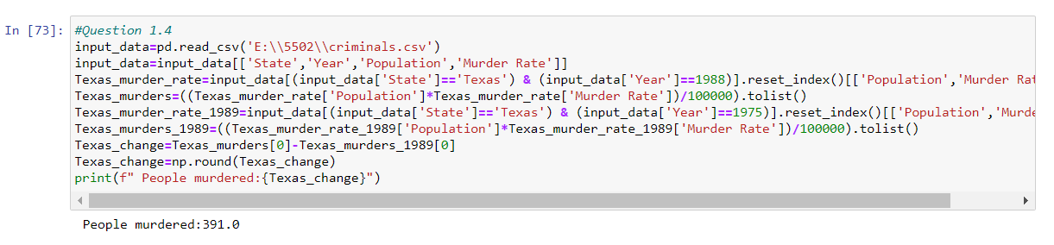

Q 2.1)

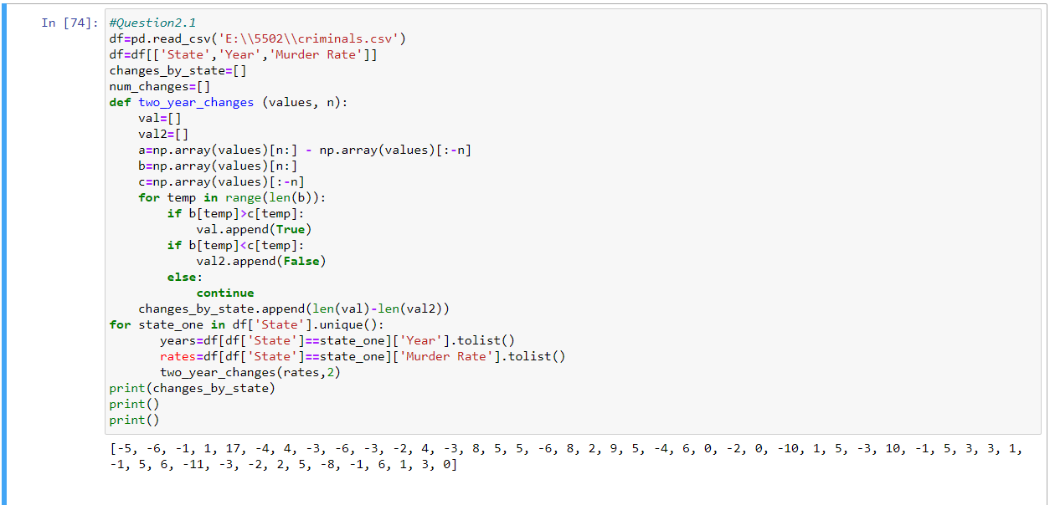

Q2.2)

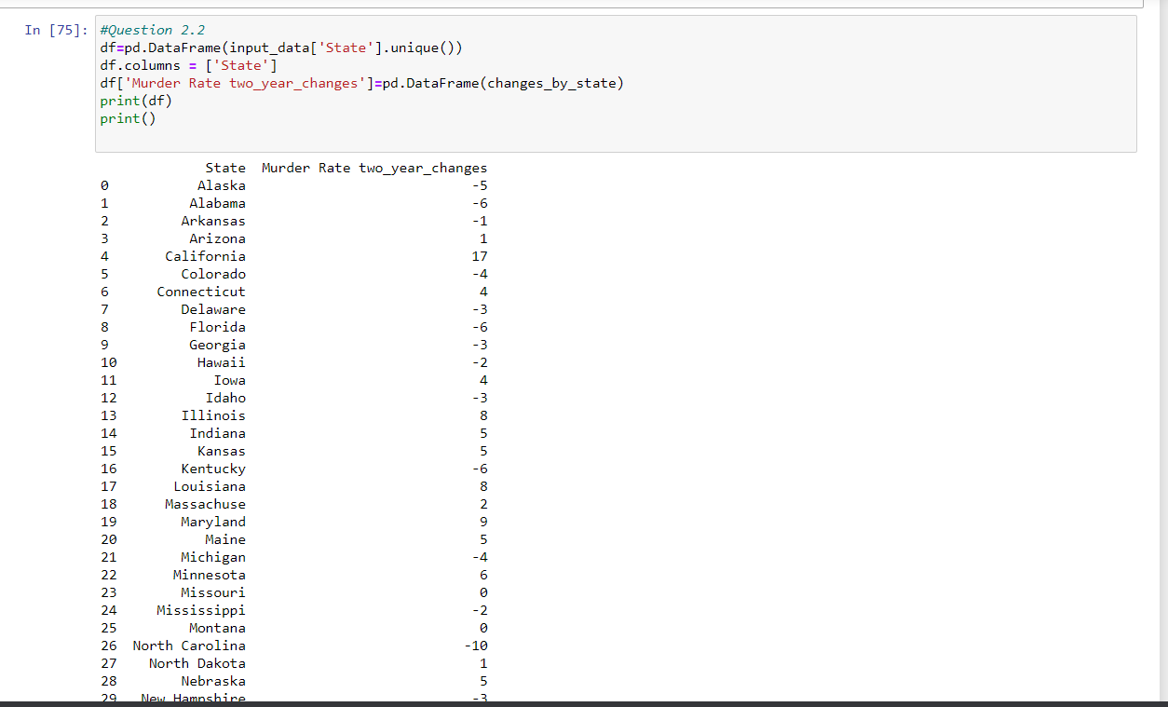

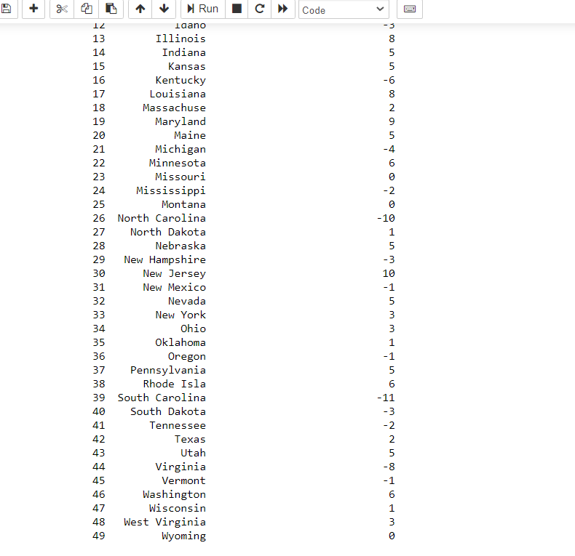

Q 2.3)

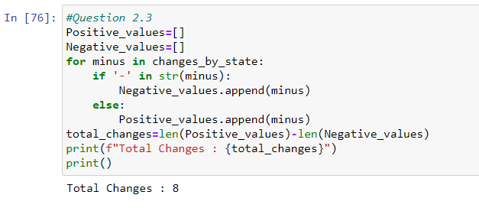

Q 2.4)

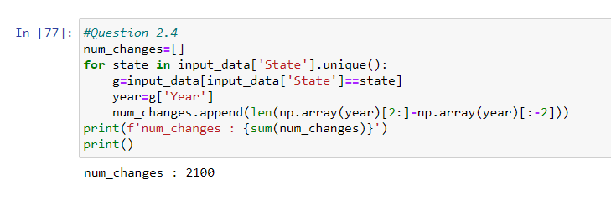

Q 2.5) The significant requirements for good test statistic defines large positive values for alternate hypothesis and other values are in favor of null hypothesis. Test statistic should only depend on murder rates variation not on size change.

Q 2.6 & 2.7)

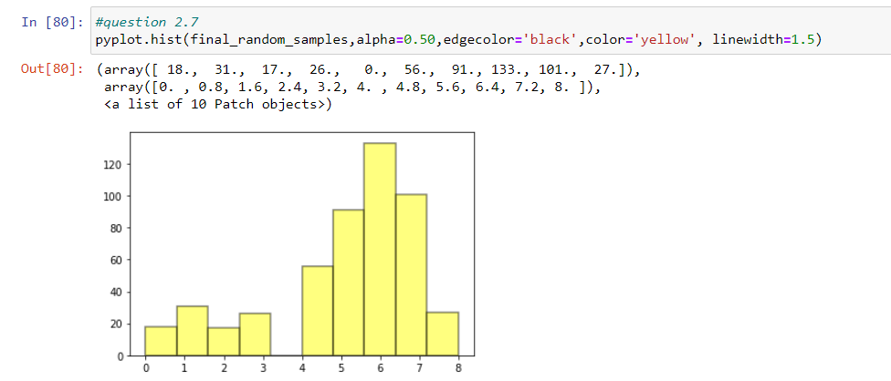

The statistics decrease with minor change when murder rate increases.

Q3.1)

1. Population of 50 USA states
2. Control group is a group of states which has no death penalty
3. Treatment group is a group of states which has death penalty implemented
4. The result if there is an increase or decrease in the murder rate given whether death penalty implemented or not.

Q3.2)

There may be other services that can influence the results if there is no death penalty and murder rate. Specific rules may affect seasonal issues that may not be included in every other state.

Q3.3)

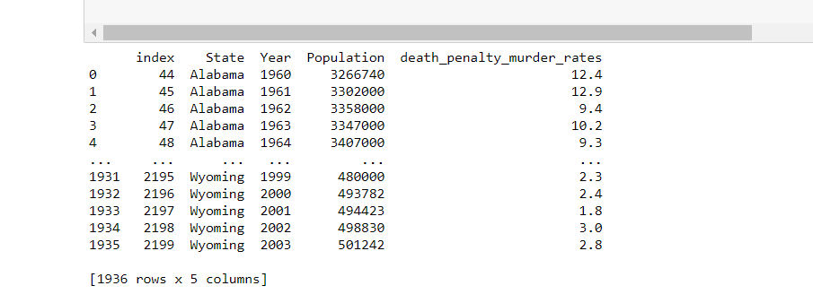

Q3.4)

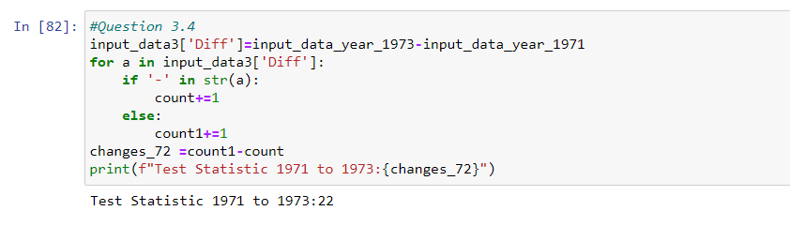

The test statistic for years 1971 to 1973 is 22

Q3.5 & 3.6)

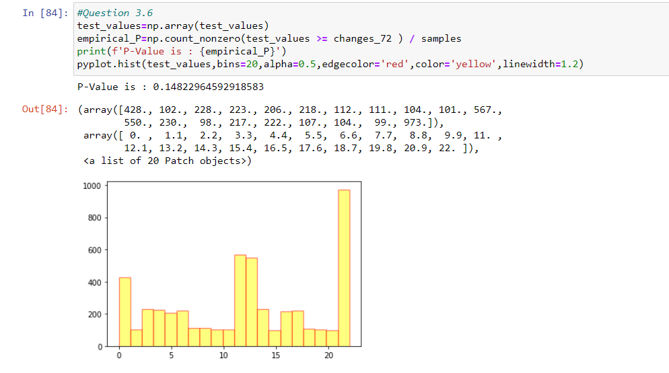  
P-value is 0.148

As P-value is >0.05, we have to use the null hypothesis

From my observations, the calculated p-value is 0.0 because changes_72 is greater than total values which are less than changes_72.

Q4.1)

The P-value is 0.0012

Q4.3)

When it is re-established, there was a decrease in the sum of total murder rates among death penalty rates of all states. We reject null hypothesis because of randomness. We can then create dependency between death penalty policy and murder rates.

Q5.1)

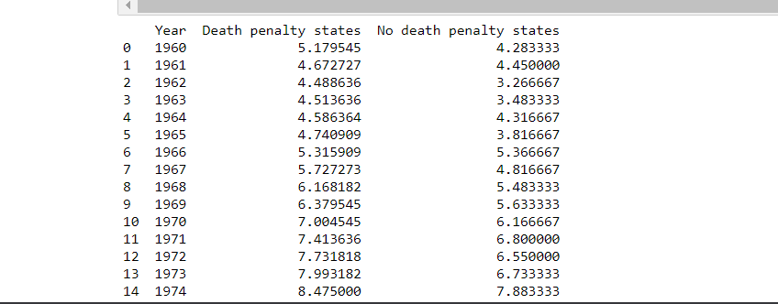

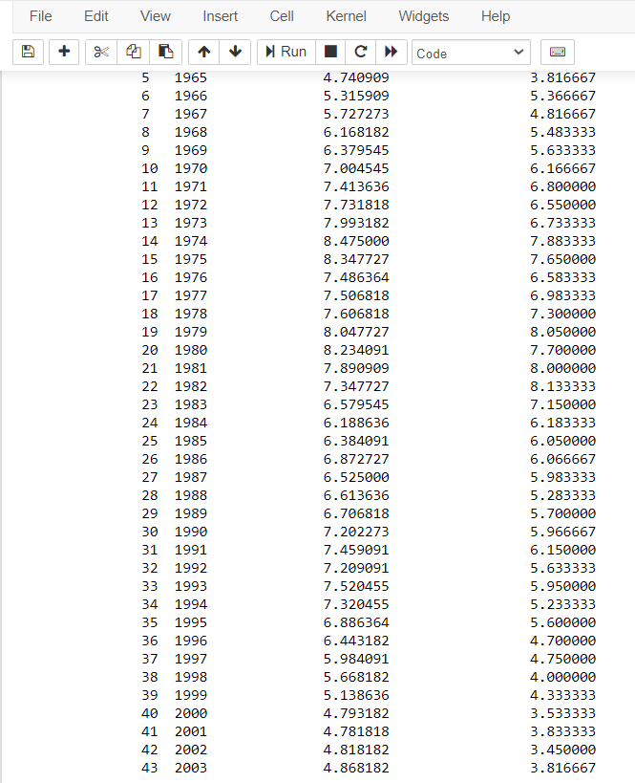

Q5.2)

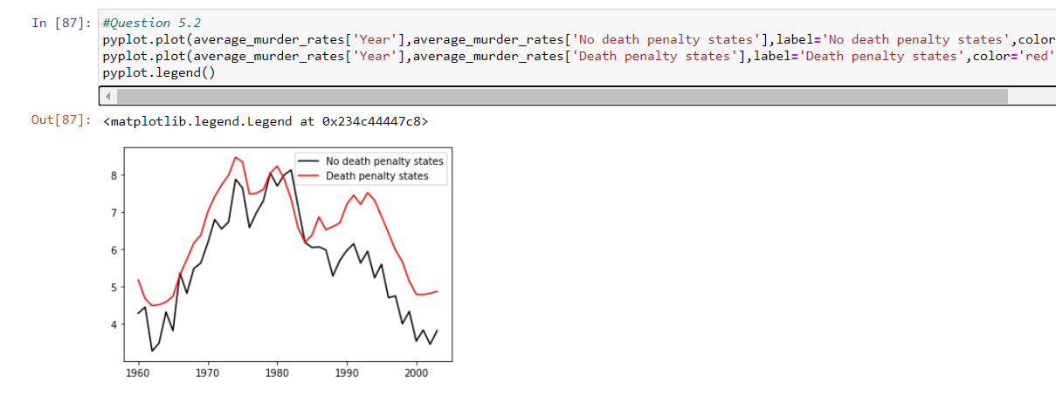

Q5.3)

The murder rate raises and falls at same rate irrespective of death penalty and maybe it depends on other external factors.

Q5.5)

The murder rates irrespective of death penalty policy even if we reject null hypothesis and small p-value shows the other external factors are responsible for murder rates.