**Assignment 3**

Code:

# In[4]:

import numpy as np

import matplotlib.pyplot as plot

N=[10,500,1000,5000,10000,50000,80000,100000,200000]

pi=[]

for i in N:

x=np.random.uniform(0,1,i)

y=np.random.uniform(0,1,i)

random=(x-0.5)**2+(y-0.5)**2<0.25

pi.append(4*np.sum(random)/i)

p=x[random]

p1=y[random]

fig=plot.figure(figsize=(5,5))

x1 = fig.add_subplot(1, 1, 1)

rect=plot.Rectangle((0,0), 1, 1,edgecolor='k',fill=False)

circle=plot.Circle((0.5,0.5),radius=0.5,edgecolor='k',fill=False)

x1.add_patch(rect)

x1.add_patch(circle)

plot.scatter(x,y,s=2,color='blue')

plot.scatter(p,p1,s=2,color='red')

print(pi)

# In[2]:

pi

# In[3]:

plot.axis([10,200000,3.2,3.11])

plot.plot(N,pi)

Output:

[3.2]

[3.2, 3.168]

[3.2, 3.168, 3.224]

[3.2, 3.168, 3.224, 3.1408]

[3.2, 3.168, 3.224, 3.1408, 3.1272]

[3.2, 3.168, 3.224, 3.1408, 3.1272, 3.14616]

[3.2, 3.168, 3.224, 3.1408, 3.1272, 3.14616, 3.14375]

[3.2, 3.168, 3.224, 3.1408, 3.1272, 3.14616, 3.14375, 3.1414]

[3.2, 3.168, 3.224, 3.1408, 3.1272, 3.14616, 3.14375, 3.1414, 3.14832]

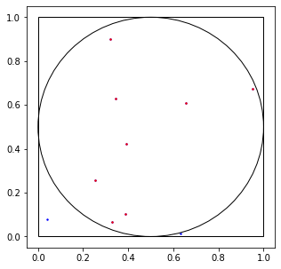

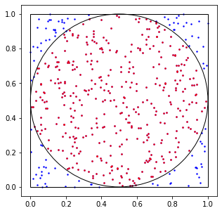

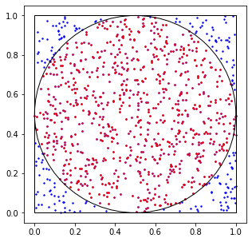

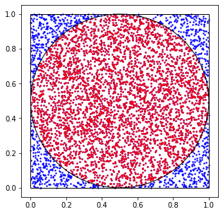

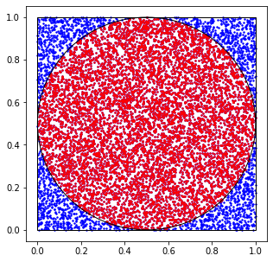

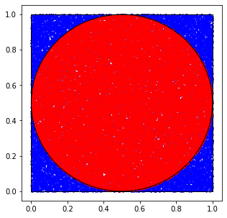

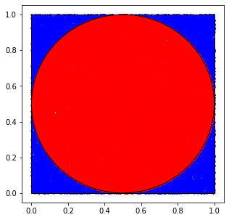

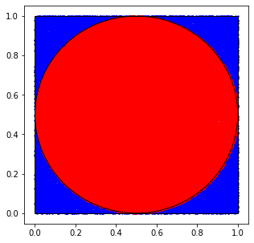

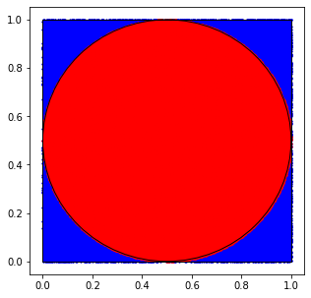

PI Values

[2.8, 3.112, 3.168, 3.108, 3.1352, 3.1308, 3.14025, 3.13176, 3.1317]

The plot of nearest values of PI

[<matplotlib.lines.Line2D at 0x2538c298fc8>]

