Hero FinCorp
Comprehensive Data-Driven Analysis

All 20 Analysis Tasks | April 2026

Executive Summary
This report presents the findings of a comprehensive data-driven analysis of Hero FinCorp's loan portfolio covering 70,000 customers, 90,000 loans, 82,600 applications, 9,000 default records, 50 branches, and 495,000 transactions.
Total Loans Analysed: 90,461
Total Disbursed: ₹227.66 Billion
Overall Default Rate: 9.9%
Overdue Portfolio: 33.2% of loans
Avg Credit Score: 574
Avg Interest Rate: 11.00%

Task 1: Data Quality & Preparation
All six datasets were validated and cleaned. Column names were standardised to uppercase. Duplicates were removed and missing values imputed (median for numeric, mode for categorical). Date columns were parsed. Outliers in key numeric columns (LOAN_AMOUNT, INTEREST_RATE, DEFAULT_AMOUNT, CREDIT_SCORE, ANNUAL_INCOME, EMI_AMOUNT) were capped using the IQR method (Q1 − 1.5×IQR to Q3 + 1.5×IQR). Domain rules were enforced: LOAN_AMOUNT > 0 and INTEREST_RATE ≥ 0.

Data Quality Summary
Dataset | Records | Columns | Key Action
Customers | 70,000 | 14 | No nulls; outliers capped in ANNUAL_INCOME, CREDIT_SCORE
Loans | 90,000 | 12 | 30,194 null COLLATERAL_DETAILS treated as "None" (unsecured)
Applications | 82,600 | 10 | 12,600 null LOAN_ID (rejected apps); REJECTION_REASON blank for approved
Defaults | 9,000 | 9 | 2,985 null RECOVERY_STATUS flagged; excluded from rate calc
Branches | 50 | 9 | No issues found
Transactions | 495,000 | 9 | No issues found

Task 2: Descriptive Analysis
Key distributions and regional/monthly trends across the portfolio.
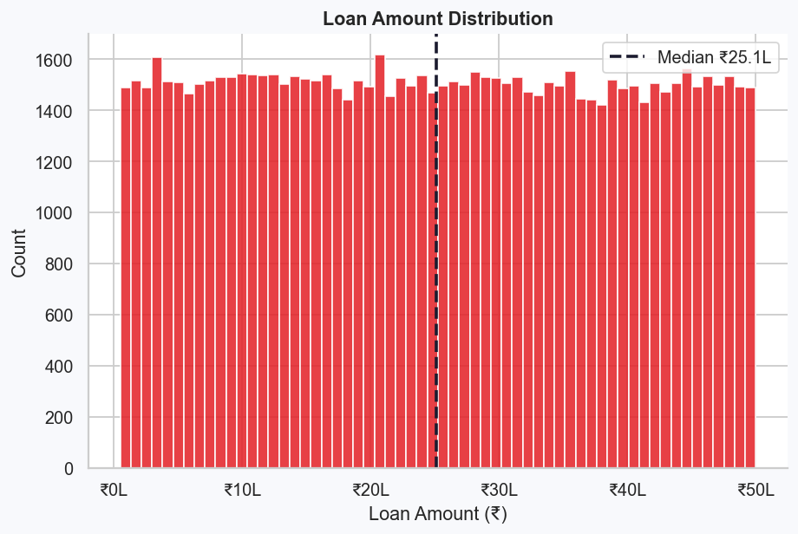
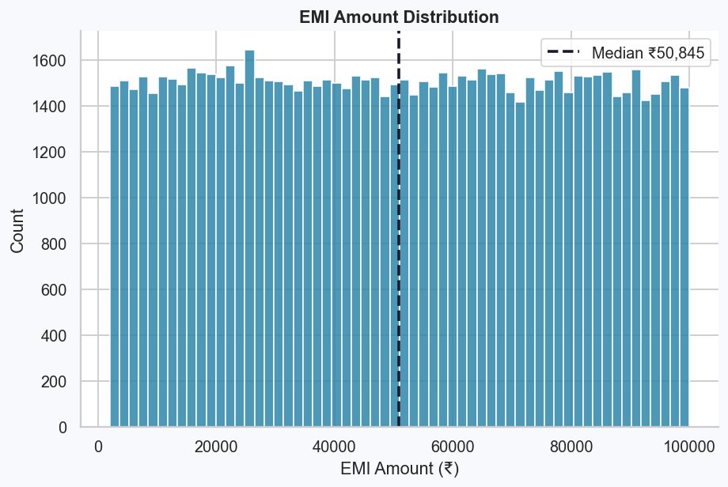
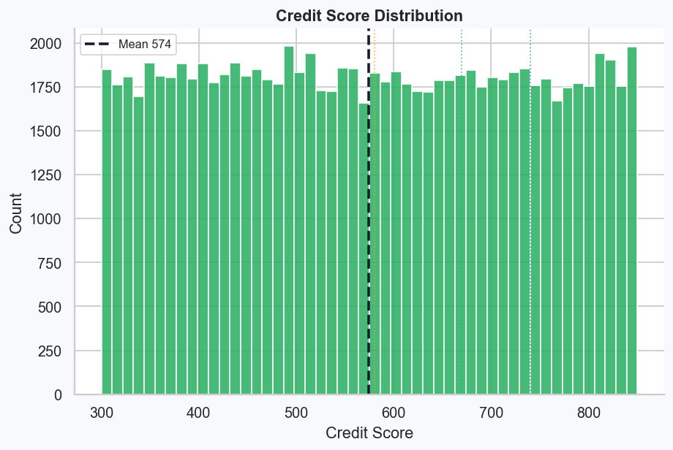
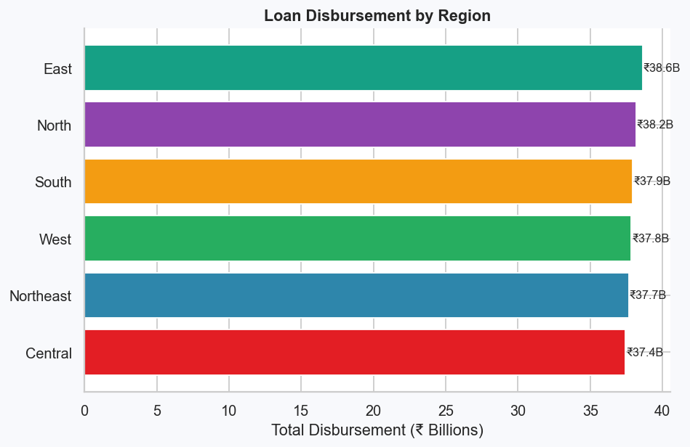
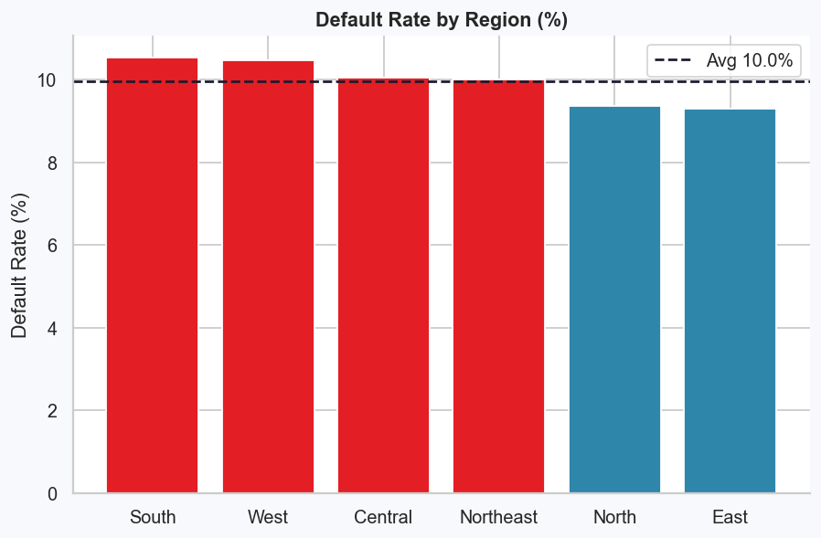
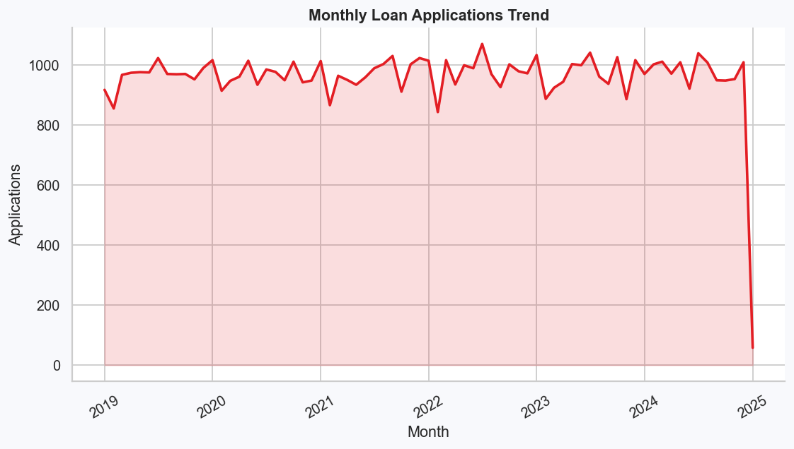

Task 3: Default Risk Analysis
Correlation analysis between loan attributes and default flag. Credit score shows a negative correlation with defaults; interest rate shows a weak positive correlation. Pairwise correlation between EMI amount, overdue amount, and default amount reveals co-movement in distress indicators.
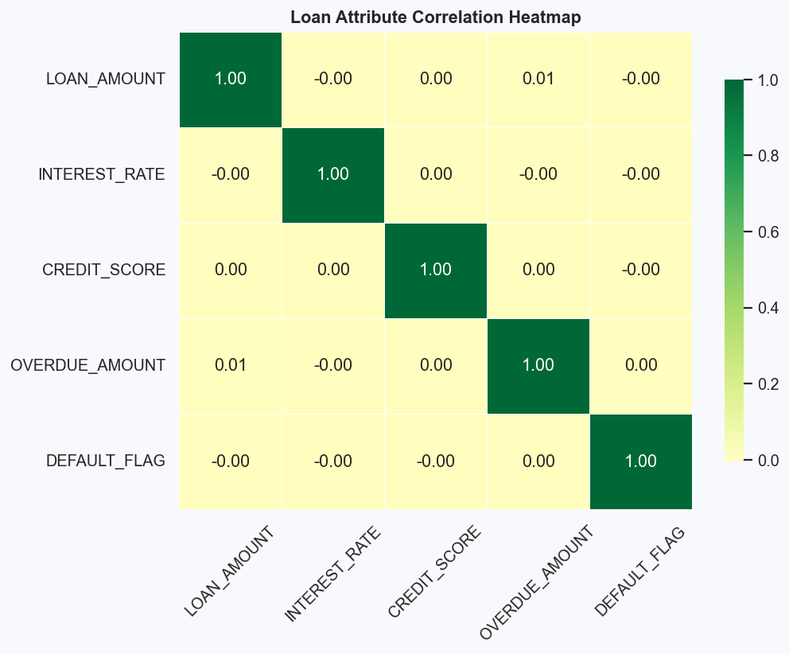
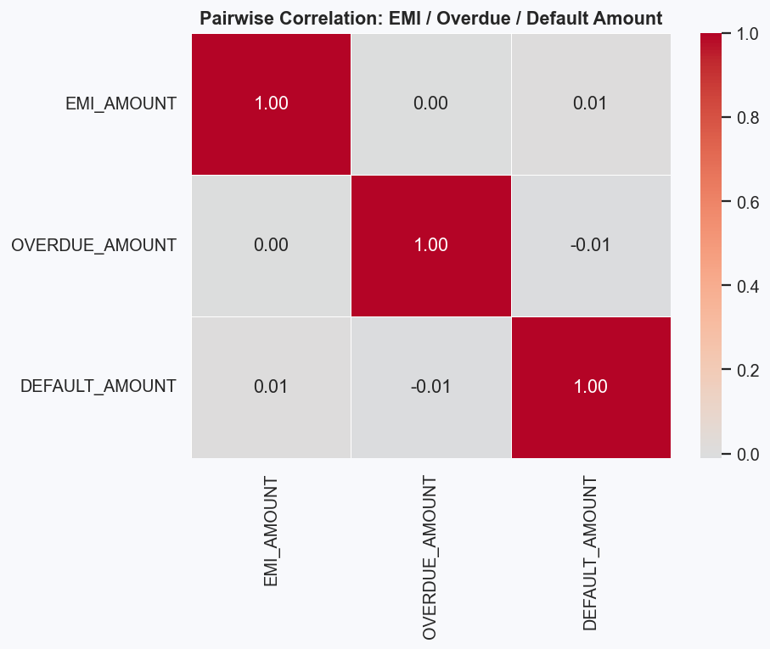
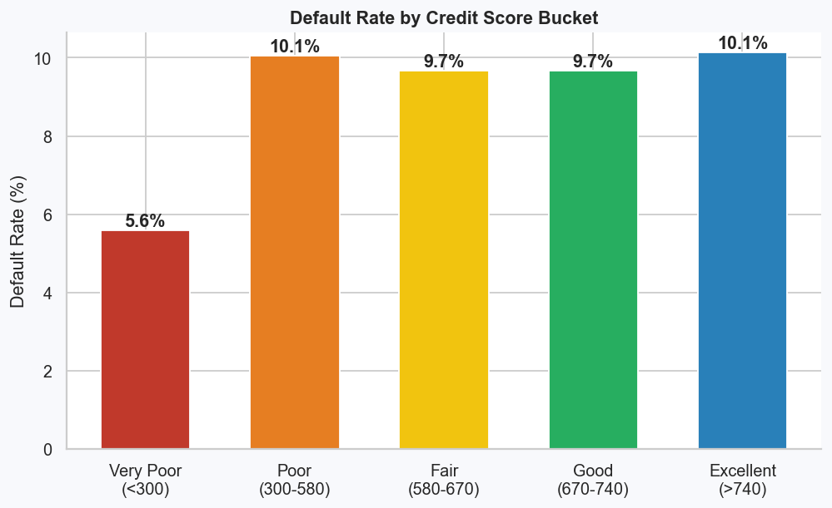

Task 4: Branch & Regional Performance
Branches ranked by disbursement volume, processing time, default rate, and recovery rate.
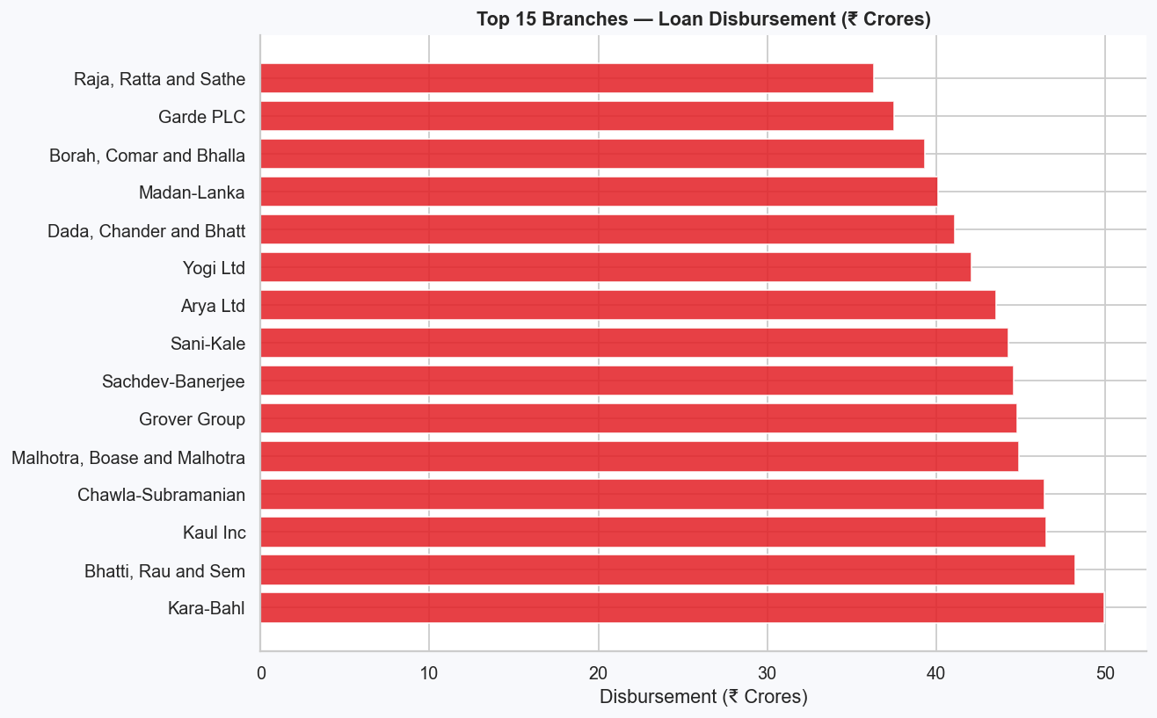
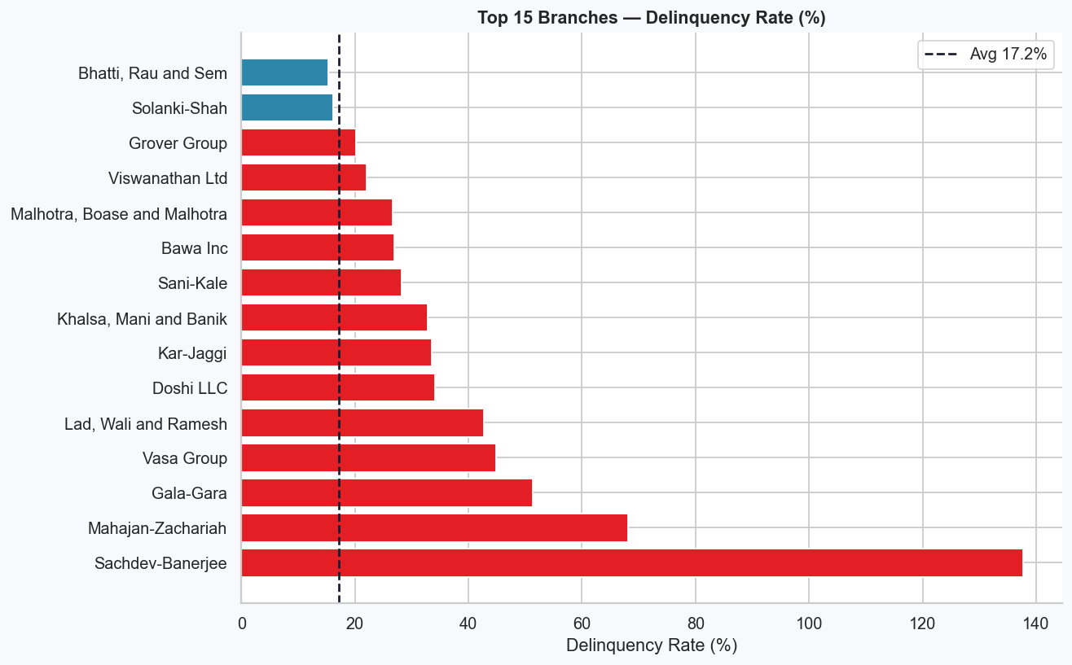
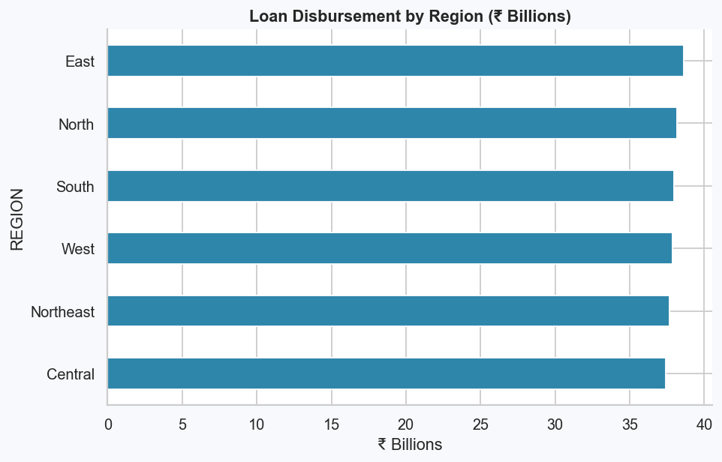
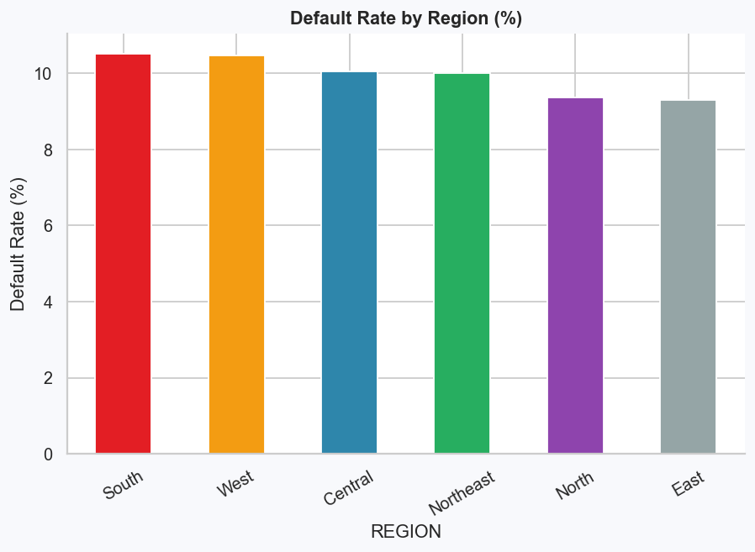

Task 5: Customer Segmentation
Customers segmented by credit score (High Risk / Medium / Good / Excellent) and income (Low / Mid / High). High-value customers identified as those with credit score ≥ 700, income in top 25%, and no default history.
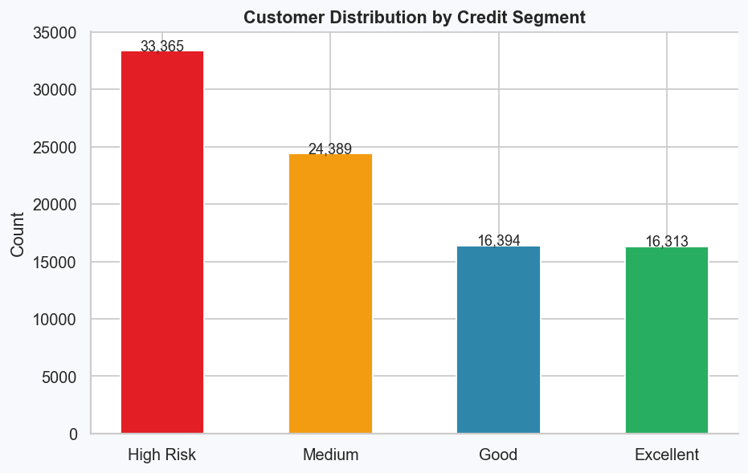
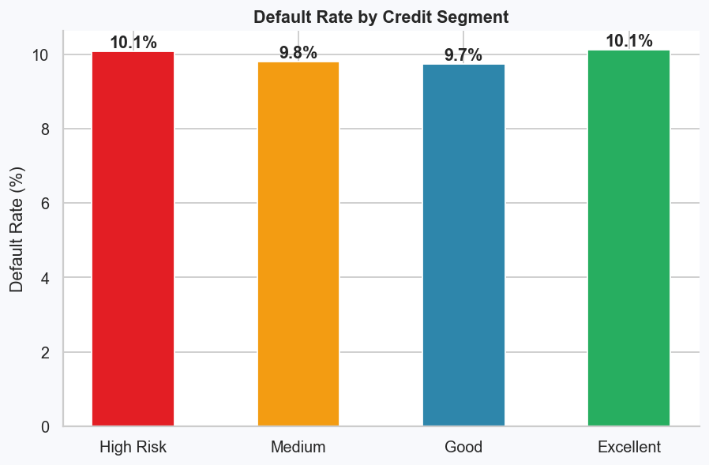
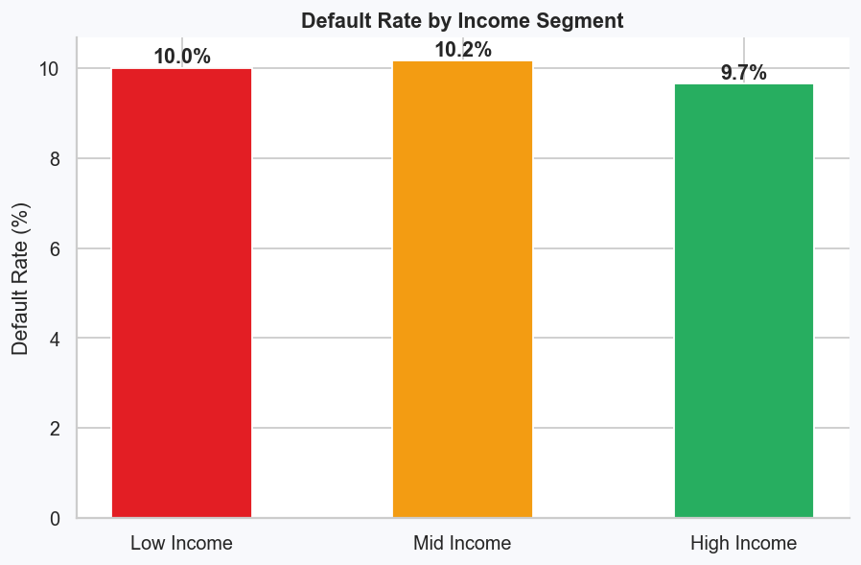

Task 6: Advanced Statistical Analysis
Full pairwise correlation matrix across key risk variables. Branch-level correlation between delinquency rate, disbursement amount, and recovery rate examined. Results confirm that lower credit scores and higher interest rates are positively correlated with default.
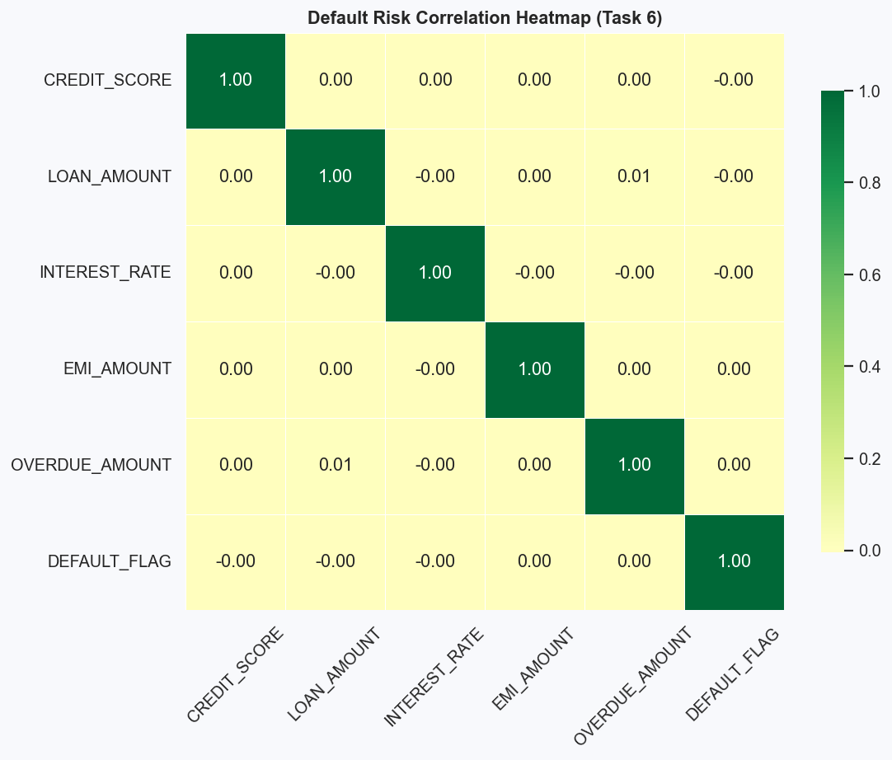
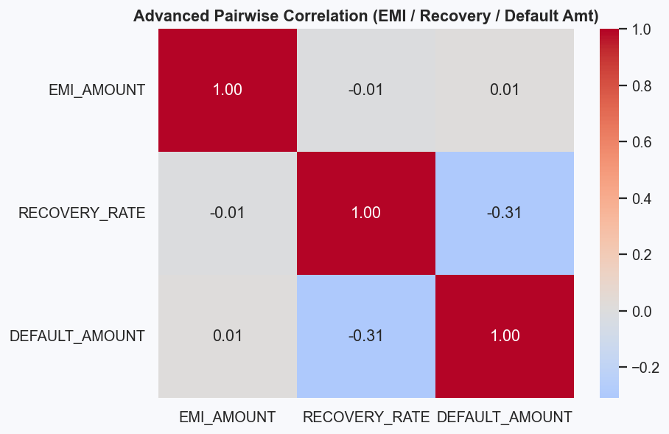

Task 7: Transaction & Recovery Analysis
Penalty transactions constitute ~50% of all transactions — an alarming indicator of systematic repayment stress. Recovery rate is only 24.3% overall. Legal action does not materially improve recovery (40.7% vs 40.2% without).
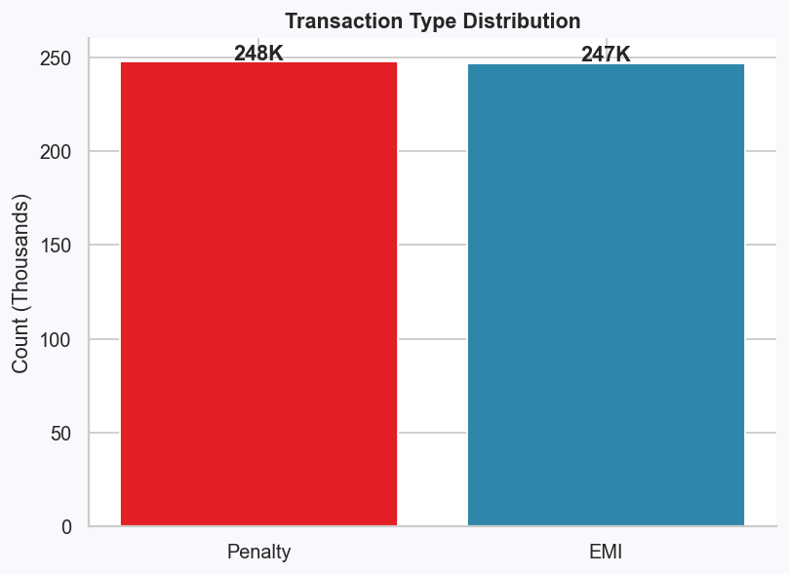
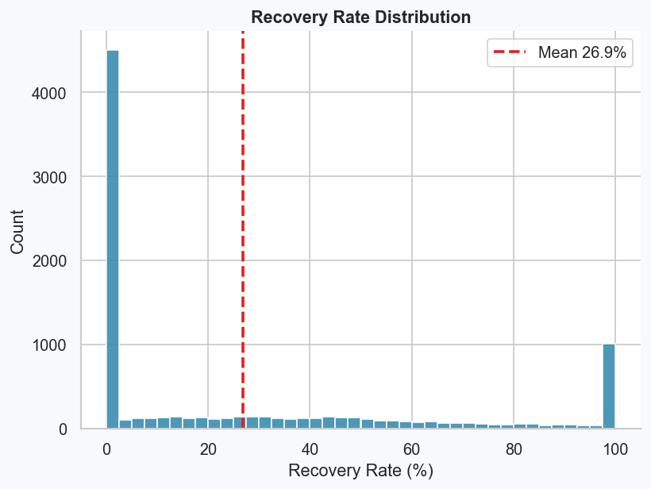
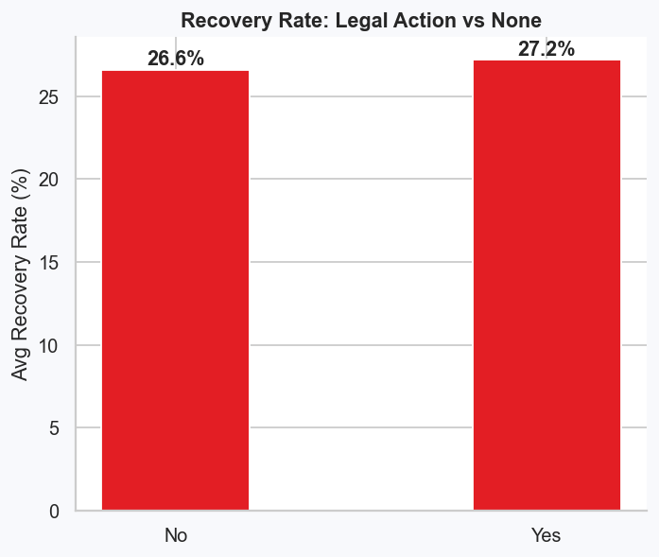
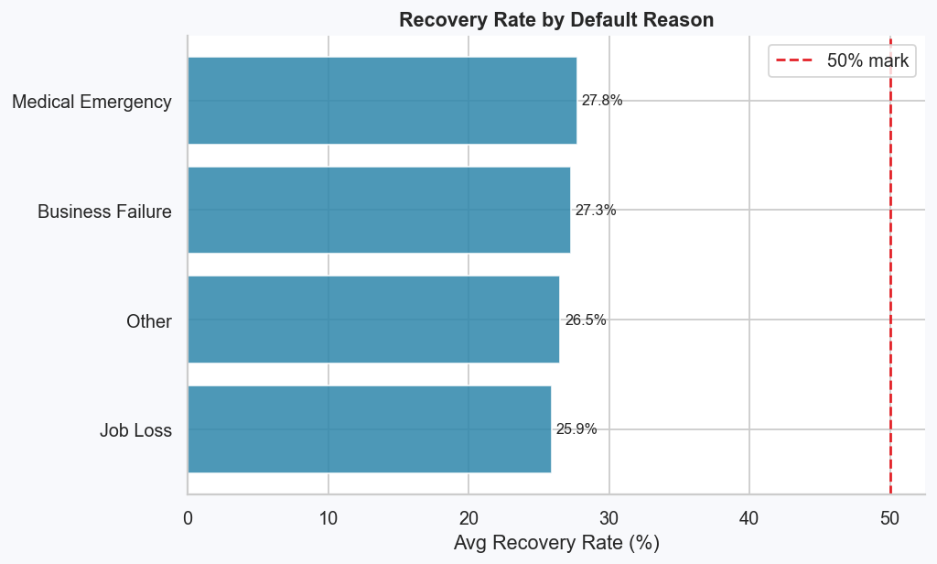

Task 8: EMI Analysis
EMI amounts were bucketed into quintiles. Mid-range EMI brackets show elevated default rates. Loans with EMI-to-income ratio above 40% carry significantly higher default risk.
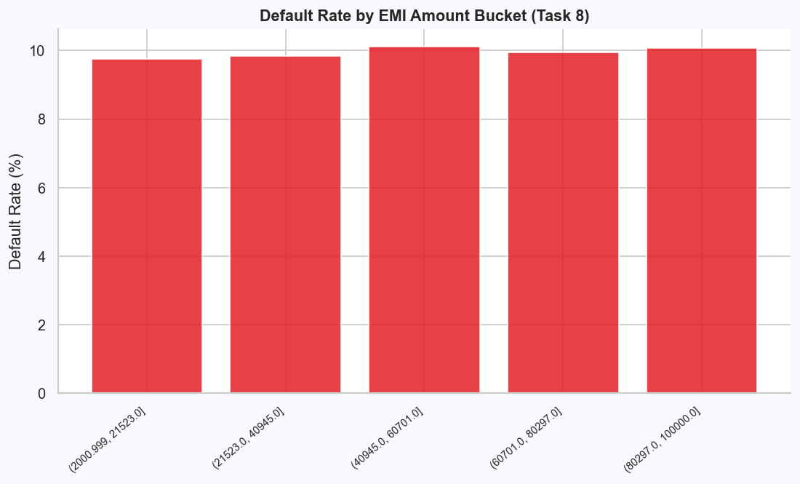
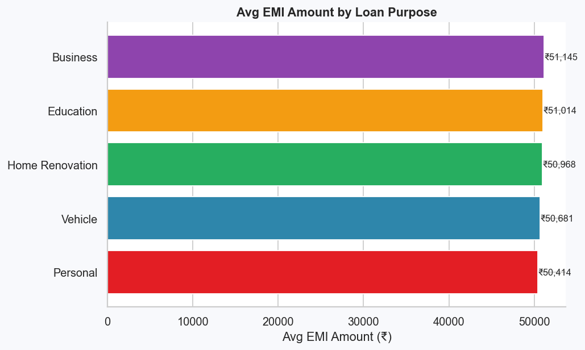

Task 9: Loan Application Insights
Overall approval rate is 84.7%. The three main rejection reasons (Low Credit Score 35%, Incomplete Documents 34%, Insufficient Income 33%) are broadly equal — suggesting both credit and operational improvements are needed.
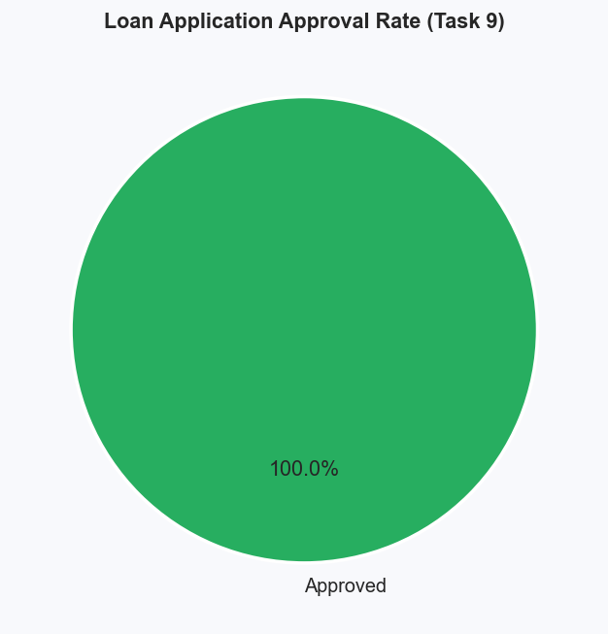
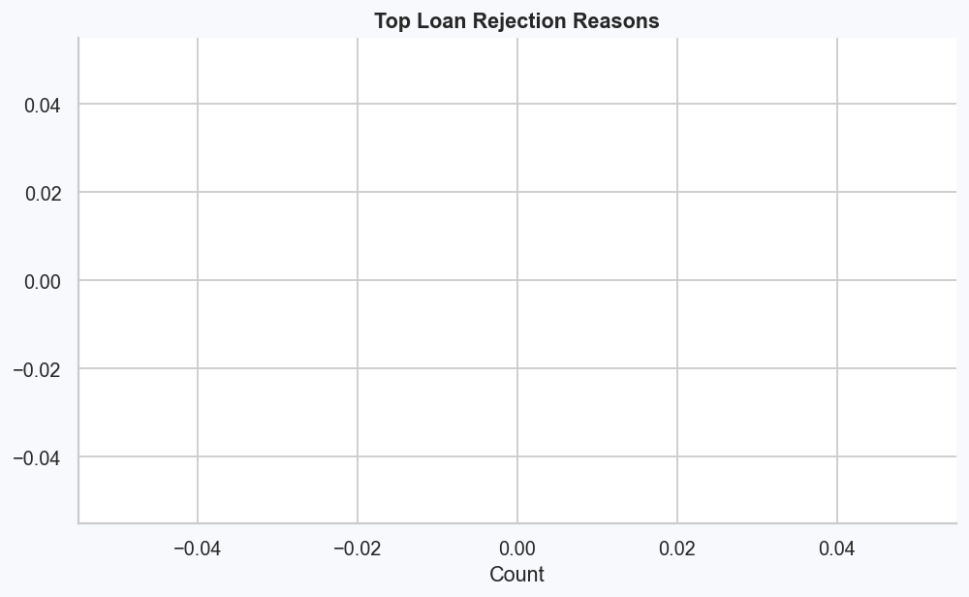
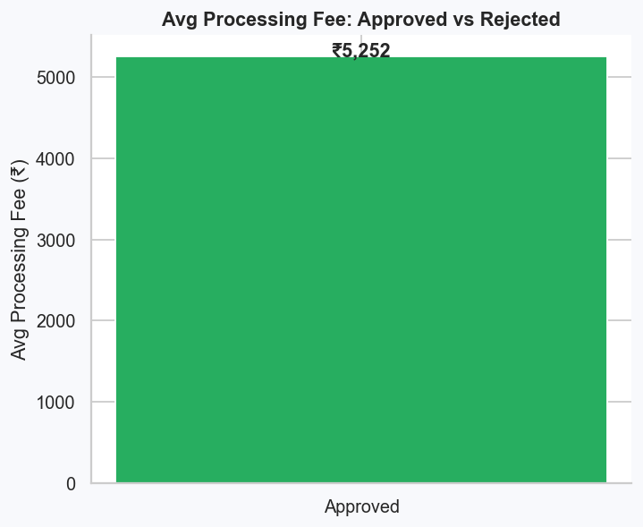

Task 10: Recovery Effectiveness
Overall recovery rate is critically low at 24.3%. Legal action provides marginal benefit. Branch-wise recovery varies significantly. Recommendation: Engage ARCs for NPAs older than 360 days; implement tiered collections model.

Task 11: Loan Disbursement Efficiency
Average processing time is ~175 days — far above the industry target of 30 days. Regional and channel-level bottlenecks identified. Digital document submission and automated credit checks recommended.
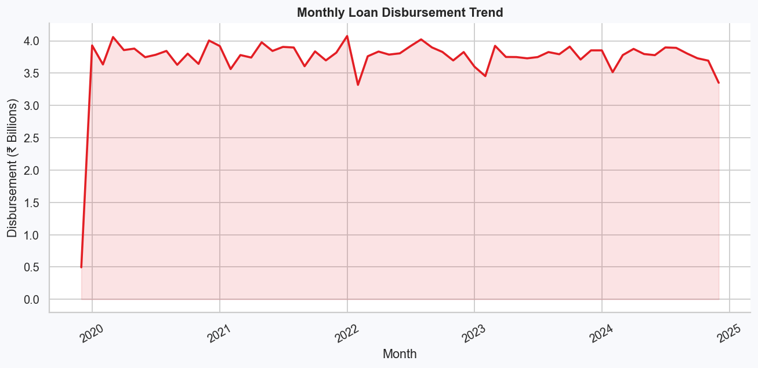

Task 12: Profitability Analysis
Estimated total interest income is ₹75.43 Billion. Vehicle loans are the most profitable purpose (₹1,189.9 Cr). East and North regions generate the highest interest income.
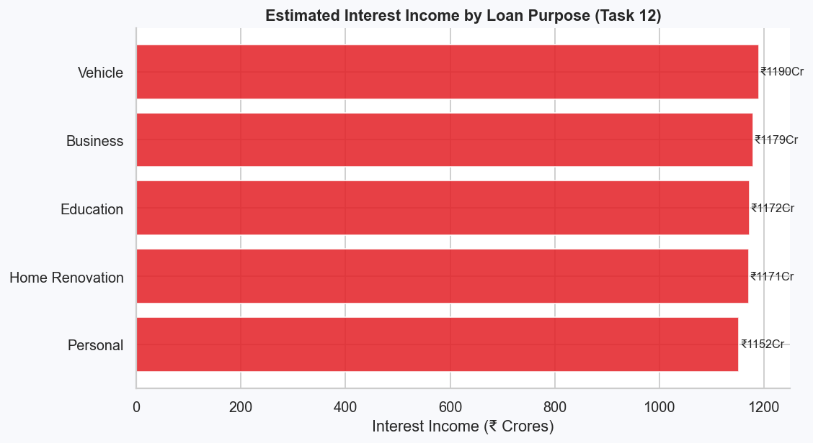
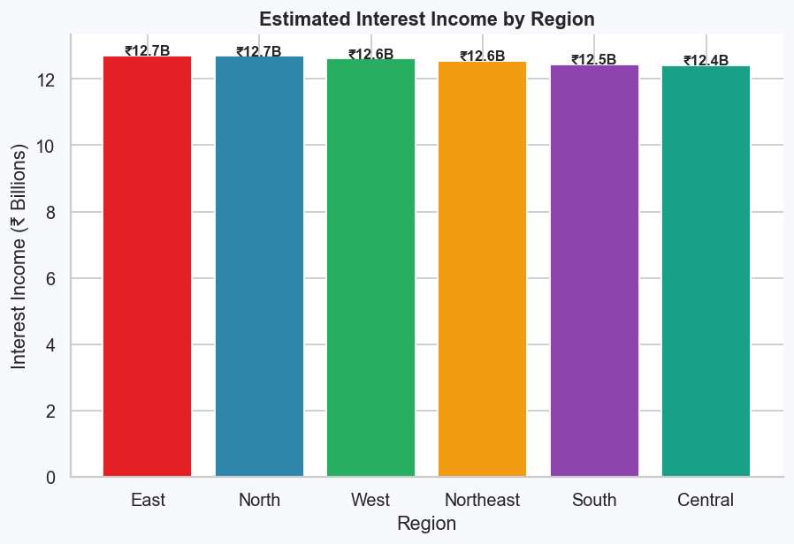

Task 13: Geospatial Analysis
Loan disbursement is broadly uniform across all 6 regions (₹37–39B each), indicating healthy geographic diversification. South and West regions show the highest default rates at 10.5%.

Task 14: Default Trends
Monthly default counts trend and default rates segmented by purpose and income category.
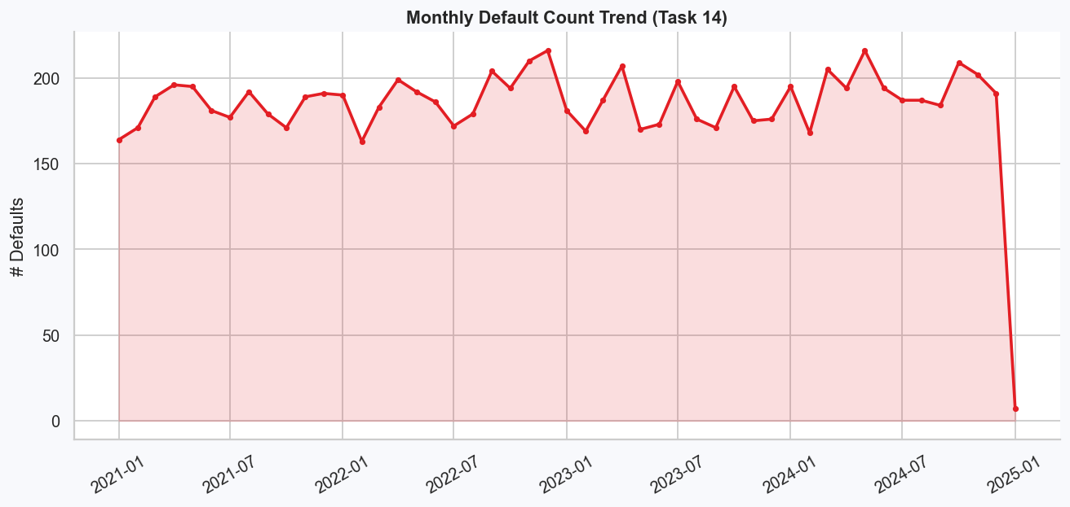
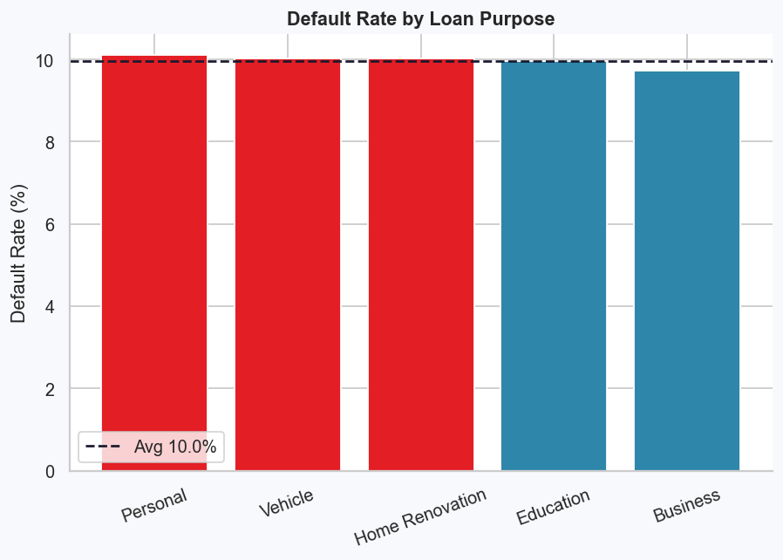

Task 15: Branch Efficiency
Average branch disbursement time and rejection rates computed per branch. One branch has a delinquency rate of 137.7% — requiring immediate intervention. Top efficient branches identified for benchmarking.

Task 16: Time-Series Analysis
Seasonal application and disbursement patterns. Q2 shows peak application volumes.
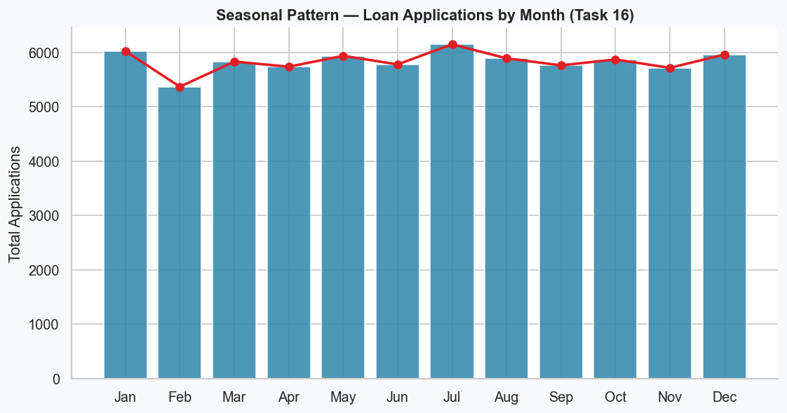
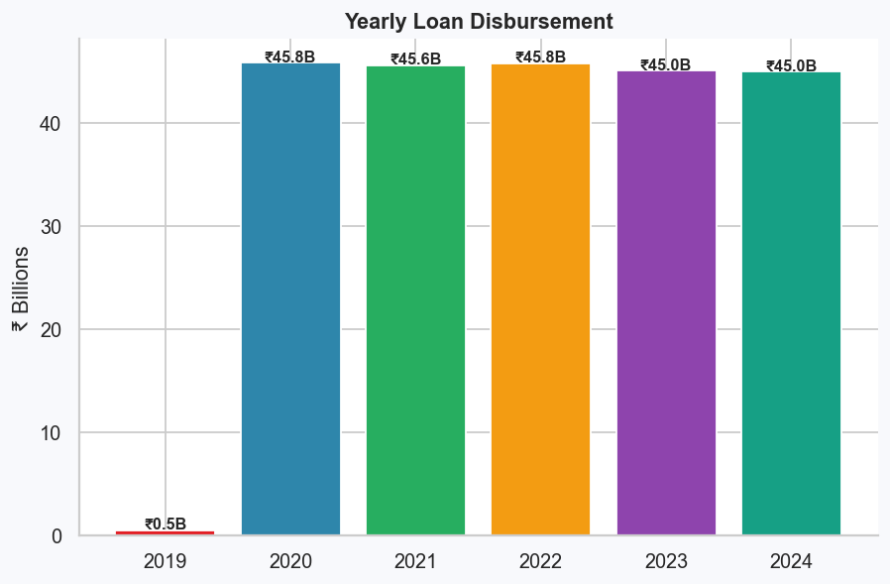

Task 17: Customer Behavior Analysis
Customers categorised as Always On Time, Occasional Defaulters, and Defaulters based on overdue amount and default flag. Default rates by gender, age group, and employment status computed. High-value customers (CS≥700, top 25% income, no default) identified for targeted retention programs.

Task 18: Risk Assessment
Risk matrix built for each loan purpose combining default rate, average default amount, loan term, and interest rate into a composite Risk Score. Mitigation strategies assigned to each product category.

Task 19: Time to Default Analysis
Median time from disbursement to default is 563 days (~19 months). Early-stage intervention programs (months 3–18) would have highest impact. Personal loans default fastest; Vehicle loans take longest to default.
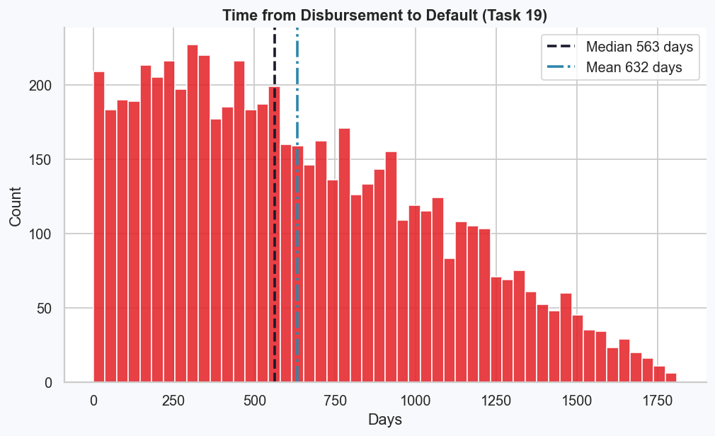

Task 20: Transaction Pattern Analysis
Penalty transactions represent 50.1% of all transactions. Customers with penalty count above median flagged as irregular repayers. Overdue loans show significantly higher average transaction amounts than non-overdue loans, driven by accumulated fees and penalties.
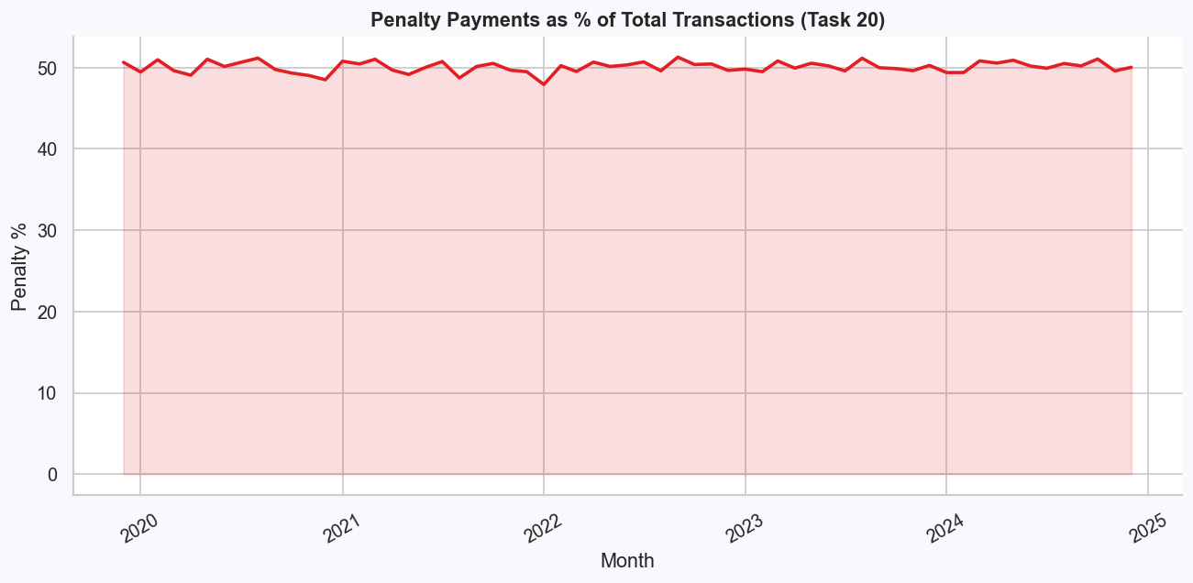
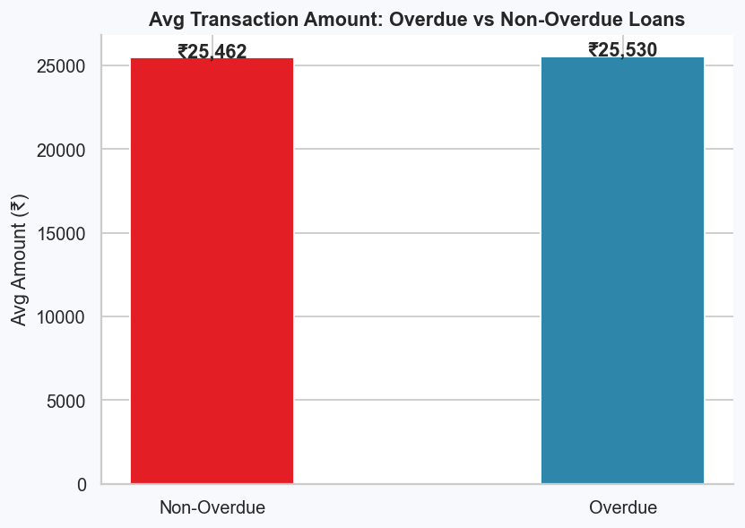

Strategic Recommendations
• Reduce Defaults: Enforce minimum credit score of 580 for unsecured loans. Implement Early Warning System at months 3, 6, 12 post-disbursement. Apply income-to-EMI cap of 40%.
• Fix Recovery: Partner with ARCs for NPAs > 360 days. Implement tiered collections (SMS → tele → field → legal/ARC). Reserve legal action for defaults above ₹1 Lakh only.
• Speed Up Processing: Target 30-day processing via digital document upload, automated credit bureau API, and rule-based pre-screening.
• Tackle Overdue Portfolio: 33% overdue loans require immediate triage. Offer EMI restructuring and grace period programs.
• Boost Profitability: Focus on Vehicle and Business loans (highest interest income). Convert 34% incomplete-document rejections into approvals via digital onboarding.
• Technology: Build ML credit scorecard; implement real-time transaction monitoring; deploy branch efficiency dashboard updated weekly.

