DEEP LEARNING — GRADED ASSIGNMENT
Fashion-MNIST: Shallow CNN vs Deep CNN Comparative Study
Image Classification | 10 Clothing Classes | Shallow CNN vs Deep CNN
Author | Mani Dixit
Batch | PGDSAI3
Notebook | Fashion_MNIST_Comparative_Study_Mani_PGDSAI3.ipynb
Dataset | Fashion-MNIST — 60,000 train + 10,000 test, 28×28 grayscale, 10 classes
GitHub Repo | https://github.com/manidixit16/Convolutional-Neural-Networks
View Notebook Online | https://nbviewer.org/github/manidixit16/Convolutional-Neural-Networks/blob/main/Fashion_MNIST_Comparative_Study_Mani_PGDSAI3.ipynb

Assignment Overview
This report presents the complete solution to the assignment (Parts 1–6): a comparative deep-learning study classifying Fashion-MNIST clothing images with two convolutional neural networks. A shallow CNN and a deep CNN are trained on the same data with an identical, fair training setup — a fixed stratified 90/10 train/validation split, the Adam optimizer, early stopping with best-weight restoration, and a learning-rate scheduler — and compared on accuracy, generalisation, efficiency, and error behaviour. A third experiment adds gentle data augmentation to the deep CNN. The full executed notebook, all figures, and run instructions are in the GitHub repository linked above.

Results at a Glance
Model | Test Accuracy | Train–Val Gap | Overfitting?
Shallow CNN | 92.20% | +4.18% | Yes
Deep CNN | 93.41% | +0.29% | No
Deep CNN + Augmentation | 91.64% | -2.53% | No
Best overall: the Deep CNN (test accuracy 93.41%) — the most accurate and the only model with essentially no overfitting.

Part 1 — Load & Explore the Dataset
Fashion-MNIST provides 70,000 grayscale 28×28 images across 10 balanced clothing classes (6,000 training images each). Pixels are normalized to [0, 1] and images reshaped to (28, 28, 1) for CNN input; a seeded, stratified 90/10 split holds out a validation set shared by every model.
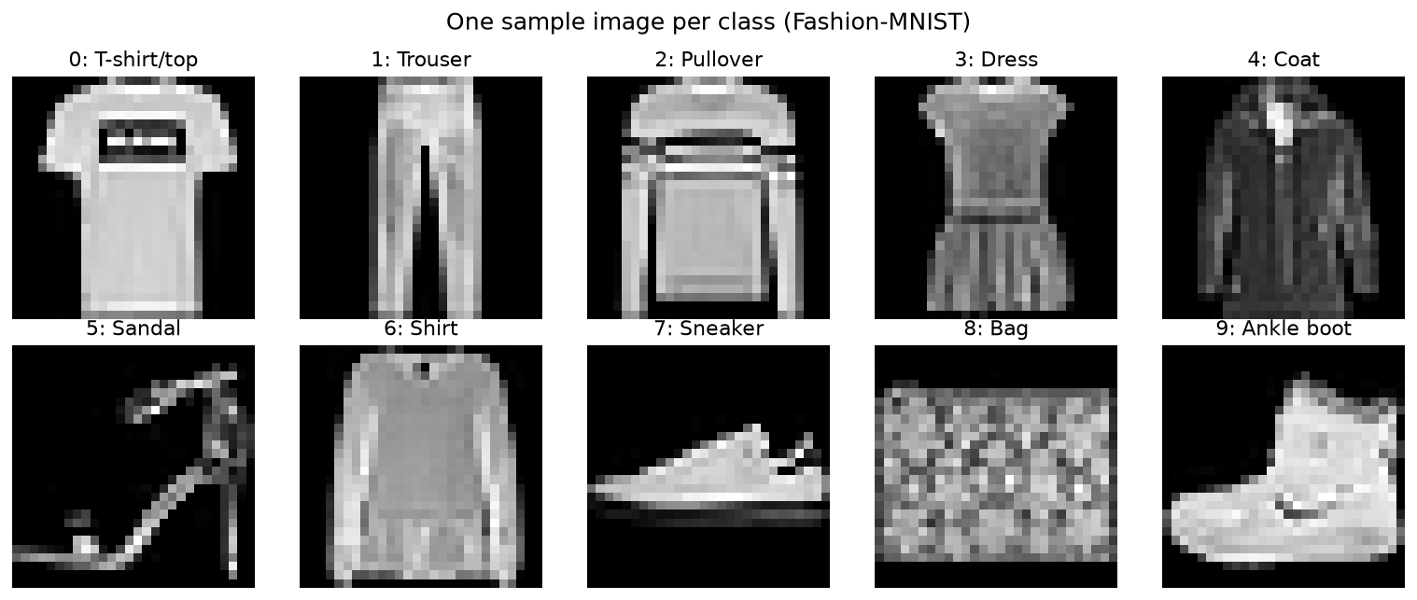
Figure 1 — One sample image per class. Distinctive items (Trouser, Bag, Sandal, Sneaker, Ankle boot) are easy; the upper-body garments (T-shirt, Pullover, Coat, Shirt) share almost identical silhouettes and drive nearly all the errors.
Why normalize? raw 0–255 pixels give large, unevenly-scaled activations/gradients that make training slow and unstable; rescaling to [0, 1] lets the optimizer converge faster and more reliably. Why reshape? a Conv2D layer convolves over a (height, width, channels) tensor, so the (28, 28) images need an explicit channel axis → (28, 28, 1).

Part 2 — Shallow CNN
Architecture: Conv2D(32) → MaxPool → Flatten → Dense(128) → Dense(10, softmax) — one convolution and one pooling layer. Almost all parameters sit in the Flatten → Dense connection, which can memorise training-set detail.
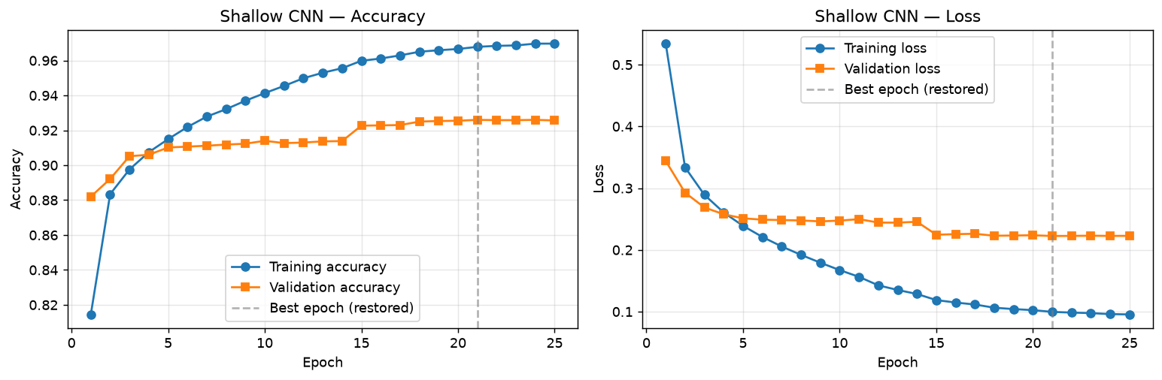
Figure 2 — Shallow CNN learning curves. Training accuracy climbs toward 0.97 while validation flattens near 0.92, and validation loss turns upward — textbook overfitting. Early stopping restores the best-validation weights (dashed line).
- Patterns learned: only low-level, local features (edges, strokes) — enough for the distinctive shapes, not the subtle differences between similar tops.
- Fit: clear overfitting — training accuracy 96.78% vs validation 92.60% (gap +4.18%). Final test accuracy 92.20%.

Part 3 — Deep CNN
Architecture: Conv(32) → BatchNorm → Conv(64) → MaxPool → Dropout → Conv(128) → BatchNorm → MaxPool → Dropout → Flatten → Dense(256) → Dropout → Dense(10, softmax) — three convolution layers with growing filters, two pooling layers, batch-norm and dropout. Same optimizer, callbacks, batch size and validation set as the shallow model.
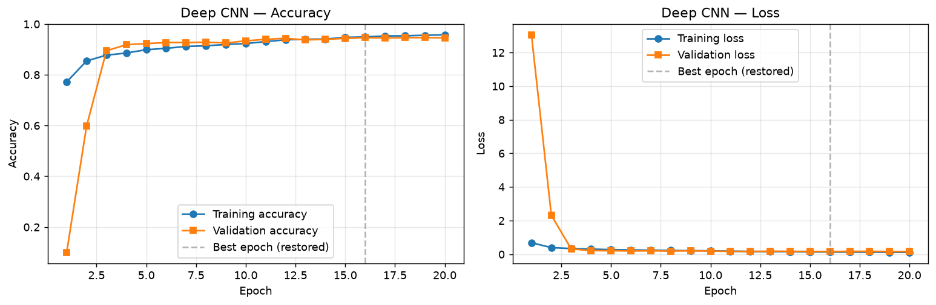
Figure 3 — Deep CNN learning curves. Training and validation rise together and stay close, and validation loss tracks training loss instead of rising — the signature of a model that generalises rather than memorises.
- Extra representations: a feature hierarchy — edges → mid-level parts (sleeves, soles, collars) → class-discriminative shapes — that separates the look-alike upper-body garments.
- Improvement: meaningful — test accuracy 93.41% (up from 92.20%) with a near-zero gap (+0.29%), i.e. genuine generalisation, not just more training-set fit.

Enhancement — Deep CNN with Data Augmentation
The same deep architecture retrained with gentle on-the-fly augmentation (random rotation ≤4%, translation ≤6%, zoom ≤6%) on the training images only — kept small because the garments are already upright and centred.
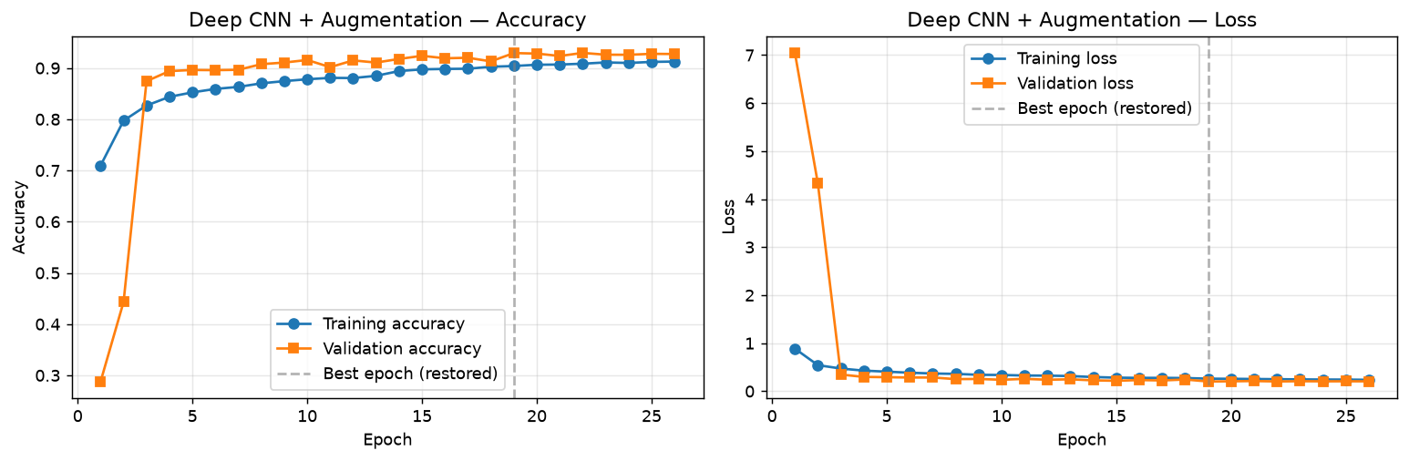
Figure 4 — Augmented deep CNN curves. Validation accuracy sits slightly above training accuracy (trained on harder augmented images, validated on clean ones) — heavy regularisation, mild underfitting, no overfitting.
- Effect: the train–val gap goes negative (-2.53%) but test accuracy (91.64%) does not beat the plain deep model on this clean dataset — augmentation is not a free accuracy win; its payoff is robustness/calibration, and its strength must match the data.

Part 4 — Comparative Study
Metric | Shallow CNN | Deep CNN | Deep CNN + Aug
Conv layers | 1 | 3 | 3
Total parameters | 693,962 | 1,701,770 | 1,701,770
Training accuracy | 96.78% | 94.94% | 90.39%
Validation accuracy | 92.60% | 94.65% | 92.92%
Test accuracy | 92.20% | 93.41% | 91.64%
Train–Val gap | +4.18% | +0.29% | -2.53%
Overfitting? | Yes | No | No
Training time (s) | 127 | 1132 | 1527
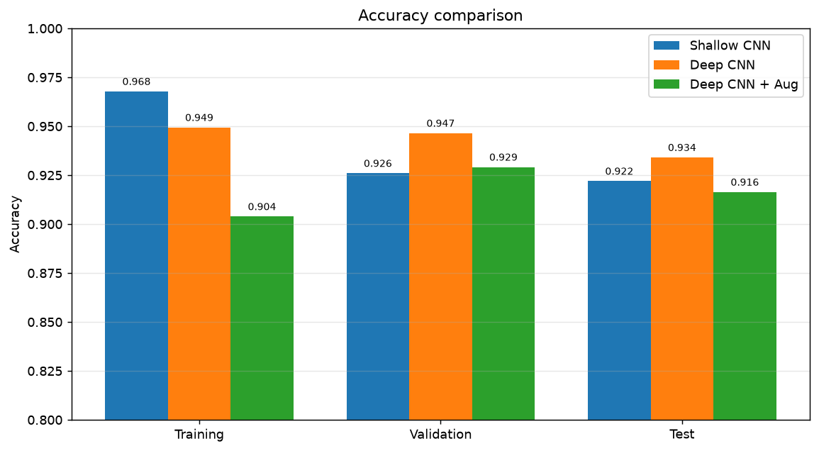
Figure 5 — Accuracy comparison. The shallow model's Training bar towers over its Validation/Test bars (overfitting); the deep model's bars are level with the tallest Test bar; the augmented model's Training bar is the shortest (mild underfitting).
- Better overall: Deep CNN — highest accuracy and smallest gap.
- Efficiency: Shallow CNN — ~9× faster to train and ~2.4× fewer parameters.
- Trade-off: compute/latency vs accuracy — shallow for speed and simplicity, deep for accuracy.

Part 5 — Prediction & Error Analysis
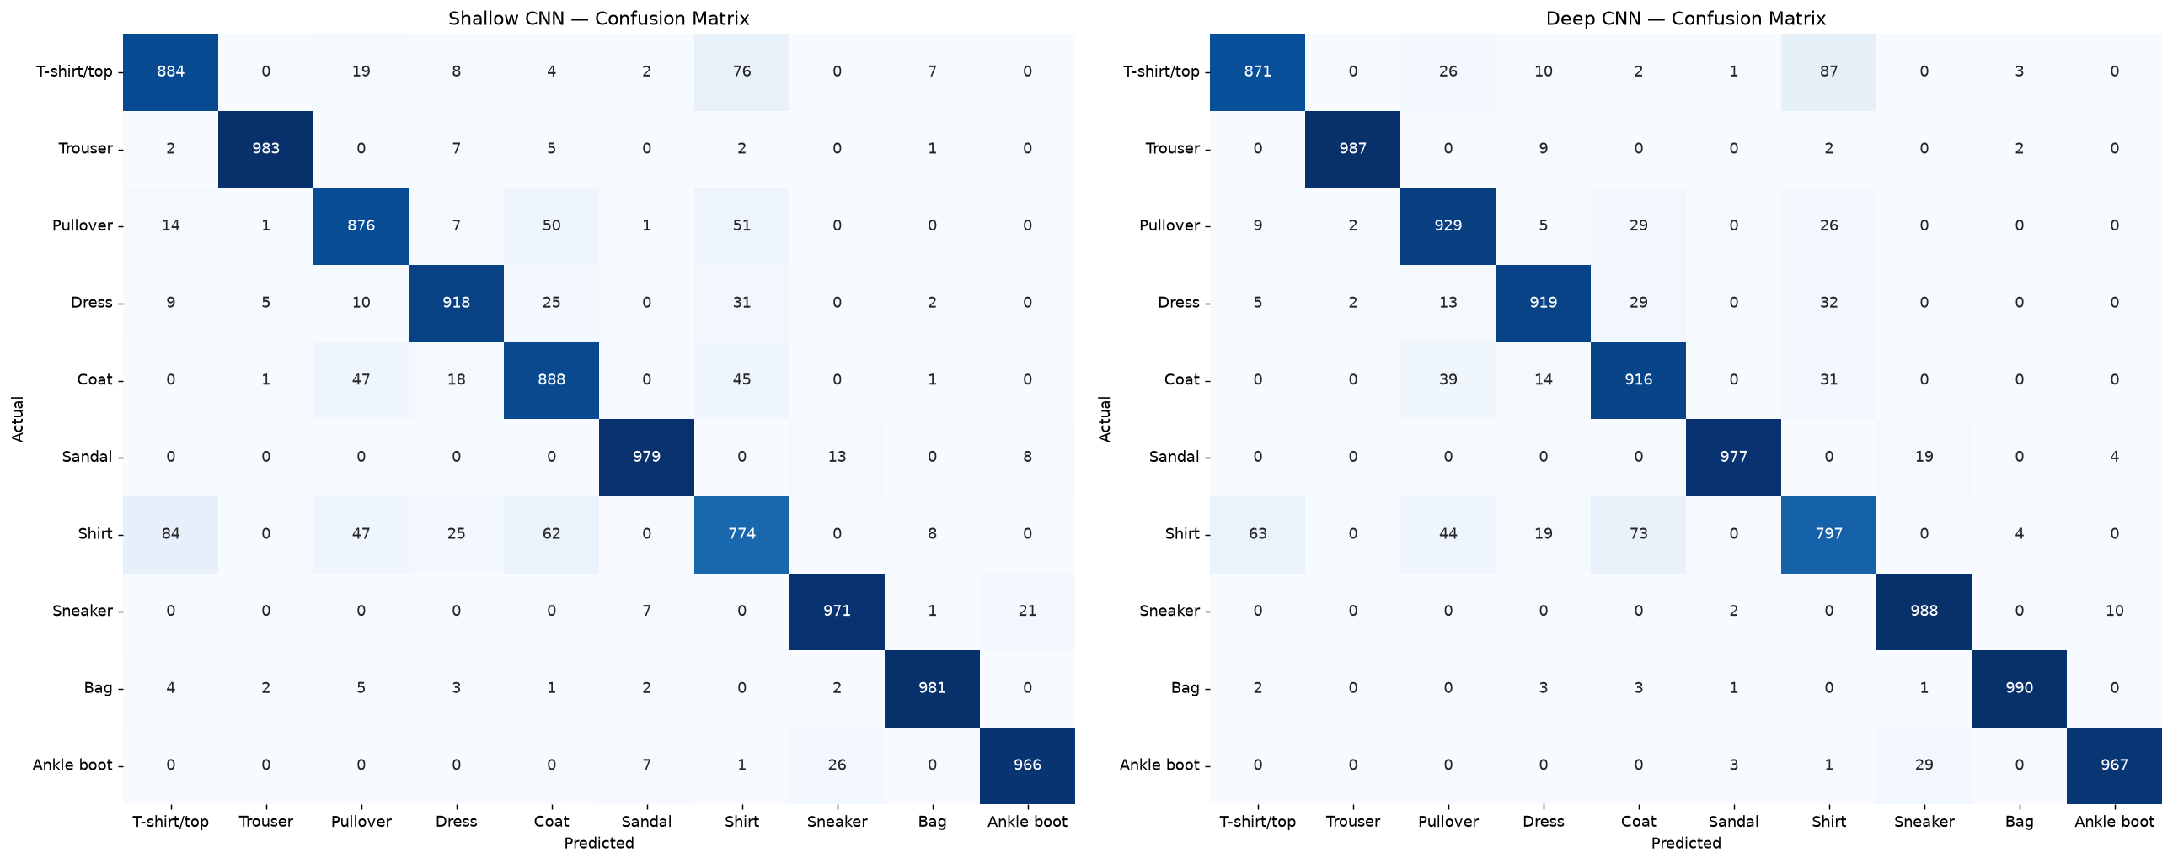
Figure 6 — Confusion matrices (rows = actual, columns = predicted). Both models are near-perfect on distinctive classes; errors concentrate in the Shirt / T-shirt / Pullover / Coat block. The deep CNN has a stronger diagonal and lighter off-diagonal cells there.
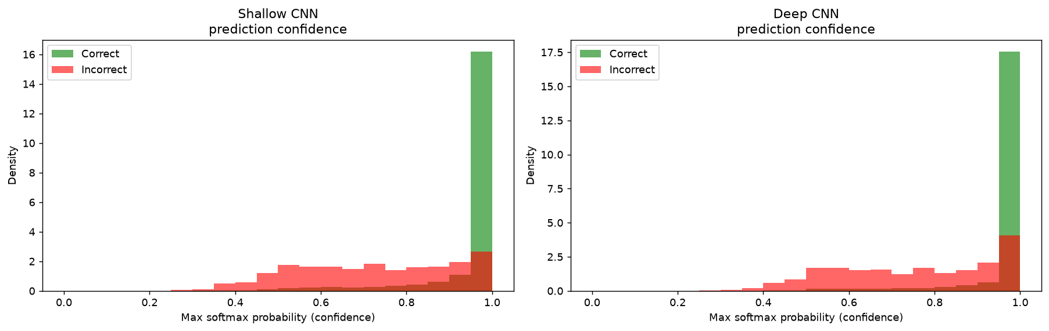
Figure 7 — Prediction confidence for correct (green) vs incorrect (red) predictions. Both are confident when correct, but the deep model's errors lean to lower confidence — it is better calibrated (less often confidently wrong).
- Easiest classes: Trouser, Bag, Sandal, Sneaker, Ankle boot — distinctive silhouettes, near-perfect recall.
- Most confused: Shirt with T-shirt/top, Pullover and Coat — nearly identical outlines at 28×28; Shirt is the hardest class for both models.
- Deep CNN vs Shallow: the deep model reduces confusion within that look-alike cluster and is better calibrated in its mistakes.

Part 6 — Final Conclusion
1. Which model would you recommend? The Deep CNN — highest, most dependable accuracy (93.41%) with no overfitting. Unless compute/latency is severely constrained, it is the better default.
2. Which model was more efficient? The Shallow CNN — ~9× faster to train, ~2.4× fewer parameters, cheaper at inference.
3. Which model was more accurate? The Deep CNN, on training, validation and test accuracy alike, and with the smaller generalisation gap.
4. What did you learn from this comparative study? Depth pays off, but only with the right supporting techniques. Extra convolution layers build a feature hierarchy that separates visually similar classes a single-conv model cannot — but that capacity would overfit without batch-norm and dropout. A fixed validation split and early stopping made the comparison fair and reproducible, the confidence analysis showed the regularised deep model is better calibrated, and the augmentation experiment showed a technique must be matched to the data. The core trade-off: more capacity buys accuracy at the cost of compute and training time, and regularisation turns that capacity into generalisation rather than memorisation.

