Comparative Study of Shallow CNN vs Deep CNN on Fashion-MNIST
Hands-on assignment report — dataset exploration, model design, training, comparison, and error analysis
GitHub Repository: https://github.com/manidixit16/Convolutional-Neural-Networks
- Jupyter Notebook (all 6 parts, executed): Fashion_MNIST_Shallow_vs_Deep_CNN.ipynb
- Comparative Report (PDF): REPORT.pdf
- Comparative Report (Markdown): REPORT.md

1. Objective
Perform a controlled comparison between a shallow CNN and a deep CNN on the Fashion-MNIST dataset — training both on the same data with an identical training setup — and determine which architecture is more suitable for this image-classification task in terms of accuracy, generalisation, and efficiency. A third experiment adds data augmentation to the deep CNN to study its effect.

2. Dataset Overview
Fashion-MNIST consists of 70,000 grayscale 28×28 images across 10 balanced clothing classes (6,000 training images each), split into 60,000 training and 10,000 test images. Pixels were normalized to [0, 1] and images reshaped to (28, 28, 1) for CNN input. A fixed, stratified 90/10 train–validation split (seeded) was held out so both models see exactly the same validation data and the experiment is reproducible.
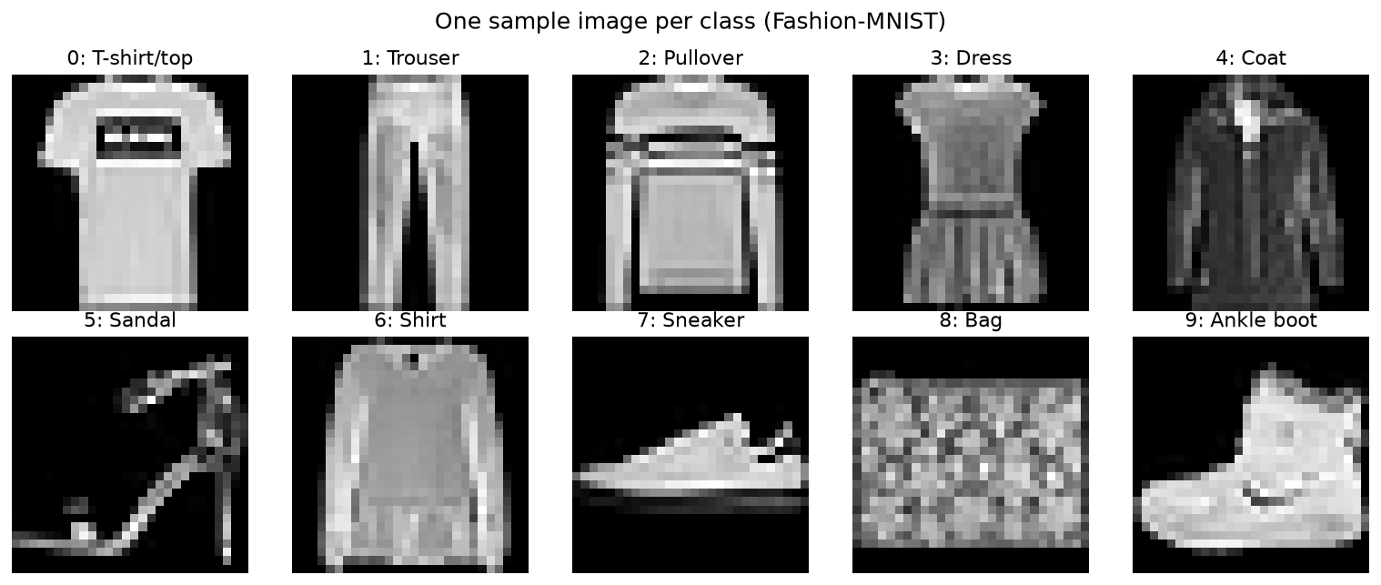
Figure 1 — One sample image per class. Distinctive items (Trouser, Bag, Sandal, Sneaker, Ankle boot) are easy; the upper-body garments (T-shirt, Pullover, Coat, Shirt) share almost identical outlines and are where most errors occur.

3. Preprocessing — Why Normalize and Reshape?
Normalization: raw pixels are 0–255; feeding such large, unevenly-scaled values in makes training slow and unstable. Rescaling to [0, 1] keeps activations and gradients in a small consistent range, so the optimizer converges faster and more reliably.
Reshaping: a Conv2D layer expects a (height, width, channels) tensor. The images arrive as (28, 28) with no channel axis, so we reshape to (28, 28, 1) — a single grayscale channel — otherwise the convolution cannot build.

4. Shallow CNN
Architecture: Conv2D(32) → MaxPool → Flatten → Dense(128) → Dense(10, softmax) — one convolution layer and one pooling layer. Almost all of its parameters live in the Flatten → Dense connection, which is powerful enough to memorise training-set detail.
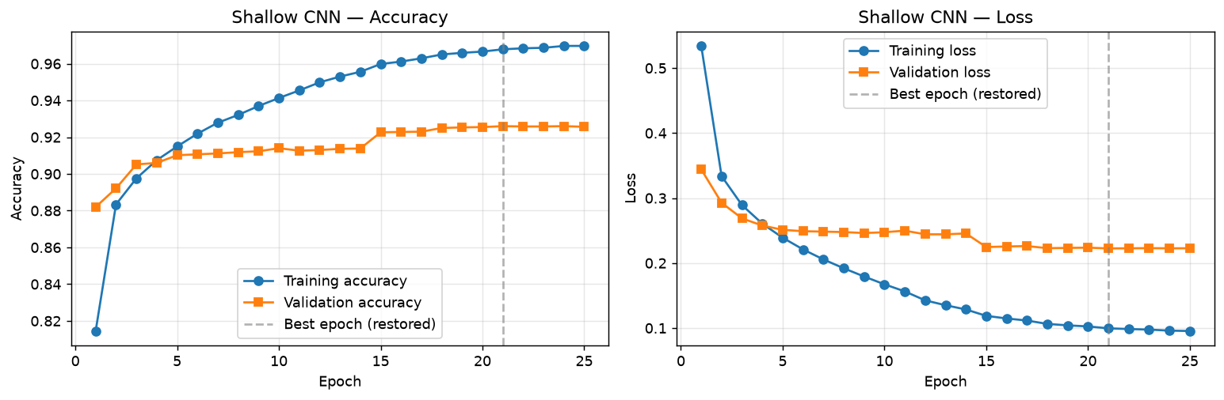
Figure 2 — Shallow CNN learning curves. Training accuracy climbs toward 0.97 while validation flattens near 0.92, and validation loss turns upward — the classic signature of overfitting. Early stopping restores the best-validation weights (dashed line).
Result: test accuracy 92.20%. The model learns only low-level features (edges, strokes) and overfits — training accuracy sits well above validation accuracy (gap 4.2%).

5. Deep CNN
Architecture: Conv(32) → BatchNorm → Conv(64) → MaxPool → Dropout → Conv(128) → BatchNorm → MaxPool → Dropout → Flatten → Dense(256) → Dropout → Dense(10, softmax) — three convolution layers with growing filters, two pooling layers, batch-norm and dropout. More filters build a feature hierarchy; batch-norm stabilises training; dropout prevents over-reliance on any single feature.
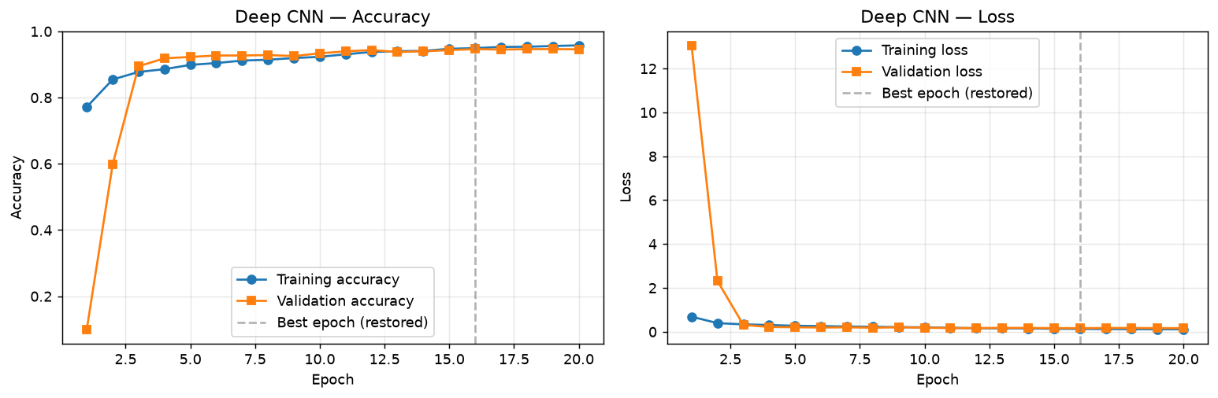
Figure 3 — Deep CNN learning curves. Training and validation rise together and stay close, and validation loss tracks training loss instead of rising — the signature of a model that generalises rather than memorises.
Result: test accuracy 93.41% — the best of all models — with a near-zero train–validation gap (0.3%), i.e. no overfitting. The deeper feature hierarchy resolves the hard look-alike classes the shallow model misses.

6. Enhancement — Deep CNN with Data Augmentation
The same deep architecture was retrained with gentle on-the-fly augmentation (small random rotation ≤4%, translation ≤6%, zoom ≤6%) on the training images only. The transforms are kept small because Fashion-MNIST garments are already upright and centred.
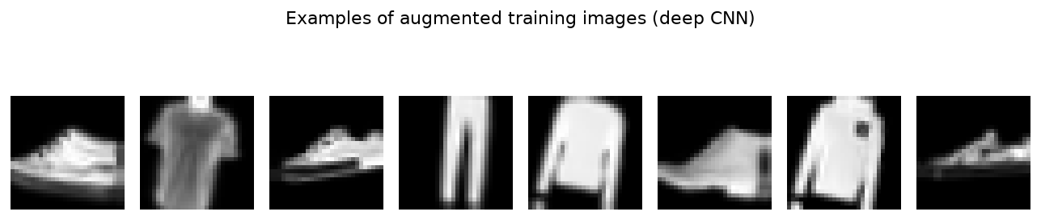
Figure 4 — Augmented training images: slightly rotated / shifted / zoomed, but still clearly recognisable.
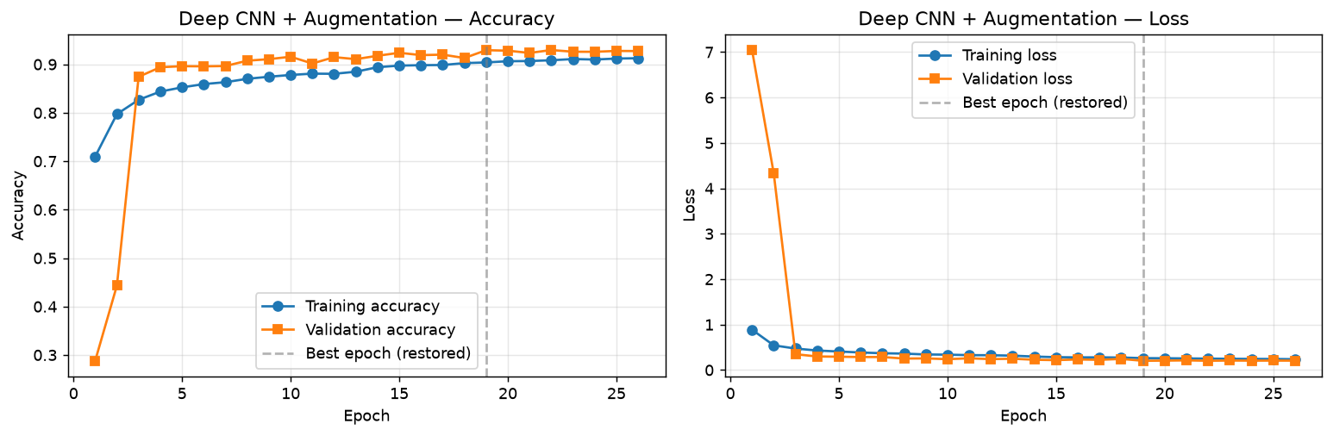
Figure 5 — Augmented deep CNN curves. Validation accuracy sits slightly above training accuracy — the model is mildly under-fit to the (harder) augmented training data: heavy regularisation, no overfitting.
Result: test accuracy 91.64% with a negative train–val gap (-2.5%). Augmentation strongly regularises but does not beat the plain deep model on this clean test set — an honest, instructive result: augmentation is not a free accuracy win; its payoff is robustness/calibration, and its strength must be matched to the data.

7. Comparative Study
All three models use the same optimizer, loss, batch size, validation set, and early-stopping recipe, so the comparison is fair. Training/validation accuracy are reported at each model's best (restored) epoch.
Metric | Shallow CNN | Deep CNN | Deep CNN + Aug
Number of Conv Layers | 1 | 3 | 3
Total Parameters | 693,962 | 1,701,770 | 1,701,770
Epochs Trained (early stop) | 25 | 20 | 26
Training Accuracy | 96.78% | 94.94% | 90.39%
Validation Accuracy | 92.60% | 94.65% | 92.92%
Test Accuracy | 92.20% | 93.41% | 91.64%
Train–Val Gap | 4.18% | 0.29% | -2.53%
Overfitting Observed? | Yes | No | No
Training Time (s) | 127 | 1132 | 1527
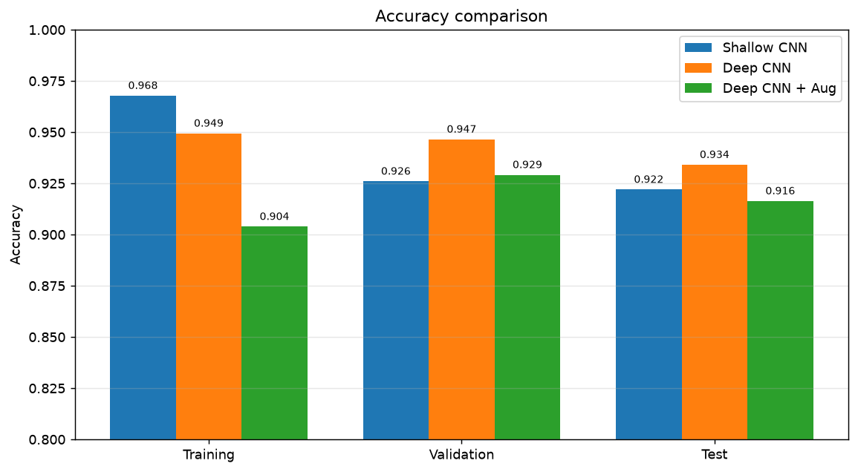
Figure 6 — Accuracy comparison. The shallow model's Training bar towers over its Validation/Test bars (overfitting); the deep model's bars are level and its Test bar is the tallest; the augmented model's Training bar is the shortest (mild underfitting).
Key observations: the deep CNN is the most accurate (93.41% test vs 92.20% for shallow) and the best-generalising (gap ~0 vs 4.2% for shallow). The shallow CNN is far more efficient — about 9× faster to train and ~2.4× fewer parameters. Data augmentation trades training-set fit for robustness without raising test accuracy on this clean dataset.

8. Prediction & Error Analysis
Predictions were generated for both models. Below: the confusion matrices, a confidence analysis, and the deep model's most confident mistakes.
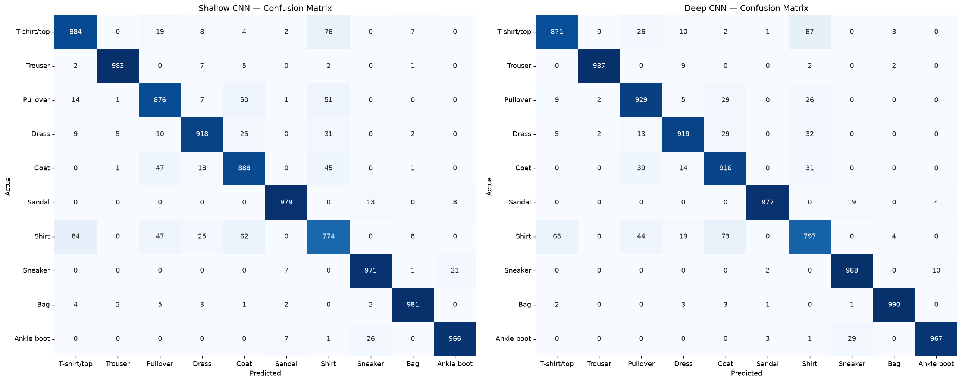
Figure 7 — Confusion matrices (rows = actual, columns = predicted). Both models are near-perfect on the distinctive classes; errors cluster in the Shirt / T-shirt / Pullover / Coat block. The deep CNN has a stronger diagonal and lighter off-diagonal cells there.
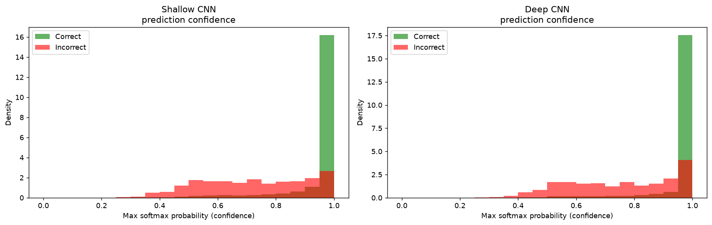
Figure 8 — Prediction confidence for correct (green) vs incorrect (red) predictions. Both are confident when correct; the deep model's errors lean to lower confidence — it is better calibrated (less often confidently wrong).
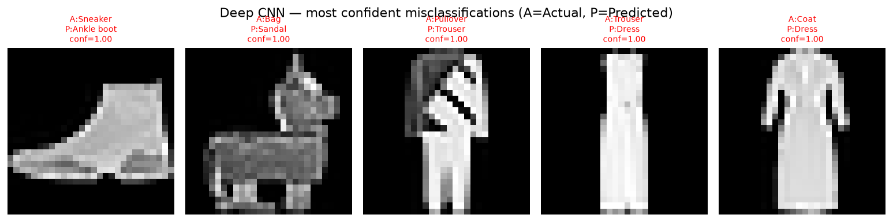
Figure 9 — The deep CNN's most confident mistakes: nearly all are Shirt/T-shirt/Pullover/Coat confusions that are genuinely ambiguous at 28×28 grayscale.
Easiest classes: Trouser, Bag, Sandal, Sneaker, Ankle boot (distinctive silhouettes). Most confused: Shirt with T-shirt/Pullover/Coat. The deep CNN reduces confusion within this cluster and is better calibrated.

9. Final Conclusion
- Recommended model: the deep CNN — highest accuracy and best generalisation, no overfitting.
- More efficient: the shallow CNN — ~9× faster to train and far lighter.
- More accurate: the deep CNN (93.41% vs 92.20% test), with the smaller generalisation gap.
What we learned: depth pays off, but only with the right supporting techniques. Extra convolution layers build a feature hierarchy that separates visually similar classes a single-conv model cannot — but that capacity would overfit without batch-norm and dropout. A fixed validation split and early stopping made the comparison fair and reproducible; the confidence analysis showed the regularised deep model is better calibrated; and the augmentation experiment showed a technique must be matched to the data. The core trade-off is concrete: more capacity buys accuracy at the cost of compute and training time, and regularisation turns that capacity into generalisation rather than memorisation.

