Kathmandu University

Department of Computer Science and Engineering

Dhulikhel, Kavre



Algorithms and Complexity (COMP 314)

Lab 3 Report

Submitted to:

Dr. Rajani Chulyadyo

Department of Computer Science and Engineering

Submitted By:

Mani Dumaru

Roll no.: 15

CE-2019 3rd year/2nd semester

Submission Date: 2nd May, 2023

**Implementation and testing of Binary Search Tree**

[*Source Code Link: binarySrarchTree*](https://github.com/manidumaru/LabWorksSem6/tree/master/Algorithm/lab3)

1. For adding a node to the binary search tree

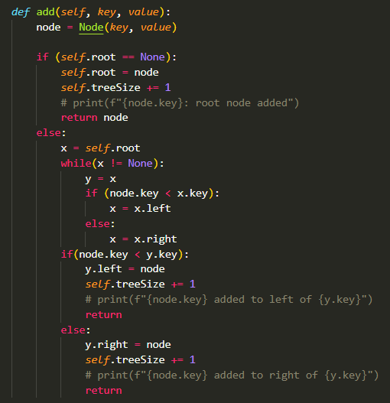

1. Finding the size of the tree

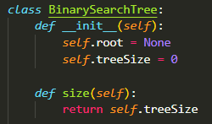

1. For searching a key in the tree

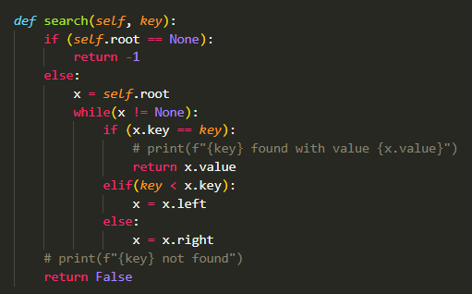

1. For finding the smallest key in the binary search tree

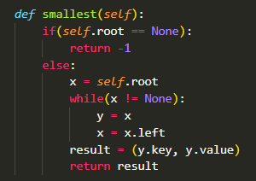

1. For finding the largest key in the binary search tree

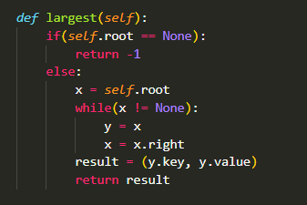

1. Inorder Walk in the tree

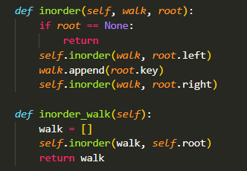

1. Preorder Walk in the tree

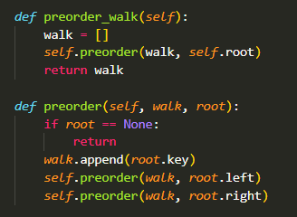

1. Postorder walk in the tree

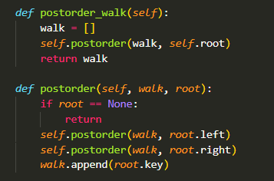

1. Removing an element from the tree

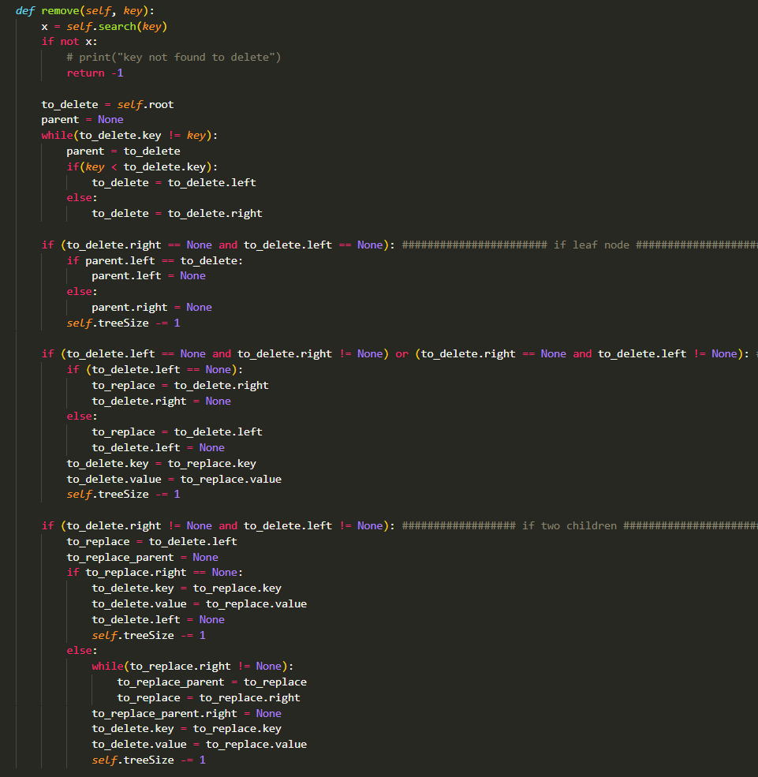

***Result for Test Cases:***

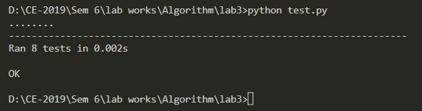

**Conclusion**Hence, given test cases were used to test the correctness of the above algorithms. All test cases passed the correctness of the algorithms. In this way a binary search tree with 8 different functions was implemented.