Kathmandu University

Dhulikhel, Kavre

Department of Computer Science and Engineering



Computer Graphics (COMP 342)

Lab 2 Report

Submitted By:

Mani Dumaru

Roll no.: 15

Year/Sem: 3rd/2nd

Submitted to:

Mr. Dhiraj Shrestha

Department of Computer Science and Engineering

Submission Date: 20th April, 2023

Implement Digital Difference Analyzer line drawing algorithm.

**Algorithm:**

Input: coordinates of two endpoints of a line. (x1,y1) and (x2,y2)

Output: a line with those two endpoints using Digital Difference analysing approach.

1. Calculate slope using two endpoints. slope = (y2-y1)/(x2-x1)
2. IF slope < 1
   1. WHILE x1 != x2
      1. Plot(x1,y1)
      2. x1 = x1 + 1
      3. y1 = y1 + slope

END WHILE

1. Else
   1. WHILE y1 != y2
      1. PLOT(x1,y1)
      2. y1 = y1 + 1
      3. x1 = x1 + (1/slope)

END WHILE

END IF

*Link to Source Code:* [*dda.py*](https://raw.githubusercontent.com/manidumaru/LabWorksSem6/master/Graphics/lab2/DDA.py)

Output:

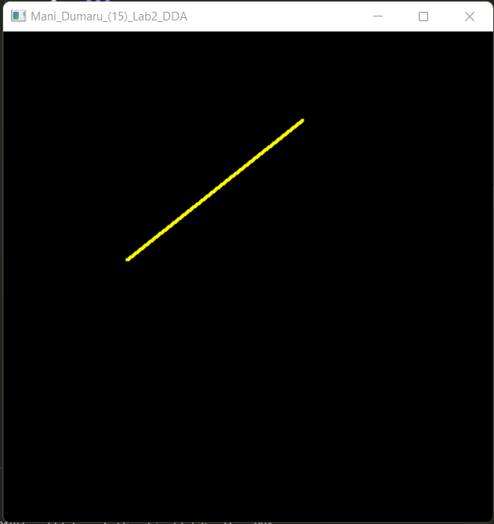

Implement Bresenham Line Drawing Algorithm for both slopes.

**Algorithm:**

Input: coordinates of two endpoints of a line. (x1,y1) and (x2,y2)

Output: a line with those two endpoints in BLA approach.

1. Calculate slope of the line. slope = (y2-y1)/(x2-x1)
2. Calculate c = y1 – (slope * x1)
3. if slope < 1
   1. while x1 != x2
      1. PLOT(x1,y1)
      2. x = x + 1
      3. Calculate actual_y = (slope*x) + c
      4. d1 = (y1+1) - actual_y
      5. d2 = actual_y – y1
      6. if d1-d2 < 0
         1. y1 = y1 + 1
      7. END WHILE
4. ELSE
   1. while y1 != y2
      1. PLOT(x1,y1)
      2. y1 = y1 + 1
      3. Calculate actual_x = (y1 - c) / slope
      4. d1 = (x1+1) – actual_x
      5. d2 = actual_x – x1
      6. If d1-d2 < 0
         1. x1 = x1 + 1
      7. END WHILE
5. END IF

*Link to Source Code:* [*bla.py*](https://raw.githubusercontent.com/manidumaru/LabWorksSem6/master/Graphics/lab2/BLA.py)

Output:

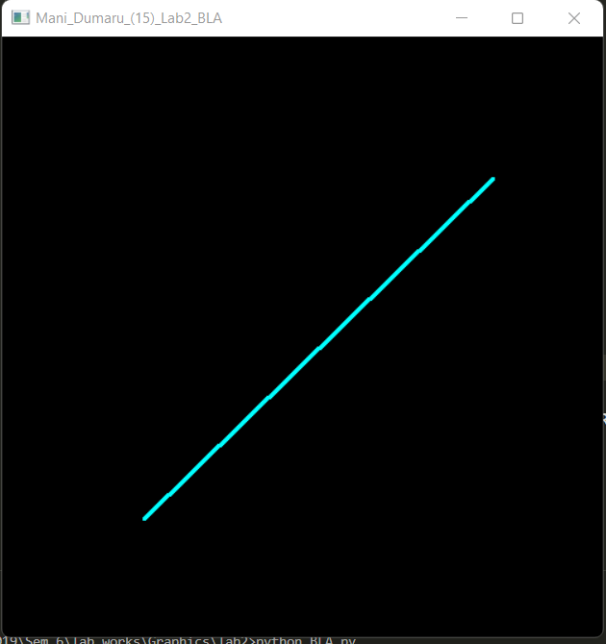

Conclusion:

Hence, a line was shaped using two endpoints by calculating its slope using digital difference analyzer algorithm and bresenham line drawing algorithm.