Kathmandu University

Department of Computer Science and Engineering

Dhulikhel, Kavre



COMP 342 (Computer Graphics)

Lab 4 Report

Submitted To:

Mr. Dhiraj Shrestha

Department of Computer Science and Engineering

Submitted By:

Mani Dumaru

Roll no.: 15

CE-2019 3rd Year/ 2nd Semester

Submission Date: 1st May, 2023

**Implementation of 2D Transformations using Homogenous Coordinates**

**Implementing 2D Translation**

*Algorithm:*

Input: Coordinates of a triangle, translation factor

Output: Translated triangle

1. Given coordinates are plotted to form a triangle
2. Use the translation matrix on each coordinate to get its translated coordinate.

Translation Matrix: $\begin{matrix}1 & 0 & tx \\ 0 & 1 & ty \\ 0 & 0 & 1\end{matrix}$. $\begin{matrix}x \\ y \\ 1\end{matrix}$

1. Use the coordinates obtained from the above product to plot a new translated triangle

*Output:*

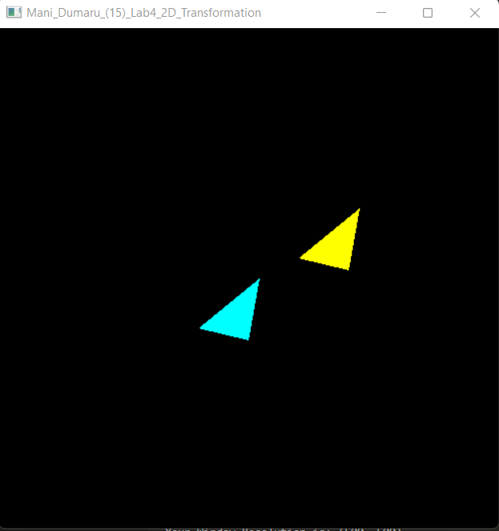

Implementing 2D scaling

*Algorithm:*

Input: Coordinates of a triangle, scaling factor

Output: Translated triangle

1. Given coordinates are plotted to form a triangle
2. Use the scaling matrix on each coordinate to get its scaled coordinate.

Scaling Matrix: $\begin{matrix}Sx & 0 & 0 \\ 0 & Sy & 0 \\ 0 & 0 & 1\end{matrix}$. $\begin{matrix}x \\ y \\ 1\end{matrix}$

1. Use the coordinates obtained from the above product to plot a new scaled triangle

*Output:*

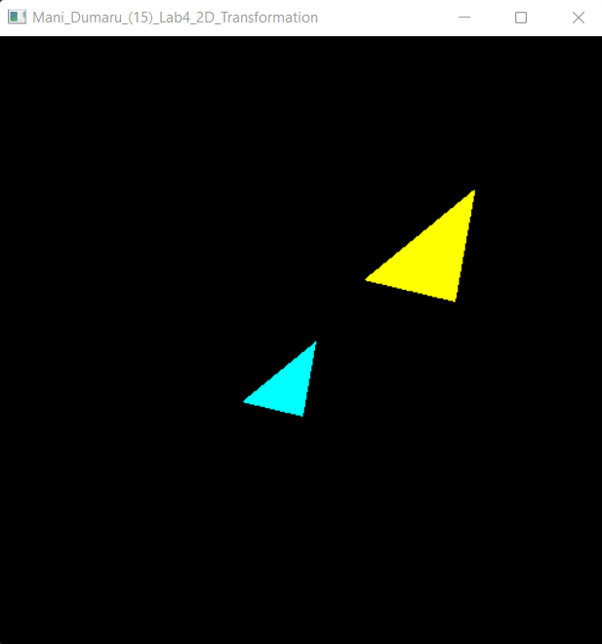

Implementing 2D rotation

*Algorithm:*

Input: Coordinates of a triangle, angle of rotation θ

Output: Translated triangle

1. Given coordinates are plotted to form a triangle
2. Use the rotation matrix on each coordinate to get its rotated coordinate.

Rotation Matrix: $\begin{matrix}cosθ & -sin θ & 0 \\ sinθ & cosθ & 0 \\ 0 & 0 & 1\end{matrix}$. $\begin{matrix}x \\ y \\ 1\end{matrix}$

1. Use the coordinates obtained from the above product to plot a new rotated triangle

*Output:*

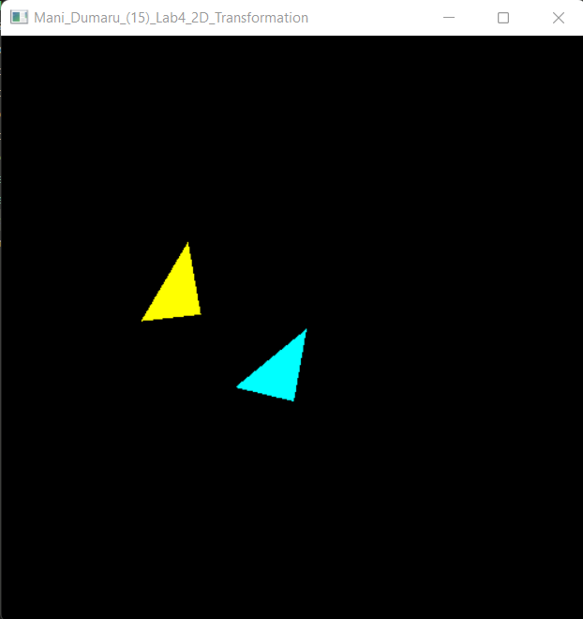

Implementing 2D shearing:

*Algorithm:*

Input: Coordinates of a triangle, angle of rotation θ

Output: Translated triangle

1. Given coordinates are plotted to form a triangle
2. Use the shearing matrix on each coordinate to get its sheared coordinate.

Shearing Matrix: $\begin{matrix}1 & shx & -shx*yref \\ 0 & 1 & 0 \\ 0 & 0 & 1\end{matrix}$. $\begin{matrix}x \\ y \\ 1\end{matrix}$ (X shear with reference to y-axis)

Shearing Matrix: $\begin{matrix}1 & 0 & 0 \\ shy & 1 & -shy*xref \\ 0 & 0 & 1\end{matrix}$. $\begin{matrix}x \\ y \\ 1\end{matrix}$ (Y shear with reference to x-axis)

1. Use the coordinates obtained from the above product to plot a new sheared triangle

*Output:*

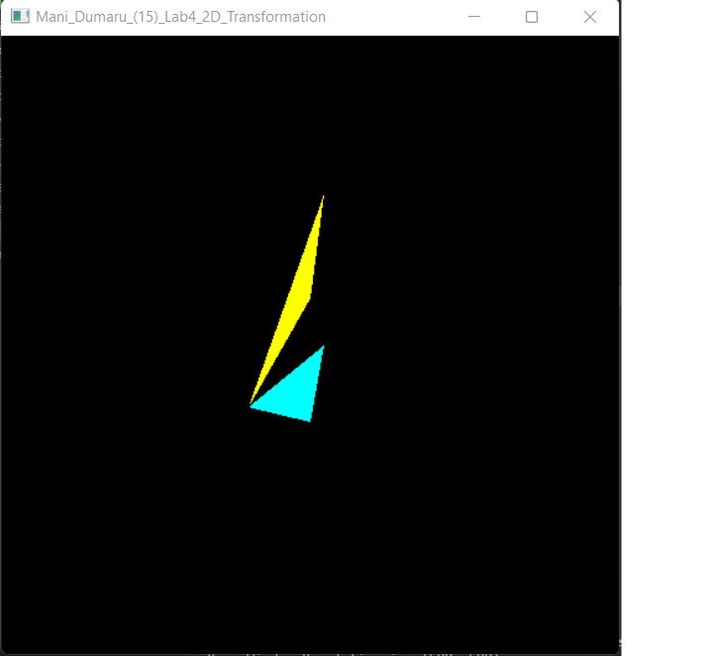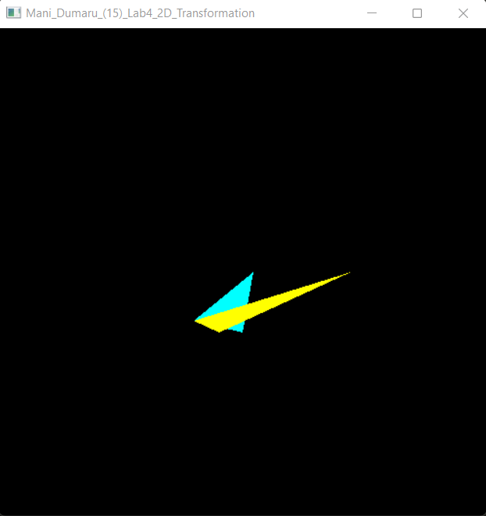

*X shear with reference to y-axis Y shear with respect to x-axis*

*Source Code for Translation, Scaling, Rotation and Shear:* [*transformations.py*](https://raw.githubusercontent.com/manidumaru/LabWorksSem6/master/Graphics/lab4/transformation.py)

Implementing 2D reflection:

*Algorithm:*

Input: Coordinates of a triangle, angle of rotation θ

Output: Translated triangle

1. Given coordinates are plotted to form a triangle
2. Use the reflection matrix on each coordinate to get its reflected coordinate.

Reflection about the line Y=0 (x-axis): $\begin{matrix}1 & 0 & 0 \\ 0 & -1 & 0 \\ 0 & 0 & 1\end{matrix}$. $\begin{matrix}x \\ y \\ 1\end{matrix}$

Reflection about the line X=0 (Y-axis): $\begin{matrix}-1 & 0 & 0 \\ 0 & 1 & 0 \\ 0 & 0 & 1\end{matrix}$. $\begin{matrix}x \\ y \\ 1\end{matrix}$

1. Use the coordinates obtained from the above product to plot a new reflected triangle

*Output*

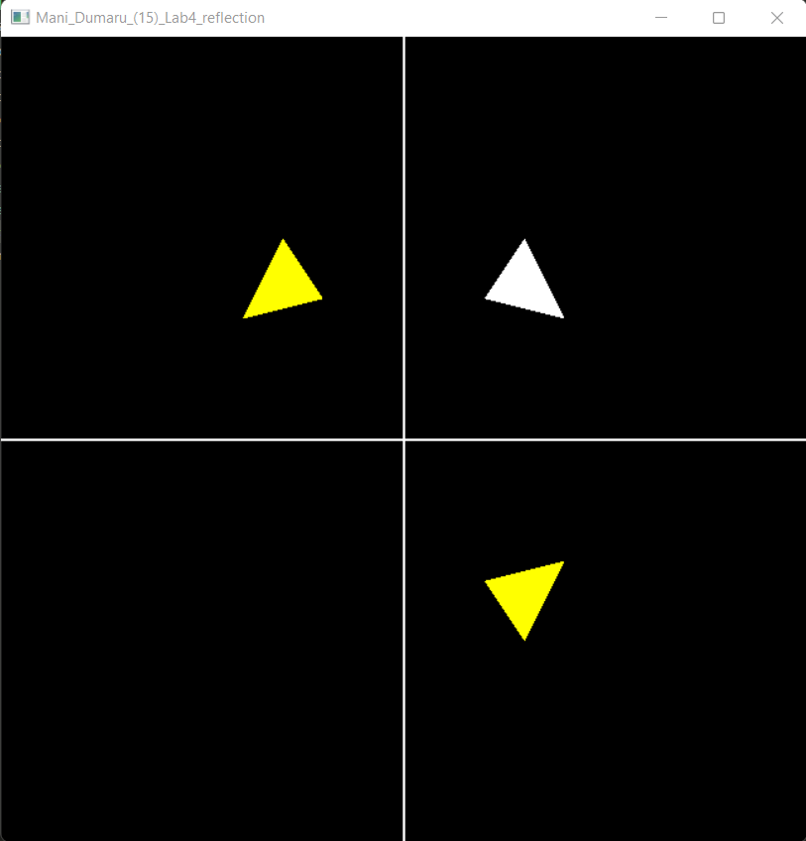

*Source Code for reflection:* [*reflection.py*](https://raw.githubusercontent.com/manidumaru/LabWorksSem6/master/Graphics/lab4/reflection.py)

Conclusion:

Hence, implementation of various basic 2D transformations were done using PyOpenGL library.